Department of Computer Science and Information Technology
COMPUTER NETWORKS – BSDCBZC481
Laboratory Work Sheet – 3

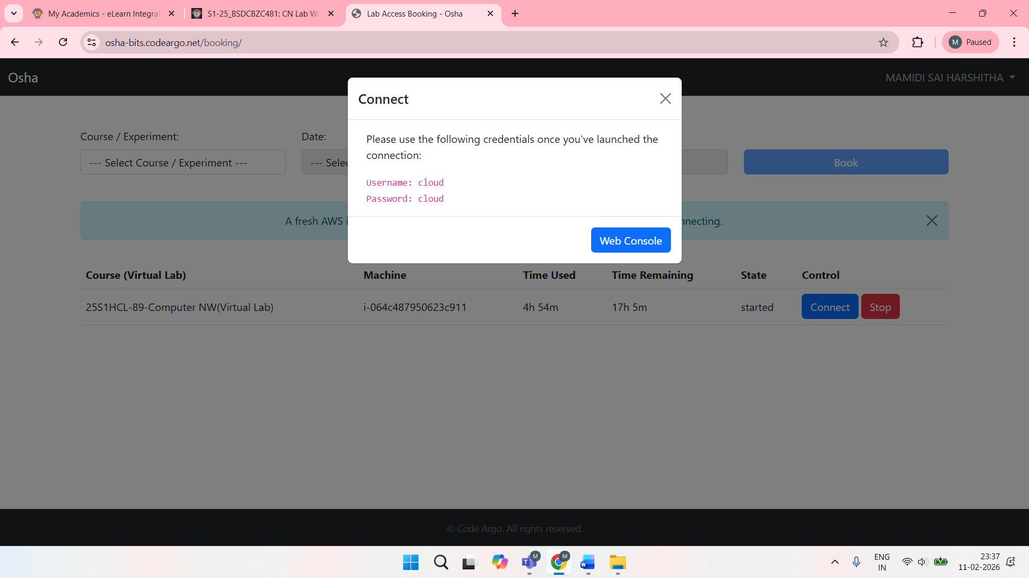
Experiment 1: Socket programming using any one of the programming languages(2M)

Server Code (socket_server.c):
#include <stdio.h>
#include <stdlib.h>
#include <string.h>
#include <unistd.h>
#include <arpa/inet.h>
int main() {
char * ip = "127.0.0.1";
int port = 5566;
int server_sock, client_sock;
struct sockaddr_in server_addr, client_addr;
socklen_t addr_size;
char buffer[1024];
int n;
server_sock = socket(AF_INET, SOCK_STREAM, 0);
if (server_sock < 0) {
perror("Error in Creating Socket.......");
exit(1);
}
printf("TCP server socket created.\n");
memset(&server_addr, '\0', sizeof(server_addr));
server_addr.sin_family = AF_INET;
server_addr.sin_port = port;
server_addr.sin_addr.s_addr = inet_addr(ip);
n = bind(server_sock, (struct sockaddr*)&server_addr, sizeof(server_addr));
if (n < 0) {
perror("Bind error");
exit(1);
}
printf("Bind to the port number: %d\n", port);
listen(server_sock, 5);
printf("Listening...\n");
while (1) {
addr_size = sizeof(client_addr);
client_sock = accept(server_sock, (struct sockaddr*)&client_addr, &addr_size);
printf("Client connected.\n");
bzero(buffer, 1024);
recv(client_sock, buffer, sizeof(buffer), 0);
printf("Client: %s\n", buffer);
bzero(buffer, 1024);
strcpy(buffer, "HI, THIS IS SERVER. My BITS ID is 202217b2159");
printf("Server: %s\n", buffer);
send(client_sock, buffer, strlen(buffer), 0);
close(client_sock);
printf("Client disconnected.\n\n");
}
return 0;
}

Terminal 1, run
$ gcc socket_server.c -o server
$ ./server

Client Code (socket_client.c):
#include <arpa/inet.h>
#include <stdio.h>
#include <stdlib.h>
#include <string.h>
#include <unistd.h>
int main() {
char *ip = "127.0.0.1";
int port = 5566;
int sock;
struct sockaddr_in addr;
socklen_t addr_size;
char buffer[1024];
int n;
sock = socket(AF_INET, SOCK_STREAM, 0);
if (sock < 0) {
perror("Error in Creating..........");
exit(1);
}
printf("TCP server socket created.\n");
memset(&addr, '\0', sizeof(addr));
addr.sin_family = AF_INET;
addr.sin_port = port;
addr.sin_addr.s_addr = inet_addr(ip);
connect(sock, (struct sockaddr *)&addr, sizeof(addr));
printf("Connected to the server.\n");
bzero(buffer, 1024);
strcpy(buffer, "HELLO, THIS IS CLIENT...What is your BITS ID.");
printf("Client: %s\n", buffer);
send(sock, buffer, strlen(buffer), 0);
bzero(buffer, 1024);
recv(sock, buffer, sizeof(buffer), 0);
printf("Server: %s\n", buffer);
close(sock);
printf("Disconnected from the server.\n");
return 0;
}

Terminal 2, run:
$ gcc socket_client.c -o client
$./client

Open Two terminals Run socket_server.c program in One terminal and socket_client.c in other terminal. (Note: Server program has to start first and then run the client program)
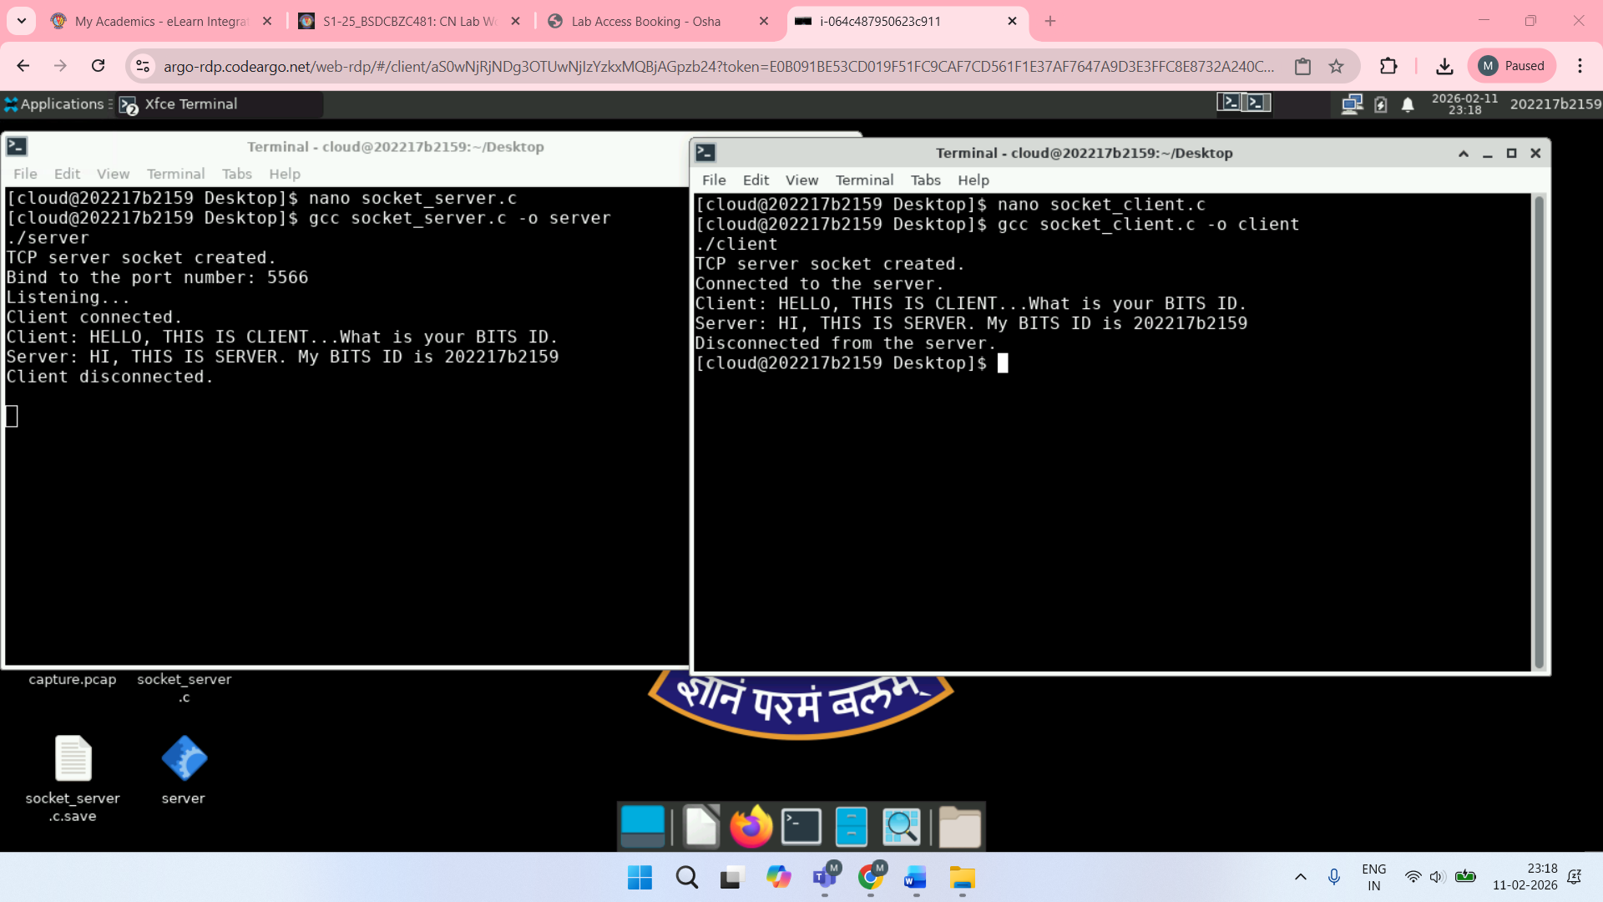
Experiment 2: Building different types of networks for experimenting with different types of applications using Network Simulators(ns-3 Tool)

Step 1: Open Terminal

Step 2: Go to NS-3 Directory
cd ns-allinone-3.43/ns-3.43

Step 3: Create Program File
nano scratch/exp4-udp.cc

Step 4: Write the Program
Step 5: Save and Exit
Press:
- CTRL + O → Enter
- CTRL + X

Step 6: Build NS-3
./ns3 build

Step 7: Run the Program
./ns3 run scratch/exp4-udp

Step 8: Observe Output
UDP packets are sent from client node to server node, confirming successful execution.
Code:

#include "ns3/core-module.h"

#include "ns3/network-module.h"

#include "ns3/internet-module.h"

#include "ns3/point-to-point-module.h"

#include "ns3/applications-module.h"

using namespace ns3;

NS_LOG_COMPONENT_DEFINE ("Experiment4UDP");

int main (int argc, char *argv[])

{

// Enable logging

LogComponentEnable ("Experiment4UDP", LOG_LEVEL_INFO);

LogComponentEnable ("UdpClient", LOG_LEVEL_INFO);

LogComponentEnable ("UdpServer", LOG_LEVEL_INFO);

// Step 1: Create nodes

NodeContainer nodes;

nodes.Create (2);

// Step 2: Configure point-to-point link

PointToPointHelper p2p;

p2p.SetDeviceAttribute ("DataRate", StringValue ("5Mbps"));

p2p.SetChannelAttribute ("Delay", StringValue ("2ms"));

// Step 3: Install devices

NetDeviceContainer devices = p2p.Install (nodes);

// Step 4: Install Internet stack

InternetStackHelper stack;

stack.Install (nodes);

// Step 5: Assign IP addresses

Ipv4AddressHelper address;

address.SetBase ("10.1.1.0", "255.255.255.0");

Ipv4InterfaceContainer interfaces = address.Assign (devices);

// Step 6: Create UDP Server (Node 1)

uint16_t port = 4000;

UdpServerHelper server (port);

ApplicationContainer serverApp = server.Install (nodes.Get (1));

serverApp.Start (Seconds (1.0));

serverApp.Stop (Seconds (10.0));

// Step 7: Create UDP Client (Node 0)

UdpClientHelper client (interfaces.GetAddress (1), port);

client.SetAttribute ("MaxPackets", UintegerValue (5));

client.SetAttribute ("Interval", TimeValue (Seconds (1.0)));

client.SetAttribute ("PacketSize", UintegerValue (1024));

ApplicationContainer clientApp = client.Install (nodes.Get (0));

clientApp.Start (Seconds (2.0));

clientApp.Stop (Seconds (10.0));

// Step 8: Run simulation

Simulator::Run ();

Simulator::Destroy ();

return 0;
}

Output:
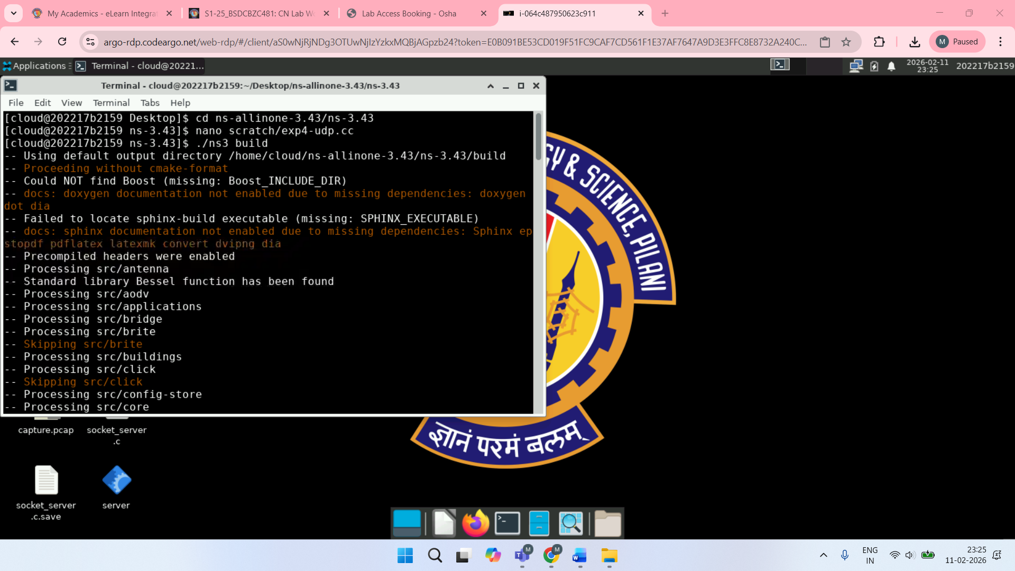

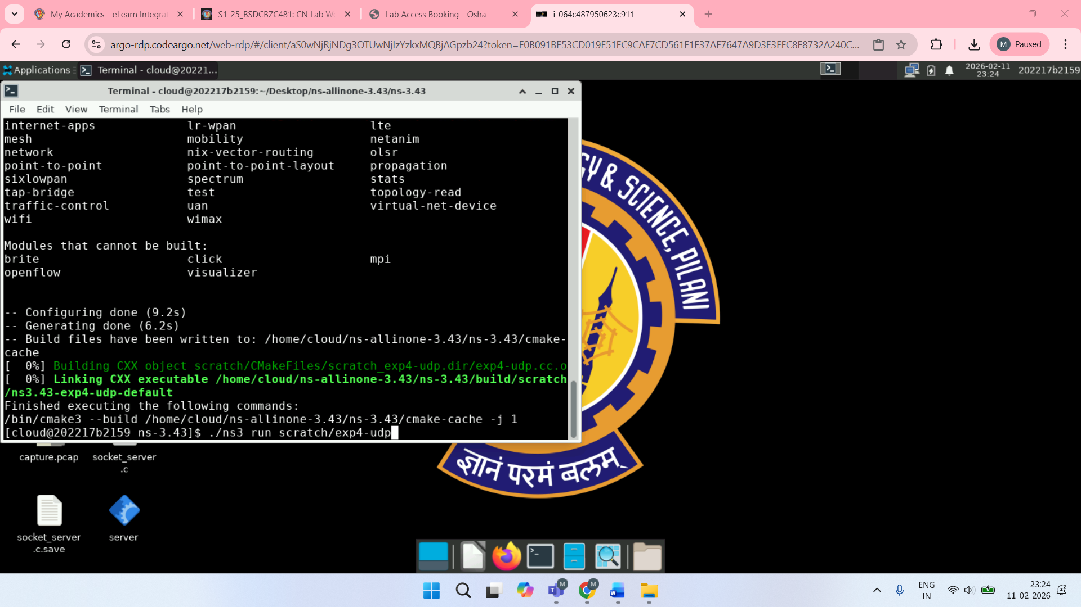
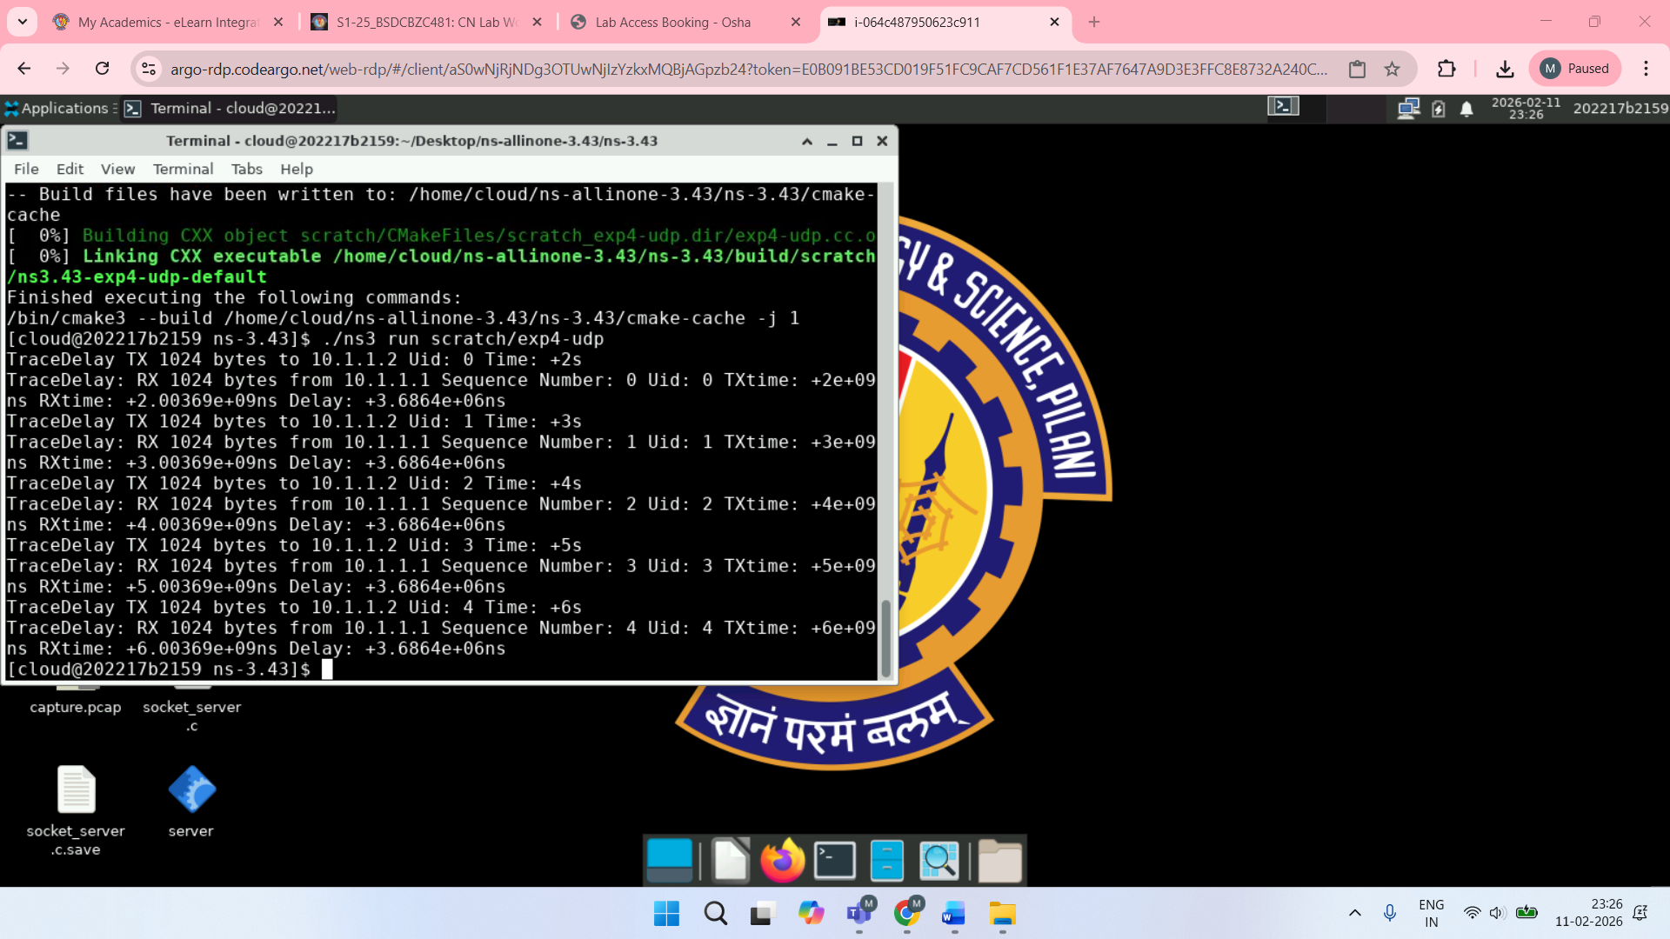

Experiment 3: Explain different examples provided in the labware modules in the eLearn course page.

Design a simple network using NS-3 and simulate TCP-based client–server communication to study reliable data transmission

Terminal: cd ns-allinone-3.43/ns-3.43

nano scratch/exp3-tcp.cc

Code:

#include "ns3/core-module.h"

#include "ns3/network-module.h"

#include "ns3/internet-module.h"

#include "ns3/point-to-point-module.h"

#include "ns3/applications-module.h"

using namespace ns3;

NS_LOG_COMPONENT_DEFINE ("Experiment3TCP");

int main (int argc, char *argv[])

{

LogComponentEnable ("Experiment3TCP", LOG_LEVEL_INFO);

LogComponentEnable ("BulkSendApplication", LOG_LEVEL_INFO);

LogComponentEnable ("PacketSink", LOG_LEVEL_INFO);

// Create nodes

NodeContainer nodes;

nodes.Create (2);

// Point-to-point link

PointToPointHelper p2p;

p2p.SetDeviceAttribute ("DataRate", StringValue ("10Mbps"));

p2p.SetChannelAttribute ("Delay", StringValue ("3ms"));

NetDeviceContainer devices = p2p.Install (nodes);

// Install Internet stack

InternetStackHelper stack;

stack.Install (nodes);

// Assign IP addresses

Ipv4AddressHelper address;

address.SetBase ("10.1.2.0", "255.255.255.0");

Ipv4InterfaceContainer interfaces = address.Assign (devices);

// TCP Server

uint16_t port = 5000;

Address sinkAddress (InetSocketAddress (interfaces.GetAddress (1), port));

PacketSinkHelper sink ("ns3::TcpSocketFactory", sinkAddress);

ApplicationContainer serverApp = sink.Install (nodes.Get (1));

serverApp.Start (Seconds (1.0));

serverApp.Stop (Seconds (10.0));

// TCP Client

BulkSendHelper client ("ns3::TcpSocketFactory", sinkAddress);

client.SetAttribute ("MaxBytes", UintegerValue (1024 * 1024));

ApplicationContainer clientApp = client.Install (nodes.Get (0));

clientApp.Start (Seconds (2.0));

clientApp.Stop (Seconds (10.0));

Simulator::Run ();

Simulator::Destroy ();

return 0;

}

End of code

Terminal: ./ns3 build

./ns3 run scratch/exp3-tcp

