/********************************************************************************/ PROJECT NAME: PractoFindingHospital

TEAM NUMBER : 02

TEAM MEMBERS: DIBYANSHU KUMAR (905378)

ABHISHEK RAI (905377)

SUROJIT DEY (904248)

PIYUSH BADHANI (904693)

VIVEK KUMAR (905379)

SUSMIT BANERJEE (905376)

/********************************************************************************/

**DESCRIPTION:**

* This test is to Finding Hospitals which is open 24*7, which has parking facility and whose rating should be more than 3.5.

**\* Test Scenario Descriptions:**

1. For Bangalore city, identify Hospitals that is Open 24/7, has Parking facility with rating more than 3.5; Display the hospital names.

2. In Diagnostics page, pick all the top cities name & store in a List; Display the same.

3. Go to Corporate Wellness, fill invalid details, schedule & capture the warning message from the alert.

**\* Project Explorer Layout:**

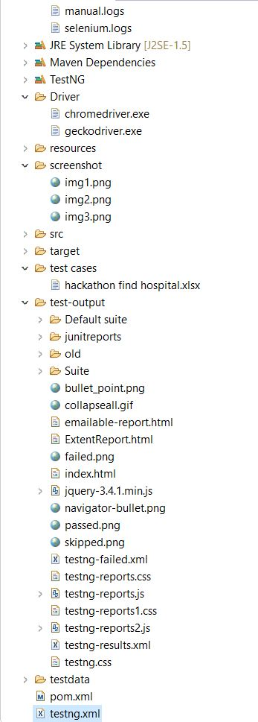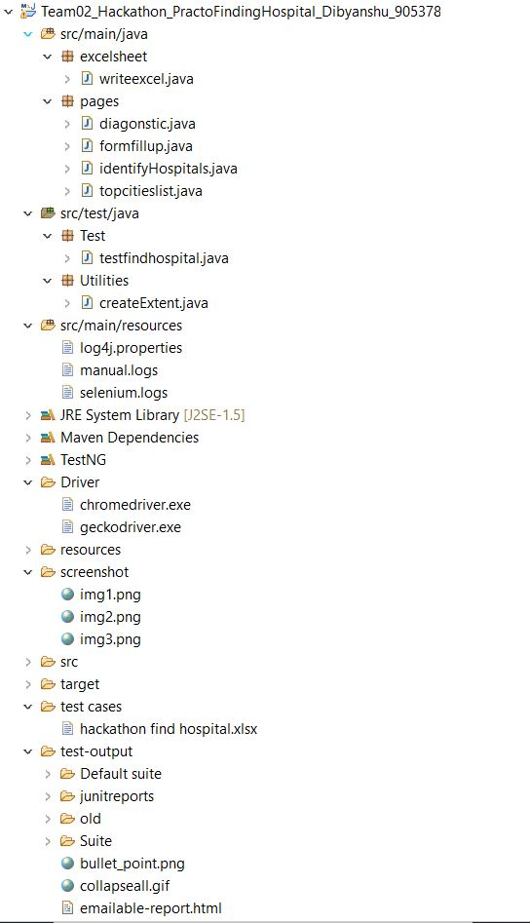

Part 1 Part 2

*This project uses TestNG

**\* Instructions:**

* This project is executable on selenium grid.

* The code to configure grid:-

~~~ for HUB, use this command:

java -jar selenium-server-standalone-3.141.59.jar -role hub

~~~ for Node, use this command:

java -Dwebdriver.chrome.driver="C:\selenium server\chromedriver.exe" -jar selenium- server-standalone-3.141.59.jar -role node -hub <http://192.168.137.1:4444/grid/register/> ​ -browser browserName=chrome,platform=WIN10

* Please change “hub <http://192.168.137.1:4444/grid/register/>” according to your system .

* After configuration of grid , change the browser name in chrome.

* Use testng.xml file to execute the test cases.Rightclick on testng.xml>run as>TestNG Suite.

* Only two drivers are provided, Google Chrome and Firefox drivers are implemented.To use any of them, change the 'value'(values are "firefox" or "chrome")attribute in 'parameter' tag in testng.xml to the desired driver.