

**Activity**: The structure of the Earth

(ATL skill:- Information literacy skills)

**Name:** Sameer Gupta **Class:** MYP 3-A **Date:** 14/07/20

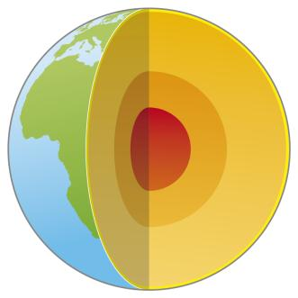

**Inner Core** is the hottest out of all and has a temperature of 5000 to 6000 degrees Celsius.

**Outer Core** comprises of hot liquid between 4000-6000 degrees

**Mantle** is the widest section of the earth and is semi-molten.

**Crust** is the thinnest layer of the earth and we live on it.

The Earth can be divided into four layers: inner core, outer core, mantle and crust.

* The inner core has a temperature of between 5000 and 6000 degrees Celsius and is the hottest part of the Earth. It is made from iron and nickel and is solid.
* The outer core is a hot liquid material of between 4000 and 6000 degrees Celsius and is made from iron, nickel, sulphur and oxygen. It surrounds the inner core.
* The mantle comprises solid and liquid material and is semi-molten. It is made from iron, oxygen, silicon, magnesium and aluminium, and is the widest section of the Earth.
* The crust is the solid layer of the Earth which we live on. It is very thin compared to the other sections of the Earth. Land is made up of a thicker continental crust and the seas and oceans are on top of a thinner oceanic crust.

**Task one**

Label the image above.

**Task two**

**Using** the information provided above, add annotations to the image. Add a short note (maximum ten words each) to each area of the Earth. (You need to summarize the information.)

**Task three**

What is the difference between annotations (notes) and labels?

One difference that I noticed was there is that each layer has a different temperature and as you go into the earthern surface, the temperature gets hotter. The different layers are different sizes as well like the mantle is the widest and crust is the smallest.

*Ref:- Hooder teachers support reference material for Ind & Soc.*