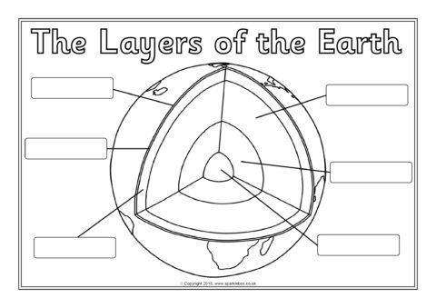

crust

Upper mantle

crust

Inner core

Outer core

mantle

crust

crust

Upper mantle

Inner core

Outer core

mantle