Ratio and Proportion

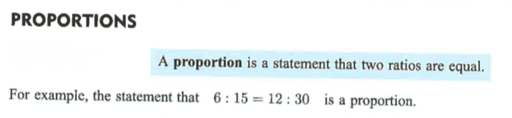

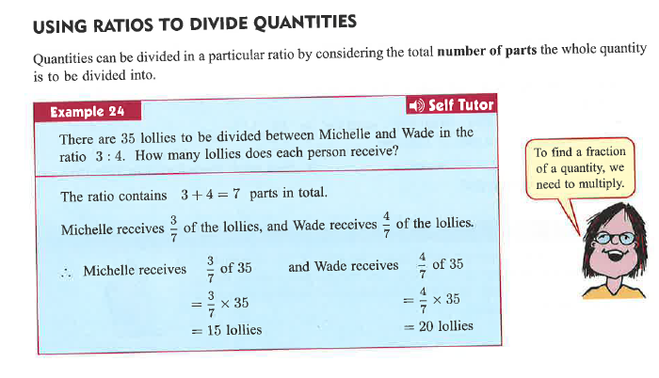

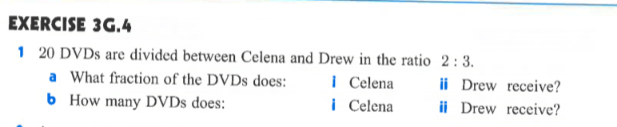

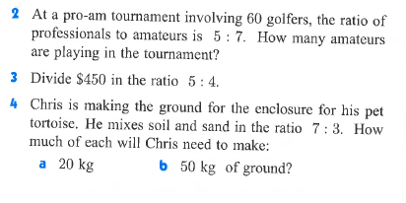

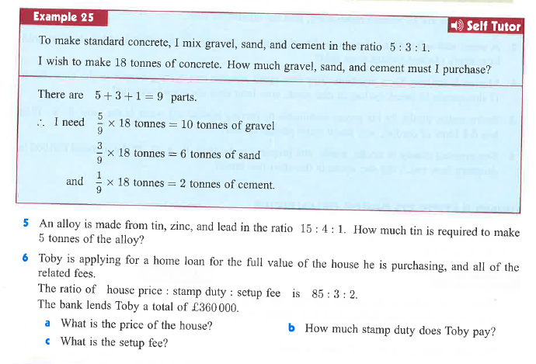

**Answers:**

**Exc 3G.4**

Q1:

a)

i) Celena receives 2/5 of the DVD’s

ii) Drew receives 3/5 of the DVD’s

b)

i) Celena receives 8 DVD’s

ii) Drew receives 12 DVD’s

Q2:

Professionals : Amateurs

5 : 7

Amateurs = 7 / (5+7) * 60

= 7/12 * 60

= 35 golfers are amatuers in the pro – am

Q3:

If we want to divide $450 into the ratio of 5:4 then we do this:

5 / (5+4) * 450

= 5/9 * 450

= $250

The division of $450 into the ratio of 5:4 is 250 : 200

Q4:

1. Soil = 7 / (7+3) * 20

= 7/10 * 20

=14 kg of soil

Sand = 20 – 14 = 6 kg

1. Soil = 7 / (7+3) * 50

= 7/10 * 50

=35 kg of soil

Sand = 50 – 35 = 15 kg

Q5:

Tin : Zinc : Lead

15 : 4 : 1

Tin = 15 / (15+4+1) * (5*1000) *coverting into kgs for easier calculations*

= 15 / 20 * 5000

=3,750 kgs

3750 kgs (3.75 tonnes) of tin will be required to make 5 tonnes of alloy

Q6:

1. Price of house = 85 / (85+3+2) * 360,000

=17/18 * 360,000

**=£340,000**

1. Stamp Duty fee = 3/ (85+3+2) * 360,000

=1 / 30 * 360,000

**=£12,000**

1. Setup Fee = 360,000 – 340,000 – 12,000

**=£8,000**