|  |  |
| --- | --- |
| Genesis Logo | **Genesis Global School**  Chapter: Real Numbers and ratio  2020-2021  Class-MYP-3 |

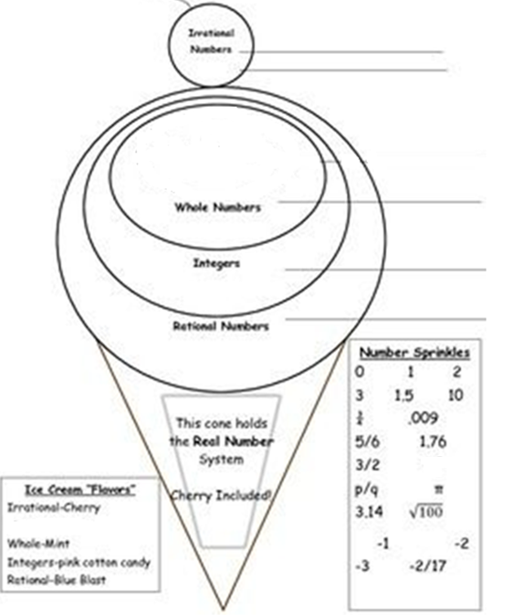

5/6, π , -2/17

1.5, ¼, .009, 1.76, 3/2, p/q, 3.14, $√$ 100,

-1, -2, -3

0, 1, 2, 3, 10