**Chapter 5 Percentage**

**Expressing one quantity as a percentage of another**

Go through the example and answer the questions:

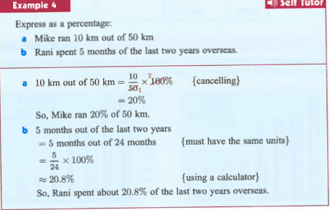

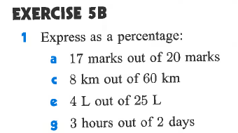

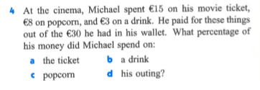

**Exc 5B**

**Q1:**

1. 17/20 * 100 = 85%
2. 8/60 * 100 = 2/15 * 100/1 = 13.333…%
3. 4/25 * 100 = 16%

g. 3/48 * 100 = 1/16 * 100/1 = 6.25%

**Q2:**

1. Ticket= 15/30 * 100 = ½ * 100 = 50%
2. Drink = 3/30 * 100 = 1/10 *100 = 10%
3. Popcorn = 8/30 = 4/15 * 100/1 = 26.666…%
4. Total outing = 50 + 10 + 26.666…% = 86.666…%