**Unit 1: How the body works?**

**Class: MYP 3**

**Skills:**

Knowledge and Understanding

**Learner Profile:**

Knowledgeable

**Date of Submission: 22/07/2020**

Objectives:

Students will be able:

1. To identify the presence of hierarchy of life present in different organisms
2. To apply the knowledge of hierarchy of life and cells in different situations or problems

**PART- A**

Hierarchy of life is not only present in animals but also in plants. An example for transportation system present in plants is shown below.

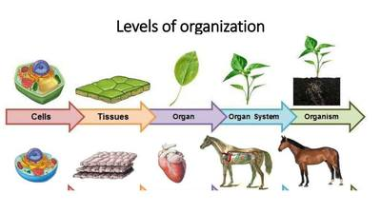

Picture 1

Based on the concepts learned in the class, answer the following questions.

1. Hierarchy of life for an organ system in plants is represented in picture 1

a. Identify the organ and the organ system depicted in picture 1.

The organ in a plant is the leaf and the organ system in a plant can be a stem or a branch

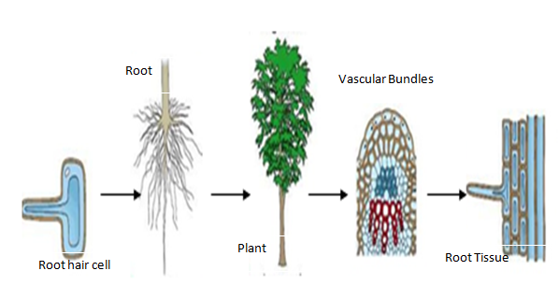

Picture 2

2. Comment, with reason if picture 2 correctly represents the levels of hierarchy. If incorrect, write down the correct order.

This is mentioned incorrectly as it is not in order from most quantity to least quantity, the correct order is root hair cell, root tissue, vascular bundles, root and a plant.

3. Comment, if blood is an organ. Justify your choice.

No, blood is not an organ of any sort but it is a tissue that moves around our body.

4. Explain hierarchy of organism using the example of digestive system.

There are 5 stages of the hierarchy of life which are cells, tissues, organs, organ system and the organism. We represent the hierarchy in a triangular form with the most quantity component in the bottom and the least quantity component at the top. In terms of the digestive system, the cells in the digestive system are enzymes and hormones, the tissues present in the digestive system are called mucosa and there are different types of mucosa like epithelium, lamina propria, muscularis mucosa etc., there are many different types of organs in our body consisting of these cells and tissues like esophagus, stomach, liver, kidney, pancreas, intestines, rectum, anus etc. and of course the combination of these organs make the digestive organ system and a combination of the digestive system and other systems make the human organism.

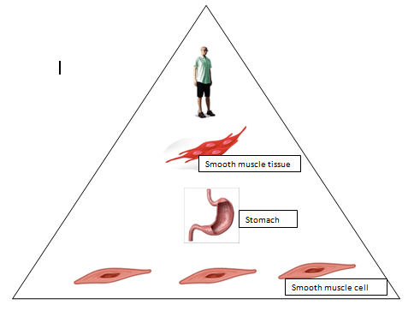

Picture 3

5. Redraw the hierarchy diagram in the correct order with proper naming and in correct number proportionately. E.g. If cells are 6, tissue should be lesser, organs should be further less in number and there should be 1 organism.

Human

Digestive System

Stomach

Smooth muscle tissue

Smooth muscle cells

6. Reflect on the learning made on unicellular and multi cellular organisms and complete the following paragraph.

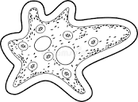

I am a/an multicellular organism.

All life processes are performed by different cells present inside me. Cell differentiation is within in me. If you any part of me I ________________.

**PART B: JIGSAW PUZZLE- Step 1 to be completed**

Detailed instructions will be shared in the class.