**HOMEWORK 1 – MYP 3**

**Submission date- 15.7.2020**

**Unit 1: How the body works?**

**Skills: Thinking**

**Objectives**:

1. To state different body systems present in human body.
2. To understand the importance of nervous system.
3. To differentiate between the concept of ‘being fit’ and ‘being healthy’.
4. To analyse information and make discrete healthy choices.

**Task 1- Research Based Questions:**

**Instructions:**

Students will research online about the concept of being fit and being healthy. They will answer the following questions on the basis of their research and understanding.

If you have cited any internet source state that as well in brackets.

1. Differentiate between the terms ‘**Being Healthy’** and ‘**Being Fit’**

|  |  |
| --- | --- |
| Being Healthy | Being Fit |
| By working to be healthy, your body will be in nice mental, emotional, relational and religious state and will help you in long term areas like aging, quality of life, freedom etc. | Being fit includes fulfilling your physical needs only and if you want to achieve being fit, then you will only be physically fit. People who regularly go to the gym are fit. |
| Being healthy will involve all your systems  Like nervous system, digestive system, skeletal system, respiratory system etc. and will allow them to work more efficiently so that your life can be very nice and healthy considering your long term life as well. | Being fit will involve some of your many systems of your body mainly the muscular system and by only achieving fitness, your body will have access of attention to the muscular system but then there will be no attention to the other systems which could lead to problems. |

1. Do you agree that fitness can be achieved even without being healthy? If yes, justify with reasons.

Yes, I strongly believe that fitness can be achieved by not being healthy and that is because we can maximize our muscle capacity and do a lot of physical training and then we will be fit but the point after achieving fitness will be rough because then we wont have the health requirements and we will have problems then. Fitness can be achieved without health but it is not recommended.

1. How successful has been media in developing correct perception of physical health amongst the masses?

Since people are too lazy to actually research anything, the often tend to believe whatever the media says and that is why, if media will give their perspective of physical health and if they will tell that fitness is good then people will believe them. Media’s attempt to do this was very successful but nowadays, people have got personal nutritionists and other sources and media has become lowly ranked in terms of fitness and health.

**Task 2-** Based on Class work and Classroom discussions answer the following questions.

Instructions:

Students refer to the learning material shared during and after class activities and answer the following questions.

1. Observe the below picture and identify different body systems present in Human body.

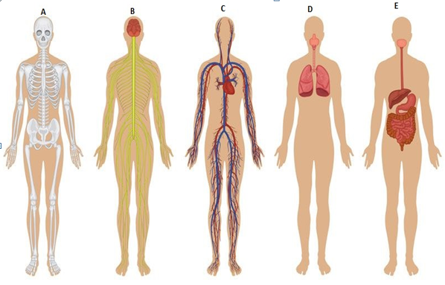

(A) Skeletal system

(B) Nervous System

(C) Circulatory system

(D) Respiratory system

(E) Digestive system

1. What would happen if nervous system was absent in human body?

If the nervous system was absent in our body then our brain wont be able to send and receive signals for all the parts of our body and in result none on our body parts will work and we wont even have the strength to move because our body isn’t getting signals from our brain to move. The complete breakdown of the nervous system means that our brain wont work so that means that we wont be able to do anything and process anything from our five senses as well.