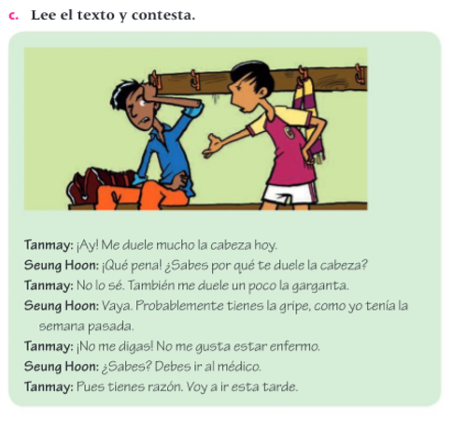

Identify all the verbs used in this text, make a list of them and write their conjugations in present tense.