22F-3298

Assignment_1

/*Question_1*/

#include<iostream>

using namespace std;

/*Palindrome & Reverse of Matrix */

void reversearray(int* array1, int* array2, int size);

bool palindromarray(int* arr2, int size);

int main()

{

int* ptr1,*ptr2;

int size;

cout << "Enter the size of an array : ";

cin >> size;

ptr1 = new int[size];

ptr2 = new int[size];

for (int i = 0; i < size; i++)

{

cout << "Enter Number of Array [ " << i << " ] : ";

cin >> *(ptr1 + i);

}

reversearray(ptr1, ptr2, size);

cout << endl;

if (palindromarray(ptr2, size))

{

cout << "Array is Palindrome !";

}

else

cout << "Array is not a palindrome number!";

cout << endl;

cout <<"-----Reversed Array is------------- " << endl;

for (int i = 0; i < size; i++)

{

cout << *(ptr2 + i) << " ";

}

}

void reversearray(int* array1, int* array2, int size)

{

int j = size - 1;

for (int i = 0; i < size; i++)

{

*(array2 + i) = *(array1 + j);

j--;

}

}

bool palindromarray(int* arr2, int size)

{

int j = size - 1;

int count = 0;

for (int i = 0; i < size/2; i++)

{

if (*(arr2 + i) == *(arr2 + j))

{

count++;

}

j--;

}

if (count == size / 2)

{

return true;

}

else

return false;

}

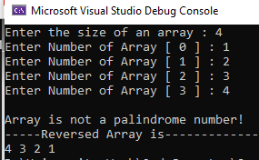

/*Question_2

Transpose of Matrix*/

#include<iostream>

using namespace std;

int main()

{

int** arr;

int** transpose_arr;

const int rows = 3, cols = 3;

arr = new int* [rows];

transpose_arr = new int* [rows];

for (int i = 0; i < rows; i++)

{

arr[i] = new int[cols];

transpose_arr[i] = new int[cols];

}

for (int i = 0; i < rows; i++)

{

for(int j = 0; j < cols; j++)

{

cin>> arr[i][j];

}

}

for (int i = 0; i < rows; i++)

{

for (int j = 0; j < cols; j++)

{

transpose_arr[j][i] = arr[i][j];

}

}

cout << endl;

for (int i = 0; i < rows; i++)

{

for (int j = 0; j < cols; j++)

{

cout << arr[i][j] << " ";

}

cout << endl;

}

cout << endl;

for (int i = 0; i < rows; i++)

{

for (int j = 0; j < cols; j++)

{

cout<< transpose_arr[i][j]<<" ";

}

cout << endl;

}

}

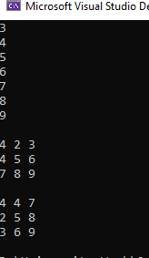

/*Qustion_3 :

Upper Triangular Matrix*/

#include<iostream>

using namespace std;

void upper_half(int **arr , int n , int m)

{

for (int i = 0; i < n; i++)

{

for (int k = 0; k < i; k++)

{

cout << " "<<" ";

}

for (int j = i; j < m; j++)

{

cout << arr[i][j]<<" ";

}

cout << endl;

}

}

void main()

{

int** arr;

int rows,cols;

cout << "Enter the rows of an array : ";

cin >> rows;

cout << "Enter the columns of an array : ";

cin >> cols;

arr = new int*[rows];

for (int i = 0; i < rows; i++)

{

arr[i] = new int[cols];

}

for (int i = 0; i < rows; i++)

{

for (int j = 0; j < cols; j++)

{

cin >> arr[i][j];

}

}

cout <<endl << "----------Original Array-----------" << endl;

for (int i = 0; i < rows; i++)

{

for (int j = 0; j < cols; j++)

{

cout << arr[i][j] << " ";

}

cout << endl;

}

cout << endl;

cout << "----------Upper Triangular Array---------------" << endl;

upper_half(arr , rows , cols);

}

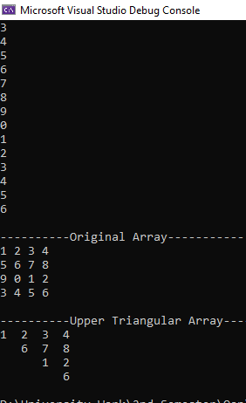

/*Question_4*/

#include <iostream>

using namespace std;

void shallow_copy(int*& destination, int* original);

void deep_copy(int*& dest, int* src, int size);

int main()

{

int size = 5;

int* original = new int[size];

for (int i = 0; i < size; i++)

{

original[i] = i;

}

int* shallow_copy_dest;

shallow_copy(shallow_copy_dest, original);

cout << "Shallow copy:\n";

for (int i = 0; i < size; i++)

{

cout << shallow_copy_dest[i] << " ";

}

cout << endl;

int* deep_copy_dest;

deep_copy(deep_copy_dest, original, size);

cout << "Deep copy:\n";

for (int i = 0; i < size; i++)

{

cout << deep_copy_dest[i] << " ";

}

cout << endl;

cout << "Enter new Values in Original Array : ";

for (int i = 0; i < size; i++)

{

cin>>original[i];

}

cout << "After changing original:\n";

cout << "Shallow copy:\n";

for (int i = 0; i < size; i++)

{

cout << shallow_copy_dest[i] << " ";

}

cout << endl;

cout << "Deep copy:\n";

for (int i = 0; i < size; i++)

{

cout << deep_copy_dest[i] << " ";

}

cout <<endl;

return 0;

}

void shallow_copy(int*& destination, int* original)

{

destination = original;

}

void deep_copy(int*& destination, int* original, int size)

{

destination = new int[size];

for (int i = 0; i < size; i++)

{

destination[i] = original[i];

}

}

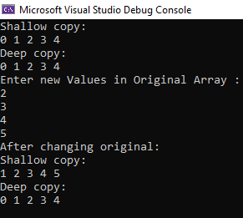

/*Question_5*/

#include<iostream>

using namespace std;

int main()

{

int N =5 , count=0,new_size=0;

cout << "enter size of array \t : ";

cin >> N;

int* arr = new int[N];

for (int i = 0; i < N; i++)

{

cout << "enter number \t";

cin >> arr[i];

count++;

if (count == N)

{

cout << "How many more elements you want to enter ? " << endl;

cout << " otherwise enter 0 if you don't want to extend the array more :\t";

cin >> new_size;

int* temp = new int[N + new_size];

for (int i = 0; i < N; i++)

{

temp[i] = arr[i];

}

delete[] arr;

arr = temp;

N = N + new_size;

}

}

cout << endl;

cout << "FINAL ARRAY IS : \n";

for (int i = 0; i < N; i++)

{

cout << arr[i]<<" ";

}

}

