Lab_4

22f-3298

/*Task-2*/

#include <iostream>

using namespace std;

struct dist

{

int feet;

float inches;

};

int main()

{

dist d1, d2, d3;

cout << "-----------------------------------Inputs--------------------------------------" << endl;

cout << "Enter 1st room Distance in feet =\t";

cin >> d1.feet;

cout << "Enter 1st Room Distance in inches =\t";

cin >> d1.inches;

d2 = { 10, 5.25 };

d3.feet = d1.feet + d2.feet;

d3.inches = d1.inches + d2.inches;

if ((d1.inches + d2.inches )>= 12)

{

d3.feet =d3.feet+ 1;

d3.inches = d3.inches - 12;

}

cout<<endl << "-----------------outputs In feet-------------------------" << endl;

cout << "Room1 Distance (d1) in feet =\t " << d1.feet << endl;

cout << "Room2 Distance (d2) in feet =\t " << d2.feet << endl;

cout << "Room3 Distance (d3) in feet =\t " << d3.feet << endl;

cout << endl << "-----------------outputs In Inches-------------------------" << endl;

cout<< " Room1 Distance (d1) in Inches =\t " << d1.inches << " inches" << endl;

cout<< " Room2 Distance (d2) in Inches =\t " << d2.inches << " inches" << endl;

cout<< " Room3 Distance (d3) in Inches =\t " << d3.inches << " inches" << endl;

return 0;

}

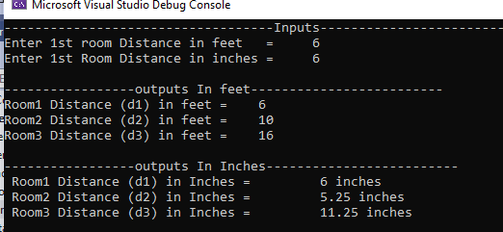

/*Task-3*/

#include <iostream>

using namespace std;

struct weatherdata

{

int hightemp;

int lowtemp;

double avgtemp;

};

int main()

{

const int tmonths = 12;

weatherdata monthlyData[tmonths];

double totalRainfall = 0.0;

int highesttemp = -100;

int lowesttemp = 140;

double avgmonthlytemp = 0.0;

cout << "--------------------------Inputs-------------------------------" << endl;

for (int i = 0; i < tmonths; i++)

{

cout << "Enter weather data for month =\t " << i + 1 << ":\n";

cout << "High temperature (F) =\t ";

cin >> monthlyData[i].hightemp;

while (monthlyData[i].hightemp < -100 || monthlyData[i].hightemp > 140)

{

cout << "Invalid temperature range, please enter a temperature between -100 and 140 degrees Fahrenheit =\t ";

cin >> monthlyData[i].hightemp;

}

cout << "Low temperature (F): ";

cin >> monthlyData[i].lowtemp;

while (monthlyData[i].lowtemp < -100 || monthlyData[i].lowtemp > 140)

{

cout << "Invalid temperature range, please enter a temperature between -100 and 140 degrees Fahrenheit =\t ";

cin >> monthlyData[i].lowtemp;

}

monthlyData[i].avgtemp = (monthlyData[i].hightemp + monthlyData[i].lowtemp) / 2.0;

cout << endl;

cout <<"Average temperature (F) =\t " << monthlyData[i].avgtemp << endl;

cout << endl;

totalRainfall = totalRainfall + monthlyData[i].avgtemp;

if (monthlyData[i].hightemp > highesttemp)

{

highesttemp = monthlyData[i].hightemp;

}

if (monthlyData[i].lowtemp < lowesttemp)

{

lowesttemp = monthlyData[i].lowtemp;

}

avgmonthlytemp = avgmonthlytemp + monthlyData[i].avgtemp;

}

cout << endl << "---------------------Outpts------------------------------" << endl;

cout << "Average monthly rainfall =\t " << totalRainfall / tmonths << endl;

cout << "Highest temperature for the year =\t " << highesttemp << endl;

cout << "Lowest temperature for the year =\t " << lowesttemp << endl;

cout << "Average of all monthly average temperatures =\t " << avgmonthlytemp / tmonths << endl;

return 0;

}

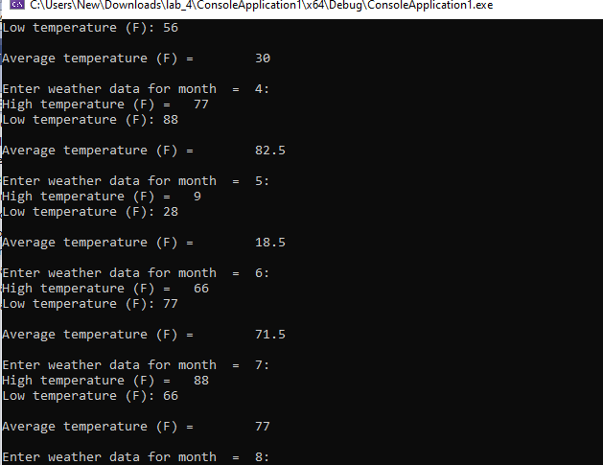

/*Task-4*/

#include <iostream>

using namespace std;

const int tdrinks = 20;

const double maxmoney = 1.0;

struct Drink

{

string name;

double cost;

int count;

};

int main()

{

Drink drinks[tdrinks] =

{

{ "Cola", 0.75, 20 },

{"Root Beer", 0.75, 20},

{"Cream Soda", 0.80, 20},

{"Grape Soda", 0.80, 20}

};

double totalMoney = 0.0;

for (int i = 0; i < tdrinks; i++)

{

cout << "\t" << drinks[i].name << "\t" << drinks[i].cost << endl;

}

bool done = false;

while (!done)

{

int choice;

cout << "Enter the number of the drink you want, or 0 to quit: ";

cin >> choice;

if (choice < 0 || choice > tdrinks)

{

cout << "Invalid choice. Please try again." << endl;

}

else if (choice == 0)

{

done = true;

}

else if(choice > 0)

{

int index = choice - 1;

if (drinks[index].count == 0)

{

cout << "Sorry, that drink is sold out." << endl;

}

else

{

double money;

cout << "Insert money (up to $"<< maxmoney << "): ";

cin >> money;

while (money < 0.0 || money > maxmoney)

{

cout << "Invalid amount. Please try again." << endl;

}

while (money < drinks[index].cost)

{

cout << "Not enough money. Please insert $" << drinks[index].cost - money << " more." << endl;

}

double change = money - drinks[index].cost;

totalMoney = totalMoney + drinks[index].cost;

drinks[index].count--;

cout << "Here's your drink. Your change is $" << change << "." << endl;

}

}

}

cout << "Total money earned =\t " << totalMoney << endl;

return 0;

}