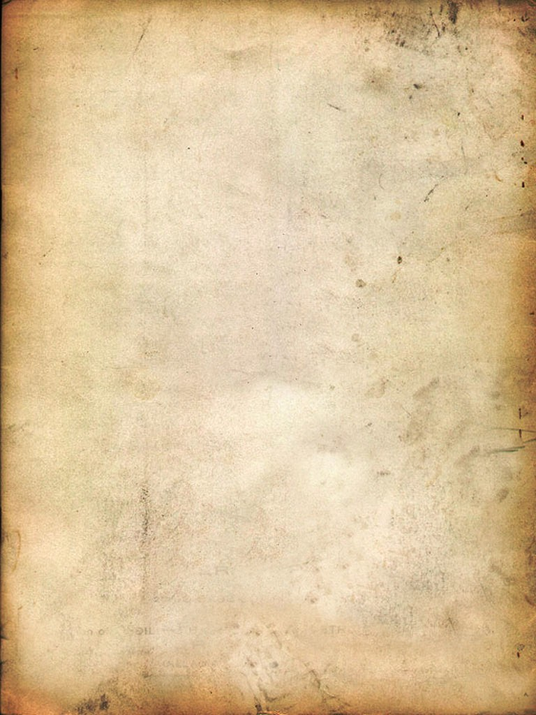

No More Pixies

User Manual

Table of content

Story 2
Characters 3
Non Playable Characters 4
Interface 5
Controls 6
Notes 7
Credits 9

Story

In a world ruled by magic and happiness, fairies, princesses and ponies were living a peaceful and long life. Some nights, around the camp, fire stories about the past were told. Those stories, mix of legends and true facts were describing the dark ancient times of the war between Good and Evil. During this war all the evilness that habited the world was destroyed and a little piece of darkness was trapped into a stone.

For thousands of years, this stone was exposed in the king castle and holding the memory of that time of fear and darkness. This could have remained the same for the next thousands of years but a simple-minded pony accidentally hit the pedestal holding the stone and broke it. The remaining of the stone scattered on the ground released a great evil force that had time to grown during its years of imprisonment. The fairy world was soon covered in darkness.

In a completely different time, space and world a team of heroes was involved in an confrontation against robot raptors. They decided to use a spatio-temporal machine to go back in time and destroy all proof of the existence of raptors in order to prevent this terrible conflict.

Fortunately (or not) for the fairy world, a solar flare disturbed the delicate mechanism of the machine and sent our heroes to their glorious destinies. Our heroes have no mercy and their only goal is their original mission. Beyond any doubt, the situation will evolve a lot for the best or the worst...

Characters

 | Name : Major Karl ''H'' Nikov  Aptitude : Having nice moustache.  Story : Major Nikov is the only survivor of the great battle of Brussels against the spaceships of the robots raptors. He is the leader of the team and enjoys long walks in the forests.

 | Name : Dr. Van Der Blutt  Aptitude : Jetpack.  Story : Dr. Van Der Blutt is a mad german scientist rejected by his peers for his work on DNA crossing of bees and elephants. He is the brain of the team and own a cool pair of glasses.

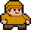 | Name : Brother Bearslayer  Aptitude : Beeing fat.  Story : Brother Bearslayer is a Benedictine monk that was expelled from his monastery by his fellow brothers because of his alcoholism and penchant for violence.

Non Playable Characters

Name : Blob

Aptitude : Looking upset.

Story : The blob is a simple-minded enemy that simple walks around and kill people by mistake. It take his orders from the evil minds.

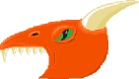   | Name : Dragon  Aptitude : Beeing evil.  Story : The dragon is one of the main evil minds that were imprisoned in the stone. He is very angry and want basically to destroyed everything.

Name : Fairy

Aptitude : Beeing trapped.

Story : Fairies are the main source of power of the fairy world. This is why they were trapped into bottles quickly after the takeover of the world. Fortunately for our heroes they can heal someone by touching him. Some say that the healing process is more powerful if the fairies are smashed…

Interface

B

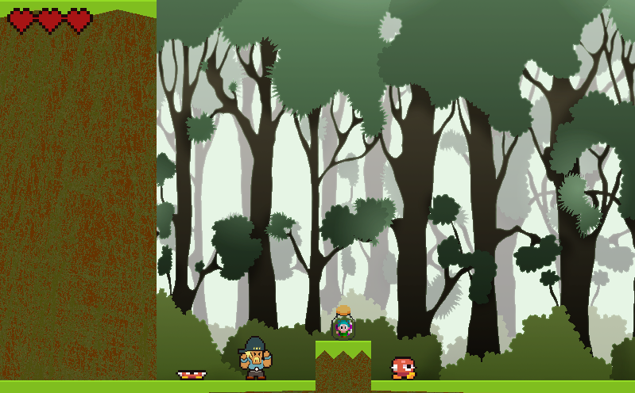
A D C

A) Character
B) Remaining lifes
C) Enemy
D) Fairy (health bonus)

Controls

Keyboard

Up arrow or space Jump
Left arrow or A Go left
Right arrow or D Go right
P Pause
Enter Menu selection
Back Menu return
Esc Close the game

Joypad

Hat Menu navigation + move
X Jump or menu selection
O Menu return
Start Pause the game

Notes

Credits

Developers
Aebischer Nadia
Chammartin Jérôme
Luyet Gil

This game was developed in Python with the use of the library Pygame.

We thanks the whole community of open-source software, data and assets to their contribution at our project.

We thanks especially the community of opengameart.org that provided most of the 2D assets and sound.

This game was developed under the MIT license.

University of Fribourg
BeNeFri Master Program
Under the licence MIT

