HANDSMEN THREADS
Project Overview, Data Model & Configuration
Salesforce CRM Project Documentation 1
Skills Wallet Project | Implementation Evidence
Document Control
Module | Purpose | Evidence
Project | HandsMen Threads – Salesforce CRM | Overall project
Business Domain | Premium men's fashion / bespoke tailoring | Use case
Platform | Salesforce | Development and runtime platform
Document | 01 – Project Overview, Data Model & Configuration | Skills Wallet evidence
Evidence | Completed Salesforce implementation screenshots supplied by the project owner | Source evidence

1. Project Overview
HandsMen Threads is a premium men's fashion and bespoke tailoring business use case implemented on Salesforce. The project is designed to centralize customer, product, order, inventory and marketing information in one CRM environment. A structured data model provides a consistent foundation for daily operations, while Salesforce automation reduces repetitive manual work and improves the speed and consistency of customer and operational communication.
The solution also addresses data integrity at the user interface level. Business data is protected through validation and configuration rules, while the Lightning application provides a focused interface for users. The completed implementation further includes security configuration, email communication, Flow automation, Apex and scheduled processing.

2. Business Problem
A premium fashion business has to coordinate customer information, product information, orders and inventory while also maintaining customer relationships. Without a common CRM structure, data can become inconsistent, stock conditions can be missed, customer communication can be delayed and staff can spend time performing repetitive updates. HandsMen Threads uses Salesforce to bring these activities into a common platform and automate the processes that are most important to the business.

3. Business Requirements / User Story
- Build a robust Salesforce data model for the business data required by HandsMen Threads.
- Maintain data integrity directly from the Salesforce UI.
- Send an automated customer email after an order is confirmed.
- Update customer loyalty status based on purchase history.
- Notify the warehouse team automatically when stock falls below five units.
- Process bulk orders daily at midnight and update the required financial and inventory information.
- Control access through Salesforce security configuration.

4. Project Objectives
- Centralize customer, product, order, inventory and marketing data.
- Provide a clear and maintainable Salesforce object model.
- Reduce invalid data through validation/data-quality controls.
- Provide a dedicated Lightning application for business users.
- Automate customer communication and inventory-related notifications.
- Use Apex for programmatic business logic and asynchronous processing where appropriate.
- Provide evidence that each Skills Wallet module has been implemented and verified.

5. Solution Architecture
The implementation combines Salesforce declarative configuration and programmatic development. Custom objects form the data layer; tabs and the Lightning app form the user-facing layer; validation/data configuration protects data quality; profiles, roles, users and permission sets control access; email templates and alerts provide reusable communication; Record-Triggered Flows automate event-driven processes; and Apex/batch scheduling supports programmatic and bulk processing.
Module | Purpose | Evidence
Data Layer | HandsMen Customer, HandsMen Product, HandsMen Order, Inventory, Marketing Campaign | Object evidence
UI | Custom tabs and HandsMen Threads app | Tabs/App Manager evidence
Data Quality | Validation rules/configuration | Validation evidence
Security | Profiles, Roles, Users, Permission Set | Security evidence
Communication | Email Templates and Email Alerts | Email evidence
Automation | Record-Triggered Flows | Flow evidence
Programmatic | Apex / Trigger | Developer Console evidence
Asynchronous | Batch / Scheduled processing | Scheduled Jobs evidence

6. Salesforce Credentials Setup
The Salesforce org is the development and demonstration environment for the HandsMen Threads implementation. The credentials/setup module establishes the Salesforce environment in which the project's objects, fields, application, security, automation and Apex components are configured.
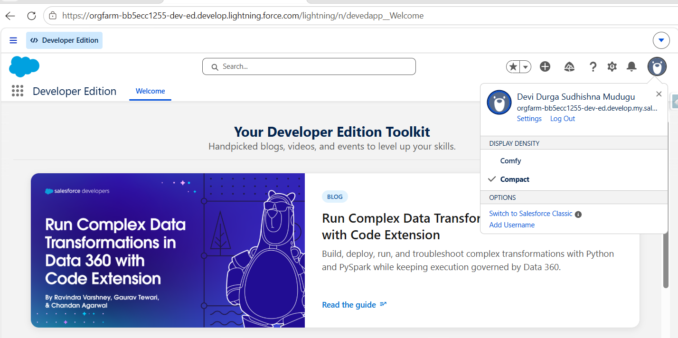
Figure1 - Evidence of the Salesforce implementation environment and initial object configuration.

7. Data Management – Objects
The implementation evidence shows five custom objects forming the core business data model:
HandsMen Customer — Stores customer information required by the CRM and loyalty processes.
HandsMen Product —Stores product information including price, SKU and stock-related product data.
HandsMen Order — Stores customer order information including customer, quantity, status and total amount.
Inventory — Stores product inventory information including stock quantity, stock status and warehouse.
Marketing Campaign — Stores campaign information and its relationship to HandsMen Customer.
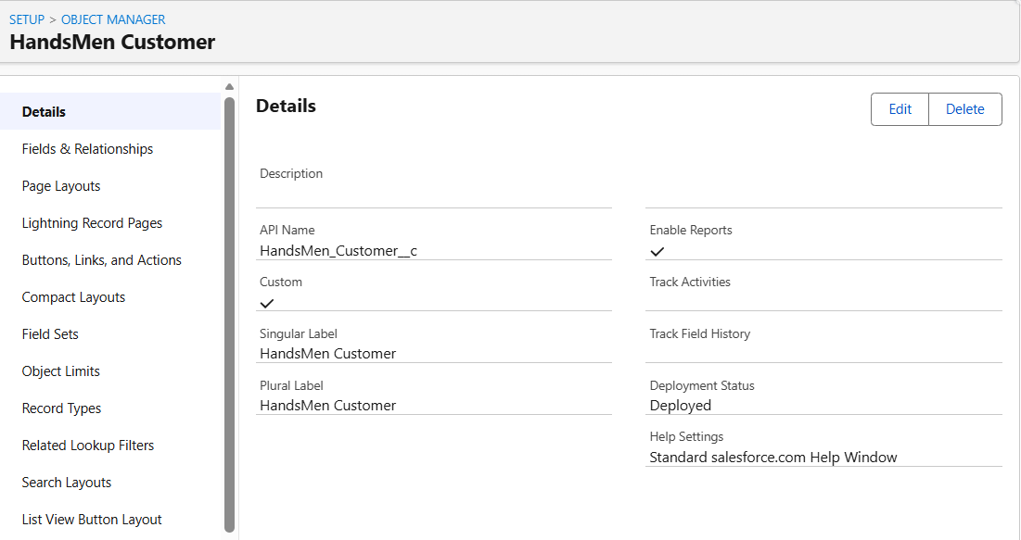
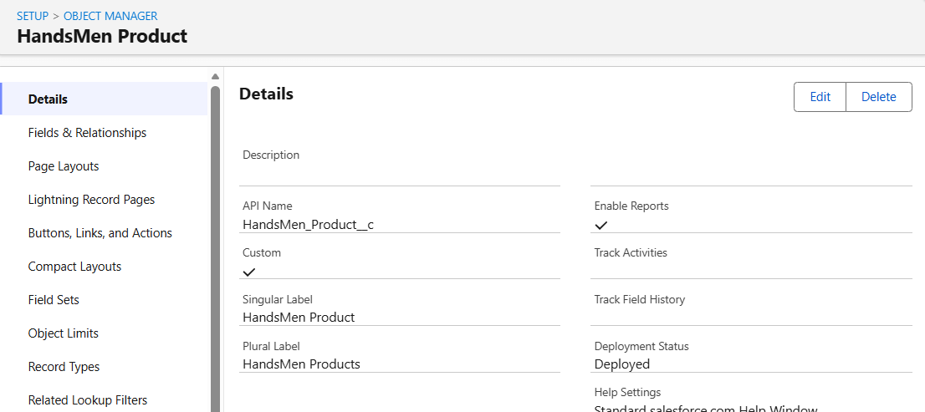
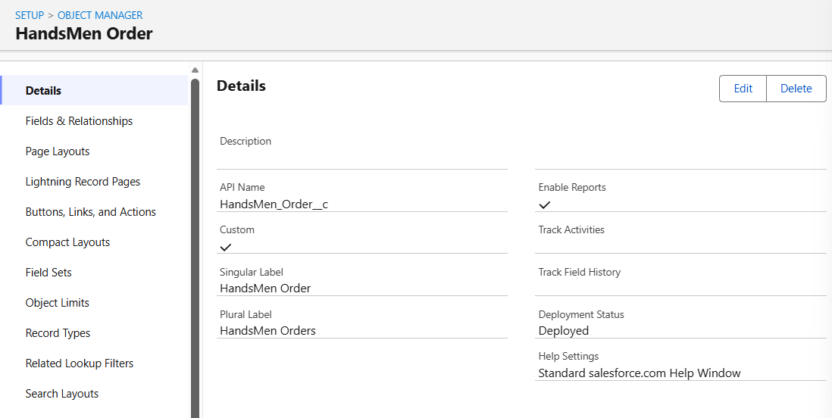
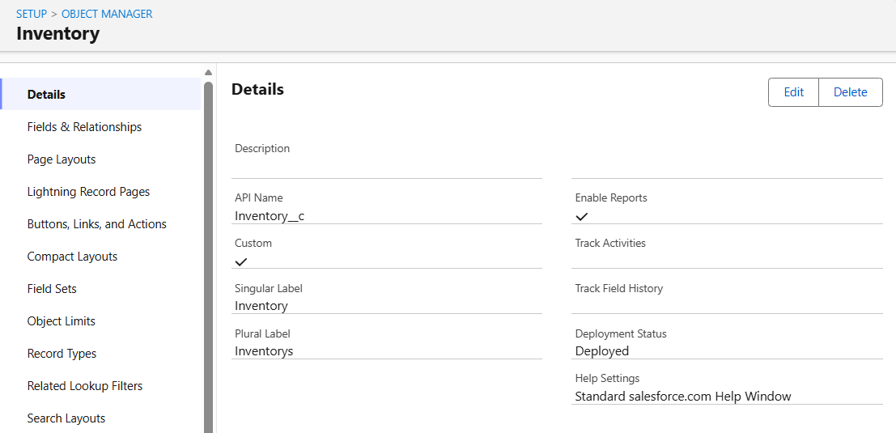
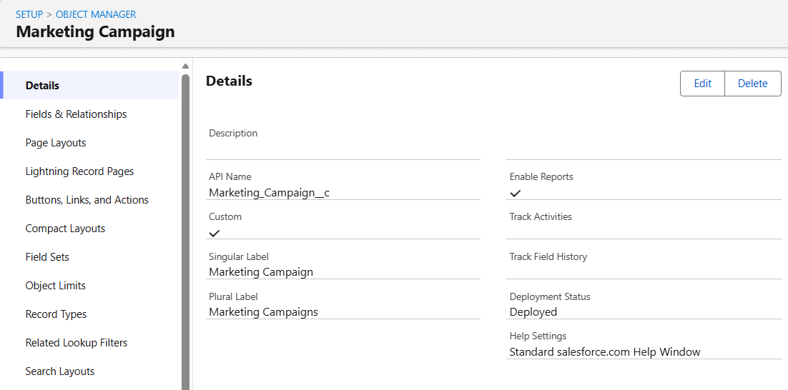
Figure – HandsMen Customer, HandsMen Product, HandsMen Order , Inventory object, Marketing Campaign configuration.

8. Data Management – Tabs
Custom object tabs make the configured business objects accessible from the Salesforce user interface. The supplied evidence shows custom-tab configurations for HandsMen Customer, HandsMen Products and additional custom objects.
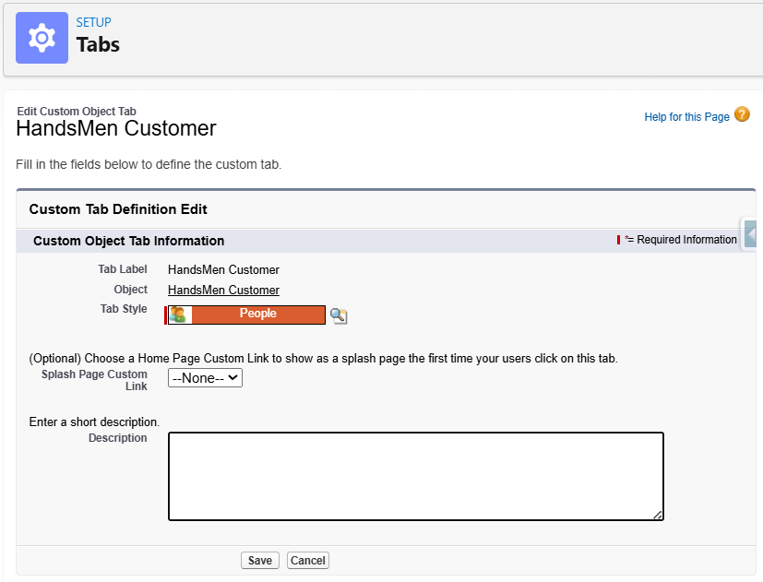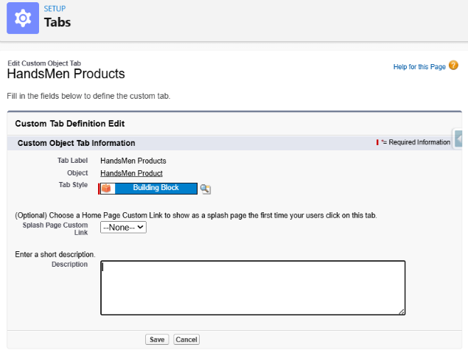
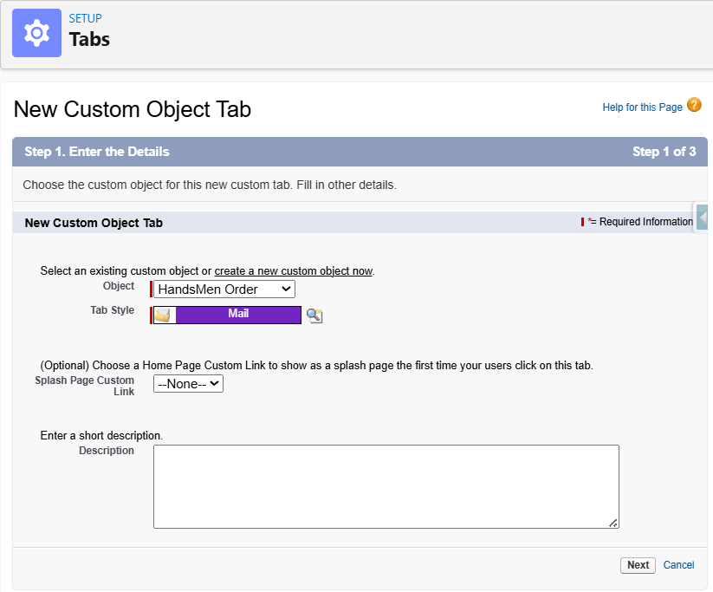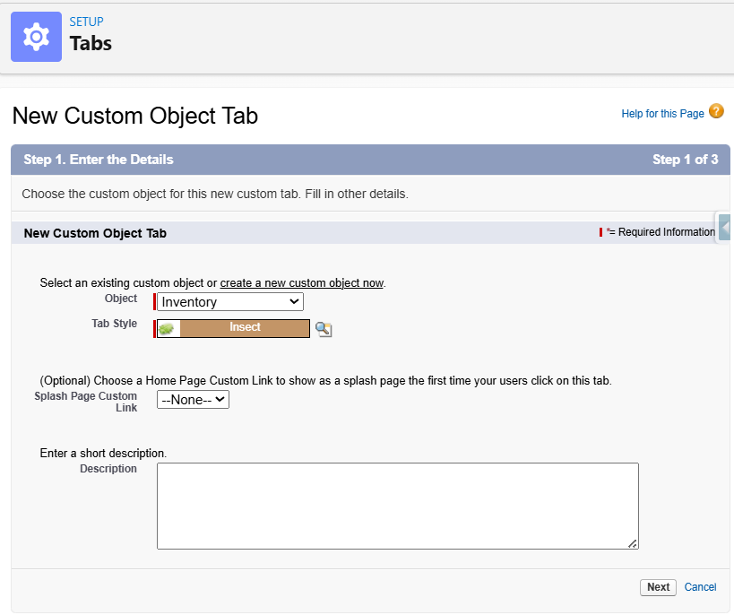
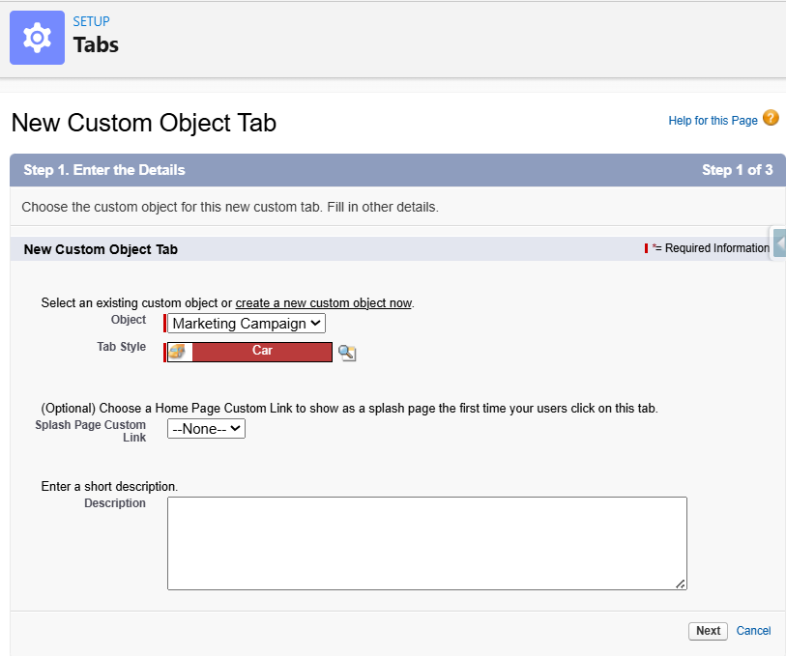

Figure - Custom Object Tab configuration evidence.

9. Data Management – App Manager
A dedicated Lightning application named HandsMen Threads was configured to bring the project objects together in one user-facing environment. App Manager provides the application details and navigation configuration, while the resulting Lightning application provides direct access to the project data.
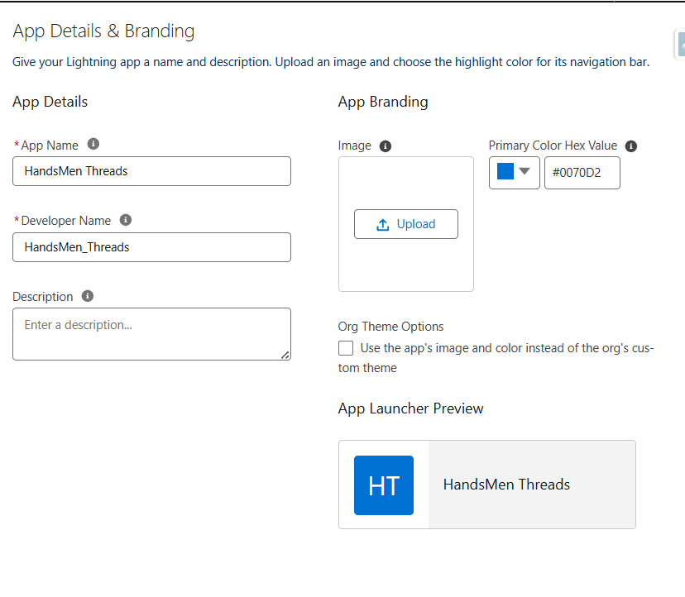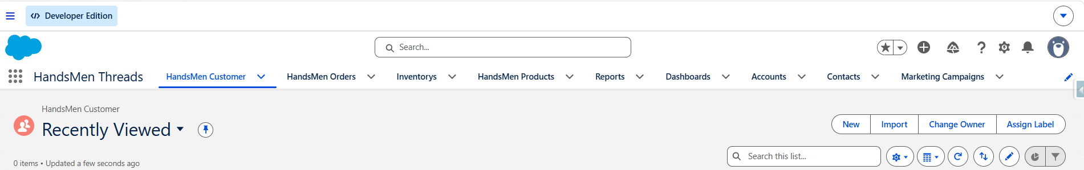
Figure – App Details & Branding / HandsMen Threads application evidence.

10. Data Management – Fields
The Data Management – Fields module covers the creation and configuration of the individual fields required by HandsMen Threads. The Skills Wallet reference divides this module into Field – Email, Field – Phone, Field – Loyalty Status, Create Lookup Relationship, Formula Fields, and Create Remaining Fields for the objects. Each submodule is documented separately below for verification. The final verification should use the exact field labels, API names and data types configured in the completed org.
Field – Email
An Email field was created in the HandsMen Customer object to store the customer's email address. This field is required for maintaining customer contact information and supports the automated communication processes implemented in the project.
Field – Phone
A Phone field was created in the HandsMen Customer object to store the customer's contact number. This provides structured customer contact information for customer-service purposes.
Field – Loyalty Status
A Loyalty Status field was created in the HandsMen Customer object using a Picklist data type. The field stores the customer's loyalty-program status and supports the Dynamic Loyalty Program requirement.
Create Lookup Relationship
Lookup relationships were created to connect related business records.
The Customer field in the HandsMen Order object establishes a relationship with the HandsMen Customer object. This allows each order to be associated with the customer who placed it.
The Product field in the Inventory object establishes a relationship with the HandsMen Product object. This allows inventory records to be associated with their corresponding products and supports inventory management.
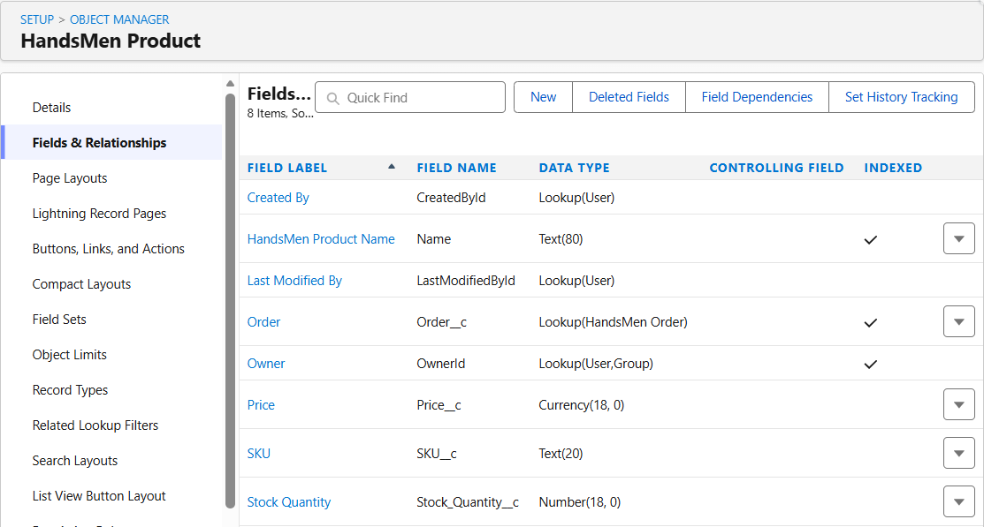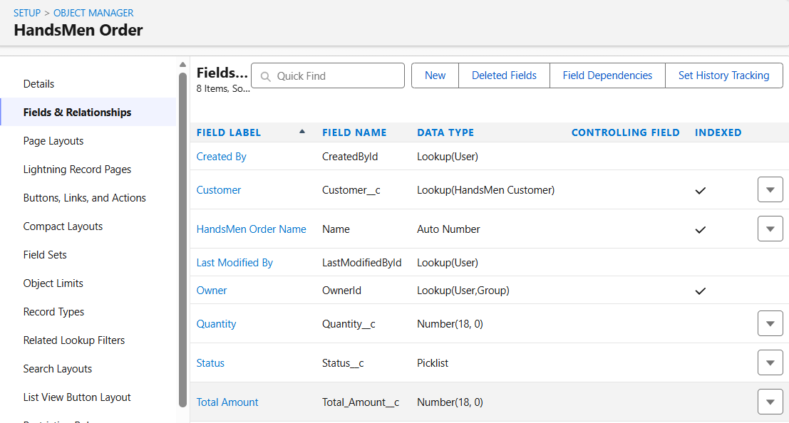
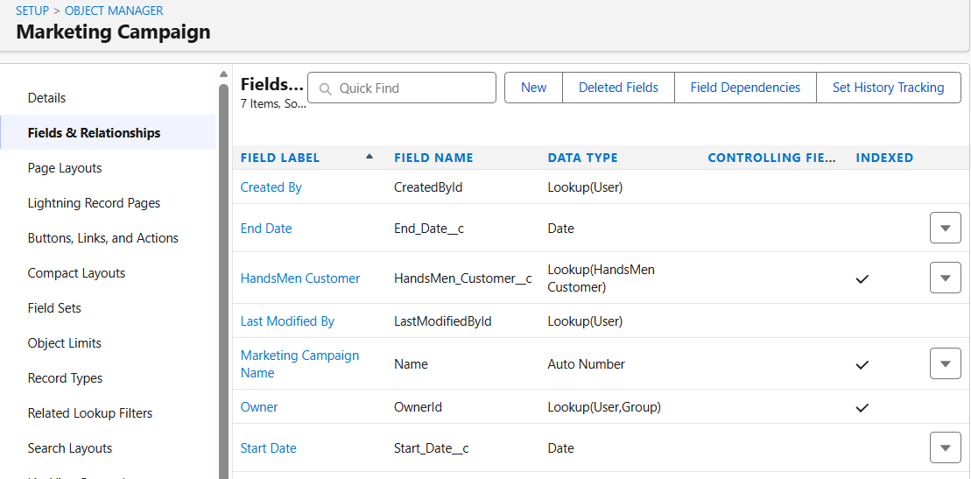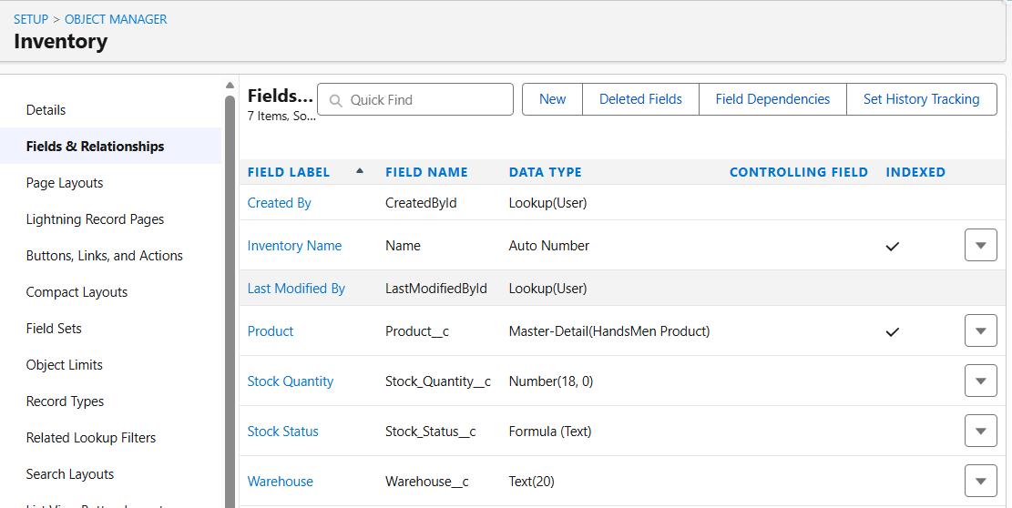
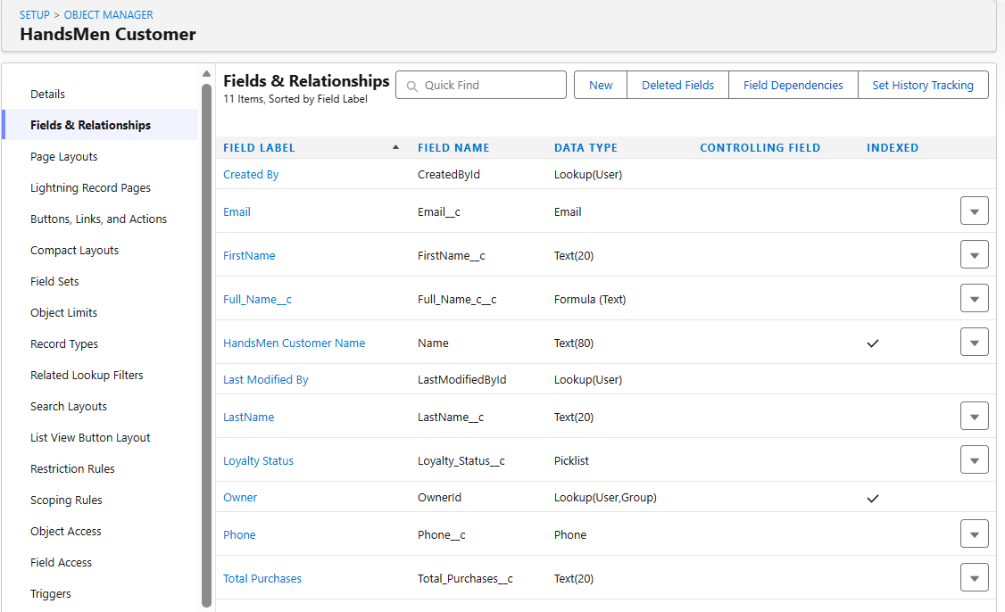
Figure – Populated fields for HandsMen Product, HandsMen Order, HandsMen Customer, Inventory, and , Marketing Campaign .
The following screenshot provides combined implementation evidence for the Data Management – Fields module. It shows the configured fields for the HandsMen Threads objects and demonstrates the completion of the Skills Wallet field requirements, including Email, Phone, Loyalty Status, Lookup Relationship, Formula Fields and the remaining fields created for the project objects.

10.1 Formula Fields
Formula fields calculate derived values from existing record information. They reduce manual data entry and ensure that calculated or interpreted information is generated consistently.
10.1.1 Full Name – Formula Field
The Full Name formula field derives the customer's display name from the stored name information. This avoids requiring users to maintain a separate manually entered full-name value.
Business purpose: Automatically present a combined customer name.
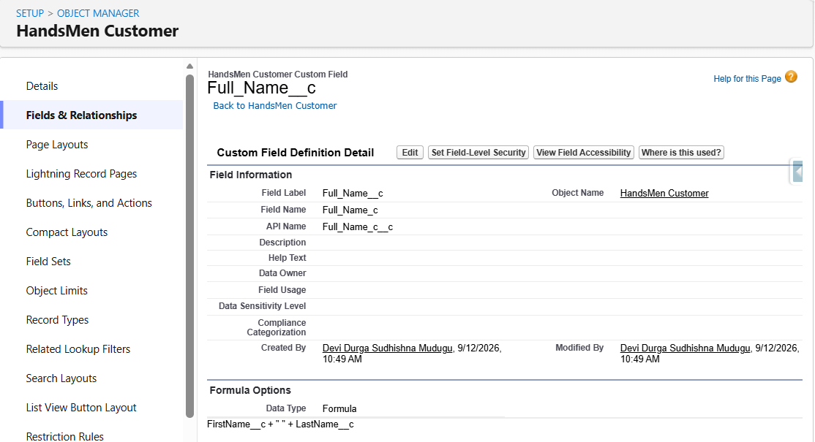
10.1.2 Stock Status – Formula Field
The Stock Status formula field derives a text-based stock condition from the inventory information. This provides users with a clear stock indicator and supports the stock-monitoring requirement.
Business purpose: Present an interpreted inventory condition based on stock information.
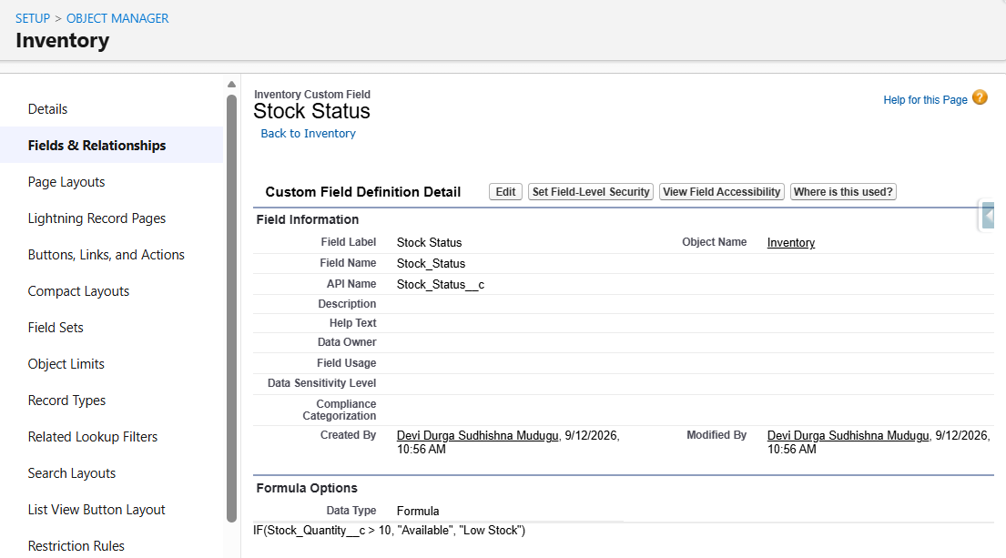

11. Validation Rules / Data Configuration
11.1 HandsMen Order – Total Amount
The HandsMen Order validation rule is named Total_Amount and checks the configured Total Amount condition. The screenshot shows an error message instructing the user to enter a correct amount when the validation condition is met. This protects order financial data from invalid values.
Configured Rule Name: Total_Amount
Configured condition shown: Total_Amount__c <= 0
Configured error message shown: Please Enter Correct Amount
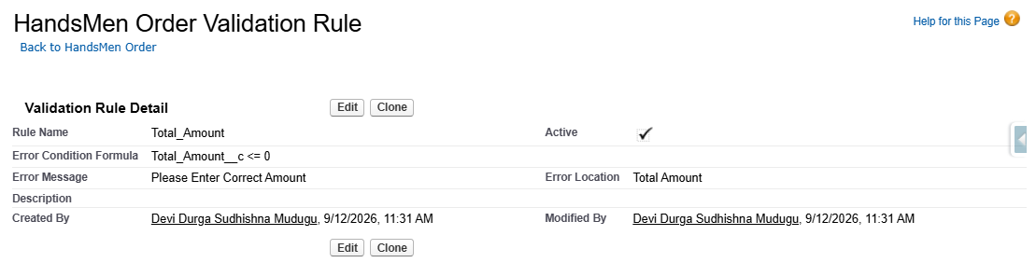
Figure – HandsMen OrderValidation Rule
11.2 Inventory – Stock Quantity
The Inventory validation rule is named Stock_Quantity and checks the configured stock quantity condition. The screenshot shows the message 'The inventory count is never less than zero.' This prevents negative inventory values.
Configured Rule Name: Stock_Quantity
Configured condition shown: Stock_Quantity__c <= 0
Configured error message shown: The inventory count is never less than zero.
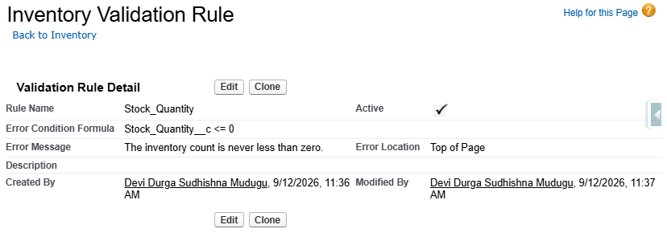
Figure – Inventory Validation Rule
11.3 HandsMen Customer – Email
The HandsMen Customer validation rule is named Please_fill_correct_Email. It checks that the entered email does not violate the configured email condition. The screenshot shows a user-facing message requesting a correct email address.
Configured Rule Name: Please_fill_correct_Email
Configured condition shown: NOT(CONTAINS(Email__c, "@gmail.com"))
Configured error message shown: Please Fill Correct Email
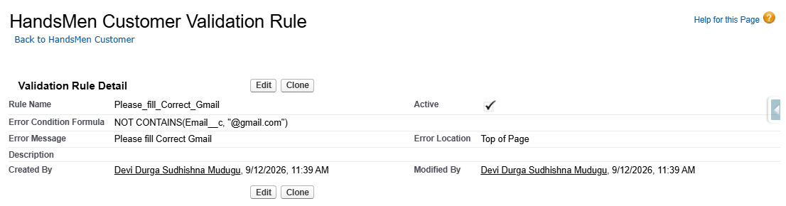
Figure – HandsMen Customer Validation Rule

12. Data Configuration Verification
Test ID | Module | Verification | Expected Result
DC-01 | Email | Enter invalid email according to configured rule | Record save is blocked and configured message is displayed.
DC-02 | Phone | Review HandsMen Customer field configuration | Phone field exists with Phone data type.
DC-03 | Loyalty Status | Review HandsMen Customer field configuration | Loyalty Status exists as a Picklist.
DC-04 | Lookup Relationship | Review HandsMen Order Customer field | Customer references HandsMen Customer.
DC-05 | Master-Detail | Review Inventory Product field | Product references HandsMen Product through Master-Detail.
DC-06 | Formula Fields | Review Full Name and Stock Status | Both are configured as Formula (Text).
DC-07 | Remaining Fields | Review object field lists | Required object-specific fields are present.
DC-08 | Order Validation | Enter invalid quantity, total amount. | Record save is prevented by validation.
DC-09 | Inventory Validation | Enter invalid Stock Quantity | Record save is prevented by validation.

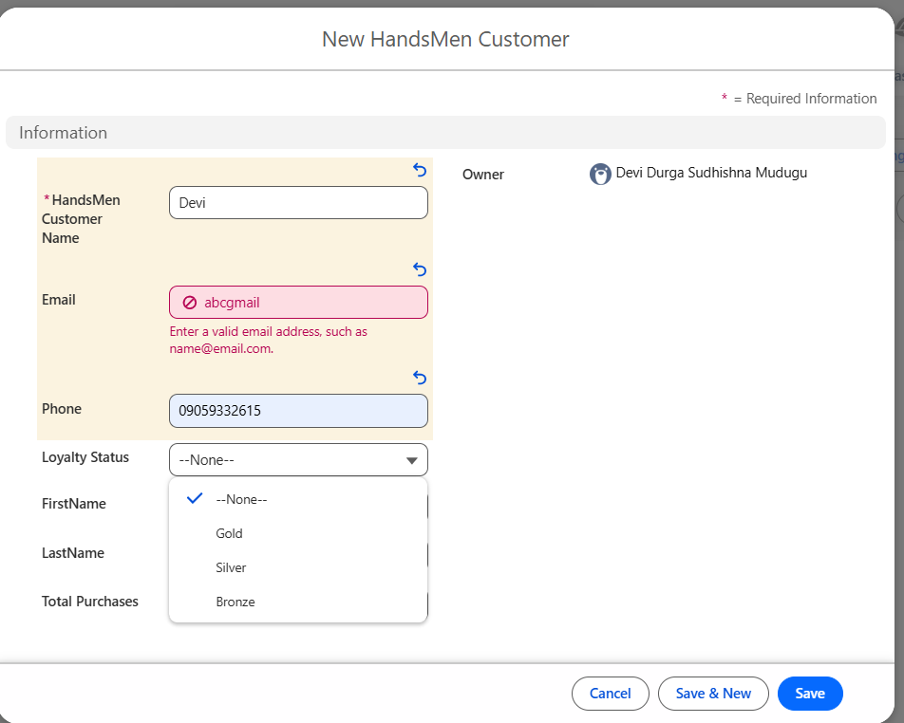
Figure - Data Configuration Verification (DC-01, DC-02, DC-03)
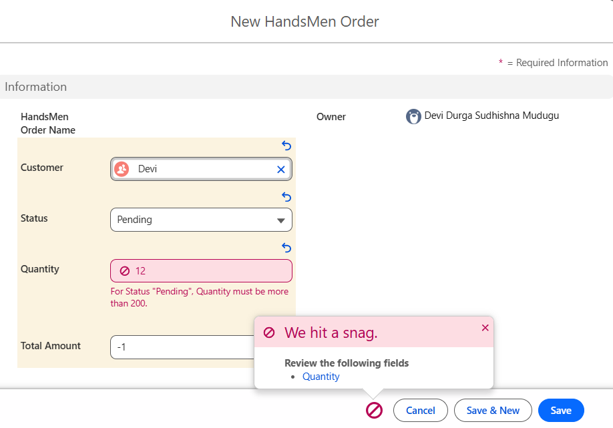
Figure - Data Configuration Verification (DC-08)
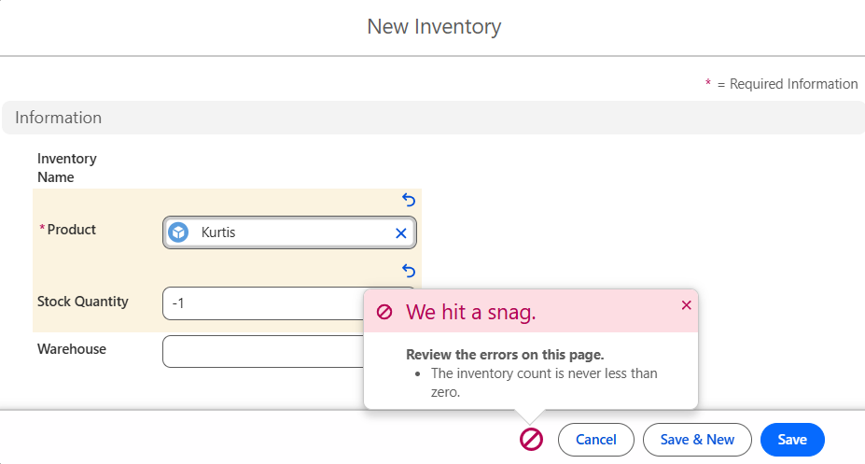
Figure - Data Configuration Verification (DC-09)

13. Conclusion
The HandsMen Threads Salesforce data foundation establishes the objects, fields, relationships, formulas and validation controls required for the project. The module-wise documentation makes each Skills Wallet field requirement independently visible and ties each requirement to evidence from the completed Salesforce implementation.

