HANDSMEN THREADS
Data Security & Customer Communication
Salesforce CRM Project Documentation 2

Document Control
Module | Purpose | Evidence
Module Group | Data Security + Customer Communication | Skills Wallet verification
Security Components | Profiles, Roles, Users, Permission Set | Access control
Communication Components | Email Templates, Email Alerts | Customer/warehouse communication
Evidence | Completed implementation screenshots | Source evidence

1. Purpose
This document presents the data-security and customer-communication implementation of HandsMen Threads. Each Skills Wallet module is documented separately so that a reviewer can understand what was configured, why it was required, how it supports the business use case, and what the accompanying Salesforce screenshot demonstrates.
The security layer controls access to the CRM, while the communication layer standardizes and automates routine customer and operational notifications.

2. Security Model
HandsMen Threads uses Salesforce's layered security model. Profiles establish baseline permissions, roles and role hierarchy provide organizational context and contribute to record visibility, user records connect those settings to individuals, and permission sets provide additional access where required. This structure separates standard access from optional additional permissions.
Module | Purpose | Evidence
Profiles | Baseline permissions | Profile screenshots
Roles | Organizational hierarchy / visibility | Role hierarchy screenshot
Users | Individual access assignments | User screenshots
Permission Set | Additional permissions | Permission-set screenshots

3. Data Security – Profiles
A Salesforce Profile defines the baseline permissions available to a user. For HandsMen Threads, the profile is used to control access to the custom business objects and the actions that users can perform on those objects.
The completed implementation contains a profile named Platform 1. The evidence shows the profile overview and object-level settings for HandsMen Products and Inventory. The configuration demonstrates that Salesforce access is not simply granted to every user equally; instead, baseline permissions are defined through the profile.
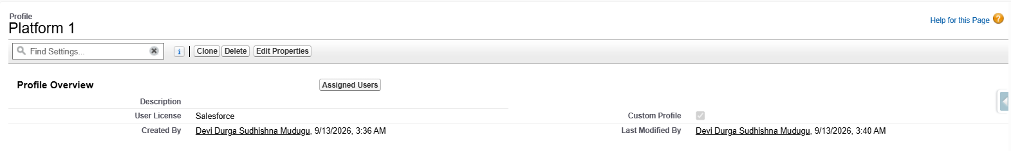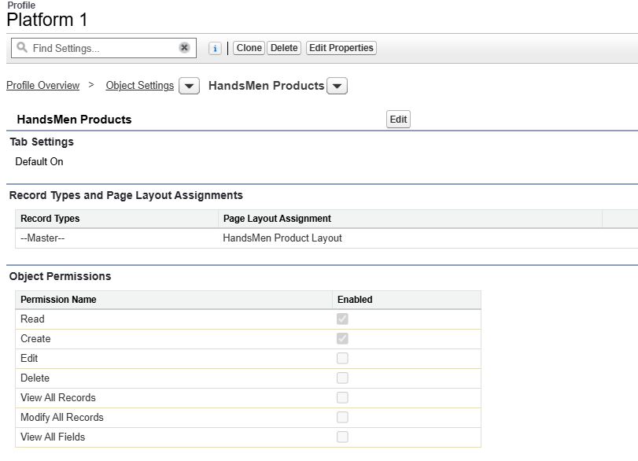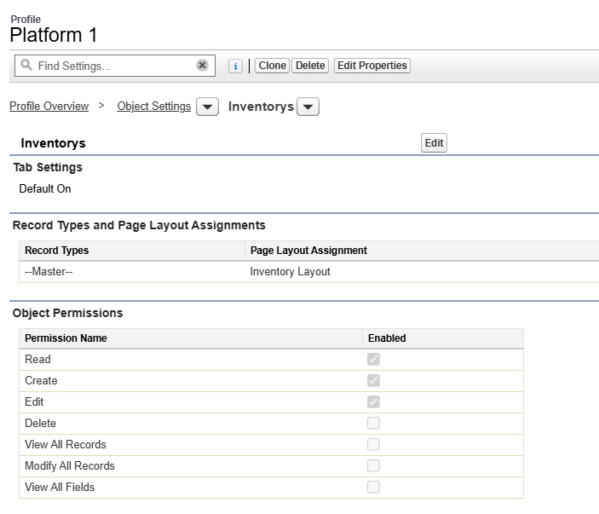
Figure – Platform 1 profile overview and object-permission configuration shown in the completed Salesforce implementation.

4. Data Security – Roles
Salesforce Roles represent the organizational hierarchy of users. In HandsMen Threads, roles are used to represent business responsibilities and provide an organizational structure for the Salesforce users.
The completed implementation contains a role hierarchy with multiple functional responsibilities. The hierarchy includes business roles such as CEO, COO, CFO, Inventory, Marketing, HR and other functional areas. Placing these roles in a hierarchy gives the project a structured access model and supports Salesforce's record-visibility behaviour.

4.1 Role Hierarchy Objectives
- Represent reporting relationships between business functions.
- Organize Salesforce users according to responsibility.
- Support record visibility through the Salesforce role hierarchy.
- Provide a clear organizational structure for the HandsMen Threads CRM.

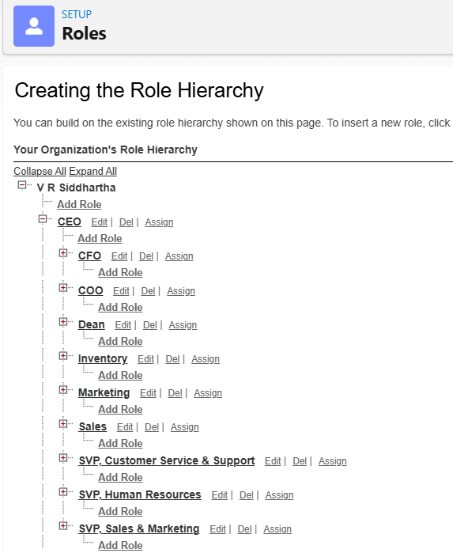
Figure – Configured HandsMen Threads role hierarchy showing the organizational structure.

5. Data Security – Users
Salesforce User records represent the individual accounts that access the HandsMen Threads Salesforce environment. Users connect the security model to real accounts through their profile, role, license and active status.
The implementation evidence shows configured user records with user details and security information. The screenshots demonstrate users associated with the Salesforce license and Platform 1 profile, together with their business role information.
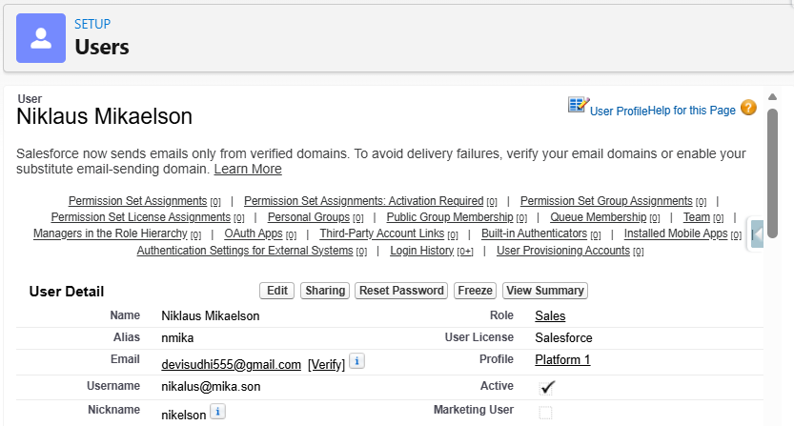
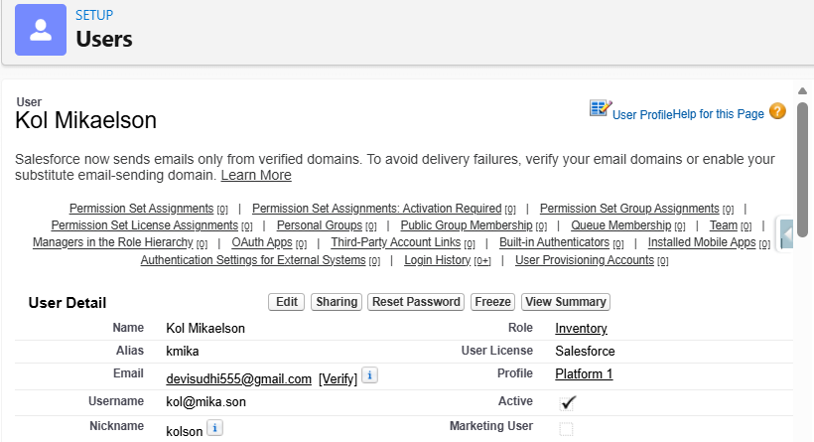
Figure – Configured user records and access details.

6. Data Security – Permission Set
A Permission Set provides additional permissions to selected users without changing their base profile. This is useful when two users share the same baseline profile but one of them requires additional access to a particular object or operation.
HandsMen Threads uses Permission_Platform_1 as the additional permission layer. The implementation evidence shows the permission-set overview, HandsMen Customer object permissions and the Assignment Summary.
The permission set is maintained separately from the Platform 1 profile. This makes the security model easier to administer because baseline access and additional access are managed independently.
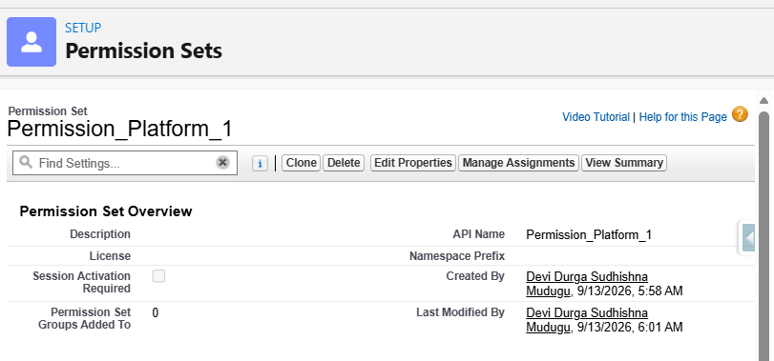
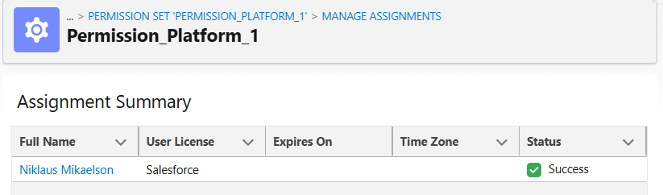
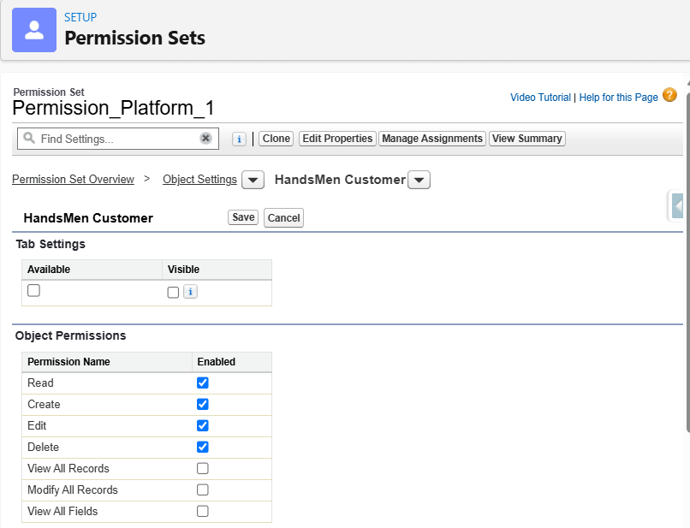
Figure – Permission_Platform_1 configuration and assignment evidence.

7. Security Verification
- Verify that each project user has the intended profile.
- Verify that each user is placed in the intended role.
- Verify that Permission_Platform_1 is assigned only where required.
- Verify that profile and permission-set object permissions match the intended responsibility.

8. Email Communication Strategy
Customer communication is a major requirement of HandsMen Threads. Salesforce Email Templates provide reusable and consistent message content, while Email Alerts provide the mechanism for delivering those templates through Salesforce automation.
The completed implementation contains three email templates: Order Confirmation, Low Stock Alert and Loyalty Program. These templates support the customer and warehouse communication requirements described in the HandsMen Threads user story.

9. Email Templates
Email Templates standardize recurring messages. They allow Salesforce automation to use predefined content rather than requiring users to compose routine messages manually. Each template is documented below according to its business requirement.

9.1 Order Confirmation Email
The Order_Confirmation_Email template is used for the order-confirmation process. Its content is customer-facing and communicates that the customer's order has been confirmed.
Business purpose: Improve customer experience by providing timely confirmation after an order reaches the configured confirmation condition
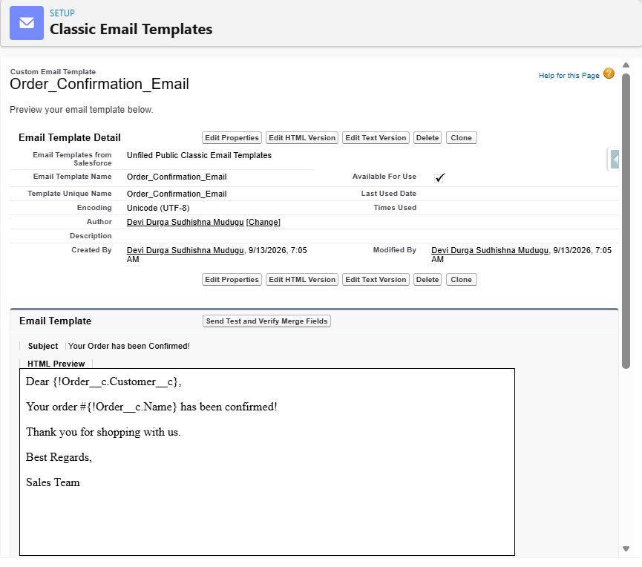
Figure : Order_Confirmation_Email template and its configured customer-facing message.

9.2 Stock Alert Email
The Low_Stock_Alert template is used for proactive inventory communication. It is intended for the warehouse or inventory-management team when the configured stock threshold is reached.
Business purpose: Give the warehouse team early visibility of low stock so that restocking action can be taken before a stockout occurs.
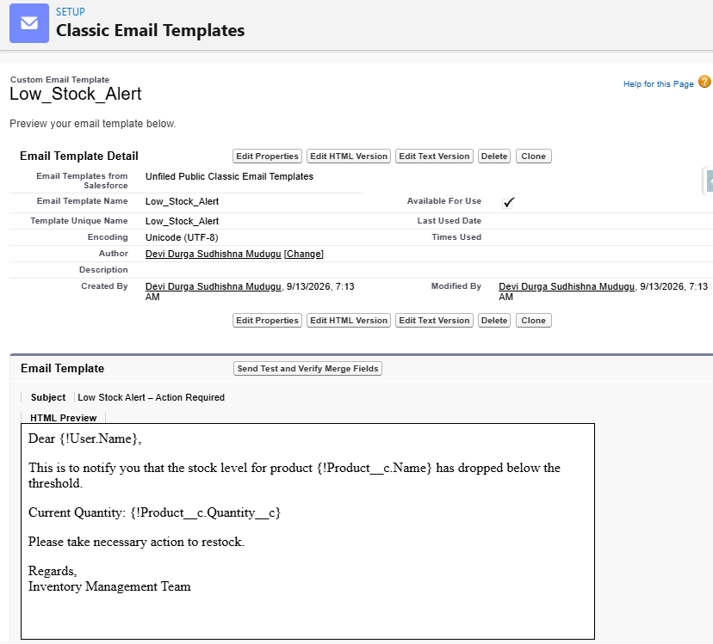
Figure - Low_Stock_Alert template showing the configured low-stock notification message.

9.3 Loyalty Program Email
The Loyalty_Program_Email template is used for customer-facing loyalty communication. It supports the Dynamic Loyalty Program requirement and provides standardized content for communicating loyalty-program information.
Business purpose: Strengthen customer engagement and support personalized communication associated with customer loyalty.
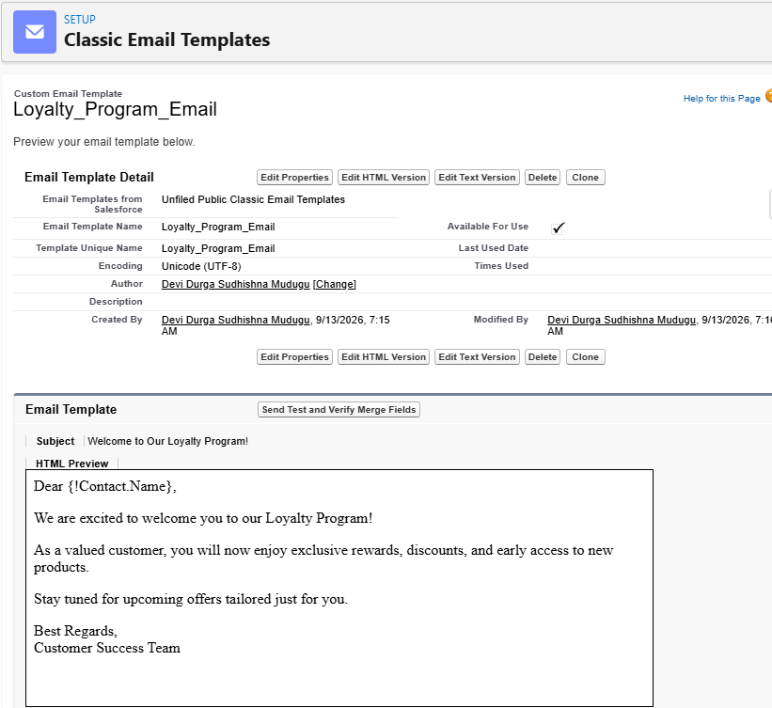
Figure – Loyalty_Program_Email template showing the configured loyalty-program message.

10. Email Alerts
Email Alerts connect the reusable email templates to Salesforce records and automation. They specify the template, object and recipients so that a Flow or other automation can invoke the appropriate communication.
The completed implementation contains an Order Confirmation Email Alert and a Stock Alert Email Alert.

10.1 Order Confirmation Email Alert
The Order Confirmation Email Alert is configured for the HandsMen Order object and uses the Order_Confirmation_Email template. When the relevant order automation invokes the alert, Salesforce can deliver the configured confirmation message to the intended recipient.
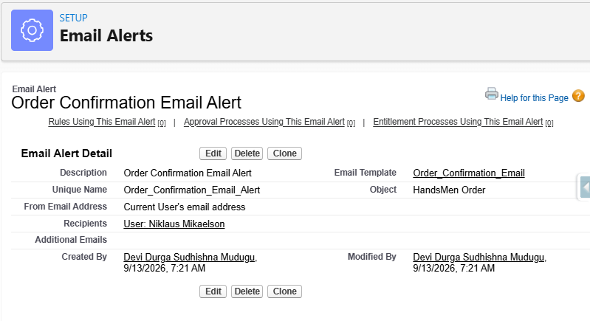
Figure - Order Confirmation Email Alert showing the HandsMen Order object, configured template and recipient information.

10.2 Stock Alert Email Alert
The Stock Alert Email Alert is configured for the Inventory object and uses the Low_Stock_Alert template. It supports the explicit business rule that inventory below five units should generate a warehouse notification
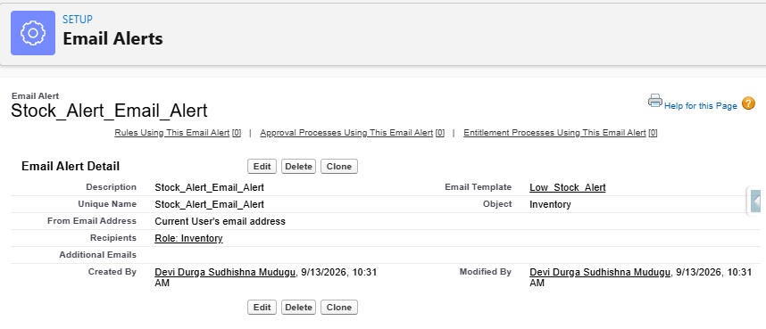
Figure – Stock Alert Email Alert showing the Inventory object and Low_Stock_Alert template.

11. Security & Communication Test Cases
Test ID | Feature | Input / Action | Expected Result | Status
TC-SEC-01 | Profile | Review/test configured profile | Expected baseline object access is available | Pass / verify
TC-SEC-02 | Role | Review user-role assignment | User is in intended hierarchy position | Pass / verify
TC-SEC-03 | Permission Set | Review Permission_Platform_1 assignment | Additional access is granted to intended user(s) | Pass / verify
TC-EMAIL-01 | Order Email | Trigger order-confirmation condition | Order Confirmation Email Alert is invoked | Pass / verify
TC-EMAIL-02 | Stock Alert | Set inventory below five | Stock Alert Email Alert is invoked | Pass / verify

12. Document 2 Summary
The HandsMen Threads security and communication implementation provides a structured approach to controlling user access and automating business communication. Profiles establish baseline access, roles organize users, user records connect individuals to the security model, and Permission_Platform_1 provides additional access where required.
The communication layer includes Order Confirmation, Low Stock and Loyalty Program email templates, together with Email Alerts for order and inventory processes. These configurations support the project's objectives of improving customer service, maintaining operational awareness and reducing repetitive manual work.

