Hayne Kim (hikim2)

Devin Tark (devinvt2)

Nidia Bucarelli (nidiaib2)

**MP4- Project Report**

1. ***Modeling the robot***

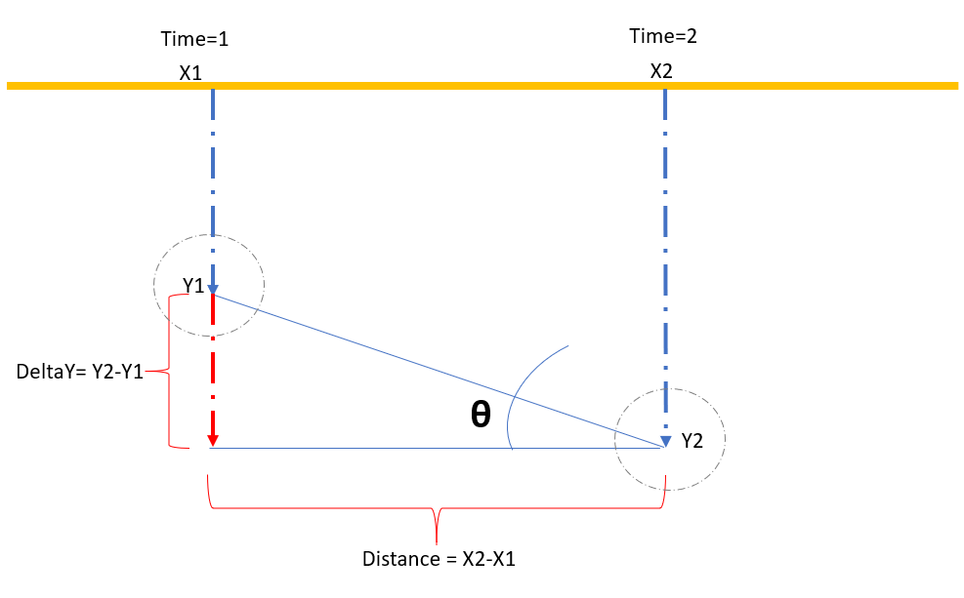The geometry of the problem is defined using the following schema.

Where

X1 = location of robot at time= 1

X2= location of robot at time = 2

Distance= Distance traveled from time 1 and time 2

DeltaY= Displacement of the robot from the wall distance between time 1 and time 2

Thus, the angle adjustment from the wall is given by:

$$\tan{θ= \frac{DeltaY}{Distance}}$$

$$θ=\tan^{-1}{\frac{DeltaY}{Distance}}$$

1. ***Modeling the sensor***

The graph below plots the readings from the robot wall signal versus the real wall-robot physical distance.

From our observations, it was noticed that wall signal readings are biased. To reduce the effect of sensor errors, the robot desired wall distance for navigation was designed based on a range value, instead of a fixed value. For this mp4, we want to keep the robot with a wall distance around to ~3cm to ~5cm. This event happens when the robot wall signal is within the range value of 20-40. When the robot signal is within that range, the robot navigates/drive straight. When the wall signal goes below or over this range, the controller is executed to return the robot to its steady state.

1. ***Designing the controller***

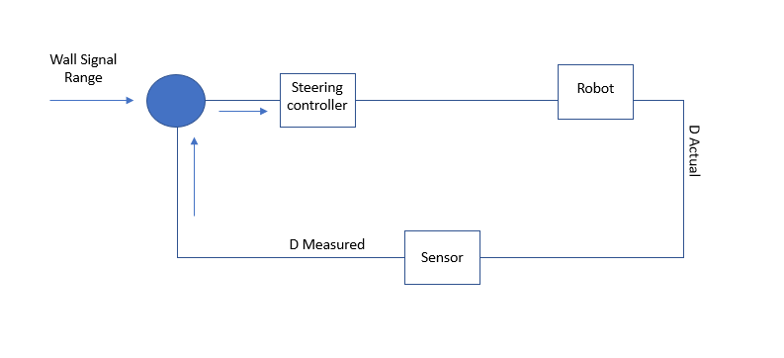

The angle rotation of the robot is designed as a function of the robot radio.

MaxR= Maximum Radius

MinR= Minimum Radius

A =Wall signal

D= Desired Wall signal, that means desired wall distance

M = Max wall signal allowed (upper bound) = 40

L= Minimum wall signal allowed (lower bound) = 20

A proportional controller has been designed:

*If A < L:*

*R = MaxR – [(A-D)*(MaxR-MinR)/(M-D)]*

*MaxR= 300*

*MinR= 1*

*D=L*

*If A >M:*

*R = MinR + [(A*(MaxR-MinR)/D]*

*MaxR= -850*

*MinR= -100*

*D= M*

Proportional controller was selected because it best fits the problem. Given a wall signal, the wall distance was adjusted estimating the error and using a constant.