Exploratory Data Analysis (EDA) Report Outline
Designing an EDA report on agribusiness trends
Prepared by: Devin, Junior Data Scientist Intern

1. Introduction and Purpose
Exploratory Data Analysis (EDA) is the stage where a cleaned dataset is examined to understand its shape, spot patterns and anomalies, test early ideas, and decide what deserves deeper modeling. In agribusiness, EDA is especially valuable because outcomes such as crop yields and market prices are shaped by weather, policy, input costs, and global demand, all at once.
This document is a complete outline of an EDA report on agribusiness trends. It explains how raw data would be turned into actionable insight for farmers, traders, processors, and policymakers, and it covers:
- The proposed structure of the final report, section by section
- The variables and metrics to be examined
- The types of analyses to be performed
- The visualization techniques matched to each type of data and question
- How statistical anomalies and feature correlations would be handled
- The outcomes expected from the EDA process
The outline assumes the data has already been collected and cleaned following the earlier data collection plan and cleaning strategy (standardized units, parsed dates, flagged imputed values).

2. Proposed Structure of the Final EDA Report
Section | Purpose | Typical contents
1. Executive Summary | Give decision-makers the main findings on one page | Objective, 3 to 5 key insights with numbers, headline recommendations
2. Background and Objectives | Set context and scope | Business problem, guiding questions, commodities, regions, and time range
3. Data and Methodology | Show how the analysis was done | Sources, variables, cleaning summary, tools, statistical methods, assumptions
4. Data Overview | Describe what the data looks like | Row and column counts, coverage, missing-value summary, summary statistics
5. Analysis and Findings | Present the patterns discovered | Univariate, time-series, regional, price, and correlation results with visuals
6. Anomalies and Data Quality Notes | Explain unusual values and how they were treated | Outlier tables, investigation notes, treatment decisions
7. Recommendations | Turn findings into action | Specific, prioritized, evidence-linked actions
8. Limitations and Next Steps | Be honest about what the analysis cannot show | Data gaps, caveats, proposed forecasting or deeper analysis
9. Appendix | Support reproducibility | Data dictionary, extra charts, code references, cleaning log
Table 1. Section-by-section structure of the final report.

3. Variables and Metrics
The analysis would draw on variables in five groups. Each is recorded with its unit and type so that the right summaries and charts are chosen later.

3.1 Production and Yield Variables
Variable | Description | Unit / Type
Area sown | Land under a crop in a season | Hectares / numeric
Production | Total output of a crop | Tonnes / numeric
Yield | Production divided by area | Tonnes per hectare / numeric
Regional production share | A state or district's share of total output | Percent / numeric
Cropping season | Kharif, rabi, or zaid | Categorical
Year-on-year growth | Change in production or yield versus the previous year | Percent / numeric

3.2 Market Price Variables
Variable | Description | Unit / Type
Modal, minimum, maximum price | Wholesale mandi prices for a commodity | Rupees per quintal / numeric
Arrivals | Quantity brought to market | Tonnes / numeric
Minimum support price (MSP) | Government-announced floor price | Rupees per quintal / numeric
Price spread | Market price minus MSP, or maximum minus minimum | Rupees / numeric
Price volatility | Rolling standard deviation or coefficient of variation | Percent / numeric
Retail price and food inflation | Consumer-level price changes | Index or percent / numeric

3.3 Resource and Weather Variables
Variable | Description | Unit / Type
Rainfall | Actual rainfall and deviation from normal | Millimetres, percent / numeric
Temperature | Mean, maximum, and anomalies | Degrees Celsius / numeric
Irrigated area share | Proportion of cropped area under irrigation | Percent / numeric
Fertilizer use | Nutrient (NPK) consumption per hectare | Kilograms per hectare / numeric
Cropping intensity | Gross cropped area divided by net sown area | Ratio / numeric

3.4 Trade and Demand Variables
- Export and import quantities and values by commodity (tonnes, rupees)
- Stock levels and public procurement (tonnes)
- Population and per-capita consumption where available

3.5 Business and Company Metrics (Optional)
- Revenue and operating margin of listed agribusiness firms
- Input cost indices (seed, fertilizer, fuel, labour)
- Futures prices for key commodities as a sentiment signal

3.6 Derived Metrics to Compute During EDA
- Compound annual growth rate (CAGR) of production and prices
- Seasonality index: average price in a month divided by the overall average
- Coefficient of variation (CV): relative variability of yield or price across regions or years
- Price-to-MSP ratio: market price divided by the minimum support price
- Yield gap: best-performing region minus the average
- Production concentration: share of the top three states in total output

4. Types of Analyses Planned

4.1 Univariate Analysis
Each variable is examined on its own to understand its centre, spread, and shape.
- Summary statistics: mean, median, standard deviation, quartiles, skewness, and kurtosis
- Distribution shape (for example, right-skewed prices) to decide whether log transformation is needed
- Frequency counts for categorical variables such as crop, state, and season

4.2 Bivariate Analysis
- Relationship between two variables, such as rainfall and yield, or arrivals and price
- Group comparisons: yield by crop, or price by season, using means, medians, and box plots
- Statistical tests where appropriate: t-test or ANOVA for group differences (or non-parametric alternatives such as the Mann-Whitney and Kruskal-Wallis tests when data is skewed)

4.3 Multivariate Analysis
- Correlation matrix across all numeric variables
- Pair plots to see several relationships at once
- Dimensionality checks (such as principal component analysis) if many correlated variables exist
- Cross-tabulations and pivot tables for crop-by-state or season-by-region summaries

4.4 Time-Series Analysis
- Trend: long-term movement in prices and production, using moving averages and CAGR
- Seasonality: repeating yearly patterns, using month-wise averages and seasonal decomposition (trend, seasonal, residual)
- Volatility: rolling standard deviation to detect periods of instability
- Autocorrelation: ACF and PACF plots to understand persistence and to prepare for ARIMA-style forecasting
- Event windows: comparing periods before and after policy changes, droughts, or export bans

4.5 Regional and Spatial Analysis
- Ranking states and districts by production, yield, and growth
- Identifying high-performing and lagging regions (yield gap analysis)
- Choropleth maps of yield, rainfall, or price levels
- Clustering regions with similar profiles (for example, k-means on yield, rainfall, and irrigation)

4.6 Market and Price Analysis
- Price comparison across markets to detect regional price gaps
- Relationship between arrivals and price (supply-driven price movement)
- MSP versus market price: how often and by how much prices fall below the floor
- Pass-through from wholesale to retail prices, using lagged comparisons

5. Visualization Plan
Each chart type is chosen for the kind of data and the insight it best reveals. The table below links questions to visuals, and Figure 1 shows four of the core chart types using hypothetical data.
Question or data type | Visualization | Insight it reveals
Distribution of one numeric variable (yield, price) | Histogram, density plot | Shape, skew, and typical range
Spread and outliers across groups | Box plot, violin plot | Medians, variability, and extreme values by crop or state
Comparison across categories (states, crops) | Bar chart (horizontal for long names), grouped bar | Ranking and relative size
Change over time | Line chart with moving average | Trend, turning points, and volatility
Seasonal patterns | Seasonal subseries plot, month-by-year heatmap | Which months are high or low each year
Relationship between two numeric variables | Scatter plot with trend line | Direction, strength, and shape of relationship
Relationships among many variables | Correlation heatmap, pair plot | Strong and weak associations, multicollinearity
Share of a total | Stacked bar or treemap (pie charts only for few categories) | Regional or crop composition
Geographic variation | Choropleth map | Spatial clusters of high or low values
Anomaly detection | Box plot, control chart, time-series with flagged points | Unusual observations in context
Decomposition of a series | Trend, seasonal, and residual panels | What drives price movement
Table 2. Visualization choices matched to questions and data types.
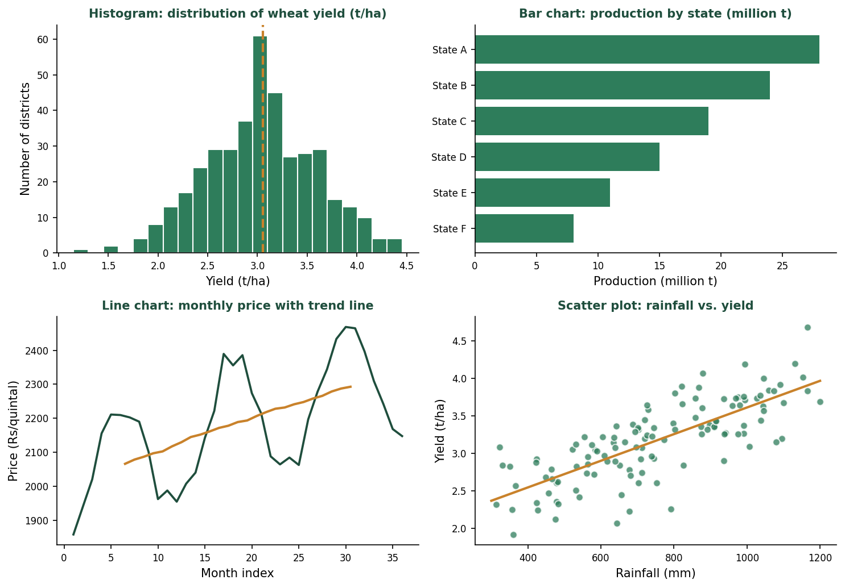
Figure 1. Illustrative examples of core chart types (hypothetical data created only to show the technique).

Visualization principles
- One message per chart, with a clear title that states the takeaway
- Labelled axes with units, and a consistent colour palette across the report
- Avoid clutter, 3D effects, and truncated axes that exaggerate differences
- Annotate key events (for example, a policy change) directly on time-series charts
- Use accessible colours and add short captions that explain how to read each visual

6. Handling Statistical Anomalies
Anomalies (outliers and unusual patterns) can be mistakes or the most important signal in the dataset, so each is investigated before any action is taken.

6.1 Detection Methods
- Visual: box plots, histograms, scatter plots, and time-series plots with flagged points
- Statistical rules: the interquartile range (IQR) rule (values beyond 1.5 times the IQR), z-scores (beyond about 3), and the modified z-score based on the median for skewed data
- Time-series methods: deviation from a rolling mean, or large residuals after seasonal decomposition
- Rule-based checks: impossible values (negative yield, minimum price above maximum price)
- Multivariate methods (if needed): Isolation Forest or Mahalanobis distance

6.2 Investigation Workflow
- Flag the observation and record where it came from (source, date, region).
- Check for data errors: typing slips, unit mistakes, and placeholder values.
- Compare with trusted sources or neighbouring regions and periods.
- Look for a real-world explanation such as drought, flood, export ban, or festival demand.
- Decide on treatment and write the decision in the anomaly log.

6.3 Treatment Options
Type of anomaly | Example | Treatment
Data entry error | Production of 45,000 t from 1,100 ha | Correct if the right value is known; otherwise set to missing and impute, with a flag
Unit error | Price of 21.5 instead of 2,150 per quintal | Convert to the standard unit
Genuine extreme event | Onion price spike after a poor harvest | Keep, flag, and discuss in the report; use robust statistics or a separate event analysis
Heavy-tailed variable | A few very large districts | Log transform or winsorize for modelling; report medians alongside means
Structural break | Level shift in prices after a policy change | Analyse periods separately or include an event indicator
Table 3. Anomaly types and treatment decisions.
Every treated value is recorded (original value, new value, reason, and method), so the results can be audited and sensitivity checks can show whether conclusions change with and without the anomalies.

7. Handling Feature Correlations

7.1 Measuring Correlation
- Pearson correlation for linear relationships between roughly normal variables
- Spearman rank correlation for skewed data, monotonic relationships, and data with outliers
- Correlation heatmap to scan all pairs at once, with the strongest relationships listed in a table
- Lagged correlation to test whether changes in one variable (for example, rainfall or arrivals) are followed by changes in another (price) after a delay
- Group-wise correlation to check whether relationships differ by crop, region, or season

7.2 Interpreting Correlations Carefully
- Correlation is not causation: a link between fertilizer use and yield may also reflect irrigation access.
- Confounders: use partial correlation or stratified analysis to control for a third variable.
- Spurious time-series correlation: two trending series can appear related; check correlations on differenced or detrended data.
- Non-linear relationships: inspect scatter plots, because a near-zero Pearson value can hide a curved pattern.
- Sample size and significance: report p-values and confidence intervals, not just the coefficient.

7.3 Dealing with Multicollinearity
- Flag pairs with absolute correlation above about 0.8.
- Calculate the Variance Inflation Factor (VIF); values above about 5 to 10 signal concern.
- Remove, combine, or transform redundant variables (for example, combine two rainfall measures), or use regularized methods or principal components later.
- Keep the variable that is easiest to explain to the business audience.

8. Draft of Key Report Sections
The following drafts show what the main sections of the final report would contain. The figures are hypothetical placeholders to illustrate tone and structure.

8.1 Executive Summary (sample)
This report explores ten years of crop production and market price data for major cereals and pulses. Three findings stand out. First, wheat yields grew steadily at about 1.8 percent a year, but growth is concentrated in a small number of states. Second, prices show a strong seasonal pattern, typically 8 to 12 percent lower at harvest than in the lean months. Third, rainfall deviation is moderately correlated with yield (r around 0.5), while irrigation access weakens this link. We recommend targeted storage and sale timing strategies and further forecasting work on seasonal price movements.

8.2 Methodology (outline)
- Data sources, time coverage, and the cleaning steps applied
- Variables analysed and derived metrics
- Statistical methods used (summary statistics, correlation tests, seasonal decomposition, group tests)
- Anomaly and missing-value handling rules
- Software and versions, for reproducibility

8.3 Analysis and Findings (outline)
- 5.1 Production and yield trends by crop and region
- 5.2 Seasonality and price behaviour
- 5.3 Market integration and price spreads
- 5.4 Weather, inputs, and yield relationships
- 5.5 Anomalies and notable events
- Each subsection: the question, the chart, the key numbers, and a one-line interpretation

8.4 Recommendations (sample)
- For farmers and cooperatives: plan storage and staggered selling to avoid harvest-time price lows.
- For traders and processors: align procurement with seasonal price lows and monitor arrivals as an early price signal.
- For policymakers: focus extension and irrigation support on regions with persistent yield gaps.
- For the analytics team: build forecasting models for the most volatile commodities and refresh the EDA each season as new data is released.
Each recommendation links to the finding that supports it, states who should act, and includes an expected benefit or metric to track.

9. Expected Outcomes of the EDA
- A clear picture of which crops and regions are growing, stagnating, or declining
- Identification of seasonal price cycles and volatility periods that affect timing decisions
- Evidence on how weather, irrigation, and inputs relate to yield, to guide variable selection
- A documented list of anomalies, their causes, and treatment decisions
- A shortlist of features and hypotheses for later forecasting models
- Visual summaries that communicate findings to non-technical stakeholders
- A reproducible notebook and report that can be refreshed with new data

10. Workflow and Tools

10.1 EDA Workflow
- Load the cleaned dataset and confirm its integrity
- Review structure, summary statistics, and missing-value patterns
- Run univariate analysis for each key variable
- Run bivariate and multivariate analysis, including correlations
- Perform time-series and seasonal analysis
- Conduct regional comparisons and clustering
- Detect and investigate anomalies
- Compile findings, select visuals, and draft the report
- Review with the mentor, refine, and finalize

10.2 Tools
- Python: pandas, NumPy, SciPy, statsmodels, matplotlib, seaborn, and Plotly
- Jupyter Notebook or Google Colab for runnable, documented analysis
- Excel or Power BI/Tableau for dashboards, if stakeholders prefer them
- Version control with Git, and reports exported to Word or PDF

11. Risks and Limitations
- Data quality and gaps: public data can be delayed, revised, or incomplete; findings should state coverage clearly.
- Aggregation bias: state-level averages can hide district-level differences.
- Overinterpretation: EDA shows patterns, not proof of cause; confirmatory analysis is needed before strong claims.
- Multiple comparisons: testing many relationships raises the chance of false findings, so results need cautious interpretation.
- Small sample for some crops or regions: treat these results as indicative only.

12. Conclusion
A well-structured EDA report turns cleaned agribusiness data into insight that people can act on. By defining clear variables and metrics, matching each question to a suitable analysis and visualization, treating anomalies and correlations with care, and presenting findings in a logical report with direct recommendations, the analysis supports better decisions on production, marketing, and policy. The same outline can be reused each season, giving the organization a repeatable way to track agribusiness trends and prepare for forecasting.

