Data Cleaning and Preprocessing Strategy
A strategy for a hypothetical agribusiness dataset
Prepared by: Devin, Junior Data Scientist Intern

1. Introduction
Agribusiness data comes from many places: government statistics, market boards, weather agencies, farm surveys, and company records. It is collected by different people, in different formats, for different purposes. As a result, raw agricultural datasets almost always contain gaps, inconsistencies, and errors that must be fixed before any trustworthy analysis or forecasting can be done.
This document describes a data cleaning and preprocessing strategy for a hypothetical agribusiness dataset. It covers:
- An overview of common data quality issues in agribusiness data
- A step-by-step data cleaning plan with specific methods for each issue
- A proposed framework for preprocessing data for analysis and modeling
- A workflow diagram showing the order of steps
- Hypothetical examples that illustrate the strategy
- The role of reproducibility in the whole process
The guiding principle is simple: clean data is the foundation of reliable insight. A model built on poorly prepared data will give confident but misleading answers, so time spent on cleaning is time well spent.

2. The Hypothetical Dataset
To keep the strategy concrete, imagine a combined dataset of district-level crop records and market prices, assembled from several public sources. Each row describes one crop in one district for one period. A small sample is shown below, with problems deliberately included.
district | crop | date | area_ha | production_t | price_qtl | rainfall_mm
Meerut | Wheat | 15/03/2023 | 1,200 | 4,800 | 2,125 | 42
meerut | wheat | 2023-03-15 | 1200 | 4800 | 2125 | 42
Agra | Paddy | 03-2023 | 950 |  | 1,980 | -
Mathura | Rice | 12/04/2023 | 800 | 3,600 | 21.5 | 38
Aligarh | Wheat | 10/04/2023 | 1,100 | 45,000 | 2,150 | 9999
Table 1. Sample of the hypothetical raw dataset (problems intentionally included).
Even in five rows, several issues are visible: duplicate records written differently (rows 1 and 2), mixed date formats, numbers stored as text with commas, a missing value, different names for the same crop (Paddy and Rice), a price in a different unit (21.5 appears to be per kilogram rather than per quintal), a placeholder value (9999), and a suspiciously large production figure.

3. Common Data Quality Issues in Agribusiness Datasets
Issue | Agribusiness example | Why it matters
Missing values | No production figure for a district; rainfall not recorded at a station | Biases averages, breaks models that cannot handle blanks, and reduces sample size
Inconsistent formats | Dates as 15/03/2023, 2023-03-15, or 03-2023; numbers with commas or text symbols | Prevents sorting, merging, and time-series analysis
Inconsistent categories | Paddy vs. Rice, Orissa vs. Odisha, extra spaces or capital letters | Splits one group into several and distorts counts and totals
Unit inconsistencies | Price per quintal vs. per kg; area in acres vs. hectares; production in tonnes vs. quintals | Produces errors of 100x or more if mixed unnoticed
Duplicates | The same market report entered twice or loaded from two sources | Inflates totals and gives some records extra weight
Outliers | A price spike during a shortage, or a typing error such as 45,000 instead of 4,500 | Can be real signal or error; wrong treatment either hides trends or distorts them
Invalid or placeholder values | -, NA, 9999, or negative yields | Misread as real numbers if not converted to missing
Temporal misalignment | Crop year (2022-23) vs. calendar year; daily prices vs. annual production | Leads to joining data from the wrong period
Integration problems | Different district codes or spellings across sources | Merges fail silently or create duplicate rows
Seasonality and reporting gaps | Prices only reported on market days; production only after harvest | Creates uneven time series that need careful handling
Table 2. Typical data quality issues, with examples and their impact.

4. Step-by-Step Data Cleaning Plan
The cleaning plan follows a fixed order. Each step builds on the previous one, so structural problems are fixed before values are filled or removed.

Step 1: Ingest and Back Up Raw Data
- Store original files in a data/raw folder and treat them as read-only.
- Record the source, download date, and file name in a data inventory.
- Load data into a notebook or script and never edit the originals by hand.

Step 2: Profile and Inspect
- Check the number of rows and columns, data types, and summary statistics (info(), describe()).
- Count missing values and duplicates for every column.
- Plot distributions and time series to spot obvious problems.
- Write down the issues found; this becomes the to-do list for the later steps.

Step 3: Standardize Structure
- Column names: lowercase with underscores and no spaces.
- Categories: trim spaces, fix capitalization, and map variants to one standard (for example, Paddy to Rice, Orissa to Odisha) using a lookup table.
- Units: convert everything to one unit per variable, such as tonnes, hectares, and rupees per quintal, and record each conversion.

Step 4: Fix Data Types and Dates
- Remove commas and symbols, then convert text to numbers.
- Parse dates into one format, and use a consistent frequency (daily, monthly, or yearly).
- Align crop years and calendar years, and add a season column (kharif or rabi) where relevant.
- Convert placeholders such as -, NA, and 9999 into proper missing values.

Step 5: Handle Missing Values
No single method suits every variable. The method is chosen by the type of data and how much is missing, and every imputed value is flagged.
Situation | Method | Example
Row or column mostly empty (for example, over 50% missing) | Drop (filtering) | Remove a column with 70% missing soil data
Short gaps in a time series | Interpolation or forward-fill | Fill a missing daily price from neighboring days
Numeric variable with scattered gaps | Median imputation by group | Fill missing yield with the median of the same crop and state
Categorical variable | Mode or an explicit Unknown category | Missing irrigation type becomes Unknown
Relationship between variables is strong | Model-based imputation (regression, KNN) | Estimate production from area and typical yield
Any imputed value | Add a flag column | `production_imputed = True`
Table 3. Missing value strategies.

Step 6: Remove Duplicates and Validate Business Rules
- Remove exact duplicates, and near-duplicates once names and dates are standardized (rows 1 and 2 in Table 1 become identical).
- Check logical rules: production is roughly area multiplied by yield, minimum price is at most modal price, which is at most maximum price, and area and yield are never negative.
- Check totals against published aggregates, such as state totals.
- Quarantine rows that break a rule in a separate file instead of silently deleting them.

Step 7: Detect and Treat Outliers
- Detect: box plots, the interquartile range (IQR) rule, z-scores, and comparison with domain knowledge.
- Investigate: decide whether each outlier is an error (typo, unit mistake) or a real event (drought, policy shock).
- Treat: correct clear errors; keep and flag genuine events; cap extreme values (winsorize) or use robust methods when they would otherwise dominate a model.
- Never remove outliers only because they are inconvenient; document every decision.

Step 8: Integrate Datasets
- Merge on common keys such as district, crop, and period, using standardized codes where possible.
- Check row counts before and after each merge to catch accidental duplication or loss.
- Resolve conflicts between sources by using a preferred source order and noting it in the log.

5. Proposed Data Preprocessing Framework
Once the data is clean, it is prepared for analysis and modeling. The framework below separates cleaning (fixing errors) from preprocessing (shaping the data for methods), and keeps the two in a fixed order.

5.1 Transformation and Normalization
- Log transformation: reduces right skew in prices and production, and makes percentage changes easier to model.
- Min-max scaling: rescales values to 0 to 1, useful for distance-based methods and neural networks.
- Standardization (z-score): centers variables at zero with unit variance, useful for regression and many machine learning models.
- Differencing: removes trend from time series (for example, month-on-month price change) so models can work with stationary data.

5.2 Encoding Categorical Variables
- One-hot encoding for crops, states, and seasons with few categories.
- Ordinal encoding for ordered categories, such as low, medium, and high rainfall.
- Grouping rare categories into Other to avoid very sparse columns.

5.3 Feature Engineering
- Lag features (price one and three months ago) and rolling averages.
- Seasonal features (month, quarter, kharif or rabi).
- Growth rates (year-on-year change in yield or price).
- Derived indicators such as yield (production divided by area) and the gap between market price and minimum support price.

5.4 Train/Test Splitting
- Split by time (for example, train on earlier years and test on the latest year), never randomly, so the model never sees the future.
- Fit scalers and imputers on the training set only, then apply them to the test set to avoid data leakage.

5.5 Final Quality Checks
- No unexpected missing values, duplicates, or impossible values remain.
- Units, date formats, and category names are consistent.
- Row counts reconcile with the raw data, minus documented removals.
- A before-and-after summary shows rows, percentage missing, duplicates removed, and outliers treated.

6. Workflow Diagram
The diagram below shows the full sequence of steps, from raw data to a cleaned, analysis-ready dataset with a log.
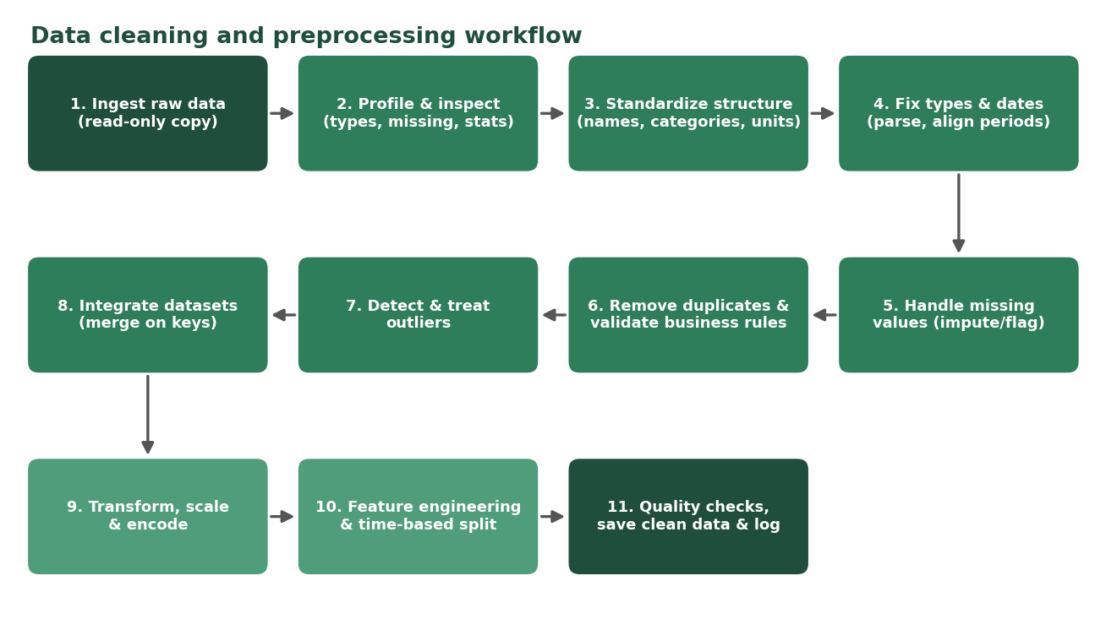
Figure 1. Data cleaning and preprocessing workflow.
In list form, the sequence is:
- Ingest raw data and keep a read-only copy
- Profile and inspect the data
- Standardize column names, categories, and units
- Fix data types and dates
- Handle missing values and flag imputed values
- Remove duplicates and validate business rules
- Detect and treat outliers
- Integrate datasets by merging on keys
- Transform, scale, and encode variables
- Engineer features and split data by time
- Run quality checks, save clean data, and write the cleaning log

7. Hypothetical Worked Example
Applying the plan to the sample in Table 1 gives the following clean result.
district | crop | date | area_ha | production_t | price_per_qtl | rainfall_mm | flags
Meerut | Wheat | 2023-03-15 | 1200 | 4800 | 2125 | 42 | duplicate removed
Agra | Rice | 2023-03-01 | 950 | 3800 (imputed) | 1980 | missing | production imputed
Mathura | Rice | 2023-04-12 | 800 | 3600 | 2150 | 38 | price unit fixed
Aligarh | Wheat | 2023-04-10 | 1100 | 4500 | 2150 | missing | outlier corrected; placeholder removed
Table 4. The same sample after cleaning.
- Row 2 removed: after trimming and lowercase fixes, rows 1 and 2 were identical, so one was dropped.
- Agra: Paddy mapped to Rice and the date parsed from 03-2023 to 2023-03-01; missing production was estimated as area multiplied by the median yield for rice (about 4 t/ha), and flagged.
- Mathura: the price of 21.5 was recognized as rupees per kg and converted to 2,150 per quintal.
- Aligarh: 45,000 tonnes from 1,100 hectares implies a yield of about 41 t/ha, which is impossible for wheat, so it was treated as a typing error for 4,500 and logged; 9999 rainfall was converted to missing.
This example shows why each correction is recorded: anyone reviewing the data can see what changed, why, and how many rows were affected.

8. The Importance of Reproducibility
Reproducibility means that someone else, or the same analyst months later, can run the same process on the same raw data and get exactly the same clean dataset. It matters in agribusiness analysis for several reasons:
- Trust: decision-makers can see and verify how the numbers were produced.
- Auditability: if a figure is questioned, each cleaning decision can be traced and justified.
- Updates: agricultural data is released regularly, and a scripted pipeline can be rerun on new data in minutes instead of redone by hand.
- Collaboration: teammates can understand and improve the process without guesswork.
- Error prevention: manual edits in spreadsheets are easy to forget and impossible to retrace.

Practices to ensure reproducibility
- Keep raw data unchanged and generate all cleaned data with code.
- Write the whole process as a script or notebook, run from top to bottom.
- Keep a cleaning log and a data dictionary (column meanings, units, allowed values).
- Use version control (Git) for code and documentation, with small, well-described commits.
- Fix random seeds and record package versions (for example, a requirements.txt file).
- Use a standard folder structure: data/raw, data/clean, notebooks, outputs.
- Automate checks, such as assertions that fail when rules are broken.

Example of a reusable pipeline
from sklearn.pipeline import Pipeline
from sklearn.impute import SimpleImputer
from sklearn.preprocessing import StandardScaler

numeric_pipe = Pipeline([
("impute", SimpleImputer(strategy="median", add_indicator=True)),
("scale", StandardScaler()),
])
# Fit on training data only, then reuse on new data:
# X_train_t = numeric_pipe.fit_transform(X_train)
# X_test_t = numeric_pipe.transform(X_test)

9. Tools
- Python with pandas and NumPy for cleaning, scikit-learn for pipelines, and matplotlib/seaborn for diagnostic plots
- Jupyter Notebook or Google Colab for documented, runnable steps
- Excel or Google Sheets for quick checks and the data inventory
- Git and GitHub for version control and sharing

10. Conclusion
A clear, ordered strategy turns messy agricultural data into a dataset that can be trusted. By profiling first, standardizing structure, handling missing values and outliers with documented methods, and then preprocessing with care for leakage, the analysis rests on solid ground. Recording every step and building the process as reusable code makes the work transparent and repeatable, so it can be rerun on new data and reviewed by others with confidence.

