EDA Report

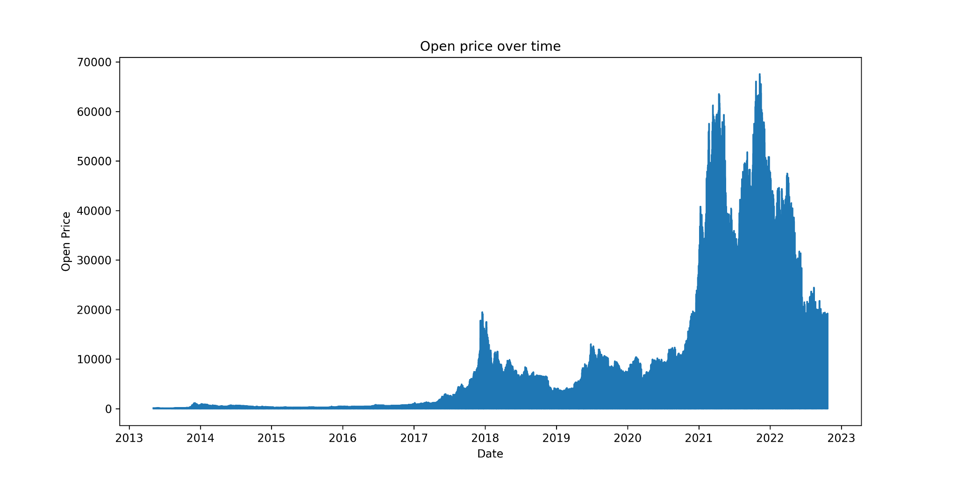

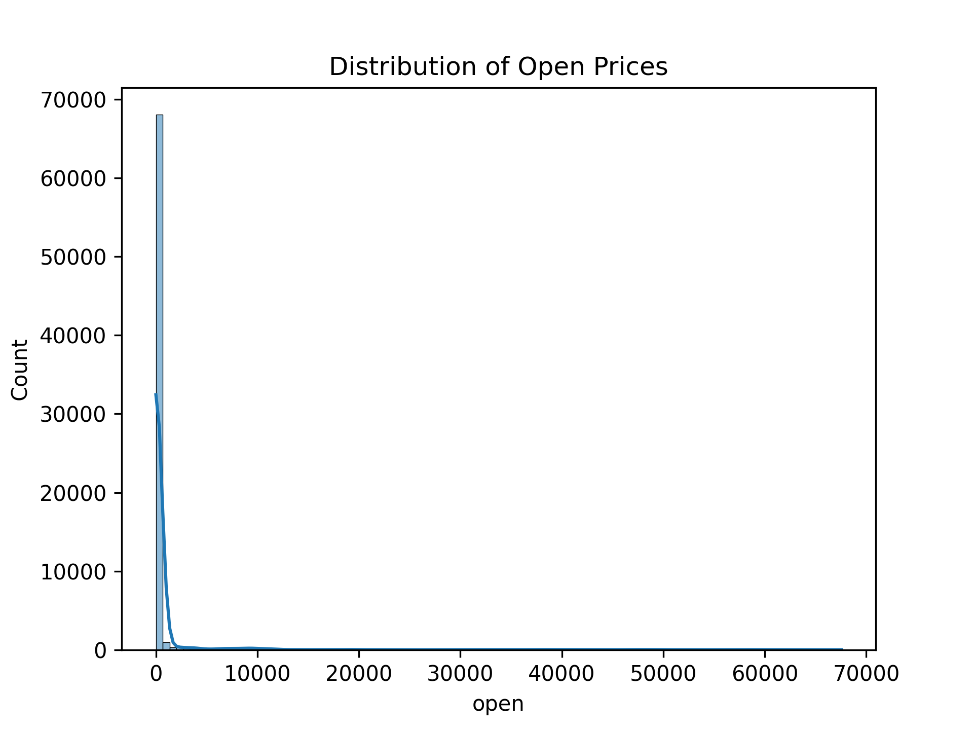
The line graph of open prices over time shows a clear upward trend, indicating that opening prices have generally increased. However, the histogram of open prices reveals a right‑skewed distribution, with most values concentrated in the 0–1000 range and fewer days experiencing much higher opening prices. Together, these plots suggest that while prices trended upward, the dataset is dominated by lower values, with occasional extreme highs creating the skew.

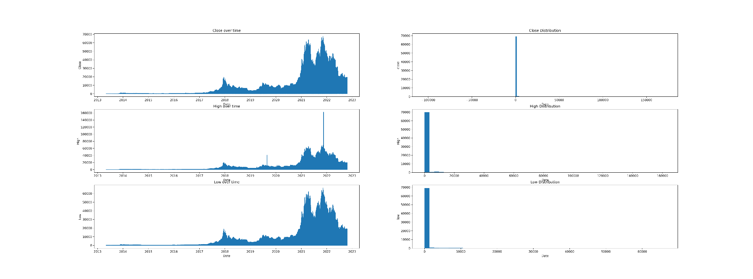
The analysis shows that low, high, and close prices have increased over time, indicating an upward trend in the market. However, the histograms reveal right‑skewed distributions, with most trading days concentrated at lower price levels and fewer days experiencing extreme highs.

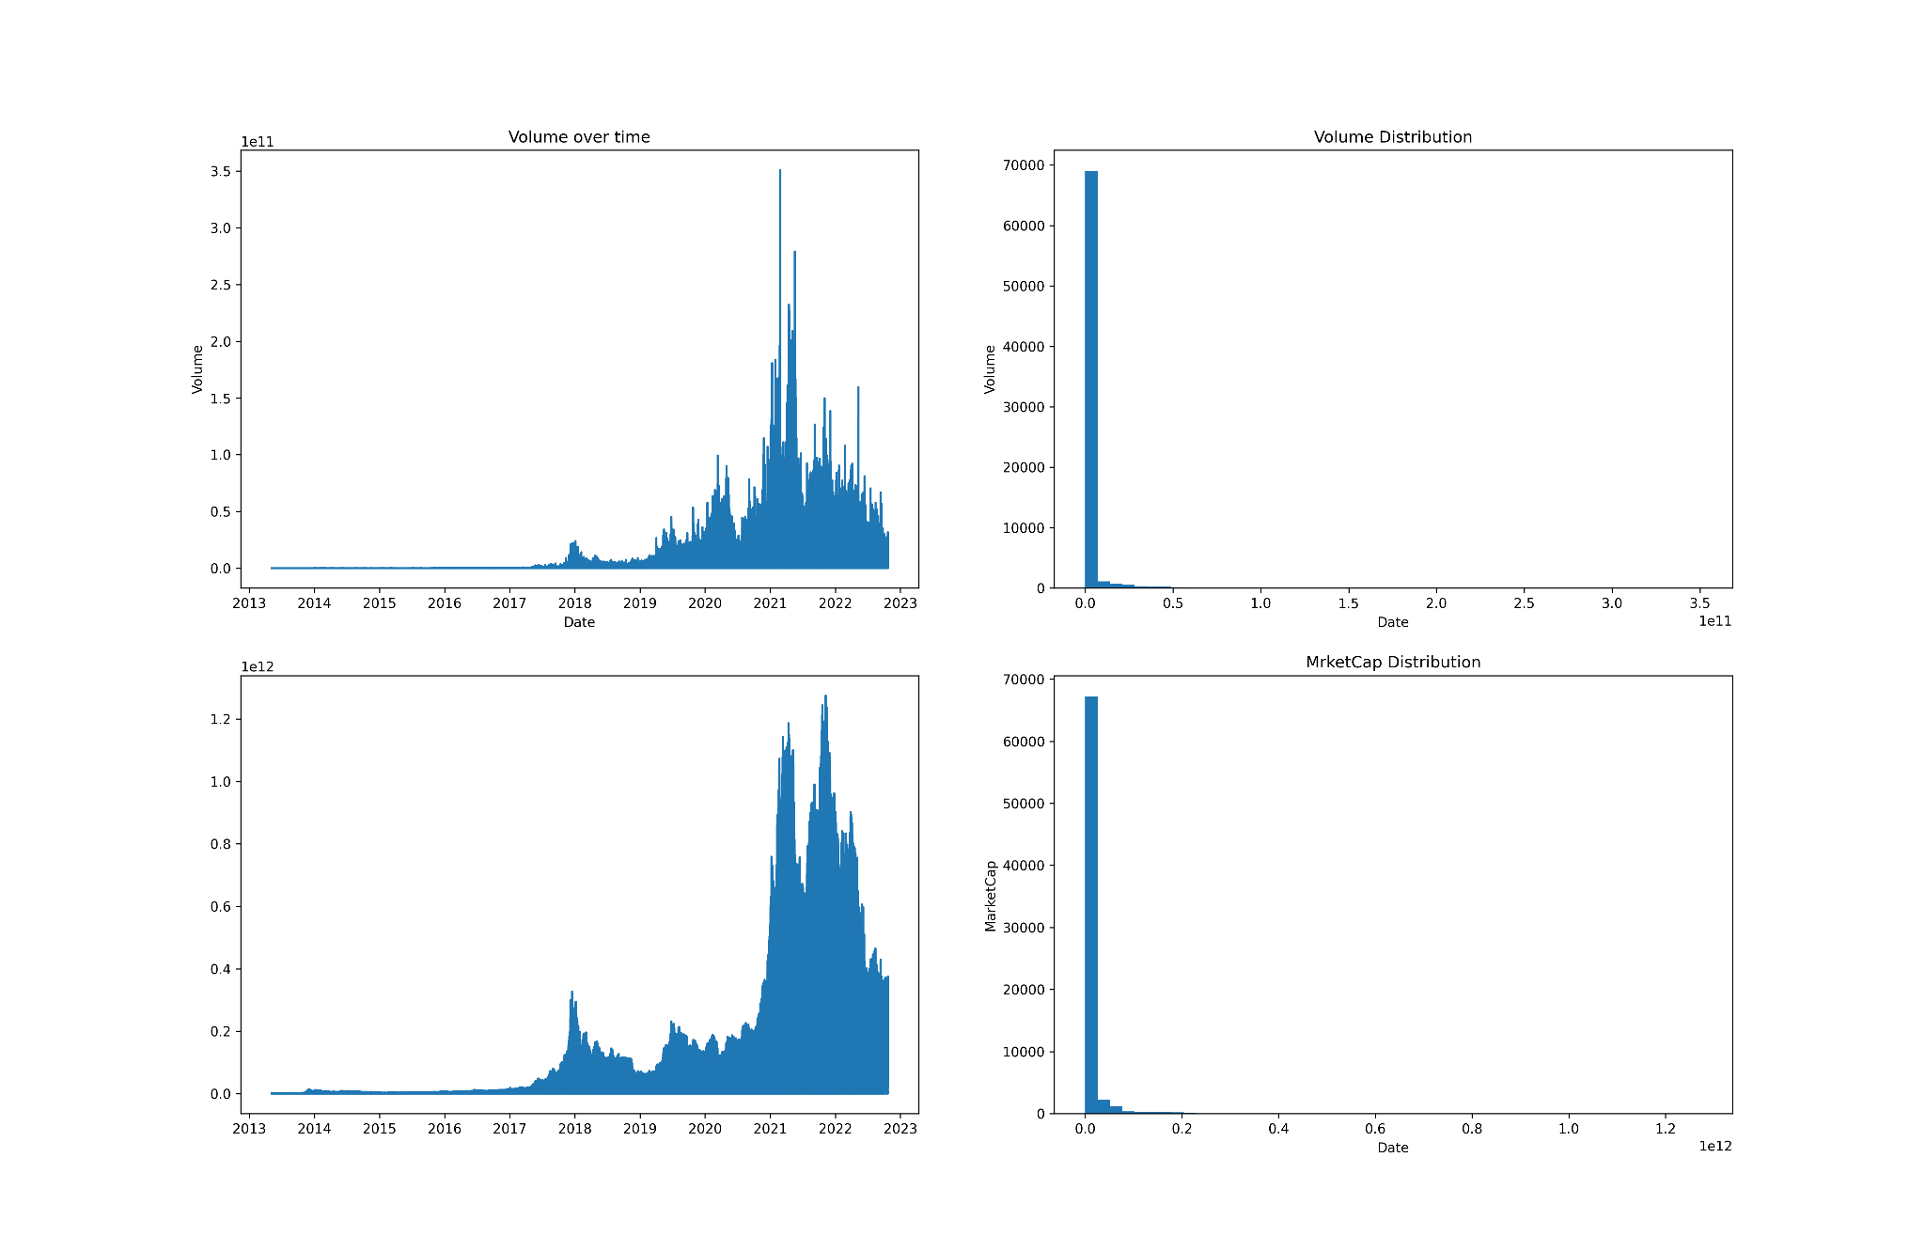
The analysis shows that trading volume and market capitalization have increased over time, reflecting growth in market activity and asset value. However, their histograms reveal right‑skewed distributions, with most trading days concentrated at lower levels and fewer days experiencing extreme surges

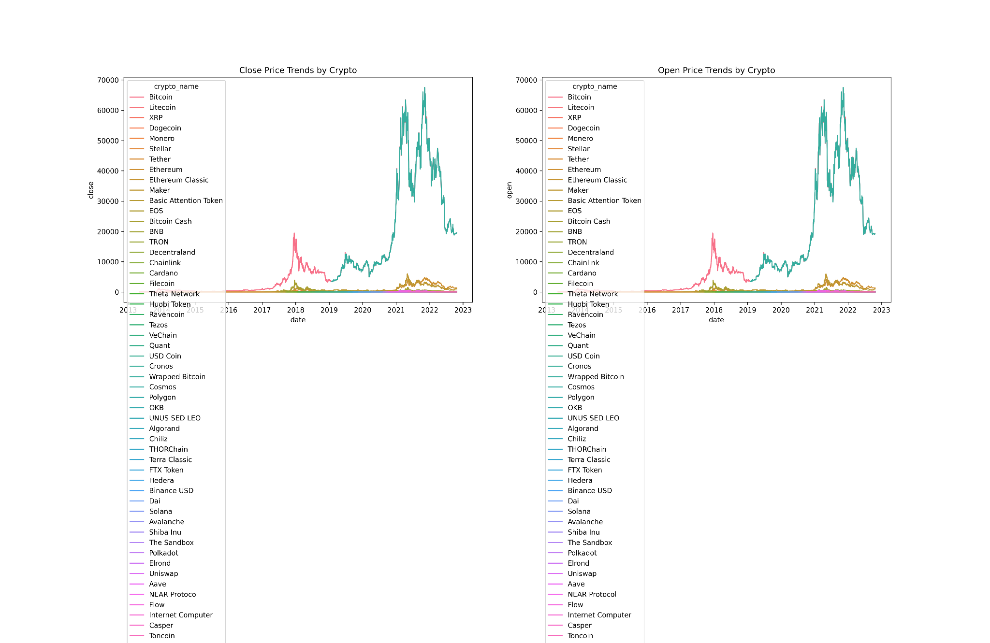

The line plot of close prices by crypto highlights distinct behaviors across assets. Some cryptocurrencies exhibit sharp increases followed by declines, reflecting volatility and market corrections. Others show a steady upward slope, indicating consistent growth. A few remain relatively flat, suggesting limited price movement.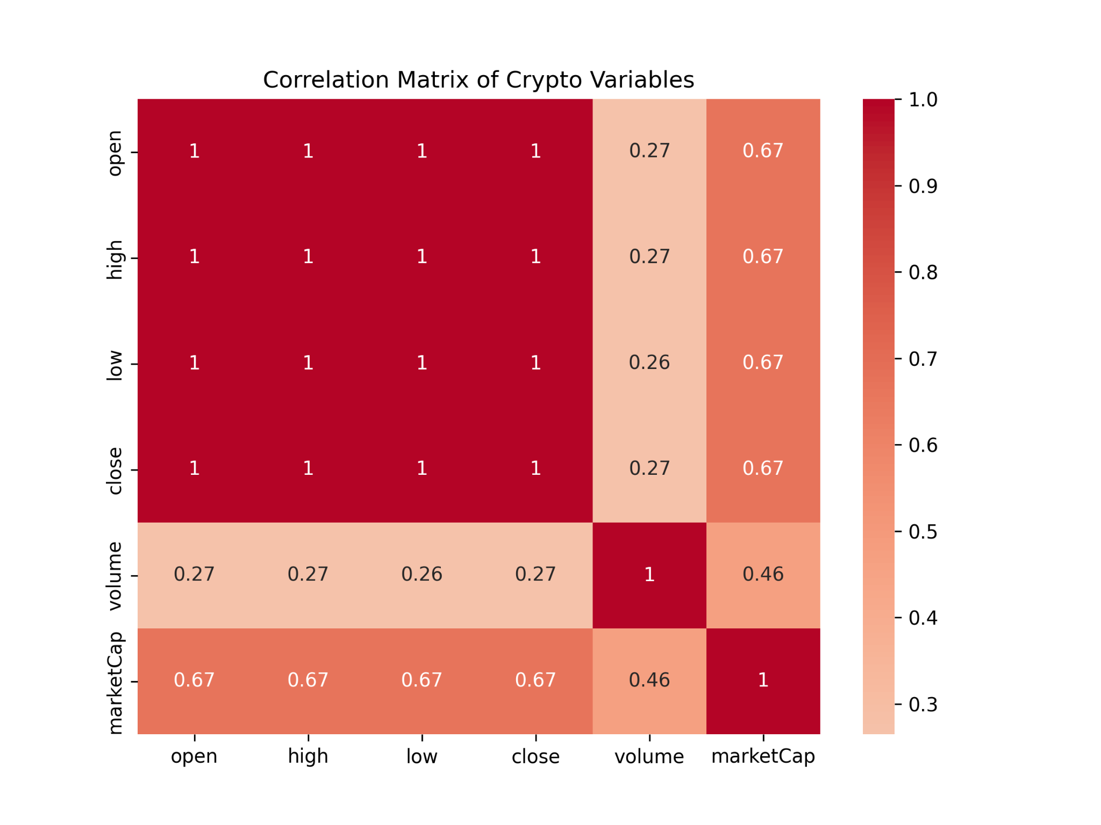
The correlation analysis shows that open, high, low, and close prices are almost perfectly correlated, reflecting their shared dependence on daily trading activity. Market capitalization is strongly correlated with prices, indicating that higher prices increase overall value. Trading volume exhibits weaker correlation with prices and moderate correlation with market capitalization

Feature Extraction:
1 open 1008.937333
2 high 189.849382
3 low 1642.439129
4 close 1326.697126

To address multicollinearity among open, high, low, and close prices, derived features were created. The high_low_spread feature captures daily volatility, while close_open_diff captures daily momentum. These transformations reduce redundancy and stabilize regression models while preserving meaningful information about market behavior.

The raw timestamp values were not used directly in clustering or PCA. Instead, the day of week was transformed into two numerical features (day_sin and day_cos) using sine and cosine functions. This encoding preserves the cyclical nature of the week, ensuring that consecutive days such as Sunday and Monday are treated as neighbors in the feature space. Only these two features were retained to keep the dataset compact while still capturing temporal patterns.

