**Online Appendix for Schickler & Caughey’s “Public Opinion, Organized Labor, and the Limits of New Deal Liberalism, 1936–1945”**

In this supplementary Appendix to Schickler and Caughey (2011), we address several issues that relate to the sampling methodology in the early polls, and provide question wording for items used in the Figures tracking comparable questions over time.

Gallup’s interviewing practices generate some special concerns about the quality of the samples, particularly in the South, where the effective electorate was much smaller than the population. Beyond the obvious problems introduced by the exclusion of southern African Americans from most of the Gallup samples (which force us to focus only on southern whites), there is the additional concern that the southern electorate interviewed by Gallup may differ in important ways from the larger southern population. While our weights attempt to account for the class bias introduced by pollsters’ sampling practices, it is certainly possible that the weights fail to account fully for these problems. In particular, one might worry that our findings regarding southern whites’ position on labor and non-labor issues, relative to the country as a whole, are partly an artifact of Gallup’s sampling practices in the south. Recall that we found that on non-labor issues, southern whites begin the period a bit to the left of the median voter nationally and drift to the right, so that they are a bit more conservative than the median by the end of the period (nonetheless, they are still centrally located relative to northern Democrats and northern Republicans throughout). On labor issues, southern whites start out about five points more conservative than the country as a whole and become even more conservative over time (relative to the national average).

Appendix Figures 1A and 1B summarize the gap between southern whites and the full sample across all non-Gallup polls, first for non-labor items (1A) and then for labor union questions (1B). For the non-labor items, the results look identical to those presented in Figure 4A of Schickler-Caughey (2011): southern whites start out a bit more liberal than the national average, but drift to the right so that they end the period a bit to the right of the national average. The labor policy series, however, is more sparse when one drops the non-Gallup polls. While the few very early data points suggest southern whites started the period more liberal than the nation as a whole on labor policy, the non-Gallup polls show a dramatic movement to the right over time, so that by the mid-1940s southern whites are clearly more conservative than the national average on labor issues. As such, both series tell a similar substantive story about the trends in the south and about where southern whites end up, even when one drops the Gallup polls. The sole difference concerns whether southern whites were more liberal, as of the start of the period, on labor issues.[1]

As a second cut at this question, we compared southern whites as a whole to southern white Roosevelt voters to examine the extent to which the white electorate differed from the full southern population. Appendix Figures 2A and 2B track the difference in the percentage liberal across all non-labor and labor items between those two groups (positive values indicate that southern white FDR voters are more liberal than southern whites as a whole). Interestingly, the differences between the two groups are fairly small. On non-labor issues, southern white FDR voters begin the period a bit more liberal than the full southern white population (e.g. about 3-5 points). The gap diminishes over time so that by the end of the period the gap is about 1 point. On labor issues, southern white FDR voters are, on average, just a tiny bit more liberal than the full southern white sample, but the difference appears stable and quite small (less than one point, on average).

Finally, we replicated the analysis of southern whites in Figures 1-3 of Schickler and Caughey (2011), which track attitudes towards labor unions, comparing the percentage liberal among the full sample of southern whites to a sample restricted to southern white voters. These items concerned the sit-down strikes, the closed / union / open shop, and general favorability towards labor unions (“Are you in favor of unions?”). Using our standard weights, we compared the level of liberal support among southern white voters to southern white non-voters for each of these items. As Appendix Figure 3 shows, it turns out that, on average, southern white voters and southern white non-voters were virtually identical in their level of liberalism on labor questions. This provides some reassurance that the skew towards voters in the Gallup sampling is not leading to highly misleading results.

Incorporating the Views of Southern Blacks

The evidence in our article suggests that there was a widespread reaction against labor unions in the late 1930s and 1940s that is associated with support for policies to rein in strikes and union activities, and that this reaction was strongest in the South. Southern whites are less distinctive in their views regarding other New Deal policies, sharing in the more general political mood of the late 1930s–40s, which can be characterized in terms of broad acceptance of most of the New Deal along with only a limited appetite for a major new wave of government programs. A key question, however, is how much different the South looks vis-à-vis the rest of the country if one “counts” the views of Southern African Americans.

As noted above, the Gallup surveys from this period largely exclude Southern African Americans. This was in part rooted in Gallup’s goal of predicting election outcomes, for which the 23.5% of Southern adults who were African American (as of 1940) were of little interest given the pervasive disfranchisement in the region.[2] Even when Southern African Americans were included in surveys, one cannot necessarily take their stated opinions at face value, particularly if white interviewers were used to interview them. For example, a 1942 NORC study reported by Hyman et al. (1954) demonstrated that African Americans in Memphis gave less liberal responses—particularly on racial policy questions—when they were interviewed by whites rather than by African Americans. (Interestingly, the race of the interviewer made little difference when African Americans were interviewed in New York City.)[3] On a more general note, we may well be concerned that the stated preferences of an oppressed and deprived group do not provide a genuine picture of their true self-interest (see Gaventa, 1980).

Still, if we are to understand the contours of Southern opinion in this era, it is essential to at least attempt to incorporate the views of the nearly one quarter of the population that was African American. Fortunately, there are a handful of early polls, mostly conducted by Roper Fortune, that do include a reasonable sample of Southern African Americans. Similarly, the National Election Study, which began shortly after our period of interest ends, represented Southern African Americans in its sampling frame. Examination of a range of domestic policy items from the Roper surveys and the early NES suggests that Southern African Americans’ policy attitudes were broadly similar to their non-Southern counterparts, with the qualification that Southerners were more likely to respond “don’t know” or otherwise to indicate a lack of a clear opinion. The greater prevalence of “don’t know” responses should not be surprising given the potential for intimidation of African American respondents in the South (see Hyman, et al., 1954), the lower education level and dismal socioeconomic status of Southern blacks, and the likelihood that exclusion from the electorate limited Southern African Americans’ political engagement. Still, among respondents who did express a preference, Southern African Americans appear to be approximately as liberal as their non-Southern counterparts.

Appendix Figure 4 presents the results of twelve labor and thirteen non-labor items included in a series of Roper surveys with reasonably large samples of Southern and Northern African Americans conducted between 1939 and 1943. In general, the two groups look quite similar, particularly when contrasted with whites in their own region. Southern African Americans appear a bit more liberal on labor policy than their Northern counterparts, but the difference are generally small in magnitude and are not consistently in the same direction.[4] On non-labor union issues, the pattern is reversed, but again the differences are typically small.These results suggest that using Northern African Americans as a proxy for their Southern counterparts, while not ideal, is a reasonable place to start.[5] It gives at least a rough sense for what the shape of Southern opinion as a whole likely would have looked like had blacks’ voices been incorporated—holding constant, of course, the views of white Southerners.[6]

In this appendix, we pursue a relatively simple strategy, though as we note below several extensions are possible. On each survey item, we take as our estimate of Southern African American opinion the overall percentage of liberal responses among all African Americans in the sample. That is, if 40% of African Americans in a given sample oppose a ban on sit-down strikes, then we assume that 40% of Southern African Americans would adopt the same position if asked the question at that time. Drawing on the 1940 census, we then construct an estimate for the percentage of the whole Southern population that takes the liberal position on the survey item as follows:[7]



Panels A and B of Appendix Figure 5 summarize how our picture of aggregate Southern opinion changes when African Americans are included. When it comes to labor policy (Panel B), including African Americans makes a noticeable difference but by no means turns the South into a liberal bastion. On the whole, the simulated South looks quite similar to the North as a whole at the start of the period on labor policy, but then drifts to the right so that it is about 5–7 points more anti-union than the North by the end of the war.[8] When it comes to support for liberal policies unrelated to organized labor (Panel A), the simulated South looks very similar to the North as a whole.[9] This suggests that even as Roosevelt and the Democrats were racking up immense margins in the South, the region simply was not a hotbed of liberalism in the late 1930s–40s, regardless of whether one includes African Americans. Much like the rest of the United States—though perhaps for different reasons rooted in its oppressive racial system, labor-regressive agrarian economy, and low-wage industrialization—Southern public opinion appears to have been broadly supportive of much of the New Deal, skeptical of labor unions’ place in the new political economy, and reluctant to push for further major liberal economic policy advances.

Several extensions of this initial analysis hold promise for providing a fuller understanding of the dynamics of African American opinion in this period. Given the relatively small African American samples even in the North, there is considerable potential for sampling variability to affect the estimates for each opinion item. As a result, it is likely a good move to use a hierarchical Bayesian approach to leverage information across surveys in estimating the distribution of African American opinion on each individual item. Furthermore, such an approach, when applied to those surveys with a reasonable sample of Southern African Americans, could pin down more precisely the relative placement of Southern and Northern African Americans across a range of specific issue domains. A further move would be to incorporate information about the occupation and education of the African American respondents in the samples in order to adjust for potential biases in which African Americans the interviewers contacted. Information on partisanship and voting behavior also could be brought into the analysis, focusing attention on the dynamics of African American realignment to the Democrats (see Schickler, 2010 on this point). Its limitations notwithstanding, even this relatively simple analysis highlights two important points. First, blacks in both the North and the South were much more liberal than whites in their region. At the same time, weighting black citizens in proportion to their share of the population does not dramatically change our picture of Southern public opinion, particularly with regard to its turn against organized labor over the course of this period.

**Text for Comparable Question Series Figures**

**FIGURE 1**

**Sit-Down Strikes**

(A) “Do you think that state and local authorities should use force in removing sit-down strikes?”

(B) “Do you think this state should pass legislation making sit-down strikes illegal?”

(C) “In the current General Motors strike are your sympathies with the John L. Lewis group of striking employees, or with the employers?”

(D) “Should the militia be called out whenever strike trouble threatens?”

(E) “In the present dispute between Henry Ford and the Automobile Workers union, are your sympathies with Ford or with the Union?”

(F) “Would you like to see John L. Lewis succeed in organizing the Ford Motor Company?”

**FIGURE 2**

**Closed Shop:**

“Are you in favor of the ‘closed shop’—that is, requiring every worker to belong to the union?” (July 1937)

“Are you in favor of the so-called ‘closed shop’—that is, hiring only persons who are already members of the union to work in a factory or a mine?”

(May 1939, November 1941)

“Are you in favor of the Closed Shop—that is, requiring every worker n a company to belong to a union before he can be hired?”

(October 1941, November 1941, July 1945)

**Union Shop:**

“Are you in favor of the so-called ‘union shop’—that is, requiring every worker in a factory or mine to join the union?”

(May 1939)

“Are you in favor of the Union Shop—that is, requiring every worker in a company to join a union after he is hired?”

(October 1941, July 1945)

“Do you think there should or should not be a law passed which: Requires every worker in a plant to belong to a union if the majority votes to have a union?”

(October 1943)

“Do you think a person who joins a union should have to continue to belong to that union in order to hold his job?”

(April 1944)

“Do you favor or oppose ‘maintenance of membership’—that is, requiring a person who joins a union to continue to belong to that union in order to hold his job?”

(April 1944)

**Open Shop:**

“Which of these arrangements do you favor for workers in factories and mines?

HAND CARD TO RESPONDENT:

1. Closed shop
2. Union shop
3. Open shop
4. No Opinion”

(November 1941)

**FIGURE 3**

**Union Favorability:**

“Are you in favor of labor unions?”

(June 1937, October 1938, May 1939, August 1939, November 1939, May 1940, June 1941, October 1941, May 1943)

**Sit-Downs Illegal:**

“Do you think this state should pass legislation making sit-down strikes illegal?”

(February 1937, March 1937)

“Do you think this state should pass a law making sit-down strikes illegal?”

(February 1939)

**Closed Shop:**

“Are you in favor of the ‘closed shop’—that is, requiring every worker to belong to the union?” (July 1937)

“Are you in favor of the so-called ‘closed shop’—that is, hiring only persons who are already members of the union to work in a factory or a mine?”

(May 1939, November 1941)

“Are you in favor of the Closed Shop—that is, requiring every worker n a company to belong to a union before he can be hired?”

(October 1941, November 1941, July 1945)

**FIGURE 5**

**Electric Utilities:**

“Would you prefer public ownership or private ownership of the electric power industry?”

(January 1938)

“Do you think the electric companies should be owned by the Government, or by private business?”

(August 1940)

“Do you think the Government should own the electric companies?”

(August 1940)

“Do you think the government should own the following things in this country?…Electric power companies”

(July 1945, September 1945)

**Banks:**

“Do you favor government ownership of the banks?”

(December 1936, July 1937)

“Would you like to have the government own and control the banks?”

(August 1937)

“Do you think the government should own the following things in this country?…Banks”

(September 1945)

**Railroads:**

“Do you favor government ownership of the railroads?”

(December 1936)

“Do you believe the government should buy, own, and operate the railroads?”

(December 1937, July 1938)

“After the war, do you think the government should or should not own the railroads?”

(August 1944)

“Do you think the government should own the following things in this country?…Railroads” (June 1945, September 1945)

Appendix Figure 1A: Gap between White Southerners and Full Population in Percent Liberal, All Non-Labor Union Items



Appendix Figure 1B: Gap between White Southerners and Full Population in Percent Liberal, All Labor Union Items

Appendix Figure 2A: Southern White FDR Voters Compared to Southern Whites as a Whole (positive values indicate FDR voters are more liberal). Non-labor issues.



Appendix Figure 2B: Southern White FDR Voters Compared to Southern Whites as a Whole (positive values indicate FDR voters are more liberal). Labor issues.



Appendix Figure 3: Comparison of Southern White Non-Voters to Southern White Voters (positive values indicate non-voters are more liberal). Labor items from Figures 1-3 of Schickler-Caughey 2011.

**Appendix Figure 4. Opinion differences among three pairs of social groups: Northern blacks vs. Southern blacks; Northern blacks vs. Northern whites; and Southern blacks vs. Southern whites. Exact question wordings are listed on the next page.**

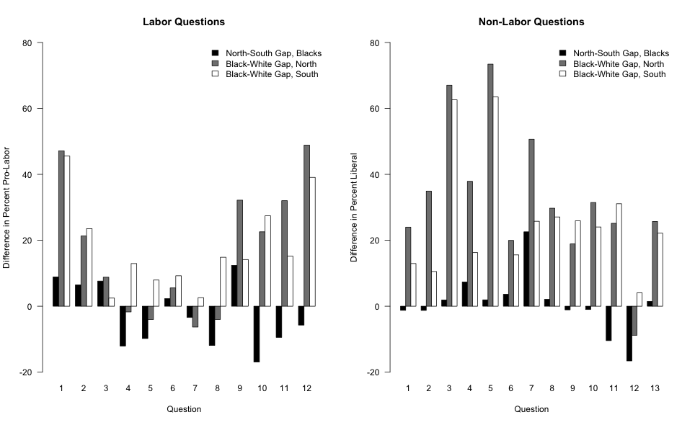

**Labor questions:**

[1] General union evaluation [*“excellent” / “good on whole” / “gone much too far”]*

[2] “Do you think there should or should not be a law passed which: Requires every workers in a plant to belong to a union if the majority votes to have a union.”

[3] Does the respondent favor a law that: “Makes it unlawful to strike during peacetime under any circumstances.”

[4] General union evaluation [*“excellent” / “good on whole” / “gone much too far”*]

[5] “On the whole, do you think the closed shop is a good idea or a bad one?” [*Asked of 60% who knew what closed shop is.*]

[6] “In a place where most of the workers belong to a union but some workers do not, do you think…” [*Coded liberal if respondent opposes open shop.]*

[7] “Do you feel that Congress should or should not pass a law forbidding strikes in defense industries for the duration of the emergency?”

[8] “Do you that the CIO has a lot, a few, or practically no Communists in it? [*Coded as liberal if “few” or “none.”*]

[9] “In a place where most of the workers belong to a union but some do not, do you think…” [*liberal if opposes management’s ability to fire without union permission.*]

[10] “Do you think it would be a good idea to compel every worker to join a labor union in order to obtain and keep a job?” [*liberal if “yes” or “sometimes*.]

[11] “Do you think the Wagner Act, providing for federal government regulation of relations between employers and workers should be kept as it is, or amended, or repealed altogether?” [*liberal if wants kept as is or if wants revised/repeal and gives pro-labor reasons*]

[12] “Do you think it is true, partly true, or untrue that our economic system doesn’t pay labor enough?”

**Non-labor questions:**

[1] “Which of these things do you think the next administration should do and which should it not do? Take the government out of all forms of competition with private business:”

[2] “Which of these two statements do you come closest to agreeing?: 1. The policies of the administration have so affected the confidence of business men that recovery has been seriously held back 2. Business men generally have been unjustly blaming the administration for their troubles.”

[3] "What do you think the next administration should do about the WPA: increase it, keep it as is, cut it down, or do away with it altogether?”

[4] “Which of these things do you think the next administration should do and which should it not do?: Turn the management of relief over to state and local authorities.”

[5] “What do you think the next administration should do about the CCC: increase it, keep it as is, cut it down, or do away with it altogether?”

[6] “Which of these things do you think the next administration should do and which should it not do?: Spend more money for slum clearance and federal housing.”

[7] “Which of these things do you think the next administration should do and which should it not do?: Reduce the number of government employees.”

[8] “Which of these comes closest to expressing your ideas of what the government should do to avoid periods of unemployment after the war?”

[9] “Do you think it would be a good idea or a bad idea to expand the U.S. Employment Service so that all jobs could be filled only through that one agency?”

[10] “Do you think it is true, partly true, or untrue that our economic system has given capital too big a percentage of profits?”

[11] “In order to increase prosperity, do you think we should increase or decrease government spending or let it continue at present rate?”

[12] “In order to increase prosperity, do you think we should raise or lower taxes or leave them as they are?”

[13] “What do you think the next administration should do about major public construction projects like PWA: increase it, keep it as is, cut it down, or do away with it altogether?”

Appendix Figure 5. Public opinion among Northern Democrats, Northern Republicans, and Southern whites compared against a simulated estimate of Southern opinion had blacks been represented in proportion to their share of the population.

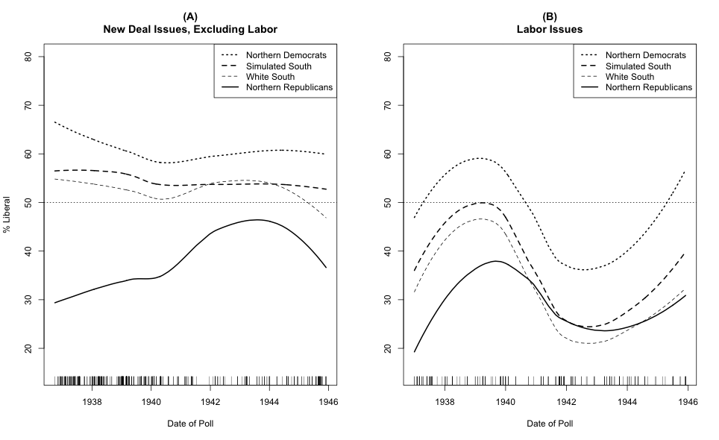

1. The four data points on which southern whites are more liberal in those early surveys include one item that explicitly cues President Roosevelt (a September 1939 Roper Fortune poll asking whether the respondent approves of Roosevelt’s handling of labor and labor unions). Across a range of issues, poll questions that cued Roosevelt resulted in more liberal aggregate responses in the South.
2. African Americans constituted 3.7% of the adult population in the North in 1940. It is worth noting that in our weighted estimates for national opinion presented above, we are essentially allowing Northern African Americans to “stand in” for Southern African Americans since we weight African Americans to their share of the national population and the vast majority of the African American respondents in the Gallup surveys live in the North (while approximately 70% of the African American population, as of 1940, is Southern).
3. Katz (1942) finds evidence that such interviewer effects even had an influence among white factory workers. He reports that factory workers, especially union members, gave less liberal responses when surveyed by white collar interviewers than when they had working-class interviewers. However, Katz also finds that the impact of interviewer social class is much reduced when experienced Gallup interviewers were used as opposed to inexperienced interviewers.
4. One item on which there is a large gap is on preference for the AFL versus the CIO. Southern African Americans are far more likely to prefer the CIO than are Northern African Americans. This should not be surprising given that the AFL was highly racially exclusionary in the South while the CIO was a lonely voice for racial inclusion in the region. This item is not included in Figure 9 because there is no unambiguously “liberal” or “pro-labor” response to this question.
5. We do not examine those issues where there is a good prior basis for thinking that Southern and Northern African Americans likely would have differed substantially. For example, farm issues and other issues that likely distinguished urban and rural residents (e.g. aid to rural hospitals, the TVA) are not included.
6. The goal is not to say how Southern politics would have changed had African Americans been enfranchised in this period. There are obviously too many moving parts to allow such an inference and much would depend on the specific circumstances surrounding such enfranchisement. Instead, the goal is much more limited: how different would aggregate Southern opinion look if one was able to include the full population of Southerners rather than just whites.
7. The Southern white estimate uses the weights we have constructed to take into account the class and gender biases in the sample of whites. In this initial analysis, we do not account for the decrease in the share of the Southern population that was African American during the war years as many African Americans moved north and west in search of better employment opportunities.
8. If we were to account for the decreased African American share of the Southern population during the war, this would likely make the Southern move to the right on labor policy a bit more substantial.
9. We do not include civil rights issues in this analysis. As noted above, see Schickler (2010) for an analysis of the distinctive characteristics of civil rights opinion during this period.