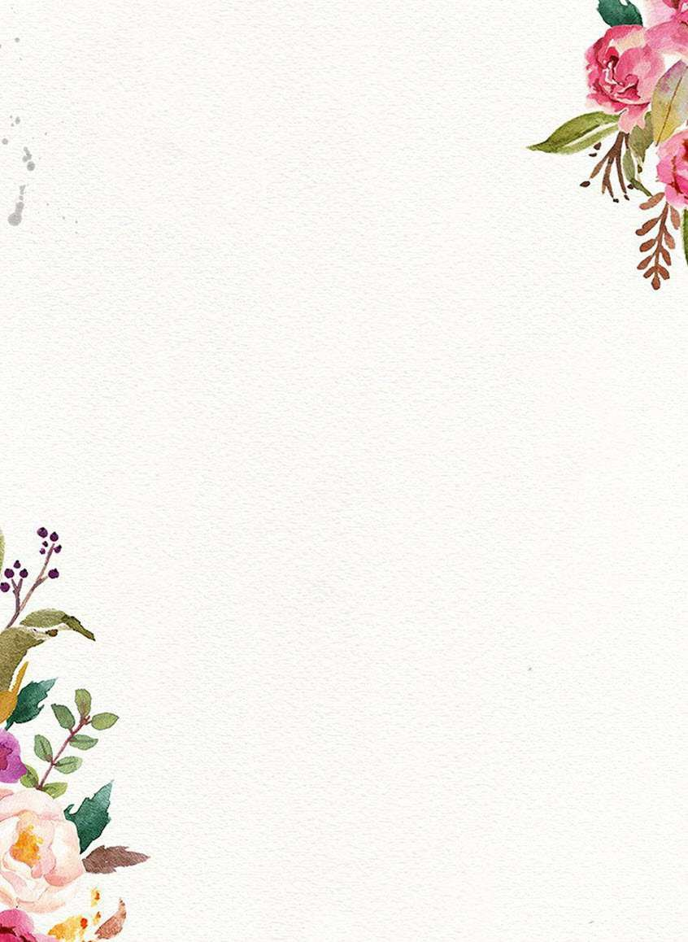**Rules and Regulations of Painting Competition**

* **Theme: Drugs Addiction**
* The competition is open for students of Classes VIII to XII only.
* There are two groups:

1st Group: 8th to 10th

2nd Group: 11th to 12th

* Each group comprises of only two students.
* Timings for painting is two hours only.
* Participants must bring all necessary drawing and painting materials (all medium).
* Drawing sheet will be provided by the school. Size of the sheet is 1/4th imperial i.e. 15x22inches.
* Participants must be in proper school uniform. They must carry their ID cards.
* **Reporting Time 8:30am**

**Note: Decision of Judges will be final**