MEALFINDER_PROJECT

NAME : DEVI NEELAM

GitHub Repository URL : https://github.com/devineelam/MEALFINDER_PROJECT
GitHub Repository

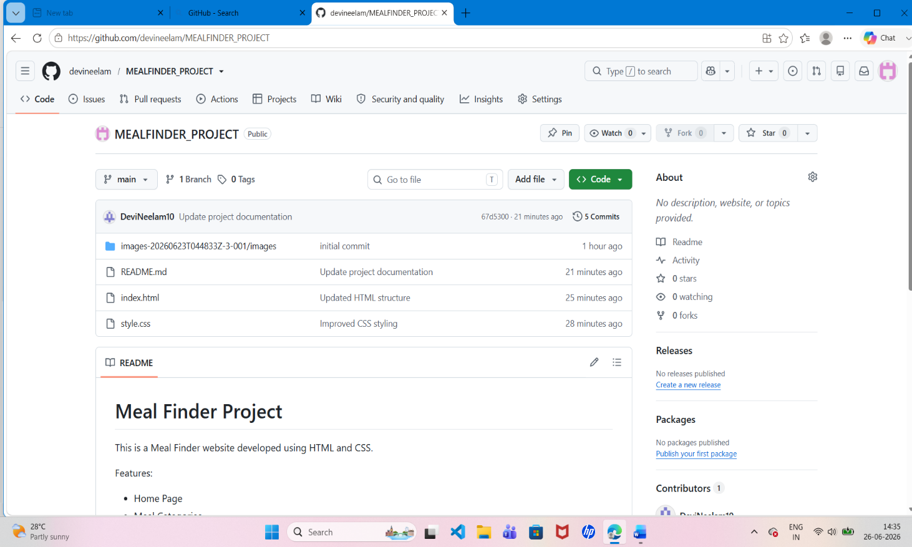

Commit History

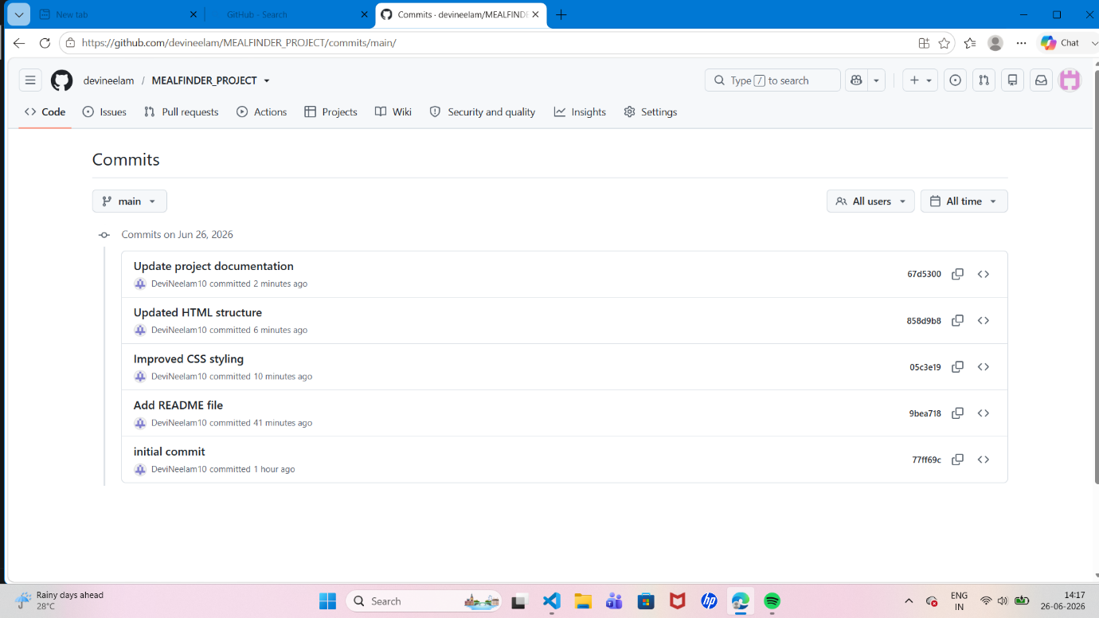

HOME PAGE OUTPUT

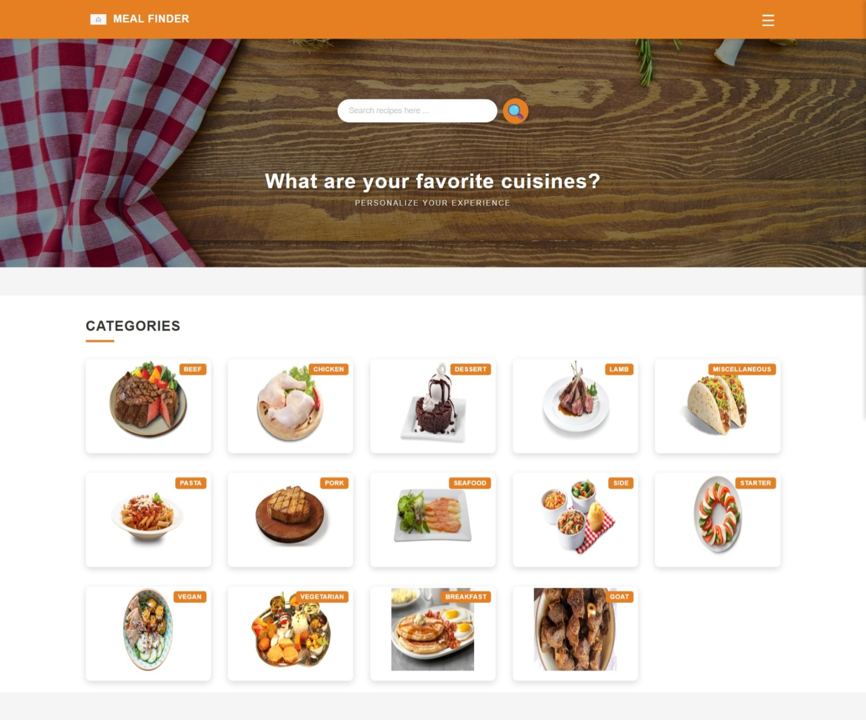
This is the home page of the MEALFINDER_PROJECT showing the main layout and navigation

CATEGORY PAGE OUTPUT
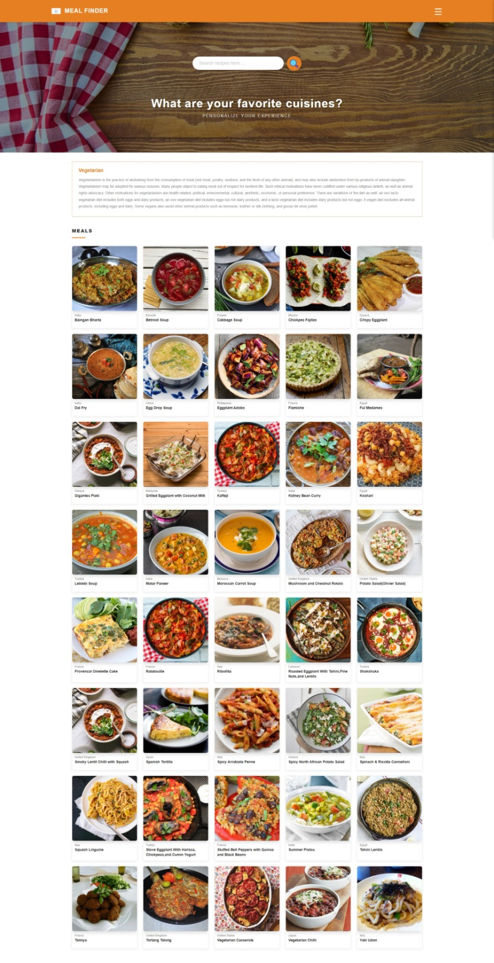

This page displays different meal categories for users to browse available food items.

MEAL DETAILS PAGE OUTPUT
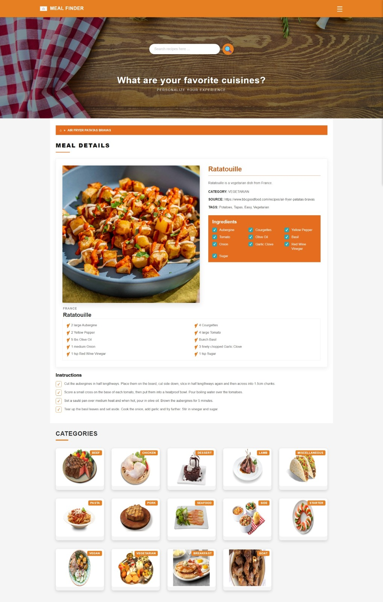

This page shows full details including ingredients and instructions.
Project Summary

The Meal Finder Project is a simple web application developed using HTML and CSS and BOOTSTRAP. The main objective of this project is to help users browse different meal categories and view detailed recipes in an easy and organized way.
The project consists of multiple pages such as the home page, category page, and meal details page. Each page is designed to provide a clear and user-friendly interface for better navigation. The home page displays the overall layout of the website, while the category page shows different types of meals available. The details page provides complete information about selected meals, including ingredients and preparation steps.
This project demonstrates basic web development skills such as page structuring, styling, and layout design. It also shows how multiple web pages can be connected to create a functional website.
Overall, the Meal Finder Project is a good practice project to understand front-end development concepts and improve HTML and CSS skills.

