Group4_Project1_Summer624

Devin Teran

6/21/2021

## Getting & Cleaning Data

First we will read the data into a dataframe from the xls. Each group will be stored into a separate variable.

df <- read.xlsx2("/Users/devinteran/MSinDS/DATA624/DATA624/Project1/Data Set for Class.xls",sheetIndex = 1,as.data.frame = TRUE,colClasses = c('character','character','double','double','double','double','double'))  
  
S01 <- df %>% filter(group == 'S01')  
S02 <- df %>% filter(group == 'S02')  
S03 <- df %>% filter(group == 'S03')  
S04 <- df %>% filter(group == 'S04')  
S05 <- df %>% filter(group == 'S05')  
S06 <- df %>% filter(group == 'S06')

## Including Plots

You can also embed plots, for example:

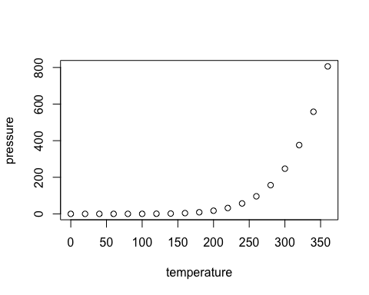

Note that the echo = FALSE parameter was added to the code chunk to prevent printing of the R code that generated the plot.