Data624 HA Chapter7 Exercises

Devin Teran

6/12/2021

#Libraries

## Exercise 7.1

Consider the pigs series — the number of pigs slaughtered in Victoria each month.

*(1)* Use the **ses()** function in R to find the optimal values of $α$ and $l_{0}$, and generate forecasts for the next four months.

fc <- ses(pigs,h=4)  
  
autoplot(fc) +  
 ggtitle("Numbers Pigs Slaughtered in Victoria Each Month") +   
 xlab("Month") +   
 ylab("Pigs")

## Warning: `filter_()` was deprecated in dplyr 0.7.0.  
## Please use `filter()` instead.  
## See vignette('programming') for more help

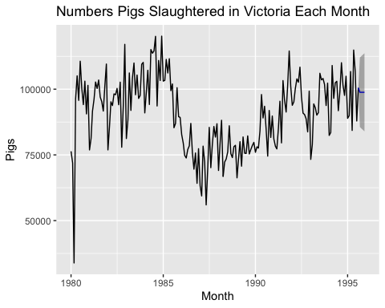

fc$model

## Simple exponential smoothing   
##   
## Call:  
## ses(y = pigs, h = 4)   
##   
## Smoothing parameters:  
## alpha = 0.2971   
##   
## Initial states:  
## l = 77260.0561   
##   
## sigma: 10308.58  
##   
## AIC AICc BIC   
## 4462.955 4463.086 4472.665

We can see the optimal alpha is 0.2971 and optimal l_0 is 77270.0561.

*(2)* Compute a 95% prediction interval for the first forecast using $\hat{y}+/−1.96s$ where *s* is the standard deviation of the residuals. Compare your interval with the interval produced by R.

1

## [1] 1

## Exercise 7.2

Write your own function to implement simple exponential smoothing. The function should take arguments y (the time series), alpha (the smoothing parameter $α$) and level (the initial level l0). It should return the forecast of the next observation in the series. Does it give the same forecast as **ses()**?

## Exercise 7.3

Modify your function from the previous exercise to return the sum of squared errors rather than the forecast of the next observation. Then use the *optim()* function to find the optimal values of and l0). Do you get the same values as the *ses()* function?

2

## [1] 2