Data624 - Week 3 - HA- Chapter 8 Exercises

Devin Teran

6/17/2021

## Exercise 8.1

Figure 8.31 shows the ACFs for 36 random numbers, 360 random numbers and 1,000 random numbers.

**a** Explain the differences among these figures. Do they all indicate that the data are white noise? 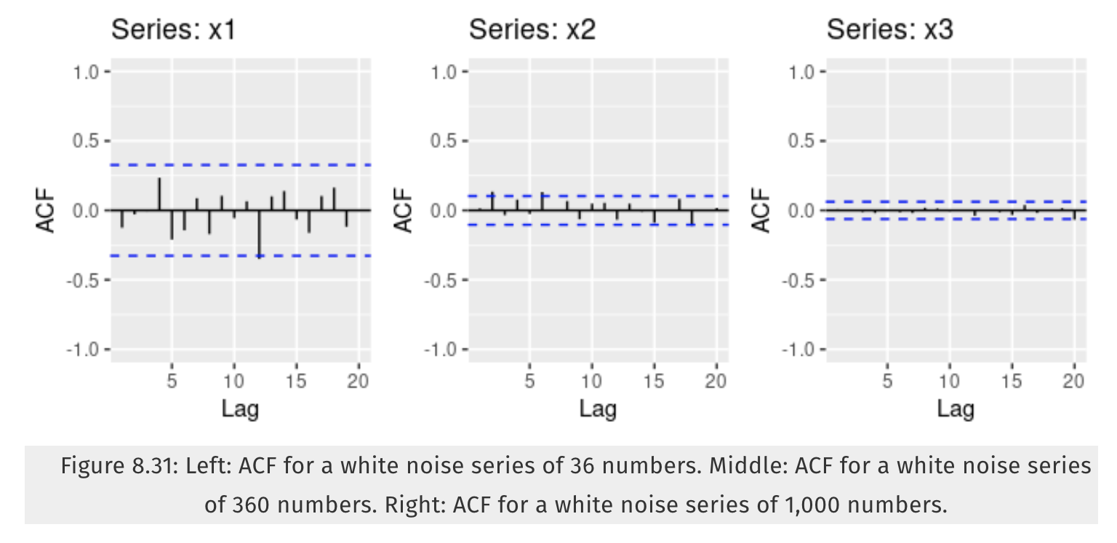 **x1** shows white noise since the ACF values all lie within the blue dotted lines and are close to zero.  
**x2** shows **x3** shows **b** Why are the critical values at different distances from the mean of zero? Why are the autocorrelations different in each figure when they each refer to white noise?

## Exercise 8.2

A classic example of a non-stationary series is the daily closing IBM stock price series (data set ibmclose). Use R to plot the daily closing prices for IBM stock and the ACF and PACF. Explain how each plot shows that the series is non-stationary and should be differenced.

#head(ibmclose)  
#  
#autoplot(ibmclose,h=1)

#ggACF(ibmclose)

#ggPACF(ibmclose)

## Exercise 8.6

Use R to simulate and plot some data from simple ARIMA models. **a** Use the following R code to generate data from an AR(1) model with $θ_{1}=0.6$ and $σ^{2}=1$. The process starts with $y_{1}=0$.

y <- ts(numeric(100))  
e <- rnorm(100)  
for(i in 2:100)  
 y[i] <- 0.6*y[i-1] + e[i]

**b** Produce a time plot for the series. How does the plot change as you change $θ_{1}$? **c** Write your own code to generate data from an MA(1) model with $θ_{1}=0.6$ and $σ^{2}=1$. **d** Produce a time plot for the series. How does the plot change as your change $θ_{1}$? **e** Generate data from an ARMA(1,1) model with $_1$ = 0.6, $θ_{1}=0.6$ and $σ^{2}=1$. **f** Generate data from an AR(2) model with . (Note that these parameters will give a non-stationary series.) **g** Graph the latter two series and compare them.

## Exercise 8.8

Consider *austa*, the total international visitors to Australia (in millions) for the period 1980-2015.

**a** Use *auto.arima()* to find an appropriate ARIMA model. What model was selected. Check that the residuals look like white noise. Plot forecasts for the next 10 periods. **b** Plot forecasts from an ARIMA(0,1,1) model with no drift and compare these to part a. Remove the MA term and plot again. **c** Plot forecasts from an ARIMA(2,1,3) model with drift. Remove the constant and see what happens. **d** Plot forecasts from an ARIMA(0,0,1) model with a constant. Remove the MA term and plot again. **e** Plot forecasts from an ARIMA(0,2,1) model with no constant.