

Faculty of Computing and Informatics (FCI)

Multimedia University Cyberjaya

**CSN6244 – Software Requirement Engineering**

**Trimester 2510**

**Group Number: G09**

**Campus Event Check-in System with Student ID**

**and Payment Integration**

**(Project Part 1 - Task 3)**

Group Members:

| NAME | ID | EMAIL(MICROSOFT) |
| --- | --- | --- |
| Tang Wei Xiong | 1211112069 | 1211112069@student.mmu.edu.my |
| Liew Wei Hong | 1211108896 | 1211108896@student.mmu.edu.my |
| Ng Kean Ping | 242UC2451V | NG.KEAN.PING@student.mmu.edu.my |
| Chan Mei Yi | 242UC2451U | CHAN.MEI.YI@student.mmu.edu.my |

**1. Introduction 3**

**2. Justification for Using the Kano Model 4**

**3. Elicitation Techniques 5**

**4. Elicitation Plan 6**

4.1 Technique: Brainstorming 6

4.1.1 Brainstorming: Preparation 6

4.1.2 Brainstorming: Execution 6

4.1.3 Brainstorming: Follow-Up 6

4.1.4 Brainstorming: Expected Output 7

4.2 Technique: Interview 7

4.2.1 Interview: Execution Plan 7

4.2.2 Interview: Follow-Up Plan 7

4.2.3 Interview: Expected Output 7

4.3 Technique: Questionnaire 8

4.3.1 Questionnaire: Preparation 8

4.3.2 Questionnaire: Execution Plan 8

4.3.3 Questionnaire: Follow-Up Plan 8

4.3.4 Questionnaire: Expected Output 8

**5. Requirement Classification (Using Kano Model) 10**

**6. Future Delighters 12**

**7. Conclusion 13**

## **1. Introduction**

To ensure the development of a functional, user-centric Campus Event Check-in System with Student ID and Payment Integration, we apply the Kano Model—a recognized framework for categorizing user requirements based on their influence on customer satisfaction. This model enables us to distinguish between essential and value-adding features, which is critical for balancing user expectations with available resources.

The Kano Model classifies requirements into three categories:

* **Dissatisfiers (Basic Needs):** Fundamental features users expect. Their absence causes dissatisfaction, but their presence does not necessarily improve satisfaction.
* **Satisfiers (Performance Needs):** Features that have a linear relationship with satisfaction. The better these are implemented, the higher the user satisfaction.
* **Delighters (Excitement Needs):** Unexpected or innovative features that delight users when present but do not cause dissatisfaction if absent.

This requirements elicitation and classification plan will guide the project team in prioritizing and implementing features effectively, ensuring a satisfying and reliable user experience.

### 

### 

## **2. Justification for Using the Kano Model**

The Kano Model is particularly effective for this project due to the diversity of stakeholders involved—students, administrators, event organizers, and IT personnel—each with varying needs and expectations. Its structured classification benefits our project in several ways:

* **Prioritization:** Clearly separates essential features from enhancements and innovations, enabling informed decisions on development priorities.
* **User-Centric Design:** Focuses on what truly matters to users, aligning system capabilities with real user expectations.
* **Strategic Resource Allocation**: Directs development effort and resources toward features that yield the most value and satisfaction.

By applying the Kano Model, we ensure that the core functionalities (Dissatisfiers) are delivered first while still identifying performance-improving features (Satisfiers) and potential innovations (Delighters).

### 

### 

## **3. Elicitation Techniques**

To gather comprehensive requirements, we utilize multiple elicitation techniques:

**Surveys and Questionnaires:**

* Use a structured Google Form with Likert-scale (Strongly Agree to Strongly Disagree) items.
* Include Kano-style questions: “How would you feel if this feature were present/absent?”
* Ideal for efficiently collecting broad insights from students.

**Stakeholder Interviews:**

* Conduct focused interviews with university administrators, IT department members, and event organizers.
* Aim to clarify expectations, understand technical constraints, and explore event-related functionalities.

**Brainstorming Sessions:**

* Internal team discussions to interpret findings, suggest innovative features, and evaluate feedback in context.

## **4. Elicitation Plan**

To ensure the system meets the actual needs of MMU students, a structured elicitation process was conducted using three main techniques: Brainstorming, Interview, and Questionnaire. These techniques aimed to identify pain points in current event management processes and validate the system’s direction from both internal team members and real users. The elicitation targeted features related to event check-in, MMU ID login, and online payment integration.

### **4.1 Technique: Brainstorming**

#### **4.1.1 Brainstorming: Preparation**

* **Who:** Internal project team (4 members)
* **What:** Identify initial system features, user roles, and assumptions
* **When:** During system planning week
* **Where:** Online meeting discussion
* **Why:** To align the team’s vision and prepare for external stakeholder sessions
* **How:** Used note-taking to capture the ideas

#### **4.1.2 Brainstorming: Execution**

The brainstorming session was executed in a structured manner, starting with defining the system features and problem scope, then listing roles (student, admin, organizer), and finally ideating solutions. The team worked collaboratively to challenge assumptions and suggest innovations.

#### **4.1.3 Brainstorming: Follow-Up**

The session notes were categorized into functional areas (Check-in, Login, Payment, Analytics) and shared with the team. Items marked as assumptions were flagged for validation in interviews and surveys.

#### **4.1.4 Brainstorming: Expected Output**

The expected output of the brainstorming session includes the following deliverables:

* A list of Proposed System Features
* Identified User Roles
* Initial Assumptions
* Functional Categorization
* A set of questions to be validated through interviews

### **4.2 Technique: Interview**

#### **4.2.1 Interview: Execution Plan**

* **Who:** 1 MMU student (frequent event attendees)
* **What:** Explore frustrations and expectations around event attendance
* **When:** Conducted over 7 days
* **Where:** Via MS Teams
* **Why:** To gather deeper insight into user experience, pain points, and improvement areas
* **How:** Semi-structured interviews with open-ended questions

#### **4.2.2 Interview: Follow-Up Plan**

After interviews, responses were summarized and compared with brainstorming assumptions. Additional clarification was sought through email. Findings were validated through questionnaire distribution.

#### **4.2.3 Interview: Expected Output**

The expected output from the interviews includes detailed insights into the user experience, specific frustrations, and expectations regarding the current event management process at MMU. Through semi-structured conversations with two MMU students who frequently attend events and one event organizer, the team aimed to uncover practical challenges and gather improvement suggestions directly from stakeholders. Their responses will be compared against initial brainstorming assumptions to validate or challenge the team’s direction.

Areas of misalignment were flagged for further investigation, and additional clarification was obtained. These findings played a crucial role in shaping the content and structure of the subsequent questionnaire, ensuring broader validation of user needs across a larger sample.

### **4.3 Technique: Questionnaire**

#### **4.3.1 Questionnaire: Preparation**

* Who: MMU students from various faculties
* What: Gather quantitative feedback to validate earlier findings
* When: 5-day window
* Where: Distributed via class groups
* Why: To validate features and gauge student expectations at scale
* How: Google Form with 20 structured questions (10 functional, 10 non-functional)

#### **4.3.2 Questionnaire: Execution Plan**

Students were encouraged to complete the form through reminders and class rep announcements. The questions covered login methods, check-in methods, ticket purchasing, payment preferences, and support access.

#### **4.3.3 Questionnaire: Follow-Up Plan**

Results were analyzed using Google Sheets and visualized in pie charts and bar graphs. Outliers were reviewed and shared with the team for discussion. Correlation with interview results was cross-checked.

#### **4.3.4 Questionnaire: Expected Output**

The expected output from the questionnaire includes quantitative data that validates or challenges the findings from the brainstorming and interview phases. Responses from MMU students across various faculties provide broad insights into preferred login methods, check-in processes, payment options, and overall expectations for an event management system. The analysis is expected to reveal trends, such as a strong preference for MMU ID-based login, QR code check-in, and online payment via e-wallets or FPX. The data, visualized using bar graphs, helps identify the most and least favored features. Outliers or unexpected patterns are flagged for further review, and overall results are compared with interview findings to ensure consistency and alignment. This structured feedback supports data-driven decision-making in the system’s design and development.

## **5. Requirement Classification (Using Kano Model)**

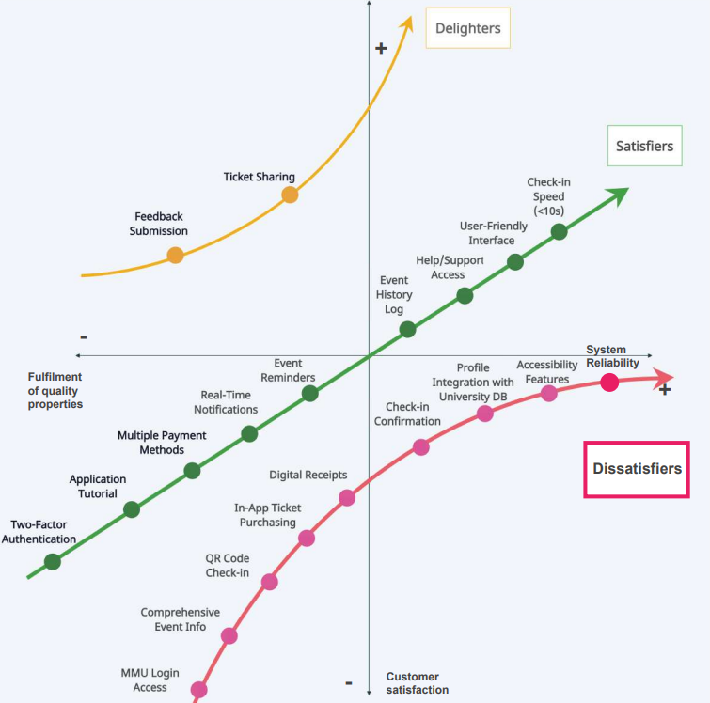

(Kano Model Example - a Case Study in Customer Satisfaction, 2025)

| **Requirement** | **Kano Category** | **Justification** |
| --- | --- | --- |
| MMU Login Access | Dissatisfier | Essential for authentication; without it, users cannot access the system. |
| Two-Factor Authentication | Satisfier | Adds a layer of security; desirable but not critical for basic access. |
| Application Tutorial | Satisfier | Enhances onboarding and usability but the system is usable without it. |
| Comprehensive Event Info | Dissatisfier | Users expect clear event details; lack of information leads to frustration. |
| QR Code Check-in | Dissatisfier | Core mechanism for verifying event attendance; absence disrupts event flow. |
| In-App Ticket Purchasing | Dissatisfier | Users expect seamless ticket handling; manual processing would cause complaints. |
| Multiple Payment Methods | Satisfier | Enhances user convenience; one method may suffice, but variety improves appeal. |
| Digital Receipts | Dissatisfier | Standard for any payment system; lack of receipts could cause trust issues. |
| Real-Time Notifications | Satisfier | Improves engagement and awareness but not essential for check-in. |
| Event Reminders | Satisfier | Boosts attendance by reminding users; system is still functional without it. |
| Event History Log | Satisfier | Helps users track past attendance; not essential for core system usage. |
| Feedback Submission | Delighter | Allows user input for improvements; appreciated but not expected. |
| Check-in Confirmation | Dissatisfier | Immediate feedback is crucial to user trust and successful check-in verification. |
| Profile Integration with University DB | Dissatisfier | Ensures accurate identity matching; manual entry risks errors and dissatisfaction. |
| Ticket Sharing | Delighter | Adds flexibility and social value; not a basic expectation. |
| Help/Support Access | Satisfier | Builds user trust and confidence; system can operate without constant support. |
| User-Friendly Interface | Satisfier | Strongly impacts user experience; poor UI can lower satisfaction even if functional. |
| Accessibility Features | Dissatisfier | Necessary for compliance and inclusivity; absence excludes certain users. |
| Check-in Speed (<10s) | Satisfier | Impacts perceived efficiency; slow check-in causes delays and frustration. |
| System Reliability | Dissatisfier | Crashes or performance issues render the system unusable and erode trust. |

## **6. Future Delighters**

As part of our long-term vision for the Campus Event Check-in System, we have identified a set of innovative features under Future Considerations that are currently outside the project's immediate scope but hold strong potential to significantly enhance user satisfaction in future development phases. These features are categorized as Delighters in the Kano Model, as they are not currently expected by users but would deliver a highly positive experience if implemented.

* **Mobile Application**

A dedicated mobile app would offer users a more seamless and convenient way to interact with the system. With push notifications, instant check-ins, and offline ticket storage, a mobile app elevates accessibility and user engagement far beyond current expectations. While not essential now, its presence in future versions could significantly increase satisfaction and adoption.

* **AI-Based Event Recommendations**

Using AI or machine learning algorithms to analyze user interests and attendance history can enable personalized event suggestions. This feature transforms the system from a passive tool into an active assistant, helping users discover relevant events. Such intelligent recommendations would surprise and delight users by adding unexpected value.

* **Gamification Elements**

Introducing game-like mechanics such as badges for frequent attendance, leaderboards, or reward points, which can increase student engagement and participation. These features make the event experience more interaction.

## **7. Conclusion**

By applying the Kano Model, we effectively prioritize and balance essential system features with performance enhancements and future innovations. This structured approach ensures that the Campus Event Check-in System not only meets core user expectations but also paves the way for continuous improvement and long-term user satisfaction. Through thoughtful requirement elicitation and classification, we align development efforts with stakeholder needs, resulting in a user-centric, scalable, and future-ready solution.