

Faculty of Computing and Informatics (FCI)

Multimedia University Cyberjaya

**CSN6244 – Software Requirement Engineering**

**Trimester 2510**

**Group Number: G09**

**Campus Event Check-in System with Student ID**

**and Payment Integration**

**(Project Part 1 - Task 4)**

Group Members:

| NAME | ID | EMAIL(MICROSOFT) |
| --- | --- | --- |
| Tang Wei Xiong | 1211112069 | 1211112069@student.mmu.edu.my |
| Liew Wei Hong | 1211108896 | 1211108896@student.mmu.edu.my |
| Ng Kean Ping | 242UC2451V | NG.KEAN.PING@student.mmu.edu.my |
| Chan Mei Yi | 242UC2451U | CHAN.MEI.YI@student.mmu.edu.my |

# Table of Content

**Table of Content 2**

**1.0 Introduction 3**

**2.0 Elicitation Execution 4**

2.1 Brainstorming 4

2.1.1 Brainstorming: Output 4

2.1.2 Brainstorming: Proof of elicitation 5

2.2 Interview 6

2.2.1 Interview: Output 6

2.2.2 Interview: Proof of elicitation 7

2.3 Questionnaire 8

2.3.1 Questionnaire: Output 8

2.3.2 Questionnaire: Proof of elicitation 9

2.4 Summary 10

**3.0 Requirements Categorization 11**

3.1 Requirements: Categories 11

3.2 Kano Model: Analysis 13

**Conclusion 14**

# **1.0 Introduction**

The purpose of this report is to document the execution of the requirements elicitation activities conducted for the development of the Campus Event Check-in System with student ID and Payment Integration. This system aims to streamline event attendance processes by integrating digital check-ins, student ID verification and secure payment functionality within a single platform.

Elicitation is a critical phase in the system development lifecycle. It helps to uncover, clarify and validate stakeholder needs and expectations. To ensure the system aligns with actual user requirements, we conducted a structured elicitation process involving target users, primarily MMU students.

This report outlines the techniques used during the elicitation sessions by providing evidence of the activities conducted. It also presents the categorized requirements using the Kano model to distinguish between essential, performance-related and delight-enhancing features.

# **2.0 Elicitation Execution**

To ensure the system meets the actual needs of MMU students, a structured elicitation process was conducted. The primary objective was to gather user preferences and expectations regarding on event check-in, student ID integration and payment features. The following activities were carried out:

## 2.1 Brainstorming

### 2.1.1 Brainstorming: Output

A brainstorming session was held among the project team to identify the potential system features, user roles and scenarios before meeting with external stakeholders. This internal session helped align the team’s initial assumptions and define the focus area for the further exploration.

**Activity details:**

* Total of 4 member of the project team
* Duration: ~5 minutes
* Method: Online meeting

**Key Outcomes:**

Idea Sharing:

Team members initiated ideation using the “What if…” prompt format to encourage open-ended suggestions. Some notable ideas generated included:

* “What if organizers could see real-time check-in status?”
* “What if our system could automatically check in students using their student ID?”
* “What if it sends a reminder before the event starts?”
* “What if students could request refunds through the app?”

This method helped uncover several use-case scenarios that may not have emerged through formal interviews alone.

Feature Listing:

Each participant was asked to propose one or two core features that they believed should be part of the system. The followings are the features that we provided:

* MMU Login System
* User-friendly Interface
* Two-factor Authentication
* QR code-based check-in
* Fast Check-in (<10s)
* Platform Tutorial
* Detailed Event Information
* Event Reminders

Kano Model Discussion:

To prioritize features, the team conducted a mini Kano Model analysis on three selected functionalities. Each feature was discussed in terms of its functional and dysfunctional impact from a student’s perspective:

* Feature 1: Two-Factor Authentication
  + Functional: Expected as a basic security feature
  + Dysfunctional: Absence would frustrate users
  + Classification: Must-be Feature
* Feature 2: Application Tutorial
  + Functional: Adds convenience, helpful for new users
  + Dysfunctional: Absence causes minor inefficiencies
  + Classification: Performance Feature
* Feature 3: Event Reminders
  + Functional: Considered a pleasant, helpful addition
  + Dysfunctional: Not critical to system usage  
    Classification: Delighter Feature

### 2.1.2 Brainstorming: Proof of elicitation

The following screenshot is taken during a brainstorming session with 4 team members, who are Tang Wei Xiong, Liew Wei Hong, Ng Kean Ping and Chan Mei Yi using Microsoft teams:

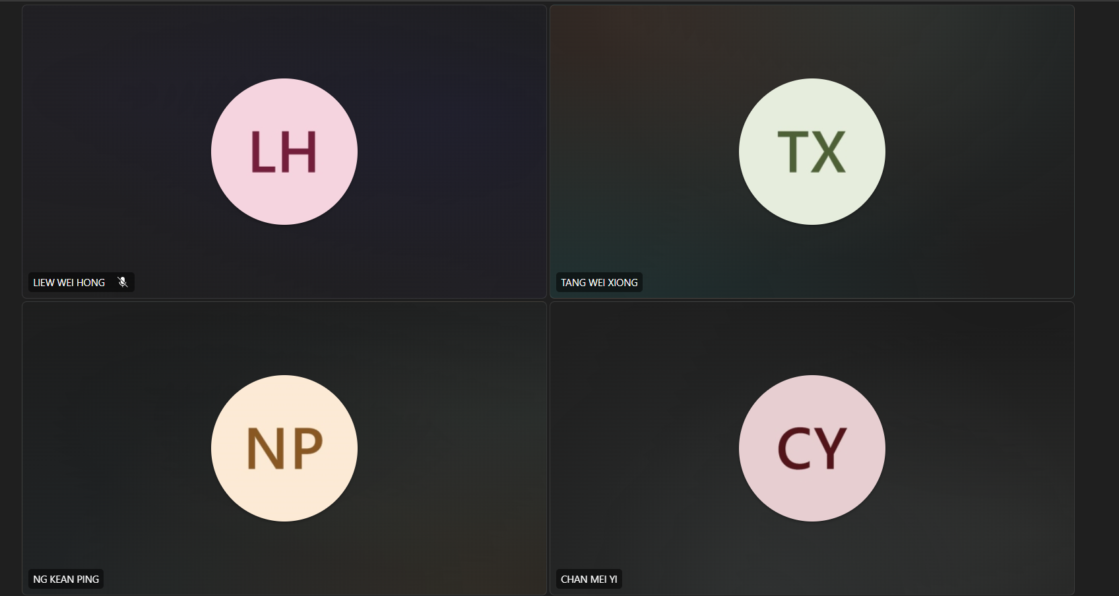

## 2.2 Interview

### 2.2.1 Interview: Output

To gather qualitative insights, short interviews were conducted with selected students who frequently attend campus events.

**Activity details:**

* 1 student from Multimedia University, who has experience on joining event
* Duration: ~3 minutes
* Platform: via MS Teams

**Key Findings:**

Feature Exploration:

* The student expressed the interest in reminder notifications prior to events, citing forgetfulness as a common barrier to attendance.
* He stated that transparency in transaction records, such as invoices or purchase history, would build his trust in the system’s payment component.

Kano-style Feedback:

The following table summarizes the selected student’s responses to system features under both functional and dysfunctional scenarios:

| **Feature** | **Functional** | **Dysfunctional** |
| --- | --- | --- |
| MMU ID Login | 4 | 3 |
| Profile Integration with University DB | 3 | 2 |
| Accessibility Features | 4 | 2 |
| System Reliability | 5 | 1 |
| Ticket Sharing | 3 | 3 |

* Based on this table, we can see that the student valued reliability the most highly, this indicates that the system stability and performance are critical to user satisfaction.
* The necessity for inclusive design was reinforced by the positive reception given to accessibility features.
* He expressed a lack of interest in ticket sharing, indicating that some users would find it to be a neutral or optional feature.

### 2.2.2 Interview: Proof of elicitation

The following screenshots is the moment when the team member, Liew Wei Hong was giving an interview session with the selected student, Lai Wei Jian using microsoft teams:



## 2.3 Questionnaire

### 2.3.1 Questionnaire: Output

To validate and quantify the data gathered during interviews and brainstorming, a structured questionnaire was designed and distributed to a larger group of MMU students.

**Distribution Method:**

* Google Forms link are shared through class groups
* Duration: 5 days
* Total responses: 20 students

**Structure:**

* 10 functional questions and 10 non-functional questions
* Topics cover:
  + MMU Login Access
  + Event Check In
  + Ticket Purchasing
  + Payment Methods
  + Payment Confirmation
  + Real-Time Notifications
  + Event History
  + Feedback Submissions
  + Check-in Confirmation
  + Help/Support Access

### 2.3.2 Questionnaire: Proof of elicitation

Sample Question:

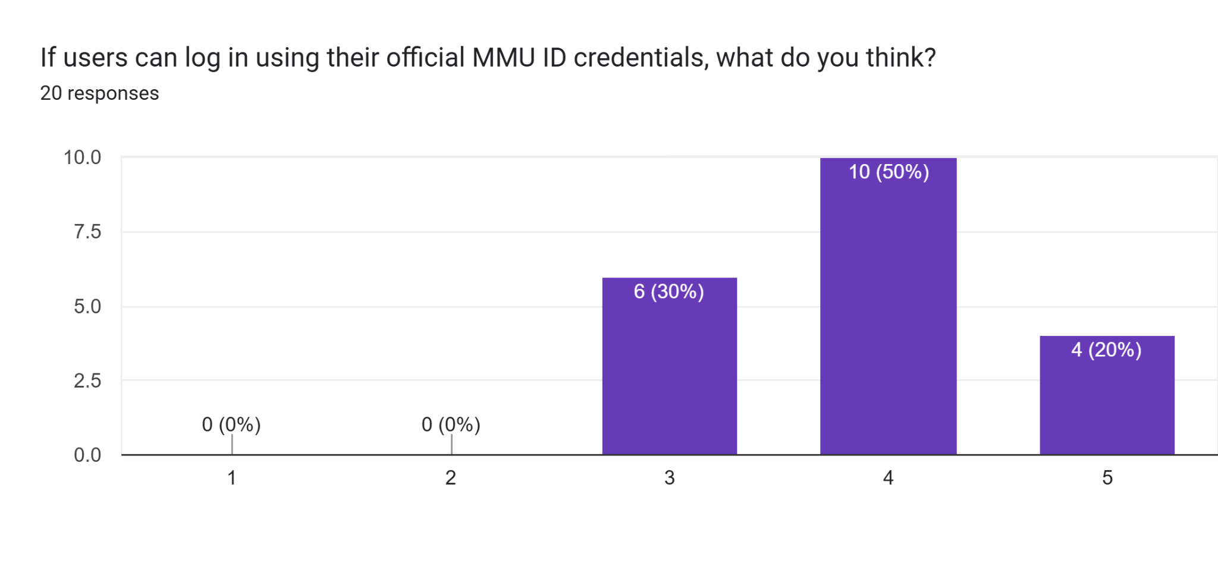

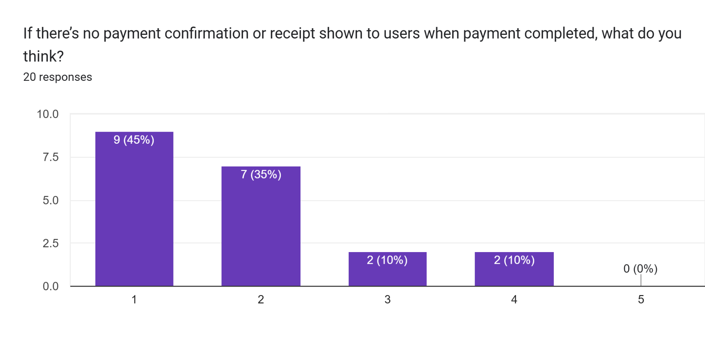

Link to see the whole questions with the result in google sheets:

**https://docs.google.com/spreadsheets/d/19Z43U6bHpR2qgnXU7EV3RLM5VIFPk_vLZkS77xMWmRE/edit?resourcekey=&gid=1505469430#gid=1505469430**

## 2.4 Summary

The elicitation process successfully gathered essential user requirements through brainstorming, interviews and questionnaires. Each method contributed valuable insights that shaped the foundation of the Campus Event Check-in System with Student ID and Payment Integration.

* The **brainstorming session** allowed the project team to explore potential features and prioritize focus areas. Some key components such as MMU ID login, QR code-based check-in and payment integration were identified early during this phase.
* Through **interviews** with MMU students and a member of the event organizer, we discover some practical issues such as slow check-in process, the absence of event date reminders and the lack of payment mode. These qualitative insights helped validate and refine the ideas generated during brainstorming.
* The **questionnaire survey**, which was completed by 20 students, provided a measurable feedback on preferences regarding system features. Most students expressed strong support for a system with MMU ID login, payment confirmations and feedback submissions.

Overall, the elicitation activities provided a well-rounded understanding of user needs and preferences.

# **3.0 Requirements Categorization**

## 3.1 Requirements: Categories

| **Requirement** | **Kano Category (Prediction)** | **Kano Category (Result)** | **Reason** |
| --- | --- | --- | --- |
| MMU Login Access | Dissatisfier | Dissatisfier | Users expect integration with the university system; lacking this reduces trust and convenience. |
| Two-Factor Authentication | Satisfier | Dissatisfier | Initially considered a bonus, but users now see it as essential for data security—absence causes dissatisfaction. |
| Application Tutorial | Satisfier | Satisfier | Enhances onboarding experience and usability, especially for first-time users. |
| Comprehensive Event Info | Dissatisfier | Dissatisfier | Users expect full event details to make informed decisions—missing info is frustrating. |
| QR Code Check-in | Dissatisfier | Delighter | While initially assumed as standard, students found it innovative and enjoyable to use. |
| In-App Ticket Purchasing | Dissatisfier | Dissatisfier | Considered a basic requirement for digital convenience—its absence negatively impacts user experience. |
| Multiple Payment Methods | Satisfier | Delighter | Users appreciate flexibility and choice, which enhances satisfaction beyond expectations. |
| Digital Receipts | Dissatisfier | Satisfier | Provides assurance and tracking for payments—important but not always expected. |
| Real-Time Notifications | Satisfier | Satisfier | Keeps users informed promptly, improving engagement and experience. |
| Event Reminders | Satisfier | Delighter | Unexpected feature that pleasantly surprises users and helps them manage schedules. |
| Event History Log | Satisfier | Dissatisfier | Users expected to be able to track past events—its absence was disappointing. |
| Feedback Submission | Delighter | Satisfier | Users value being heard, and it boosts engagement though it’s not essential. |
| Check-in Confirmation | Dissatisfier | Satisfier | Ensures peace of mind and transaction assurance; adds clarity to the process. |
| Profile Integration with University DB | Dissatisfier | Indifferent | Users showed little concern as long as the system functions correctly with manual entry. |
| Ticket Sharing | Delighter | Indifferent | While considered a bonus, most users didn’t find this feature necessary or relevant. |
| Help/Support Access | Satisfier | Dissatisfier | Users expect quick and easy support in case of issues—absence leads to frustration. |
| User-Friendly Interface | Satisfier | Satisfier | A straightforward, clean interface is consistently valued and improves overall experience. |
| Accessibility Features | Dissatisfier | Indifferent | Many users without disabilities didn’t perceive accessibility tools as personally impactful. |
| Check-in Speed (<10s) | Satisfier | Satisfier | Fast check-in improves efficiency and user flow, contributing to satisfaction. |
| System Reliability | Dissatisfier | Satisfier | While taken for granted, users feel more satisfied when the system consistently performs well. |

## 3.2 Kano Model: Analysis

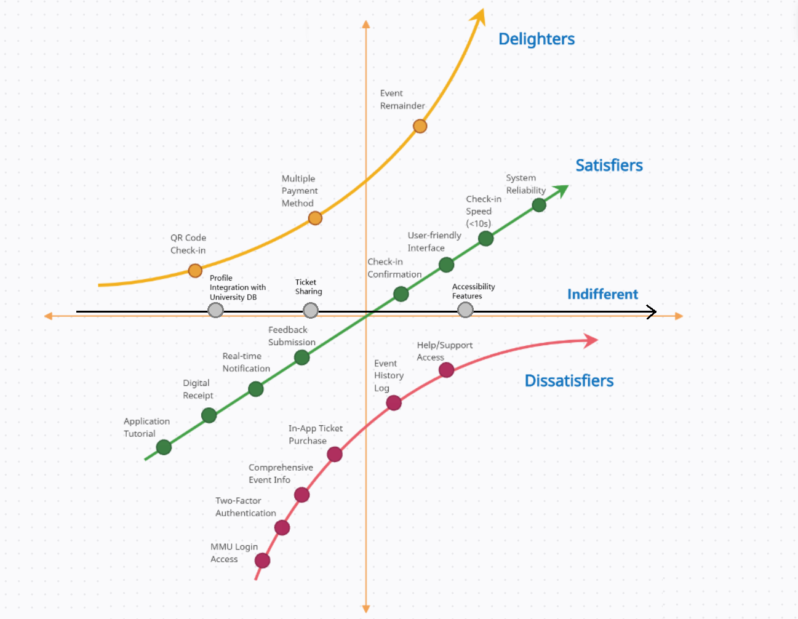

# **Conclusion**

The development of the Campus Event Check-in System with Student ID and Payment Integration represents a crucial step toward digital transformation within the MMU campus environment. This project aims to streamline how students interact with campus events.

Throughout the elicitation phase, a structured approach was taken to ensure the system requirements were comprehensive and grounded in real user needs. With the techniques we used enabled the project team to capture both qualitative insights and quantitative data.

By applying the Kano model, these features were categorized based on user expectations, which distinguish between must-have requirements, performance attributes, and potential delight factors. This classification provides a prioritized roadmap for future design and implementation stages.

Moreover, the strong positive feedback received through the survey responses validates the relevance and demand for such a system among MMU students. Users not only expect efficiency and ease of use but also value security, speed, and clarity when interacting with event-related platforms.

In conclusion, the insights gained during this elicitation phase lay a strong foundation for building a user-centered, scalable, and reliable event check-in system. These insights not only define what the system should achieve but also emphasize the importance of aligning technological solutions with actual user behaviors and preferences. By understanding and prioritizing these needs, the project is anchored on a solid foundation of relevance, purpose, and practical impact within the MMU community.

Prepared by: TT1L Group 9

Date: 19/5/2025

Version: 2.0