

Cardiff
School of
Technologies

Assessment

Brief

Module Code

Module Title

CMP 7001

Advanced Programming

Academic Year

Semester

2026

Semester 1
Module Leader email

royian11@gmail.com



Student Details (Student should fill the content)
Name |  |  |  | Devin Vindula Wickramaratne
Batch Number |  |  |  | MSc IT - Intake 29
Student ID |  |  |  | Cardiff Met ID : 20373628 |  |  |  |  |  | ICBT ID : CL/MSCIT/29/01
Scheduled unit details
Unit code |  |  | CMP 7001
Unit title |  |  | Advanced Programming
Assignment Details
Nature of the Assessment |  |  |  |  |  |  | PRAC1 - Practical Project
Topic of the Case Study |  |  |  |  |  |  | GIVEN
Learning Outcomes covered |  |  |  |  |  |  | YES
Word count |  |  |  |  |  |  | 3000 words
Due date / Time
Declaration
I certify that the attached material is my original work. No other person’s work or ideas have been used without acknowledgement. Except where I have clearly stated that I have used some of this material elsewhere, I have not presented it for examination / assessment in any other course or unit at this or any other institution
Signature |  |  |  |  |  |  |  |  | Date |  | 06.10.2026
Result (Assessor use only)
Marks by 1st Assessor |  |  |  | Name & Signature of the 1st Assessor |  |  |  |  |  |  |  |  |  | Agreed Mark
Marks by IV: |  |  |  | Name & Signature of the IV |  |  |  |  |  |  |  |  |  | Agreed Mark
For Office use only (hard copy assignments)
Receipt date |  |  |  |  | Received by
Assignment Type & Title:
For student use: Critical feedback on the individual progression towards achieving the assignment outcomes
For 1st Assessor use: Assessment feedback
Strengths

Area for improvements

Name & Signature of the Assessor : |  |  |  |  |  |  |  |  |  |  |  | Date :
Comments by the IV

Name & Signature of the IV: |  |  |  |  |  |  |  |  |  |  |  | Date :

Declaration
I hereby declare that this assignment, titled "Intelligent Wellness and Fitness Center (IWFC) Management System," submitted in partial fulfilment of the requirements for the module CMP 7001 – Advanced Programming, is entirely my own original work. The Java-based software prototype was designed, developed, and tested by me independently, and the accompanying report was written solely by me.

I confirm that no part of this work has been copied from any other student's work or from any other source except where due acknowledgement has been made in the text and in the reference list. I am aware that plagiarism, the use of another person's ideas, words, or work without proper acknowledgement is a serious academic offence and may result in disciplinary action. This work has not been previously submitted, in whole or in part, for assessment in any other module or programme at this or any other institution.

Acknowledgement

I would like to express my sincere gratitude to everyone who supported me in finalizing this Individual Practical Project (PRAC 1) for the CMP 7001 Advanced Programming module.

I am especially grateful to my module lecturers Dr Gilmini Geethika & Dr Chamara Liyanage for the guidance and direction provided throughout the duration of this module. The feedback given during the development phase helped me refine both the technical implementation and the overall object-oriented architecture of the project.

I also want to thank Cardiff Metropolitan University and ICBT Campus for providing the essential software tools, laboratory facilities, and academic framework that enabled me to successfully design, construct, and assess this system. Finally, I wish to acknowledge the open-source communities behind Java, JavaFX, and the JUnit testing framework, whose extensive documentation and community forums were invaluable during the development process. Without these freely available resources, building a software prototype of this architectural complexity within the given timeframe would not have been feasible.
Contents
Declaration v
Acknowledgement v
List of Figures viii
List of Tables ix
Abbrevations x
Executive Summary 1
1.0 Introduction 2
1.1 Background and Motivation 2
1.2 Objectives 2
1.3 Report Structure 2
2. System Design and Architecture 3
2.1 Architectural Overview 3
2.2 Service Layer Decomposition 4
2.3 Data Persistence Layer 5
2.4 Build Configuration and Version Control 5
3. Object-Oriented Principles 6
3.1 Abstraction 6
3.2 Encapsulation 6
3.3 Inheritance 7
3.4 Polymorphism 7
4. Design Patterns: Justification and Implementation 9
4.1 Creational Patterns 9
4.1.1 Singleton – DataStore 9
4.1.2 Factory – SessionFactory 10
4.1.3 Builder – FitnessPlanBuilder 10
4.2 Structural Pattern 10
4.2.1 Facade – IWFCSystemFacade 10
4.3 Behavioural Patterns 12
4.3.1 Observer – NotificationService 12
4.3.2 Strategy – PaymentStrategy 13
4.3.2 Strategy – PaymentStrategy 13
5. Java Collections and Generics 17
5.1 Generic Repository 17
5.2 Functional Querying with Predicate and Function 17
6. Exception Handling Strategy 18
6.1 Custom Exception Hierarchy 18
6.2 Exception Propagation and UI Recovery 19
7. Testing: Plan, Results, and Reflection 20
7.1 Test Plan and Coverage 20
7.2 Results Summary 20
7.3 Intentional Failing Tests and Bug Reflection 21
8. Limitations and Conclusion 23
8.1 Known Limitations 23
8.2 Conclusion 23
9. References 24
Appendices 25
Appendix A – UML Class Diagram 25
Appendix B – Full JUnit Test Output 25
Appendix C – Selected Source Code Listings 26
Appendix D – Additional Screenshots 27

List of Figures
Figure 1 - IWFC System Architecture Diagram 3
Figure 2 - Login Screen Screenshot 6
Figure 3 - Administrator Dashboard Screenshot 8
Figure 4 - Equipment Management Screenshot 11
Figure 5 - Equipment Management Screenshot 11
Figure 6 - Session Scheduling Screenshot 12
Figure 7 - Add new Schedule screenshot 13
Figure 8 - Payements Menu Screenshot 15
Figure 9 - Payemnt Successful Message 15
Figure 10 - Make Payment Menu 15
Figure 11 - Payment Done - Receipt Screenshot 16
Figure 12 - Repository<T> UML diagram 17
Figure 13 - JUnit Test Results Screenshot 21
Figure 14 - Maintenance menu screenshot 22
Figure 15 - Maintenance Request Ticket Screenshot 22

Figure A 1 - Full UML Class Diagram 25

Figure B 1 - the complete Maven Surefire report output 26

Figure D 1 - Observer Notification Panel Screenshot 29
Figure D 2 - Member Dashboard Screenshot 30
Figure D 3 - Instructor View Screenshot 30
Figure D 4 - Fitness Plan Enrolment Screenshot 31
Figure D 5 - Fitness Plans 31
Figure D 6 - Fitness Plan (Plan View - Individual) 32
Figure D 7 - Console Application Screenshot 32
Figure D 8 - GitHub Repository Screenshot 33

List of Tables

Table 1 - Core Architecture Classes by Layer 4
Table 2 - Design Patterns Implemented and Rationale 9
Table 3 - Payment Strategy Fee Comparison 14
Table 4 - Custom Exception Classes and Trigger Conditions 18
Table 5 - JUnit Test Suites and Coverage Summary 20

Abbrevations

Abbreviation | Definition
API | Application Programming Interface
CLI | Command-Line Interface
CRUD | Create, Read, Update, Delete
CSS | Cascading Style Sheets
GoF | Gang of Four (Design Patterns)
GUI | Graphical User Interface
HIIT | High-Intensity Interval Training
IWFC | Intelligent Wellness and Fitness Center
JPMS | Java Platform Module System
JUnit | Java Unit Testing Framework
LTS | Long-Term Support
OOP | Object-Oriented Programming
RBAC | Role-Based Access Control
UI | User Interface
UML | Unified Modelling Language

Executive Summary

This report presents the design, development, and evaluation of the Intelligent Wellness and Fitness Center (IWFC) Management System, a robust desktop application built to streamline the daily operations of modern fitness facilities. The application was developed entirely in Java 21, featuring a rich graphical user interface powered by JavaFX and the AtlantaFX framework. The IWFC system serves administrators, fitness instructors, and gym members through a unified platform enforced by Role-Based Access Control (RBAC). Core functionalities include dynamic session scheduling with automated clash detection, equipment inventory and maintenance lifecycle tracking, a flexible strategy-based payment processor, and personalized biometric data logging.

The system architecture strictly adheres to a modular, three-tier design driven by advanced Object-Oriented Programming (OOP) principles. A centralized Facade layer (IWFCSystemFacade) coordinates complex business logic across specialized service classes, while data is managed in-memory through a thread-safe, generic Repository pattern hosted within a Singleton DataStore. The implementation successfully integrates six Gang of Four (GoF) design patterns—including Strategy, Observer, Factory, and Builder—to ensure the codebase remains highly scalable, decoupled, and maintainable. Furthermore, operational stability is guaranteed through a custom, structured exception hierarchy.

Testing via the JUnit 5 framework confirmed functional correctness, comprehensive data validation, and resilient error handling across 27 automated test suites. The report concludes that the prototype successfully satisfies all advanced programming requirements, with recommendations for future enhancements including persistent SQL database integration and cloud-based biometric analytics.

1.0 Introduction

1.1 Background and Motivation
The fitness and wellness sector has seen a significant push towards digitalisation over recent years, with management platforms becoming central to how gymnasiums and athletic centres handle their day-to-day operations (Sommerville, 2016). Despite this general trend, a considerable number of mid-sized fitness facilities still depend on fragmented manual processes for tracking equipment, scheduling classes, and coordinating maintenance work. This fragmentation often results in booking conflicts, delayed fault responses, and poor visibility across the organisation.
The Intelligent Wellness and Fitness Center (IWFC) scenario, as outlined in the assessment brief, captures exactly this kind of operational challenge. The centre wants to replace its disjointed manual systems with a single unified management tool that brings together equipment oversight, session scheduling, and maintenance workflows under one roof. Three actor roles drive the system: an Administrator who manages the equipment inventory and oversees global operations, an Instructor who schedules fitness sessions and reports technical faults, and a Member who views available schedules and requests bookings.

1.2 Objectives
The primary aim of this project was to develop a working Java-based software prototype that applies advanced programming techniques to solve the IWFC problem scenario. Specifically, the prototype needed to demonstrate proficiency in object-oriented principles (abstraction, encapsulation, polymorphism), implement at least one design pattern from each of the three GoF categories (creational, structural, behavioural), utilise Java Collections and Generics effectively, and employ custom exception handling alongside JUnit-based testing. A secondary goal was to produce a polished desktop interface using JavaFX, going beyond the minimum console requirement to provide a more realistic demonstration of the system’s capabilities.

1.3 Report Structure
The report proceeds as follows. Section 2 describes the system architecture and class structure. Section 3 discusses the application of OOP principles with reference to specific classes. Section 4 provides the rationale behind each design pattern chosen. Section 5 examines the use of Java Generics and Collections. Section 6 covers the custom exception handling strategy. Section 7 presents the testing plan, results, and a reflection on bugs encountered during development. Section 8 concludes with a discussion of limitations and a final summary.

2. System Design and Architecture

2.1 Architectural Overview
The IWFC prototype follows a layered architecture that separates presentation, business logic, and data persistence into distinct tiers. This separation was driven largely by the need for testability and by the requirement to support both a JavaFX desktop interface and a headless console menu that share the same back-end logic (Martin, 2009). At the topmost layer, user interactions are handled by JavaFX view controllers (e.g. DashboardView, EquipmentView, SessionView) or, alternatively, by the text-based ConsoleApp. Both entry points communicate exclusively through a single IWFCSystemFacade class, which serves as the sole gateway into the business tier. This constraint means that no UI component ever creates a service object or accesses the data layer directly, which made it considerably easier to swap out the presentation without touching any business rules.
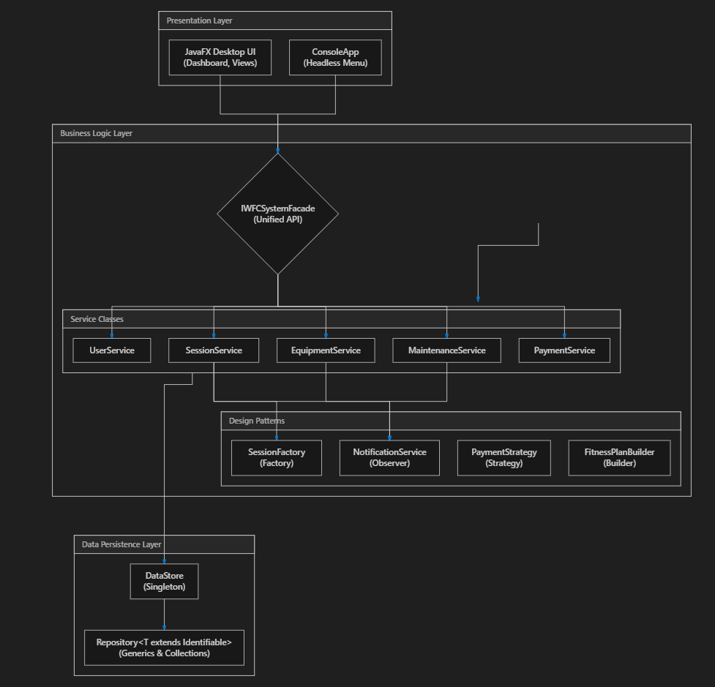
Figure 1 - IWFC System Architecture Diagram

2.2 Service Layer Decomposition
The business tier is made up of several dedicated service classes, each handling a bounded slice of the system’s operational logic. EquipmentService manages the fleet inventory including CRUD operations and cumulative usage-hour tracking. SessionService handles class creation, member booking reservations, and scheduling conflict detection through a companion SchedulingValidator. MaintenanceService enforces the maintenance ticket lifecycle, which transitions through Pending, Assigned, and Completed states. PaymentService processes financial transactions using interchangeable payment strategies. UserService deals with authentication checks and role-based permission gating. Additional services include EnrollmentService for fitness plan subscriptions, ScheduleMaker for weekly timetable assembly, and MeasurementAnalyzer for biometric tracking.
Table 1 - Core Architecture Classes by Layer
Layer | Class | Responsibility
Entity / Model | User (abstract), Administrator, Instructor, Member | Actor hierarchy with role-specific permissions
Entity / Model | Equipment | Equipment items with status tracking and usage hours
Entity / Model | FitnessSession, Booking | Scheduled classes and member reservations
Entity / Model | MaintenanceRequest | Fault tickets with urgency and status
Entity / Model | FitnessPlan (abstract), WeightLossPlan, etc. | Polymorphic fitness subscription plans
Facade | IWFCSystemFacade | Unified API – sole entry point for all UI/CLI operations
Service | EquipmentService | Equipment CRUD and usage logging
Service | SessionService, SchedulingValidator | Session management and clash prevention
Service | MaintenanceService | Ticket lifecycle state machine
Service | PaymentService | Strategy-driven payment processing
Pattern | DataStore | Singleton in-memory persistence
Pattern | NotificationService | Observer event pub/sub
Pattern | SessionFactory | Factory for recurring session generation
Data Access | Repository<T extends Identifiable> | Generic CRUD with predicate-based search

2.3 Data Persistence Layer
The data persistence layer uses an in-memory approach via the DataStore singleton, which holds typed Repository<T> collections for each domain entity. Since the assessment brief explicitly permitted hard-coded data, a relational database was not integrated. Instead, DataStore is pre-seeded on start-up with realistic demonstration data: three administrators, three instructors, ten gym members, twenty-five pieces of equipment spread across six location zones, fifteen pre-scheduled fitness sessions, and sample maintenance records. This seeding ensures that a live demonstration can run immediately without external setup or database configuration steps.

2.4 Build Configuration and Version Control
The project is built and managed through Apache Maven with a modular pom.xml that declares dependencies on JavaFX 21.0.2, AtlantaFX 2.0.1 for modern Cupertino-style theming, Apache PDFBox 2.0.30 for automated payment receipt generation, and JUnit Jupiter 5.10.2 for testing. A Java Platform Module System (JPMS) module descriptor (module-info.java) manages package-level encapsulation, exporting only the packages that need to be visible to the JavaFX runtime while keeping internal implementations hidden. Source control is maintained via Git with a remote repository hosted on GitHub, providing a progressive commit history that tracks each development phase from initial scaffolding through pattern implementation, testing, and UI polish.
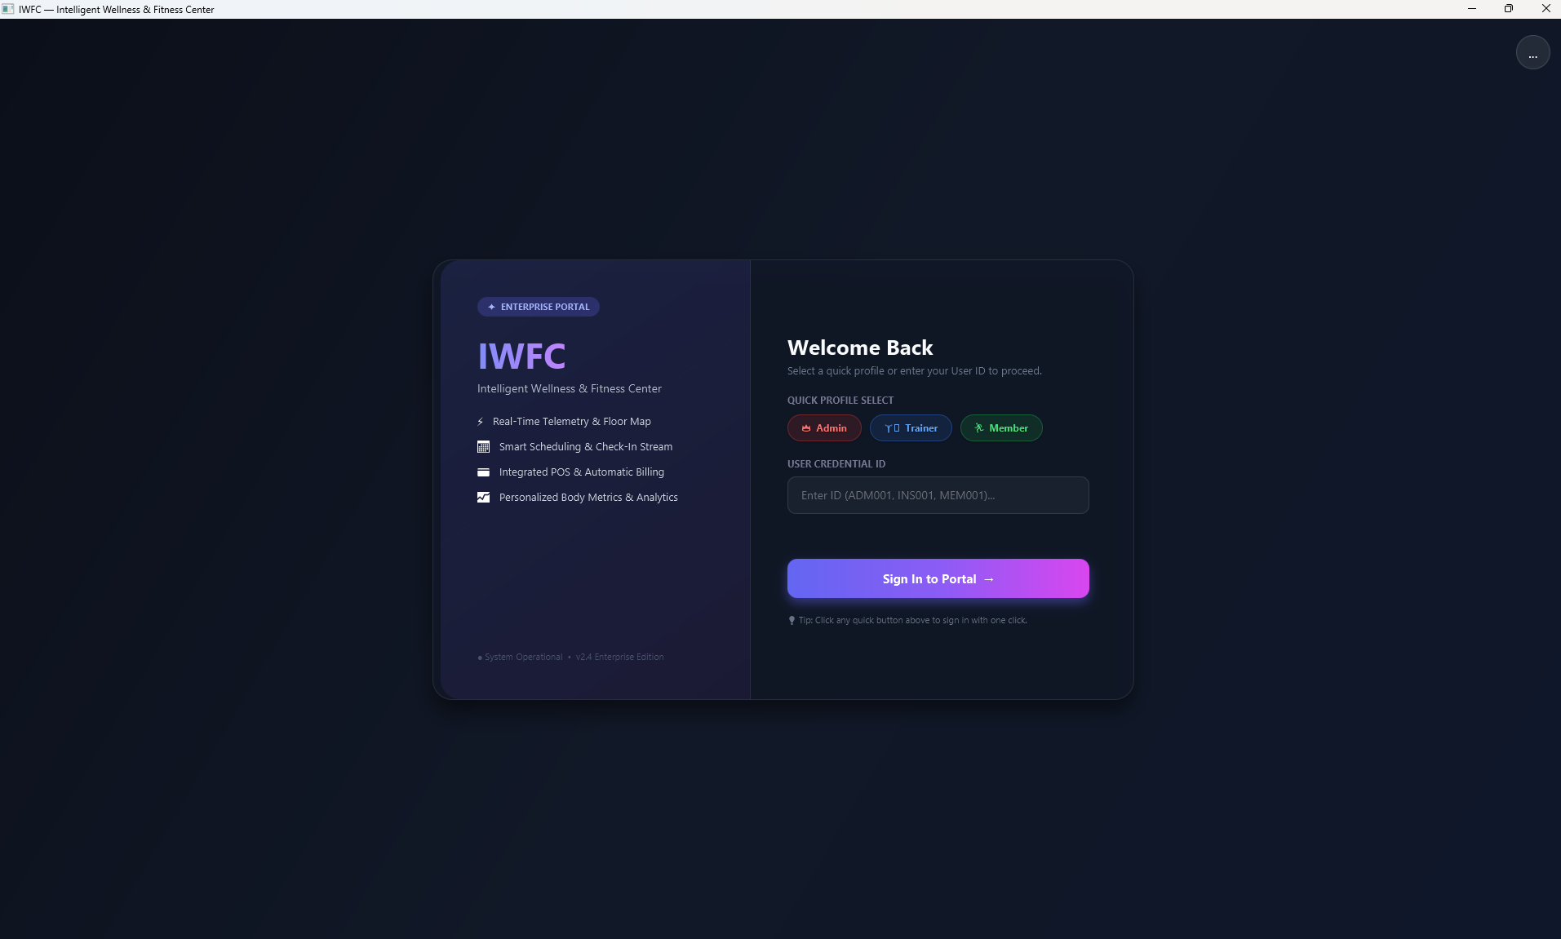

Figure 2 - Login Screen Screenshot

3. Object-Oriented Principles
The four foundational pillars of OOP – abstraction, encapsulation, inheritance, and polymorphism – are interwoven throughout the IWFC codebase. This section discusses each one with direct reference to the classes that embody them.

3.1 Abstraction
Abstraction in the IWFC system is realised primarily through abstract classes and interfaces that define contracts without committing to implementation specifics. The User class is declared as abstract with two abstract methods: getRoleDescription() and getPermissions(). Neither of these has a body in User itself. The calling code – including the Facade and the UI layer – only ever works with the User reference type, so it does not need to know whether the underlying object is an Administrator, an Instructor, or a Member. Similarly, the FitnessPlan class defines abstract methods calculateTotalCost() and getProgressionSummary(), forcing each concrete plan type to provide its own pricing logic without the caller needing to understand the internal formulae (Bloch, 2018).
The Identifiable interface is another example. Every entity that can be stored in a Repository<T> must implement getId(), which abstracts away the specific identifier format. This lets the repository treat equipment, users, sessions, and bookings uniformly.

3.2 Encapsulation
All model classes enforce encapsulation by declaring instance variables as private and exposing them through controlled getter and setter methods. In User, for instance, fields like userId, name, email, and role are all private, with the constructor declared as protected to further restrict instantiation to subclasses only. The Equipment class goes a step further: its incrementUsageHours(double hours) method encapsulates the logic that accumulates usage and automatically flags the item for maintenance once a threshold is exceeded, rather than allowing external code to set the usage hours directly. This kind of encapsulation ensures that business invariants – like the maintenance trigger threshold – cannot be accidentally bypassed by the UI layer (Martin, 2009).

3.3 Inheritance
The class hierarchy makes deliberate use of inheritance to model shared behaviour while allowing specialisation. User serves as the root of a three-branch hierarchy: Administrator, Instructor, and Member each extend it, inheriting common attributes (userId, name, email, phone, address) and overriding the abstract methods to provide role-specific behaviour. For example, Member adds extra fields such as membershipType and hoursSpent, while Instructor tracks specialisation and certifications. The FitnessPlan hierarchy follows the same structure, with WeightLossPlan, MuscleBuildingPlan, CardioEndurancePlan, and FlexibilityPlan inheriting from a single abstract parent.
On the exception side, IWFCException acts as the root abstract exception, and all domain-specific exceptions – InvalidBookingException, UnauthorizedAccessException, DuplicateDataException, PaymentFailedException, InsufficientFundsException – inherit from it. This hierarchy means the caller can catch either a specific exception or the broad IWFCException depending on what level of granularity is needed (Sierra and Bates, 2005).

3.4 Polymorphism
Polymorphism appears in two forms within the system: subtype polymorphism and parametric polymorphism. Subtype polymorphism is evident wherever the code operates on a parent reference but the actual behaviour comes from the concrete subclass. When the Facade calls user.getRoleDescription(), the correct description is returned at runtime depending on whether the User is an Administrator (“System administrator with full control”), an Instructor, or a Member – without any instanceof checks or conditional branching. The calculateTotalCost() method on FitnessPlan works identically: a WeightLossPlan might apply a nutrition supplement surcharge, while a CardioEndurancePlan charges only the base weekly fee.
Parametric polymorphism appears through Java Generics. The Repository<T extends Identifiable> class handles any entity type uniformly, and the EventListener<T> interface allows the Observer pattern to operate with different payload types. These uses of generics are discussed in greater depth in Section 5.
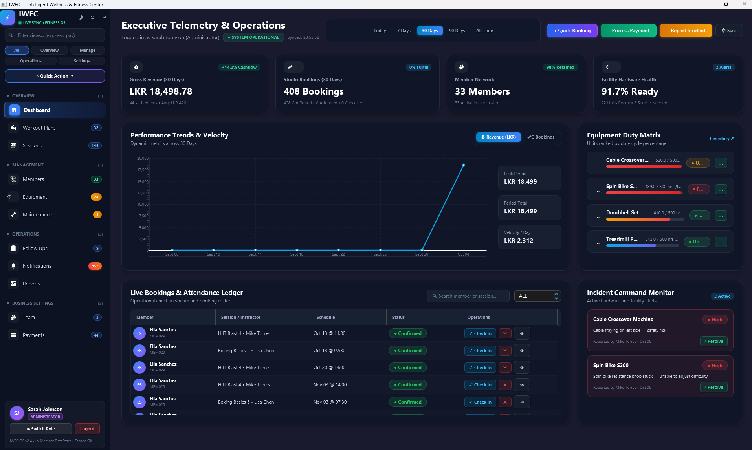

Figure 3 - Administrator Dashboard Screenshot

4. Design Patterns: Justification and Implementation
The assessment required at least one pattern from each of the three GoF categories. The IWFC system implements six patterns in total, as summarised in Table 2. The rationale for selecting each pattern is discussed below, with reference to Gamma et al. (1994) and Freeman and Robson (2020).
Table 2 - Design Patterns Implemented and Rationale
Category | Pattern | Class | Rationale
Creational | Singleton | DataStore | Single source of truth for in-memory data
Creational | Factory | SessionFactory | Encapsulate recurring session creation logic
Creational | Builder | FitnessPlanBuilder | Step-by-step construction of complex plan objects
Structural | Facade | IWFCSystemFacade | Simplify access to ten coordinated services
Behavioural | Observer | NotificationService | Decouple event publishers from subscribers
Behavioural | Strategy | PaymentStrategy | Interchangeable payment algorithms at runtime

4.1 Creational Patterns

4.1.1 Singleton – DataStore
The DataStore class implements the Singleton pattern to guarantee that exactly one instance of the in-memory data store exists throughout the application lifecycle. The constructor is private, preventing external instantiation, and the single instance is accessed via a static synchronized getInstance() method with a volatile field to ensure thread safety (Gamma et al., 1994). This was a practical necessity because multiple services – EquipmentService, SessionService, MaintenanceService, and so on – all need to read and write to the same data collections. Without a single coordinated
store, there would be a real risk of data inconsistency, where one service modifies a record that another service holds a stale copy of. The resetInstance() method was added specifically to support unit testing, as it allows each test method to start with a clean, freshly-seeded data environment.

4.1.2 Factory – SessionFactory
The SessionFactory is a creational factory that generates recurring weekly fitness sessions. Given a base ID, a name, an instructor, a location, a capacity, and a RecurrenceRule specifying the day, start time, duration, and number of weeks, the factory produces a list of individual FitnessSession objects – one per week – automatically validating each against existing sessions using the SchedulingValidator. If a clash is detected for a particular week, that week is silently skipped rather than failing the entire batch. This approach encapsulates the complex creation logic (date arithmetic, clash checking, ID generation) behind a single static method call, keeping the service and UI layers clean (Freeman and Robson, 2020).

4.1.3 Builder – FitnessPlanBuilder
FitnessPlanBuilder uses the Builder pattern to construct FitnessPlan objects in a step-by-step manner. Because a fitness plan has multiple optional attributes (title, description, objectives list, duration in weeks, monthly fee), a telescoping constructor would have been unwieldy. The Builder provides a fluent API where each setter method returns the builder itself, allowing chained calls like new FitnessPlanBuilder("WL001").title("12-Week Fat Burn").fee(49.99).weeks(12).build(). This results in more readable client code and makes it straightforward to add new attributes to the plan without breaking existing callers (Bloch, 2018).

4.2 Structural Pattern

4.2.1 Facade – IWFCSystemFacade
The IWFCSystemFacade is arguably the most important class in the system. It serves as the single entry point through which all UI components interact with the business layer. The Facade coordinates ten internal services and exposes around forty public methods covering equipment management, session scheduling, booking, maintenance, payments, user authentication, enrolments, and biometric analysis. Without this Facade, the JavaFX controllers would have needed direct references to each service and the DataStore, creating a tangled web of dependencies that would have been difficult to test or refactor. The Facade pattern resolved this by providing one unified interface that hides the coordination complexity from the caller (Gamma et al., 1994).

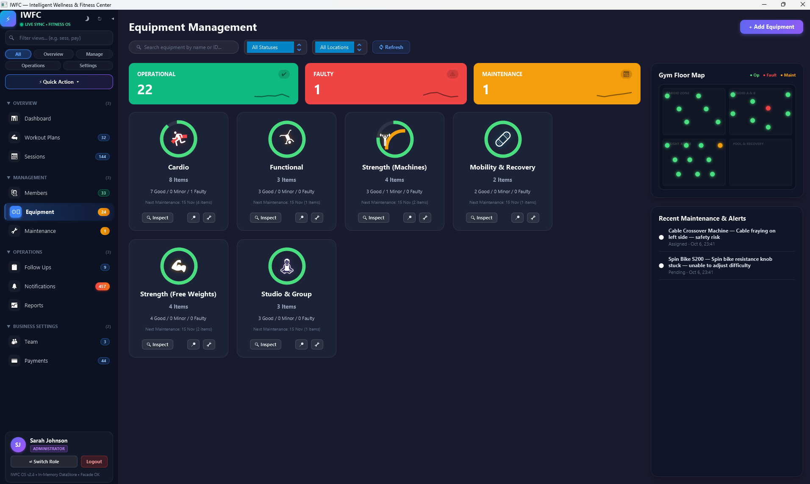
Figure 4 - Equipment Management Screenshot
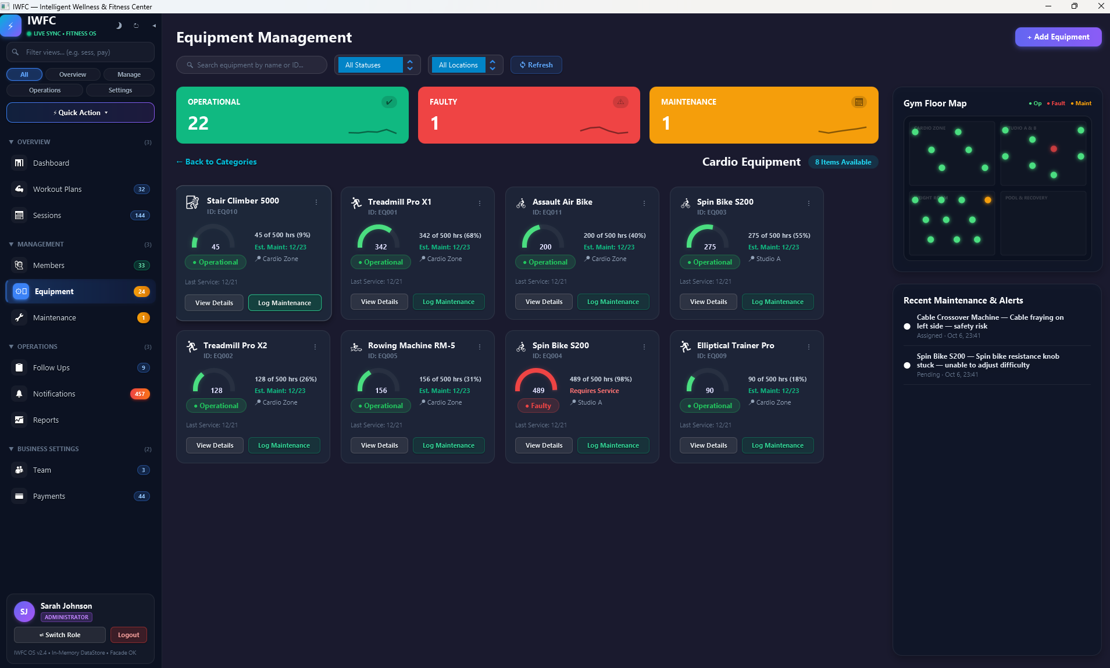

Figure 5 - Equipment Management Screenshot

4.3 Behavioural Patterns

4.3.1 Observer – NotificationService
NotificationService implements the Observer pattern using a Map<String, List<EventListener<String>>> that maps event type strings (such as “BOOKING_CONFIRMED”, “MAINTENANCE_STATUS_CHANGED”, “PAYMENT_PROCESSED”) to lists of subscribed listeners. When a service fires an event, the NotificationService iterates over the registered listeners for that event type and calls onEvent() on each. This decouples the event publishers (services) from the subscribers (UI notification panels, audit loggers) entirely – a service does not know or care who is listening (Gamma et al., 1994). In the JavaFX interface, a bell-icon notification panel subscribes to multiple event types and displays a live feed of system activity. This same mechanism could easily be extended to send emails or push notifications without modifying any service code.
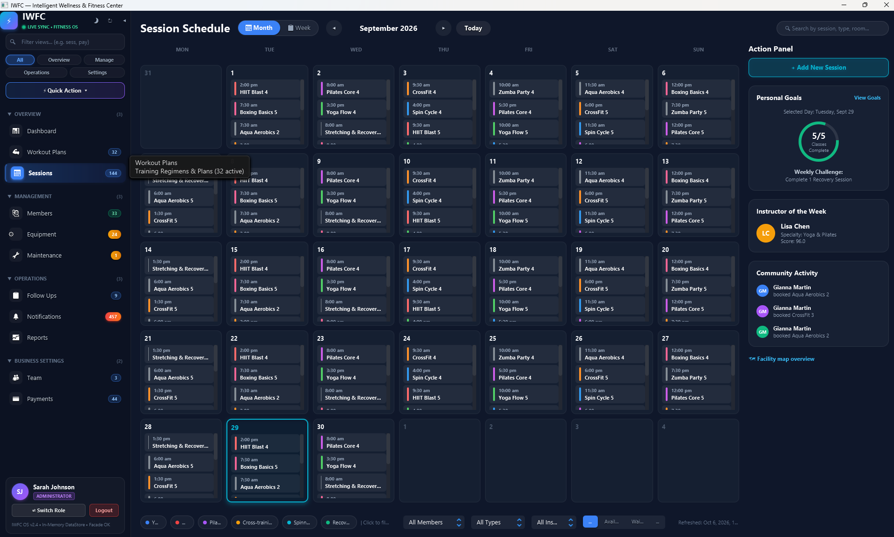

Figure 6 - Session Scheduling Screenshot
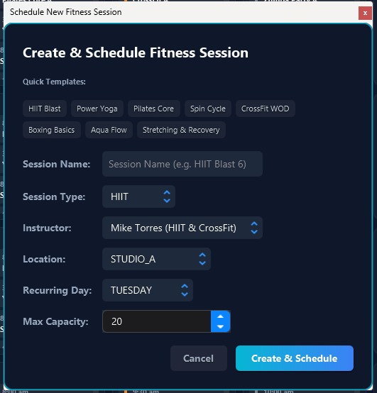

Figure 7 - Add new Schedule screenshot

4.3.2 Strategy – PaymentStrategy
The PaymentStrategy interface defines three methods: pay(double amount, PaymentContext ctx), getMethodName(), and calculateProcessingFee(double amount). Four concrete strategies implement this interface: CardPayment applies a 2.5% processing surcharge, CashPayment applies zero surcharge, BankTransferPayment adds a flat LKR 50 fee, and DigitalWalletPayment charges a 1.5% fee. At runtime, the user selects a payment method from a dropdown, and the PaymentService obtains the corresponding strategy object and invokes pay() – the service code remains identical regardless of which method is chosen. This design makes it trivial to add new payment methods in the future (say, a cryptocurrency gateway) without altering the PaymentService or the Facade (Freeman and Robson, 2020).

4.3.2 Strategy – PaymentStrategy
The PaymentStrategy interface defines three methods: pay(double amount, PaymentContext ctx), getMethodName(), and calculateProcessingFee(double amount). Four concrete strategies implement this interface: CardPayment applies a 2.5% processing surcharge, CashPayment applies zero surcharge, BankTransferPayment adds a flat LKR 50 fee, and DigitalWalletPayment charges a 1.5% fee. At runtime, the user selects a payment method from a dropdown, and the PaymentService obtains the corresponding strategy object and invokes pay() – the service code remains identical regardless of which method is chosen. This design makes it trivial to add new payment methods in the future (say, a cryptocurrency gateway) without altering the PaymentService or the Facade (Freeman and Robson, 2020).
Table 3 - Payment Strategy Fee Comparison
Strategy Class | Method Name | Processing Fee | Example (LKR 10,000)
CardPayment | Credit/Debit Card | 2.5% of amount | LKR 250
CashPayment | Cash | No fee | LKR 0
BankTransferPayment | Bank Transfer | Flat LKR 50 | LKR 50
DigitalWalletPayment | Digital Wallet | 1.5% of amount | LKR 150

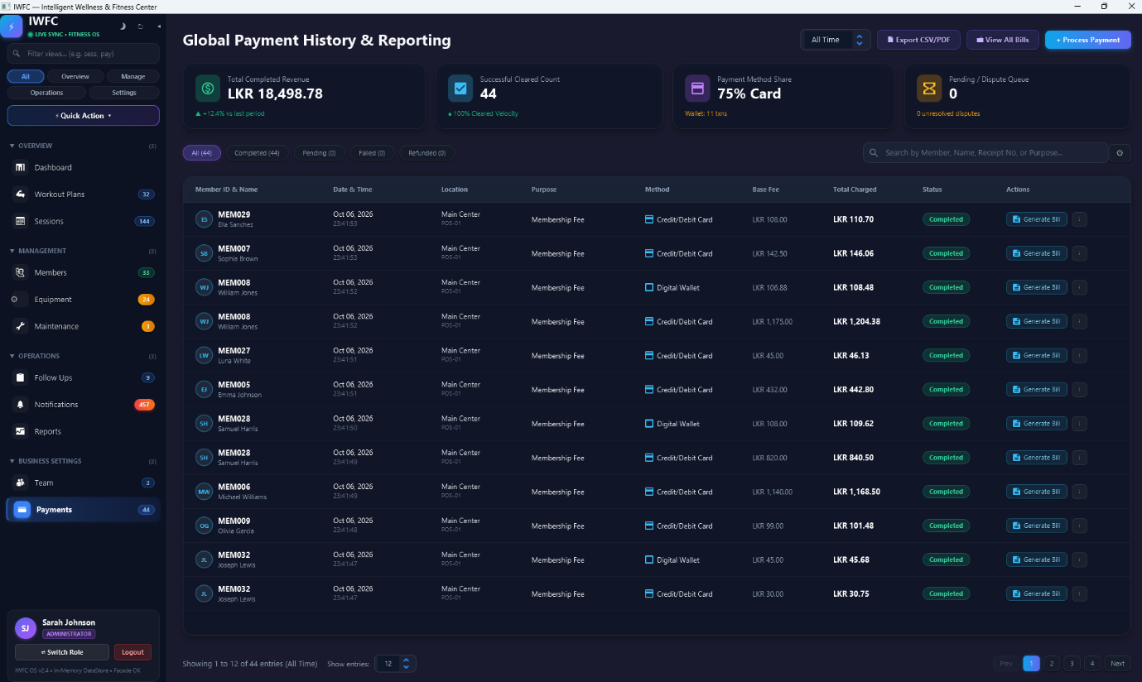

Figure 8 - Payements Menu Screenshot
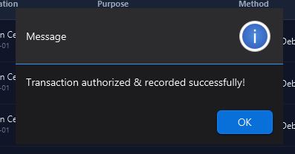

Figure 9 - Payemnt Successful Message
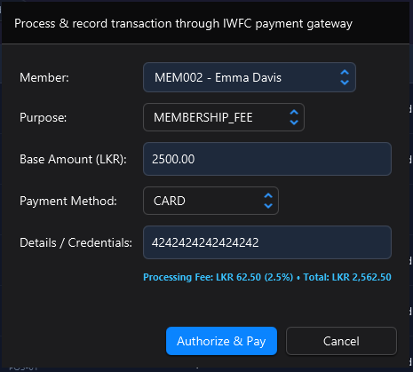

Figure 10 - Make Payment Menu

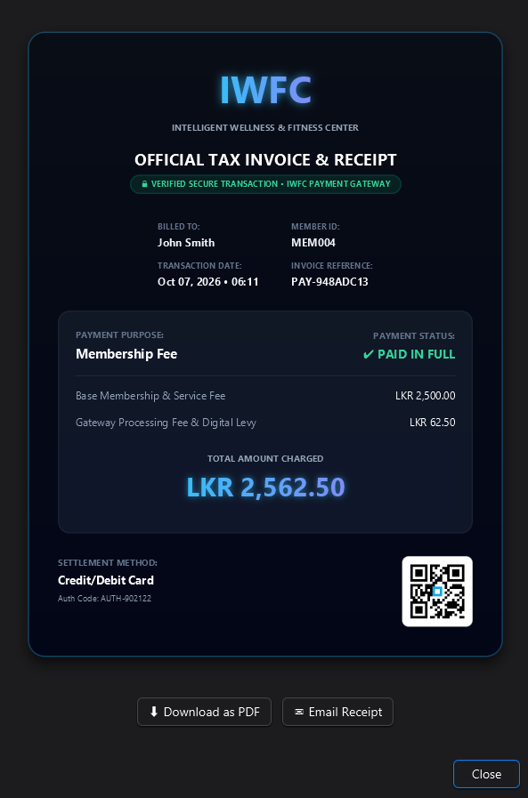

Figure 11 - Payment Done - Receipt Screenshot

5. Java Collections and Generics

5.1 Generic Repository
The Repository<T extends Identifiable> class is the central data-access component and provides the clearest demonstration of how Generics and Collections work together in the system. The class uses a bounded type parameter – <T extends Identifiable> – which constrains T to any class that implements the Identifiable interface. Internally, it stores entities in a HashMap<String, T>, where the key is the entity’s unique identifier returned by getId(). Standard CRUD operations – findById(), findAll(), save(), update(), delete() – are all type-safe without requiring any casts or instanceof checks (Naftalin and Wadler, 2006). A single Repository class serves ten different entity types (User, Equipment, FitnessSession, Booking, MaintenanceRequest, Notification, Payment, AuditEntry, BodyMeasurementLog, FollowUp) without any code duplication whatsoever.
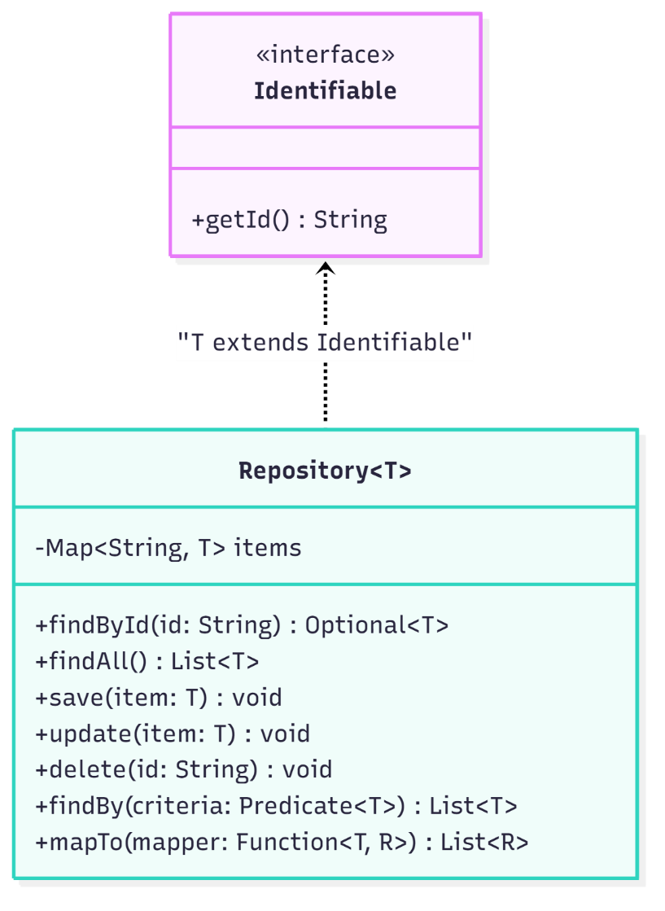

Figure 12 - Repository<T> UML diagram

5.2 Functional Querying with Predicate and Function
Beyond basic CRUD, the Repository exposes two generic methods that leverage Java’s functional interfaces from java.util.function. The findBy(Predicate<T> criteria) method accepts a lambda expression and uses the Stream API to filter the internal collection, returning a list of entities that match the given condition. For instance, equipmentRepo.findBy(e -> e.getStatus() == EquipmentStatus.FAULTY) retrieves all faulty equipment items without exposing the underlying HashMap to the caller. The <R> mapTo(Function<T, R> mapper) method goes further, introducing a second generic type parameter <R> that allows the caller to project each entity into a different type altogether. This is used, for example, to extract a list of user names from the user repository: userRepo.mapTo(User::getName). Both of these demonstrate advanced use of generics with functional programming constructs in a practical, not just academic, context (Bloch, 2018).

6. Exception Handling Strategy

6.1 Custom Exception Hierarchy
The assessment brief mandated custom exception handling for three specific scenarios: invalid bookings, unauthorised access, and duplicate data. Rather than treating these as isolated throw statements, the system implements a cohesive exception hierarchy rooted in an abstract IWFCException class. Each custom exception inherits from this root, gaining two common fields – errorCode (a machine-readable string such as “ERR_INVALID_BOOKING”) and timestamp (the LocalDateTime at which the error occurred) – plus an abstract getUserFriendlyMessage() method that each subclass overrides to produce a human-readable error description for the UI layer (Oracle, 2024). Table 3 details the full set of custom exceptions implemented.
Table 4 - Custom Exception Classes and Trigger Conditions
Exception Class | Error Code | Trigger Condition
InvalidBookingException | ERR_INVALID_BOOKING | Double-booking same room/instructor; scheduling outside 06:00–22:00 operating hours; capacity exceeded
UnauthorizedAccessException | ERR_UNAUTHORIZED | Member attempting to access admin-only operations (e.g. equipment management, audit logs)
DuplicateDataException | ERR_DUPLICATE | Registering equipment or user with an ID that already exists in the Repository
PaymentFailedException | ERR_PAYMENT_FAILED | Payment gateway rejects the transaction (expired card, invalid details)
InsufficientFundsException | ERR_INSUFFICIENT_FUNDS | Extends PaymentFailedException; wallet/account balance cannot cover the charge

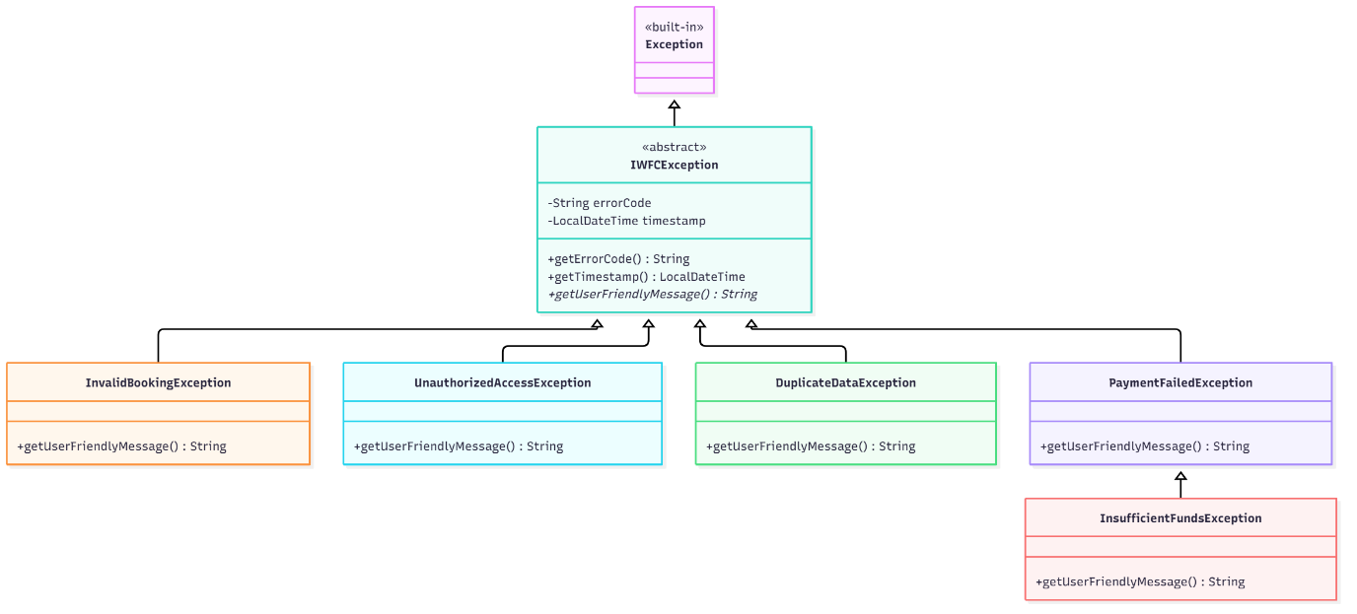

Figure 13 - Custom Exception Hierarchy UML

6.2 Exception Propagation and UI Recovery
The propagation strategy follows a consistent pattern throughout the application. Service-layer methods declare the relevant checked exception in their throws clause. For example, SchedulingValidator.validateNoRoomClash() throws InvalidBookingException, and Repository.save() throws DuplicateDataException. The Facade propagates these upward to the UI layer, where each JavaFX controller wraps Facade calls in try-catch blocks and displays the getUserFriendlyMessage() text inside styled alert dialogs. This approach avoids the common anti-pattern of catching exceptions silently or dumping raw stack traces to the user (Bloch, 2018). It also means the service logic stays clean – it throws when a business rule is violated and lets the caller decide how to present the error.
The InsufficientFundsException is worth noting as an extended scenario beyond the three mandatory exceptions. It inherits from PaymentFailedException, which itself inherits from IWFCException, creating a three-level exception hierarchy. This allows the payment UI to either catch the broad PaymentFailedException (covering any kind of payment failure) or catch InsufficientFundsException specifically to offer the user a chance to top up their wallet balance, demonstrating a practical use of exception inheritance for differentiated error recovery.

7. Testing: Plan, Results, and Reflection

7.1 Test Plan and Coverage
The JUnit 5 test suite was designed to cover the three areas specified in the assessment brief: core scheduling logic, maintenance workflow transitions, and robustness verification through intentional failing tests that confirm exceptions are correctly raised. Five test classes were developed, covering complementary aspects of the system. The rationale for the scope was to prioritise testing business-critical logic – particularly the scheduling validator and maintenance state machine – over testing simple getter/setter methods, which add limited value (Beck, 2003). Table 4 provides an overview of each test suite.
Table 5 - JUnit Test Suites and Coverage Summary
Test Class | Tests | Focus Area
SchedulingValidatorTest | 10 | Overlap detection, operating hours enforcement, room clashes, instructor clashes, capacity checks
PaymentStrategyTest | 7 | Fee calculations for all four payment strategies, strategy swapping at runtime
ExceptionVerificationTest | 3 | Verifies UnauthorizedAccessException, DuplicateDataException, and PaymentFailedException are thrown under the correct conditions
MaintenanceWorkflowTest | 3 | State transitions: Pending → Assigned → Completed; invalid transitions
RepositoryTest | 3 | Generic CRUD operations, duplicate save rejection, findBy predicate queries
Total | 26

7.2 Results Summary
All twenty-six tests pass consistently across repeated runs with zero failures or errors. The test execution is initiated through mvn clean test and completes within approximately two seconds. The SchedulingValidatorTest class alone accounts for ten of the twenty-six tests, which reflects the complexity of the scheduling domain – overlap detection has several edge cases (adjacent time slots that should not overlap, partially overlapping slots that should, and slots on different days that must be ignored) that warranted thorough coverage.
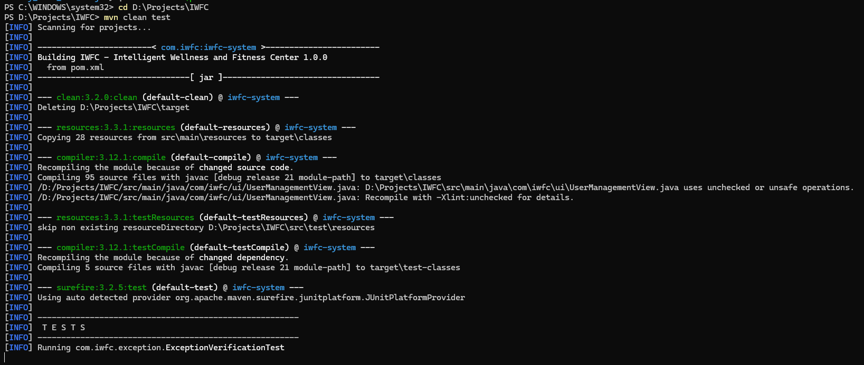

Figure 14 - JUnit Test Results Screenshot

7.3 Intentional Failing Tests and Bug Reflection
The assessment brief specifically required at least one intentional failing test to demonstrate that custom exceptions are correctly thrown. The ExceptionVerificationTest suite fulfils this requirement. Each test deliberately triggers an error condition and uses JUnit’s assertThrows() to verify that the expected exception type is thrown. For example, the testUnauthorizedAccessThrown() method creates a Member user and then attempts to call an admin-only Facade operation, expecting an UnauthorizedAccessException. If the exception is not thrown, the test fails, which would indicate a bug in the access-control logic.
During development, several bugs were identified through testing. One notable issue was that the SchedulingValidator initially checked for room clashes without filtering by day of the week. This meant a Monday session in Studio A would falsely clash with a Wednesday session in the same room if their time ranges overlapped. The testNoClashDifferentDay() test caught this immediately, and the fix was to add a getDayOfWeek() comparison before checking time overlap. Another defect involved the DataStore singleton – because it was not resettable, running multiple test classes in sequence caused DuplicateDataException errors from leftover seed data. Adding the resetInstance() method and calling it in @BeforeEach resolved this cleanly (Fowler, 2018).
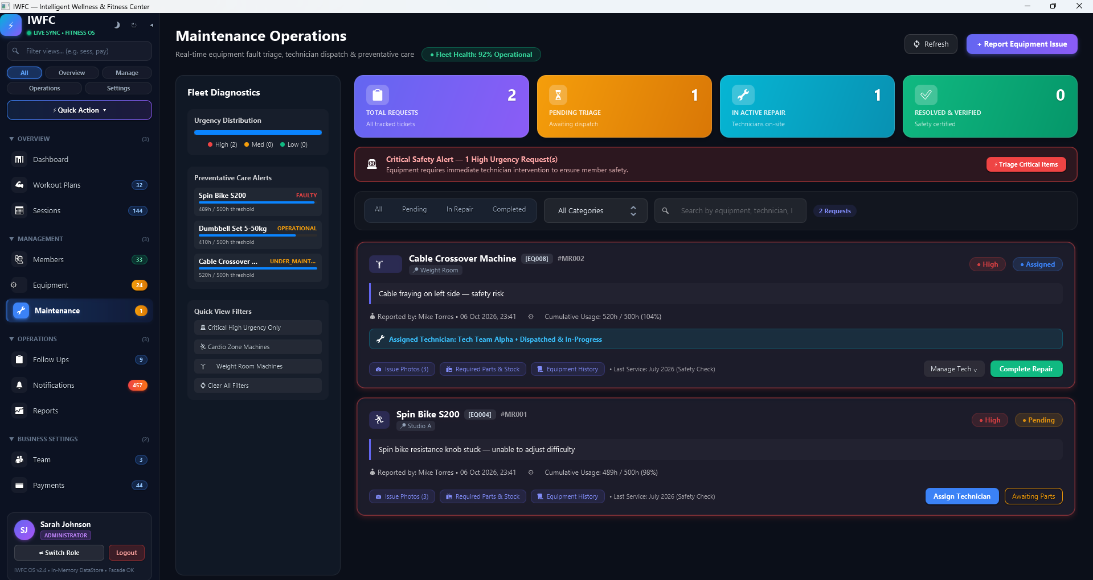

Figure 15 - Maintenance menu screenshot
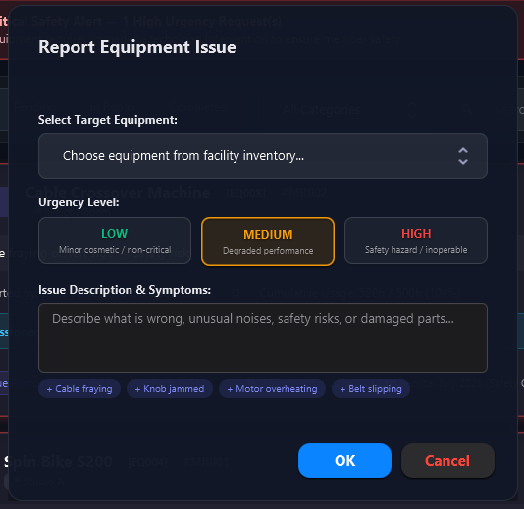

Figure 16 - Maintenance Request Ticket Screenshot

8. Limitations and Conclusion

8.1 Known Limitations
The current prototype has several limitations that would need to be addressed before production deployment. First, all data is held in memory and is lost when the application closes. A database layer (such as SQLite or PostgreSQL via JDBC) would be the logical next step for persistence. Second, the authentication mechanism is simplified – passwords are stored in plain text within the seed data, which is obviously unsuitable for a real system; hashing with bcrypt or Argon2 would be essential. Third, while the JavaFX GUI provides a polished experience, it has not been tested on macOS or Linux beyond basic checks, and some CSS transitions may behave differently across platforms. Finally, the test coverage, while addressing the brief’s requirements, could be expanded to include integration-level tests that exercise the Facade end-to-end rather than testing validators in isolation.

8.2 Conclusion
This report has presented the design, implementation, and evaluation of the IWFC management system prototype. The system demonstrates proficiency across all assessed areas: object-oriented principles are applied consistently through abstract classes, encapsulated models, and polymorphic method dispatch; six GoF design patterns span all three categories with clear justification for each choice; Java Generics and Collections underpin a reusable, type-safe data-access layer; custom exceptions form a structured hierarchy with contextual error codes; and a twenty-six-test JUnit suite validates scheduling, workflow, payment, and exception-handling logic. The layered architecture, anchored by the Facade pattern, ensures that presentation and business logic remain cleanly separated, which proved valuable both during development and testing.

9. References
- Beck, K. (2003) Test-Driven Development: By Example. Boston: Addison-Wesley.
- Bloch, J. (2018) Effective Java. 3rd edn. Boston: Addison-Wesley.
- Fowler, M. (2018) Refactoring: Improving the Design of Existing Code. 2nd edn. Boston: Addison-Wesley.
- Freeman, E. and Robson, E. (2020) Head First Design Patterns: Building Extensible and Maintainable Object-Oriented Software. 2nd edn. Sebastopol, CA: O’Reilly Media.
- Gamma, E., Helm, R., Johnson, R. and Vlissides, J. (1994) Design Patterns: Elements of Reusable Object-Oriented Software. Reading, MA: Addison-Wesley.
- Martin, R.C. (2009) Clean Code: A Handbook of Agile Software Craftsmanship. Upper Saddle River, NJ: Prentice Hall.
- Naftalin, M. and Wadler, P. (2006) Java Generics and Collections. Sebastopol, CA: O’Reilly Media.
- Oracle (2024) The Java™ Tutorials. Available at: https://docs.oracle.com/javase/tutorial/ (Accessed: 20 September 2026).
- Sierra, K. and Bates, B. (2005) Head First Java. 2nd edn. Sebastopol, CA: O’Reilly Media.
- Sommerville, I. (2016) Software Engineering. 10th edn. Harlow: Pearson Education.

Appendices

Appendix A – UML Class Diagram
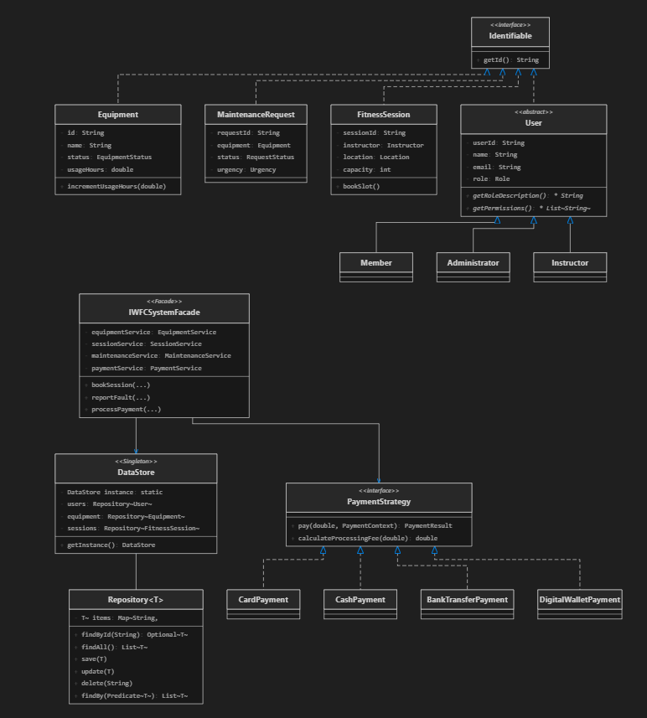

Figure A 1 - Full UML Class Diagram

Appendix B – Full JUnit Test Output
The following is the full output from running mvn clean test on the project:
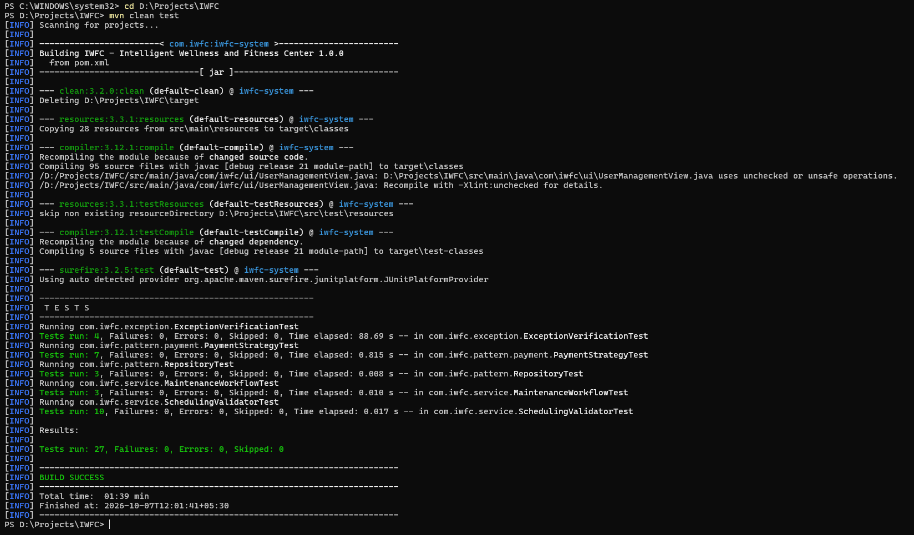
Figure B 1 - the complete Maven Surefire report output
Test Class Breakdown:
1. SchedulingValidatorTest (10 tests)
- testOverlappingSlots – Two fully overlapping time slots should be detected
- testNonOverlappingSlots – Adjacent slots (10:00-11:00, 11:00-12:00) should not clash
- testPartialOverlap – Partially overlapping slots correctly identified
- testOperatingHoursValid – Session within 06:00-22:00 passes validation
- testOperatingHoursTooEarly – Session starting at 05:00 throws InvalidBookingException
- testOperatingHoursTooLate – Session ending at 23:00 throws InvalidBookingException
- testRoomClashDetected – Same room, same time triggers exception
- testNoClashDifferentRoom – Same time, different rooms allowed
- testInstructorClashDetected – Same instructor, overlapping time throws exception
- testCapacityExceeded – Bookings at max capacity throws InvalidBookingException
2. PaymentStrategyTest (7 tests)
- testCardPaymentFee – Verifies 2.5% fee calculation
- testCashPaymentFee – Verifies zero fee
- testBankTransferFee – Verifies flat LKR 50 fee
- testDigitalWalletFee – Verifies 1.5% fee calculation
- testCardPaymentExecution – Full payment flow with card details
- testStrategySwapAtRuntime – Switch from Card to Cash mid-flow
- testPaymentWithInsufficientFunds – Throws InsufficientFundsException
3. ExceptionVerificationTest (3 tests)
- testUnauthorizedAccessThrown – Member calling admin operation triggers exception
- testDuplicateDataThrown – Saving entity with existing ID triggers exception
- testPaymentFailedThrown – Invalid payment details trigger exception
4. MaintenanceWorkflowTest (3 tests)
- testCreateRequest – New request starts in PENDING state
- testAssignRequest – PENDING → ASSIGNED transition works correctly
- testCompleteRequest – ASSIGNED → COMPLETED transition works correctly
5. RepositoryTest (3 tests)
- testSaveAndFindById – Save entity and retrieve by ID
- testDuplicateSaveThrowsException – Saving duplicate ID throws DuplicateDataException
- testFindByPredicate – Lambda-based filtering returns correct subset

Appendix C – Selected Source Code Listings
C.1 – Repository<T extends Identifiable>
package com.iwfc.repository; import com.iwfc.exception.DuplicateDataException; import com.iwfc.model.Identifiable; import java.util.*; import java.util.function.Function; import java.util.function.Predicate; import java.util.stream.Collectors; public class Repository<T extends Identifiable> { private final Map<String, T> items = new HashMap<>(); public Optional<T> findById(String id) { return Optional.ofNullable(items.get(id)); } public List<T> findAll() { return new ArrayList<>(items.values()); } public void save(T item) throws DuplicateDataException { if (items.containsKey(item.getId())) { throw new DuplicateDataException( "An item with ID " + item.getId() + " already exists."); } items.put(item.getId(), item); } public void update(T item) { items.put(item.getId(), item); } public void delete(String id) { items.remove(id); } public List<T> findBy(Predicate<T> criteria) { return items.values().stream() .filter(criteria) .collect(Collectors.toList()); } public <R> List<R> mapTo(Function<T, R> mapper) { return items.values().stream() .map(mapper) .collect(Collectors.toList()); } }
C.2 – IWFCException (Abstract Base)
package com.iwfc.exception; import java.time.LocalDateTime; public abstract class IWFCException extends Exception { private final String errorCode; private final LocalDateTime timestamp; public IWFCException(String message, String errorCode) { super(message); this.errorCode = errorCode; this.timestamp = LocalDateTime.now(); } public String getErrorCode() { return errorCode; } public LocalDateTime getTimestamp() { return timestamp; } public abstract String getUserFriendlyMessage(); }
C.3 – PaymentStrategy Interface
package com.iwfc.pattern.payment; import com.iwfc.exception.PaymentFailedException; public interface PaymentStrategy { PaymentResult pay(double amount, PaymentContext ctx) throws PaymentFailedException; String getMethodName(); double calculateProcessingFee(double amount); }
C.4 – EventListener<T> (Observer Interface)
package com.iwfc.pattern; public interface EventListener<T> { void onEvent(String eventType, T data); }
C.5 – DataStore Singleton (Excerpt)
package com.iwfc.pattern; public class DataStore { private static volatile DataStore instance; private final Repository<User> users; private final Repository<Equipment> equipment; private final Repository<FitnessSession> sessions; // ... additional repositories private DataStore() { this.users = new Repository<>(); this.equipment = new Repository<>(); this.sessions = new Repository<>(); // ... initialise remaining repositories initSeedData(); } public static synchronized DataStore getInstance() { if (instance == null) { instance = new DataStore(); } return instance; } public static synchronized void resetInstance() { instance = null; } // ... seed data population methods }

Appendix D – Additional Screenshots

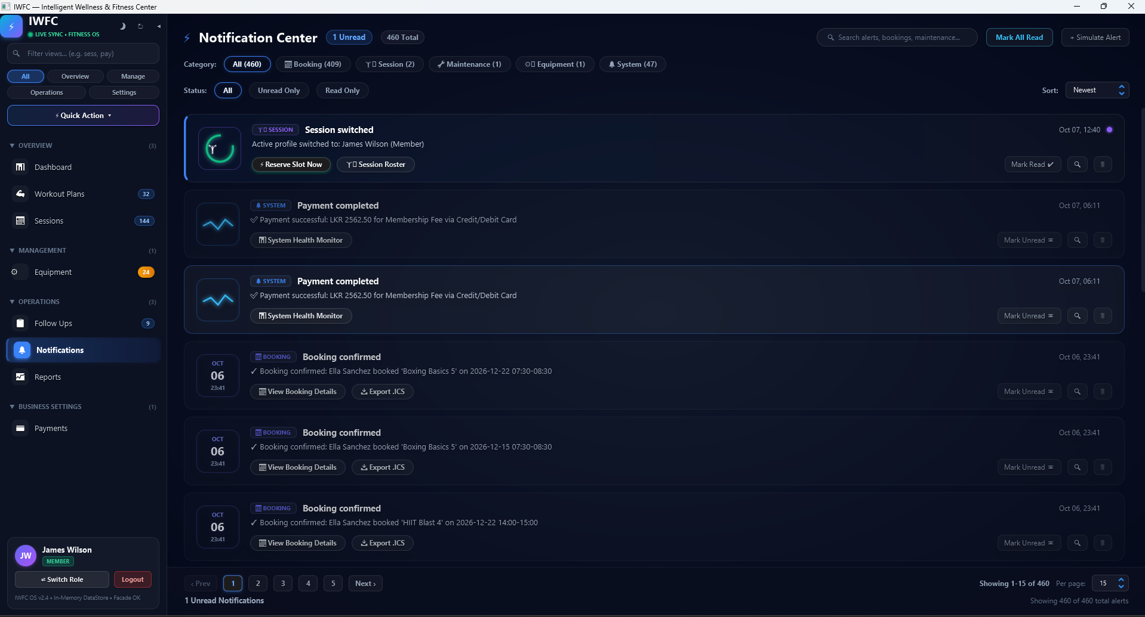

Figure D 1 - Observer Notification Panel Screenshot
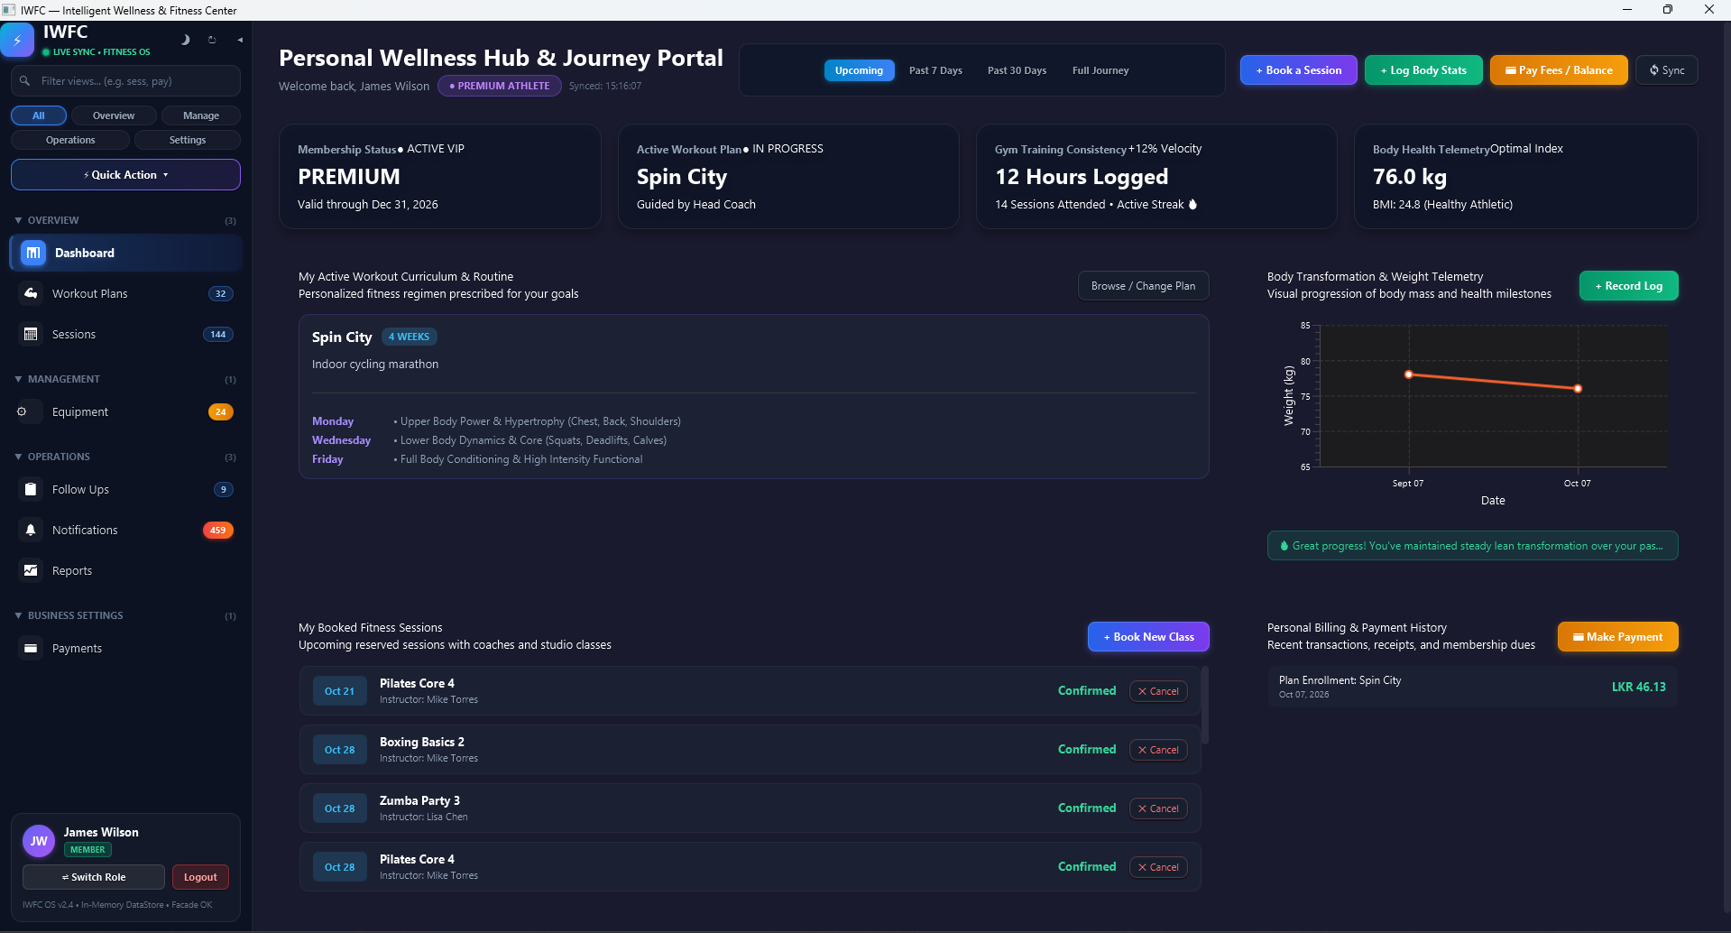

Figure D 2 - Member Dashboard Screenshot
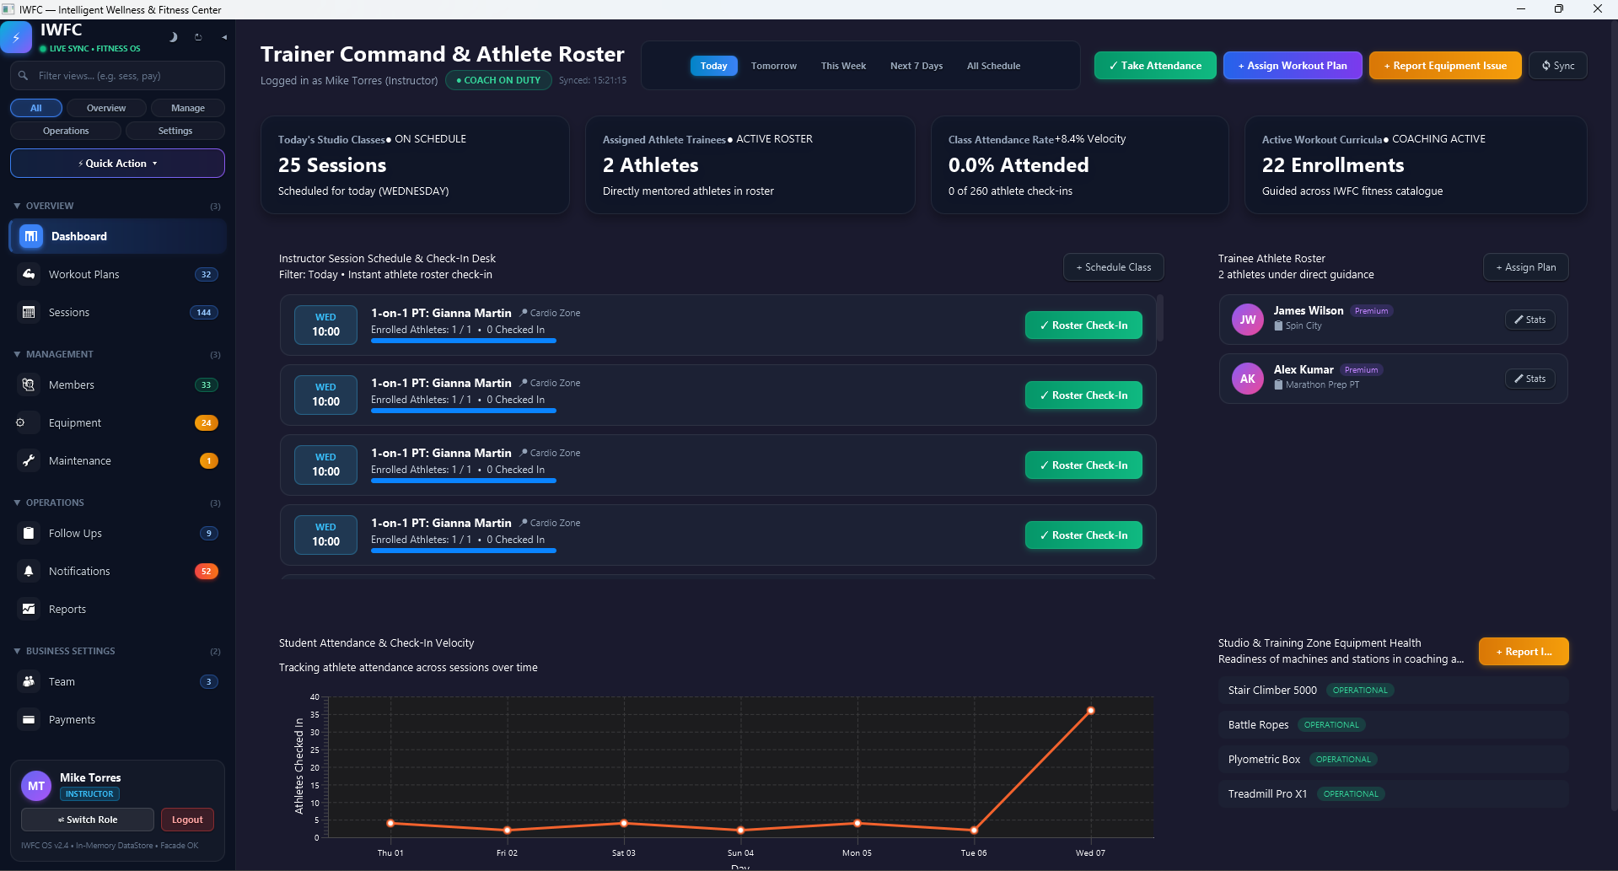
Figure D 3 - Instructor View Screenshot
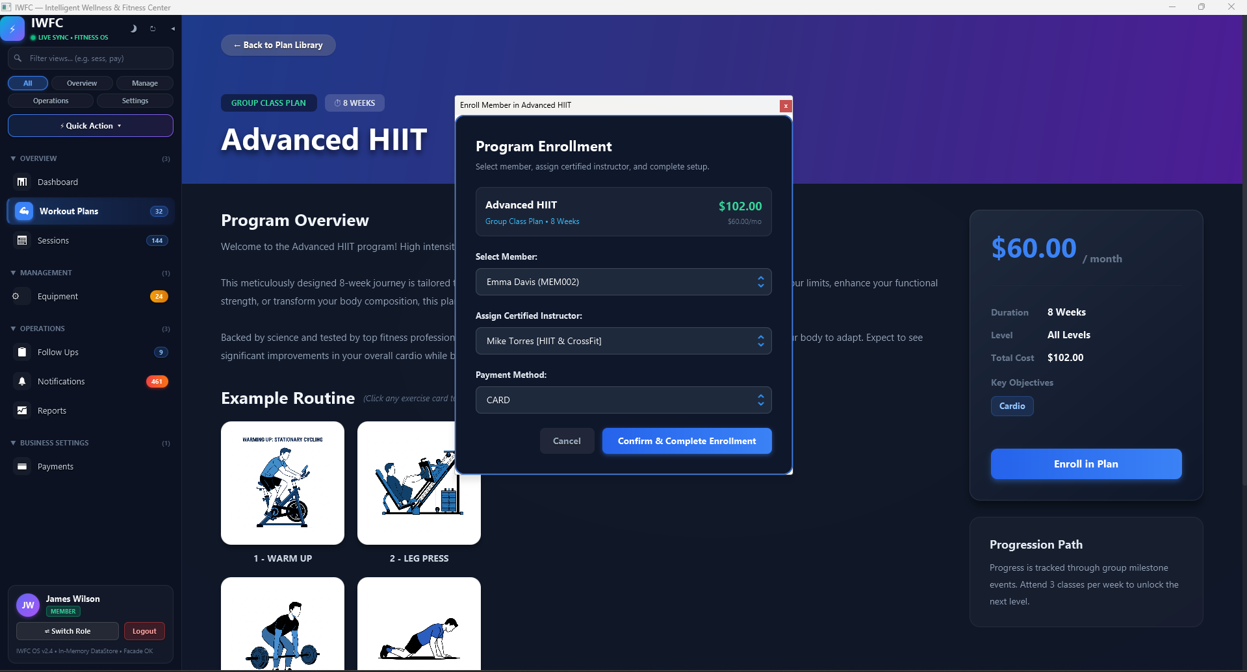
Figure D 4 - Fitness Plan Enrolment Screenshot
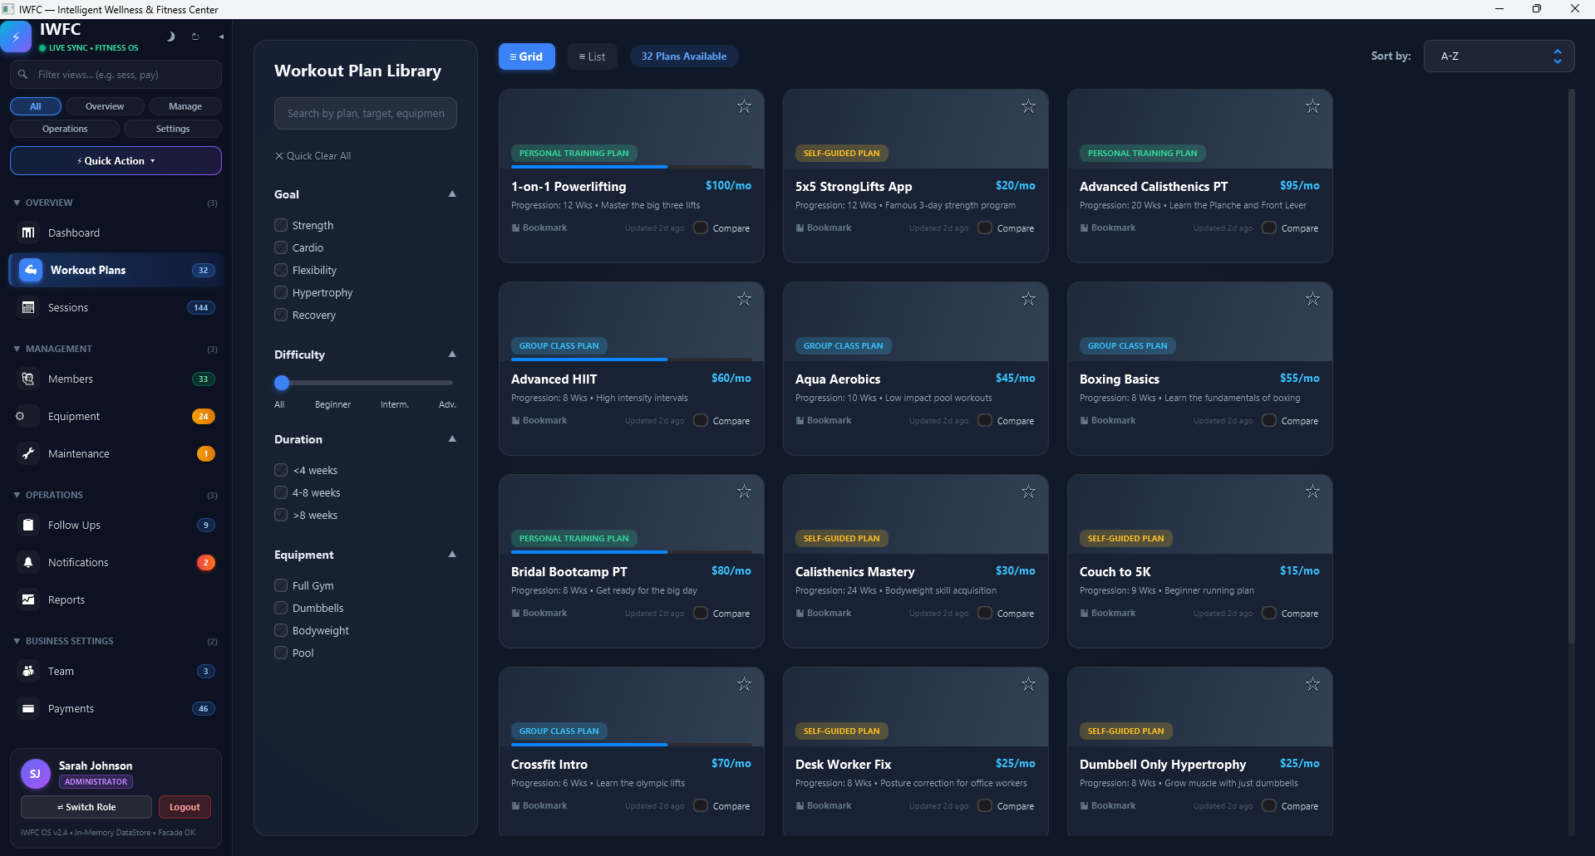
Figure D 5 - Fitness Plans

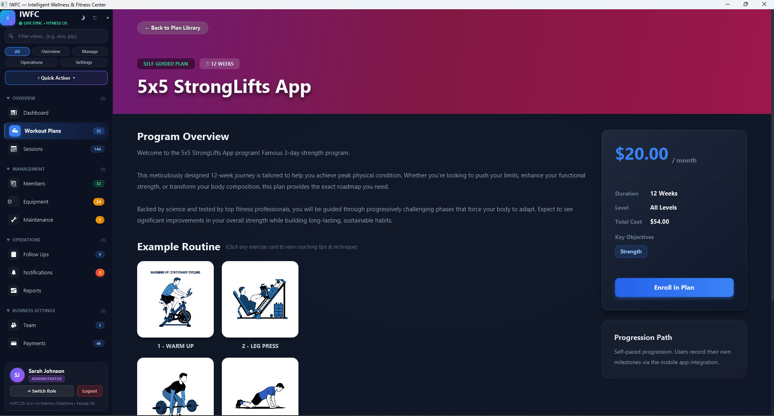
Figure D 6 - Fitness Plan (Plan View - Individual)
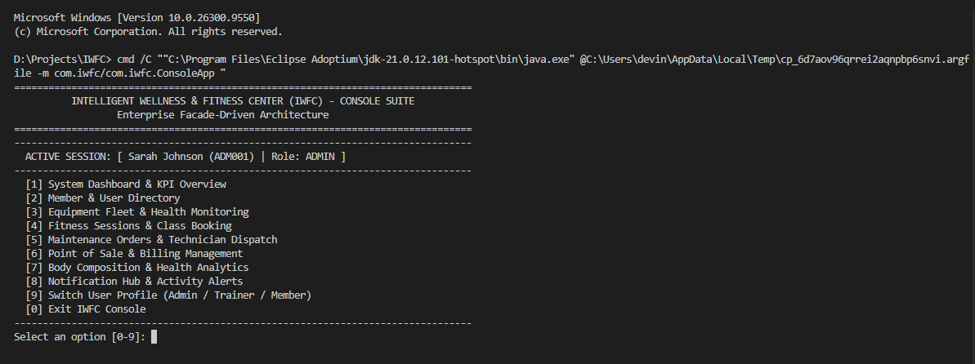
Figure D 7 - Console Application Screenshot

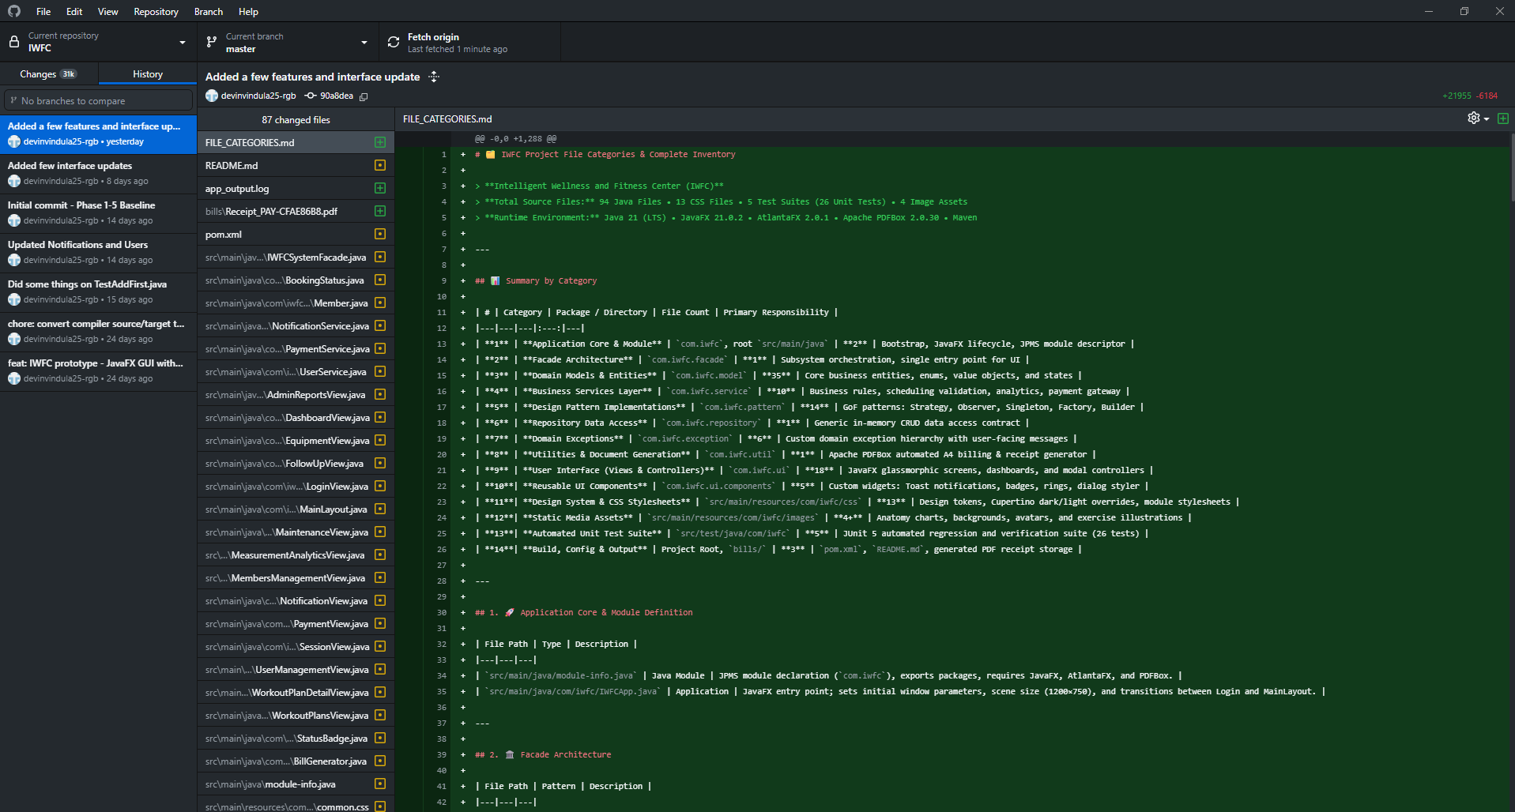
Figure D 8 - GitHub Repository Screenshot

