CS6362 Software Architecture and Design

SPRING 2013

Project Phase ii- FINAL

cyberminer Search Engine SYSTEM

USER MANUAL

Done by:

Abhishek Dey Das

Aishwarya Muthukumaran,

Brian Boyle

Clay Houllion

David Riviera

Gowrav Deivasigamani

Harshita Vissa

Naveen Kumar Devaraj

Pooja Dhondge

Sanjitha Srinivasan

Shiva Malavika Ganesh

Sripadmanabhan Subramanian

Sudharsan Lakshminarasimhan

Web URL: <http://sadteam.abhis.ws/>

1. **Introduction**
   1. **Brief introduction**

This document summarizes the requirements for the Cyberminer search system. Cyberminer is a search engine that utilizes the KWIC indexing system developed in phase I to develop the indexes that will be used for carrying out the search. This document only presents the requirements for Cyberminer. KWIC Indices requirements are given in the Phase I requirements specification document.

* 1. **Purpose**

The document’s purpose is to identifies the issues with the customer requirements, analyzes them and presents a refined set of requirements.

* 1. **Project overview**

The project is going to inplement the Cyberminer using the KWIC indexing system that was constructed in the previous phase.

The KWIC system shall accept an ordered set of lines, where each line consists of two parts:

* *The URL part*, whose syntax is:

URL ::= ‘http://’ identifier ‘.’ Identifier ‘.’ [‘edu’ | ‘com’ | ‘org’ | ‘net’]

identifier ::= {letter | digit}+

letter ::= [ ‘a’ | ‘b’ | … | ‘y’ | ‘z’ | ‘A’ | ‘B’ | … | ‘Y’ | ‘Z’]

digit ::= [‘1’ | ‘2’ | … | ’9’ | ‘0’]

* *The descriptor part*, whose syntax is:

identifier {‘ ‘ identifier}*

The descriptor part of any line shall be “circularly shifted” by repeatedly removing the first word and appending it at the end of the line. The KWIC index system shall output a listing of all circular shifts of the descriptor parts of all lines in ascending alphabetical order, together with their corresponding URLs. No line in the output list shall start with any noise work such as “a”, “the”, and “of”.

The KWIC system shall allow for two modes of operation:

1. for building an initial KWIC indices
2. for growing the indices with later additions.

Cyberminer shall allow for:

• Case sensitive search: The system shall store the input as given and retrieve the input

• Hyperlink enforcement: When the user clicks on the URL, which has been retrieved as the result of a query, the system shall take the user to the corresponding web site;

• Specifying OR/AND/NOT Search: A keyword-based search is usually an OR search, i.e., a search on any of the keywords given. The system shall allow the user to specify the mode of search, using “OR”, “AND” or “NOT”;

• Multiple search engines: to run concurrently;

• Deletion of out-of-date URL: and corresponding description from the database;

• Listing of the query result in ascending alphabetical order;

• Setting the number of results to show per page, and navigation between pages; and also possibly

• Autofill, while correcting typographical errors,

• Filtering out symbols that are not meaningful.

**USER START GUIDE**

**CyberMiner HomePage:**

The following steps would help to get started with CyberMiner web search engine.

The website is accessible through – and the user could enter the search term in the text box.



**Results Per Page:**

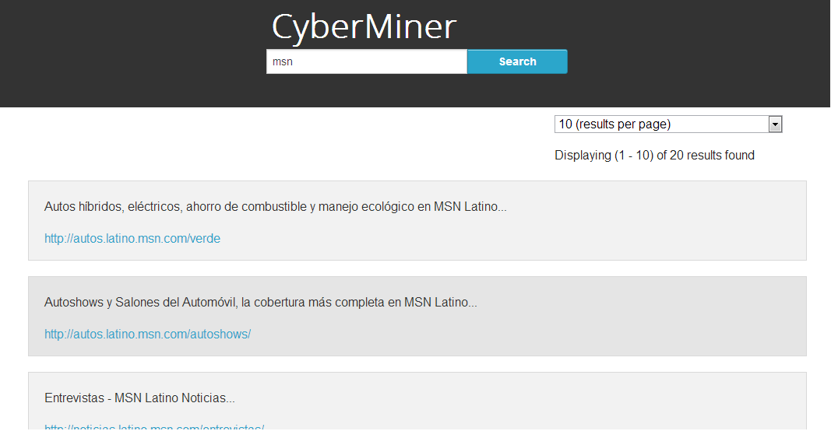

The user can select the number of results to be displayed per page. The options provided are “10 results per page”, “20 results per page” and “30 results per page”. Also, based on the options selected, the pagination also changes dynamically.

**Page Navigation:**



The page number that is active would be highlighted and the user could click on page numbers to browse through the results. Once the search results are displayed, the search engine also displays, the number of matched results found corresponding to the keyword searched.

**Customer Support:**

If you have any questions or want to leave a comment, please contact our customer service center by email at asad-project-team@googlegroups.com.