**Python Programming**

**Lab Assignment-2**

**Team ID:** 10

**Student 1:** Devi Prasad Kada, Class ID: 13

**Student 2:** Sushmanth Makkena, Class ID: 16

**Introduction:**

In this lab assignment 2 we are working on different programs to get us familiarize with python and machine learning. We are using different concepts like Regression, Clustering, Classification, Python NLTK etc.

**Objectives:**

Creating a prediction model based on Naive Bayes classification and evaluating your model.

Implementation of Support Vector Machine Classification.

Taking an input file and applying lemmatization, bigrams

Reporting the views on K-nearest neighbours when changing the values of k and see how it affects accuracy.

**Workflow:**

Question 1:

Picking a data set and how many of each category available in your dataset. Creating a prediction model based on Naives bayes Classification.

**Program code:**

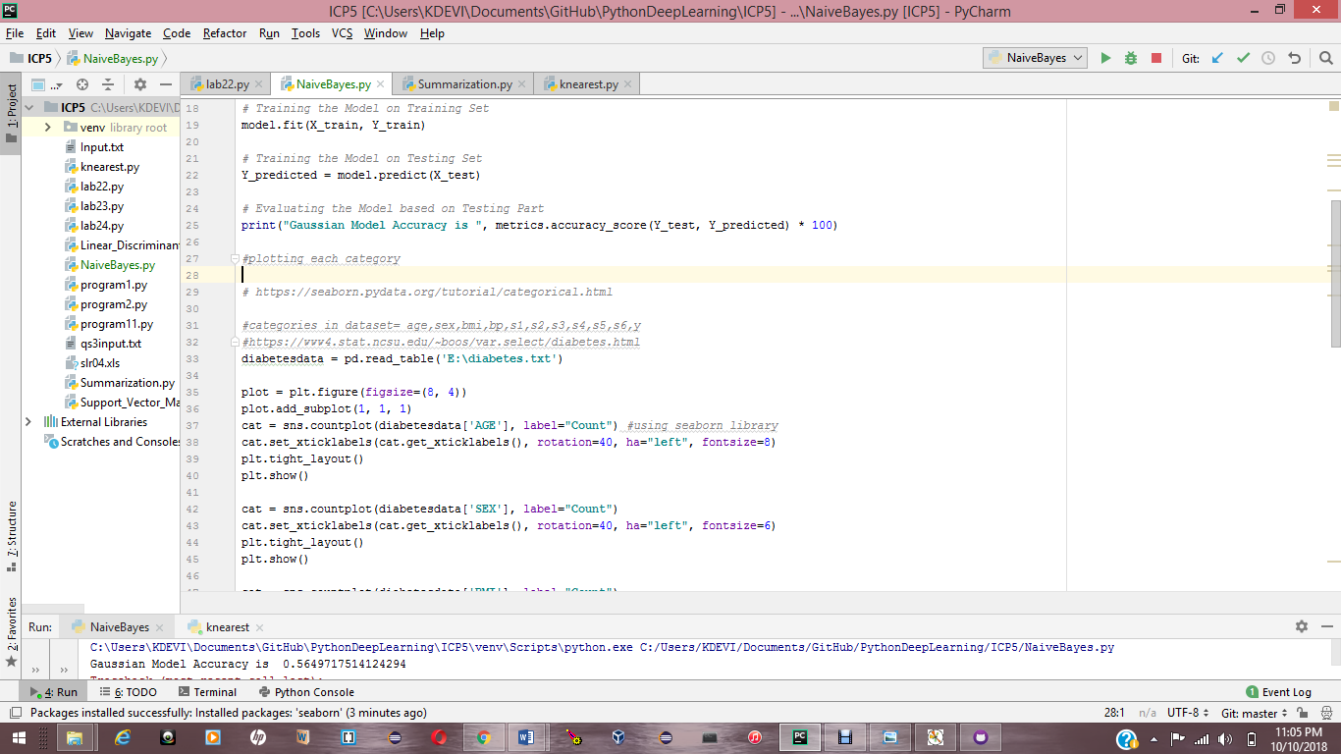

**Question 2:**

Implementing Support Vector Machine Classification.

**Program code:**

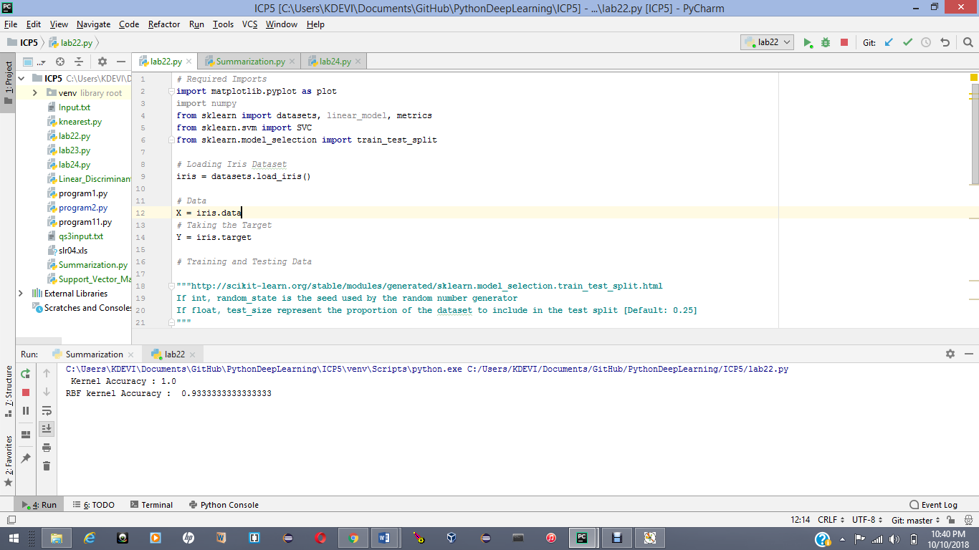

Output:

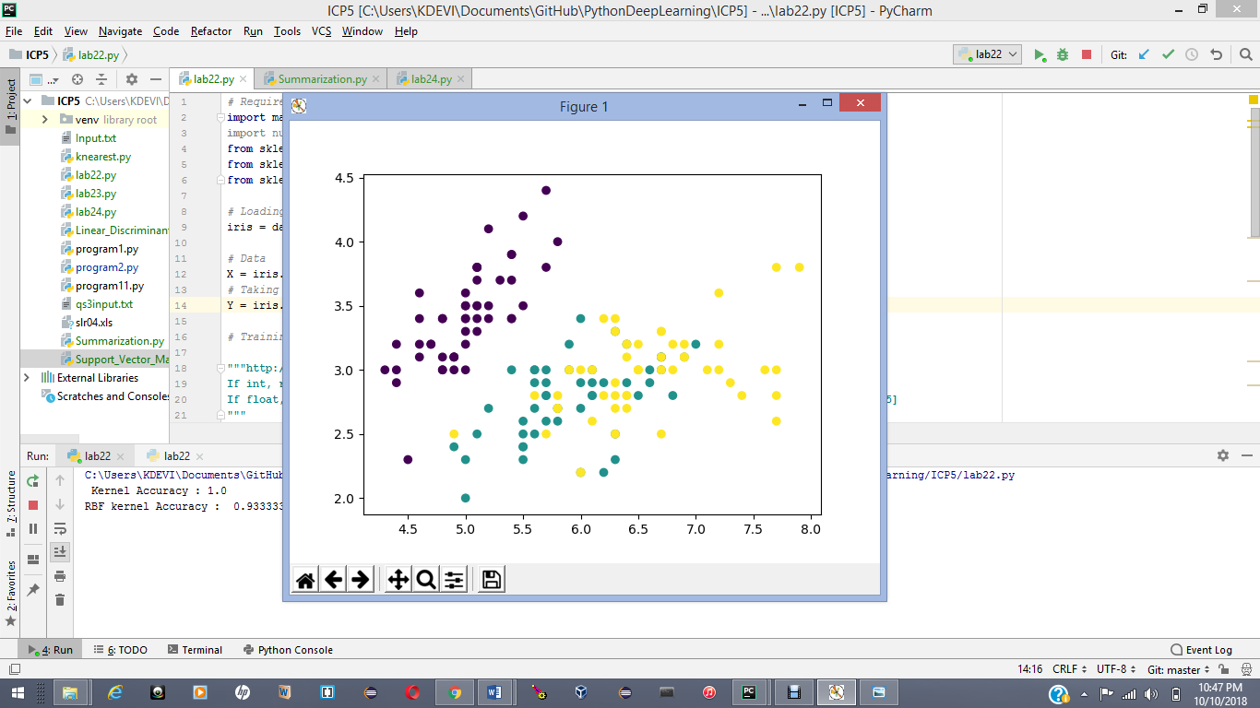

**Question 3:**

Take an input file and applying lemmatization, Bigrams etc.

**Program code:**

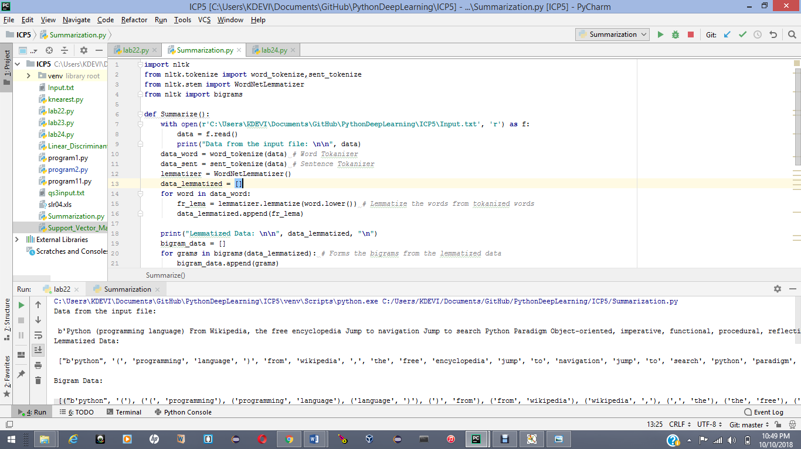

Output:

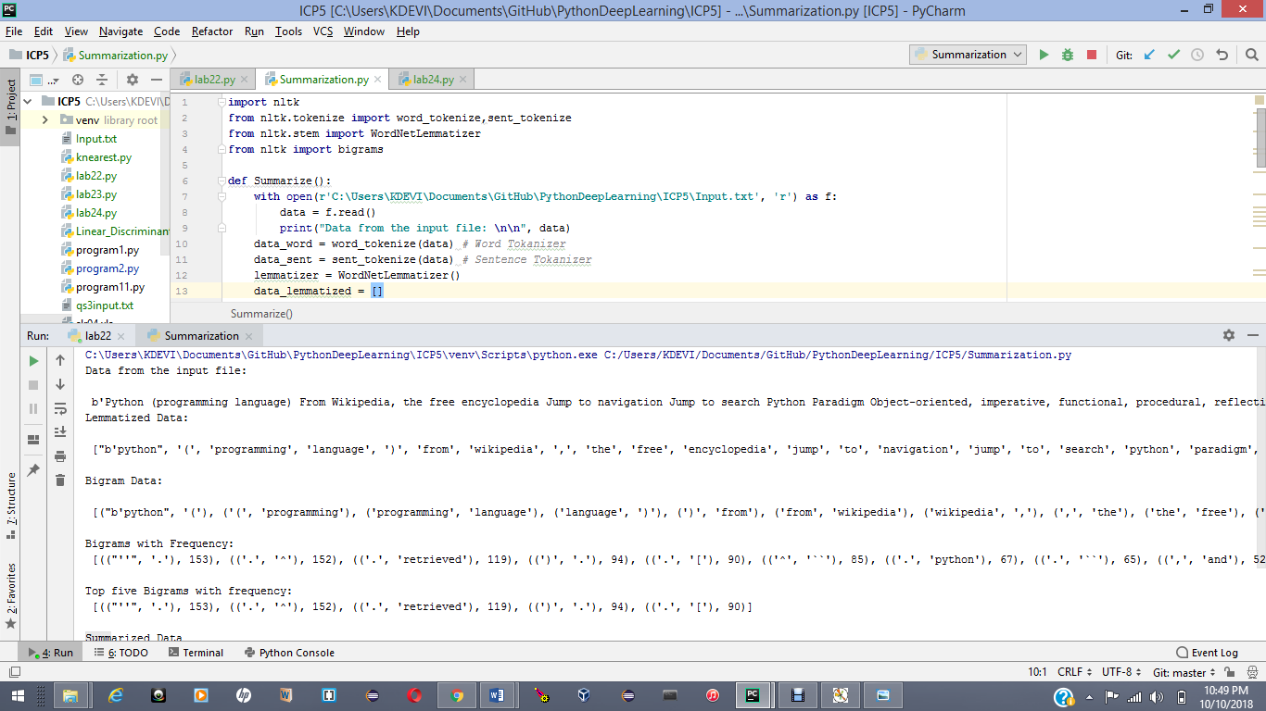

Question 4:

Reporting views on k-nearest neighbours.

Code snippet:

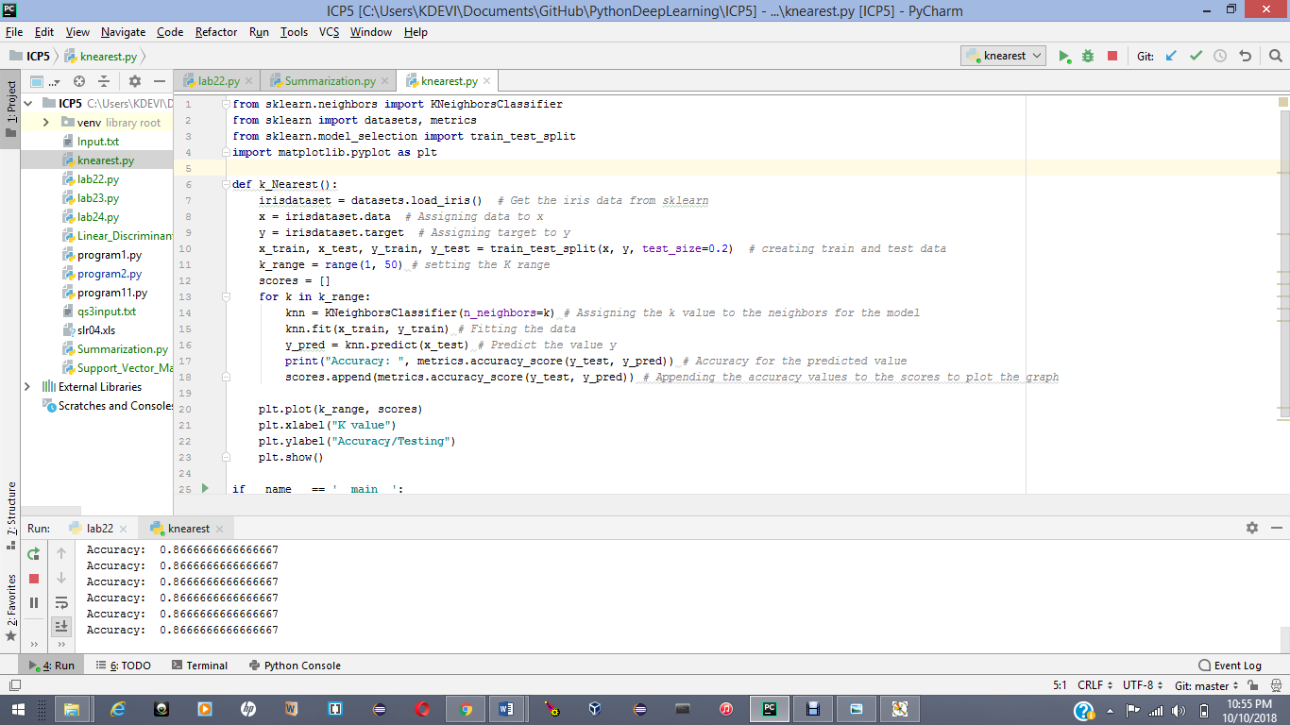

Output:

