**Deep Learning Programming**

**Lab Assignment-4**

**Team ID:** 10

**Student 1:** Devi Prasad Kada, Class ID: 13

**Student 2:** Sushmanth Makkena, Class ID: 16

**Introduction:**

In this lab assignment 4 we are implementing the text classification with CNN, RNN/LSTM model and comparing the results of CNN, RNN/LSTM models and describing which model is best for text classification based on results.

**Objectives:**

Based on the results for accuracy, loss suiting which is best for text classification.

**Workflow:**

Question 1:

Implementing the text classification with CNN model, with a new dataset.

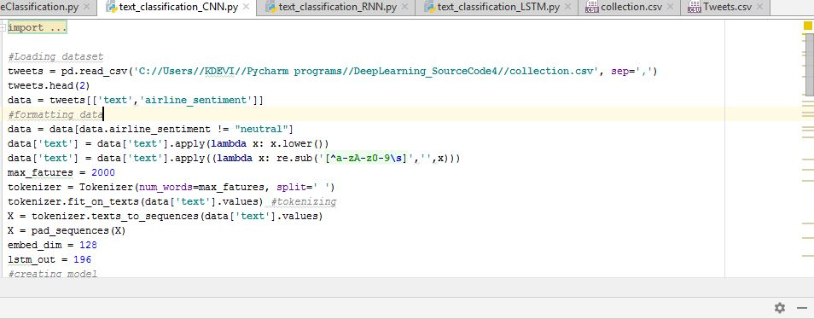

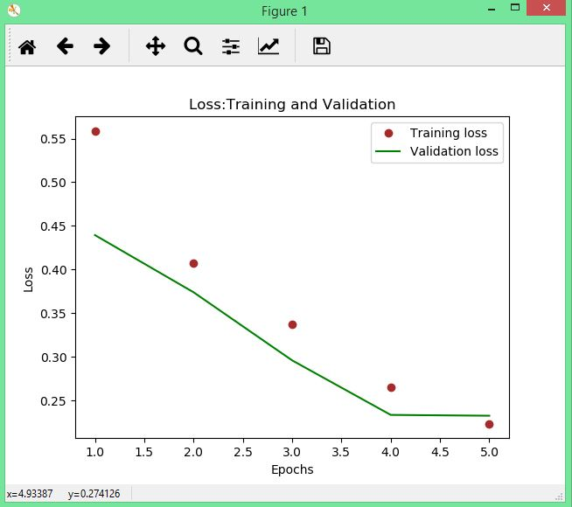

**Question2:**

**Implementing the text classification with RNN/LSTM**

**RNN:**

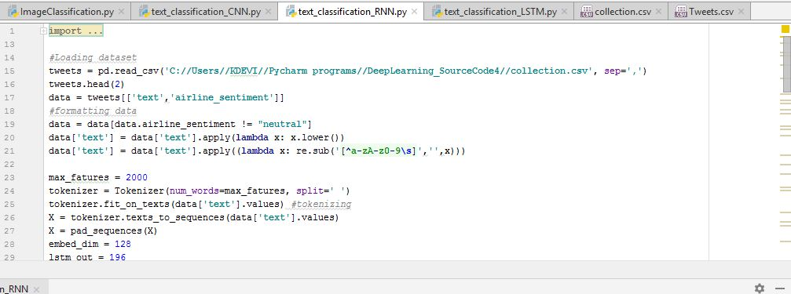

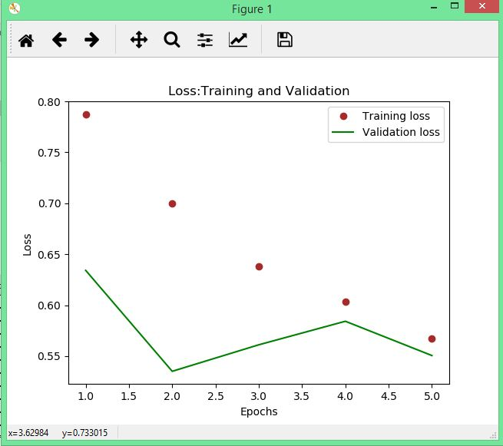

**LSTM:**

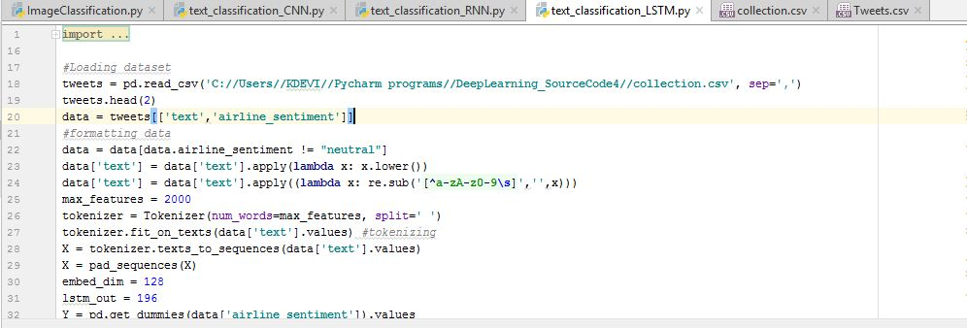

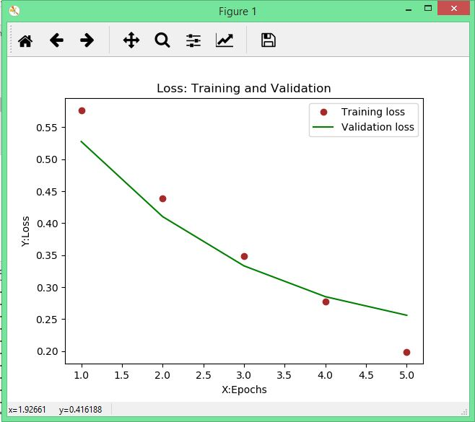

**Question3:**

**Comparing the results of CNN, RNN, LSTM we figured that the RNN gives the best result.**

**Question 4:**

**Implementing Image classification with CNN model, with a new data set.**

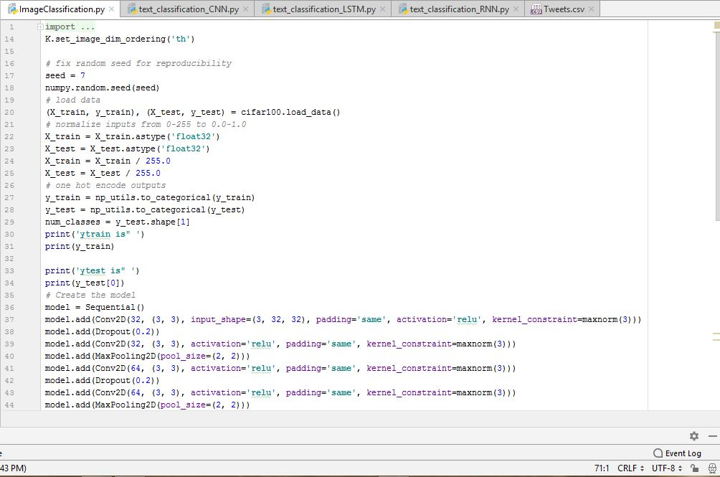

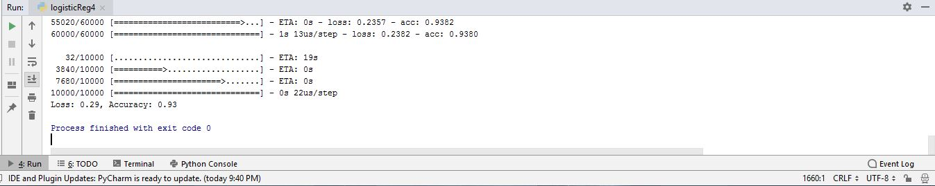

**Conclusion:**

Hence the accuracy changes and loss changes for every model of CNN, RNN, LSTM but the best result is for the model RNN which have less loss and high accuracy when compared to other two.