Power BI - Inventory ABC Analysis
Warmehands Logistics case study and build documentation
Tool | Power BI
Analysis focus | Inventory value, turnover, revenue, and ABC/Pareto classification
Methods used | Power Query, data modeling, DAX, dashboard design
Evidence included | 57 process and dashboard figures

Project Overview
This project analyses the inventory of Warmehands Logistics, a fictional retailer, to determine which products drive the business and how stock should be managed. Raw data was imported and cleaned in Power Query, structured into a relational data model, enriched with DAX measures and calculated columns, and surfaced through an interactive Power BI dashboard.
The core technique is ABC (Pareto) analysis: products are ranked by their cumulative share of 2021 revenue and classified into Class A (high value), Class B (medium value) and Class C (low value), so purchasing and inventory effort can be focused where it matters most. The analysis also covers cost of goods sold (COGS), profitability, year-over-year sales trends, inventory turnover and order geography.

Data Sources
Six related tables were used: Stock (product master), Price (retail price), Categories (product category), Costs (raw material, labour, equipment rent), Orders (transactions with quantity, country and invoice date) and Customer.

Tools & Techniques
Power BI Desktop · Power Query (ETL) · Star-schema data modeling · DAX calculated columns and tables (CALCULATE, FILTER, SELECTCOLUMNS, EARLIER, VAR/RETURN, nested IF) · ABC/Pareto classification · KPI cards, Pareto curve, bar/column charts, map and table visuals.

1. Data Import & Preparation (Power Query)
Imported the Warmehands Logistics data from excel sheet to power query editor.
In Price table, changed the first row as header.
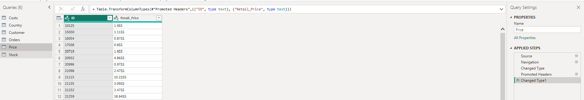
Figure 1
Step 3. For all the tables checked for missing values and errors using View – column quality.
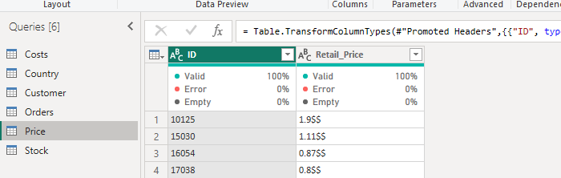
Figure 2
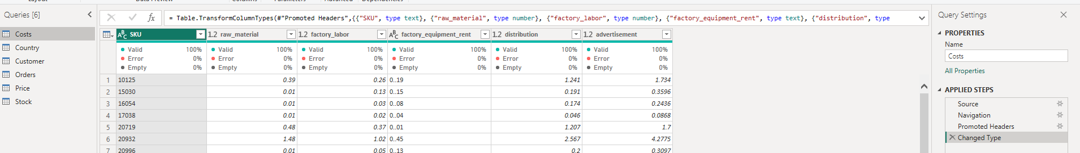
Figure 3
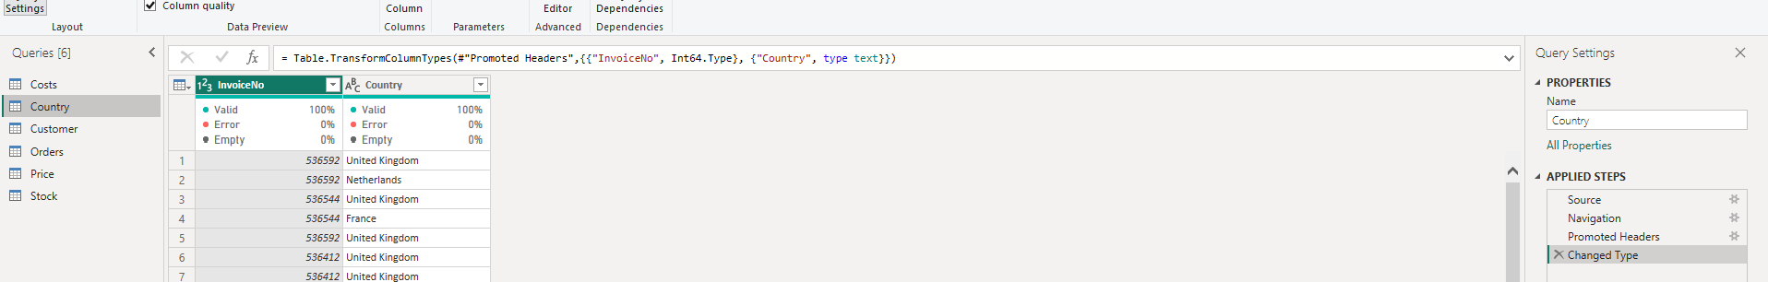
Figure 4
Step 4. Merging the price to stock table.
Selected SKU-ID from stock and ID from Price table , used left outer join to merge the tables.
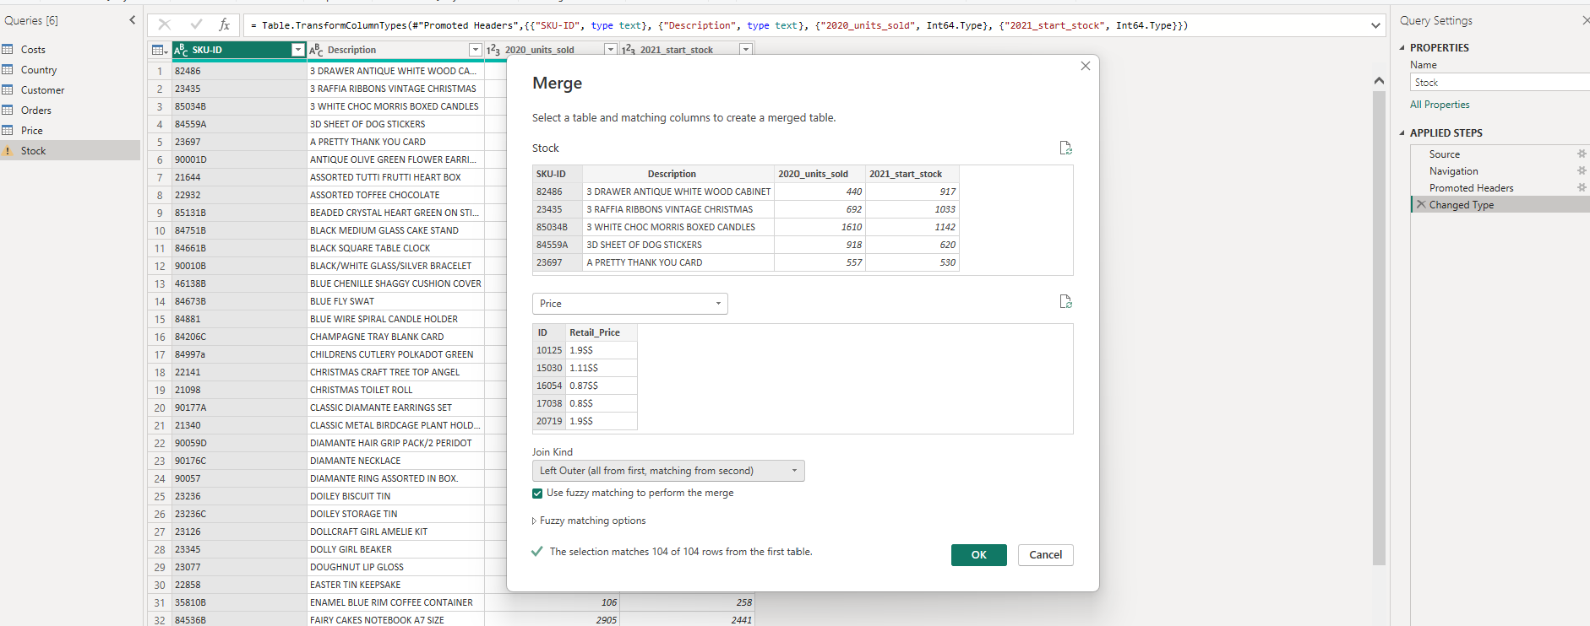
Figure 5
Step 5. Expanded the price column.
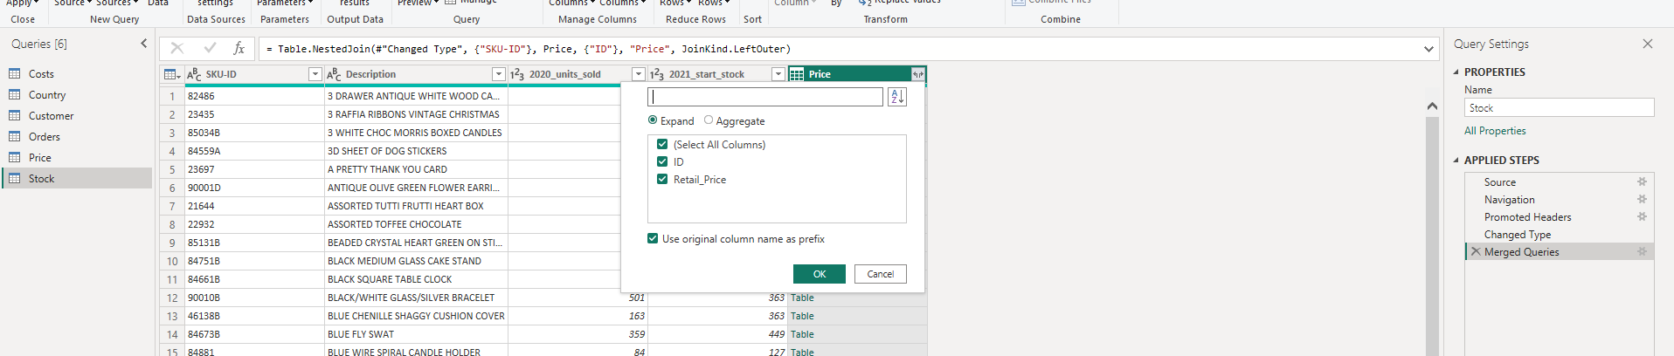
Figure 6
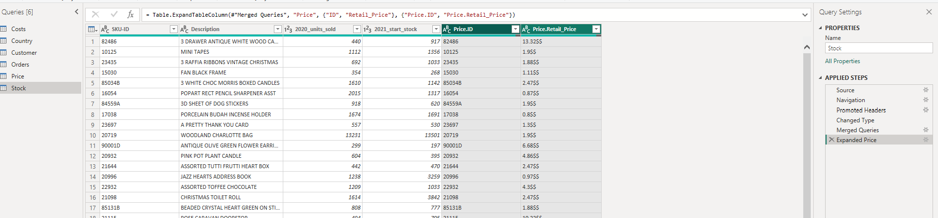
Figure 7
Step 6. After Merging the tables I got 199 rows in total, removed duplicates from the table using remove duplicates by right clicking the column.
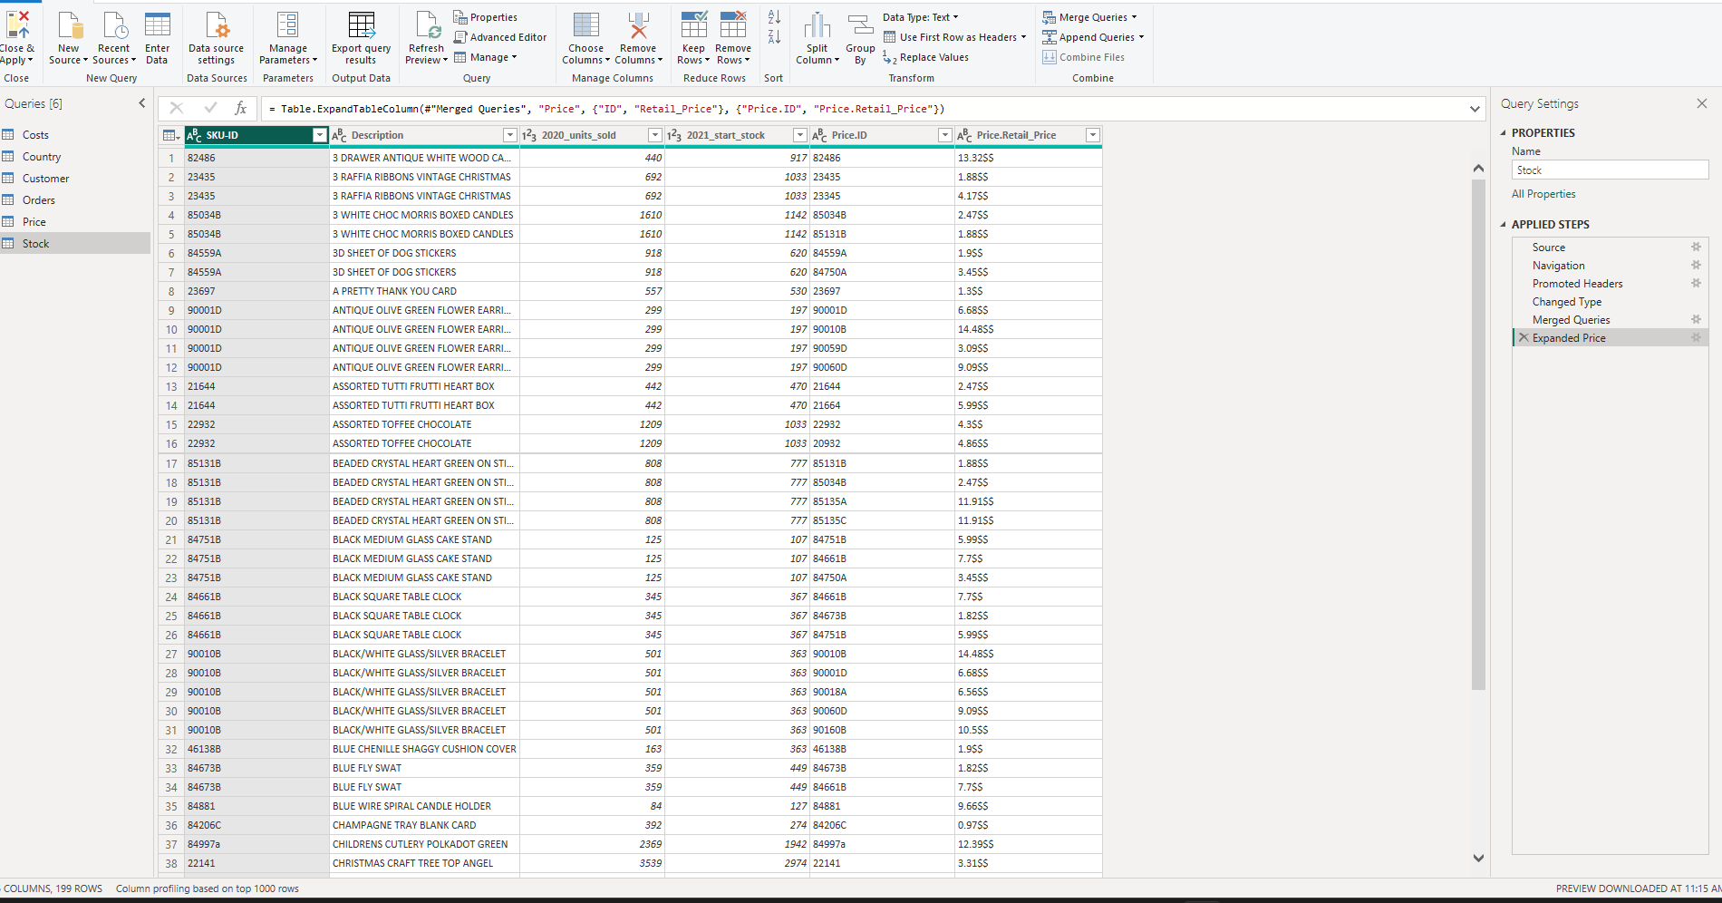
Figure 8
Step 7. Visualization to see each item’s precise value of quantity, 2020 units sold, retail price.
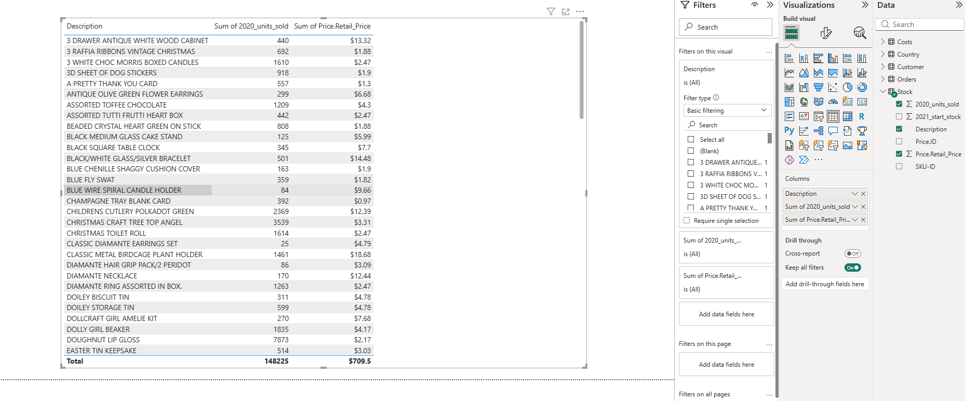
Figure 9
Step 8. Retail price for red dragonfly helicopter
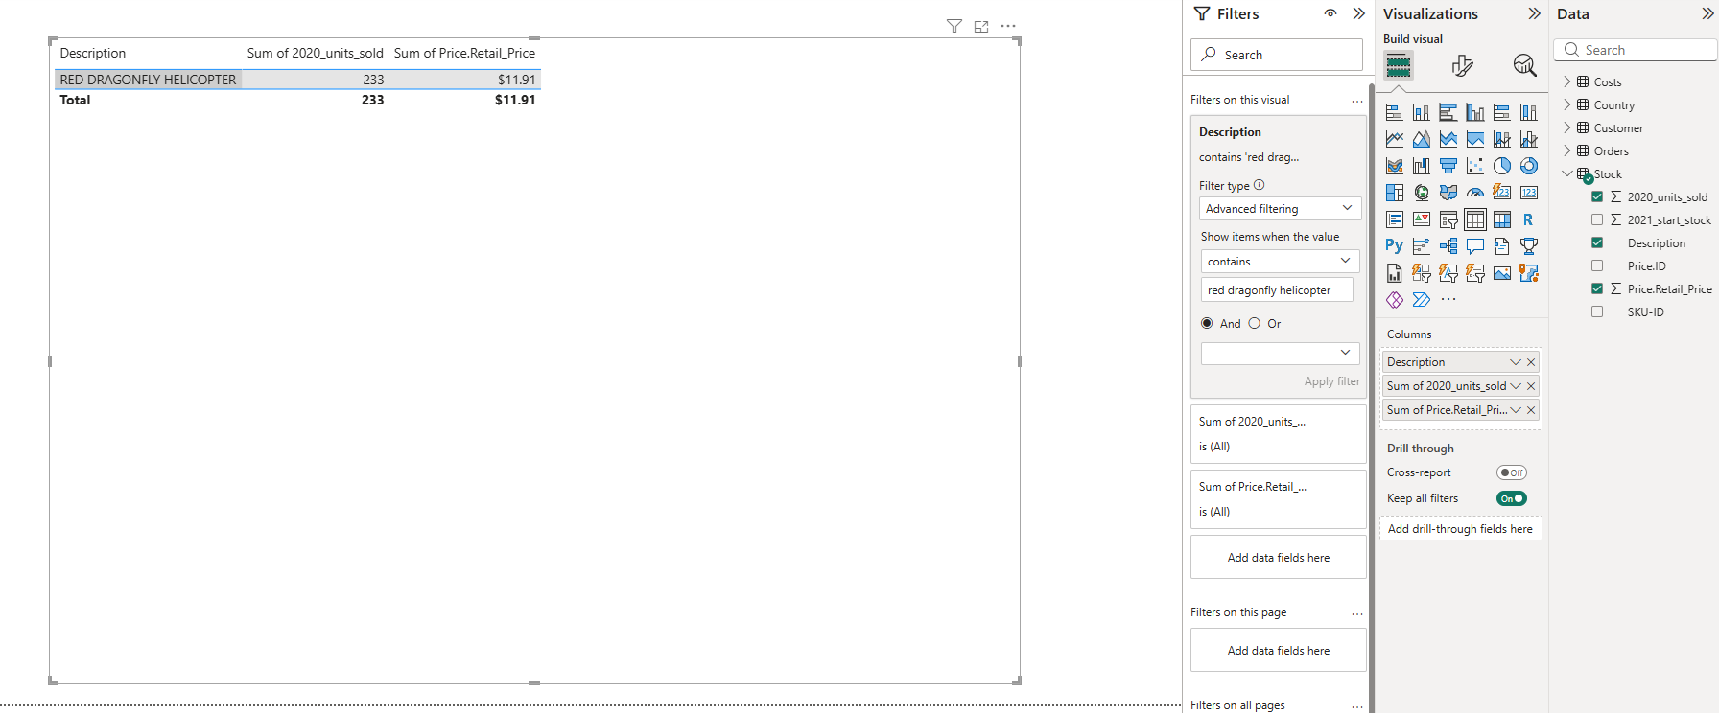
Figure 10
Step 9. Imported categories file to power query editor, In category column "home accessories" and toys was given, replaced the values from home ace to home accessories. Toys to toys & accessories.
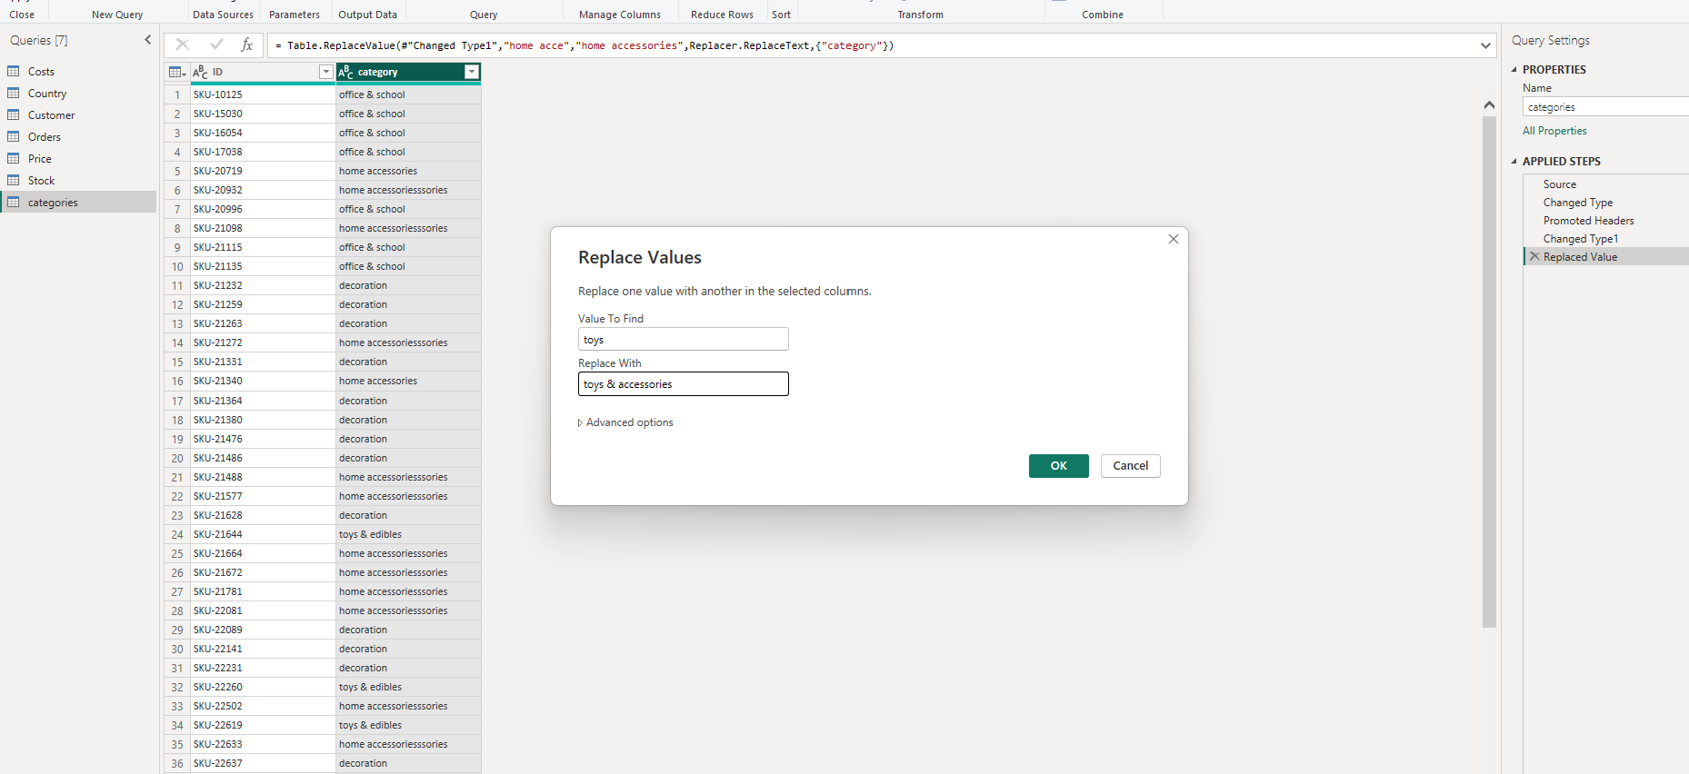
Figure 11
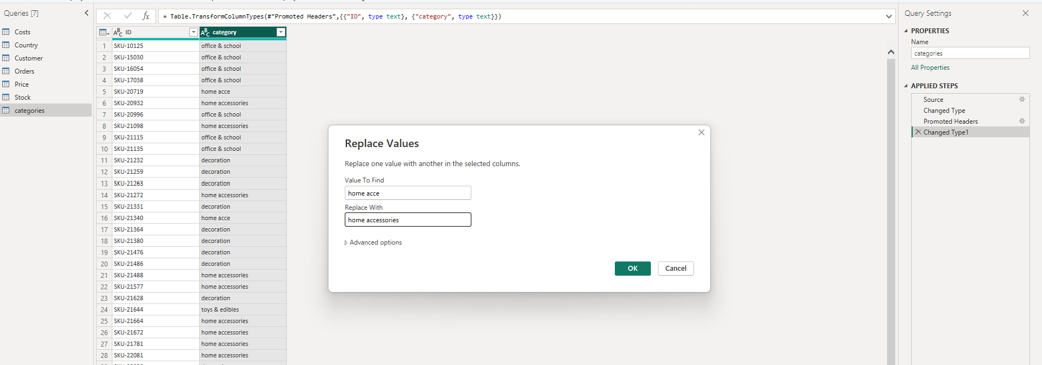
Figure 12
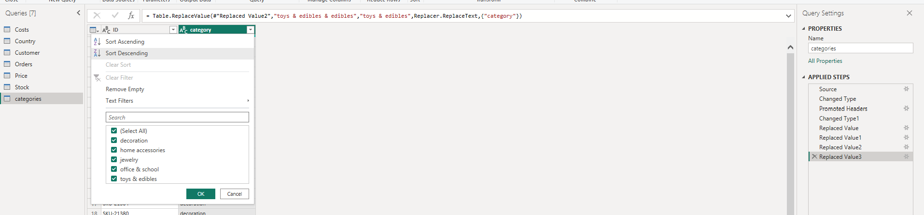
Figure 13

2. Data Modeling
Step 10. Data modeling.
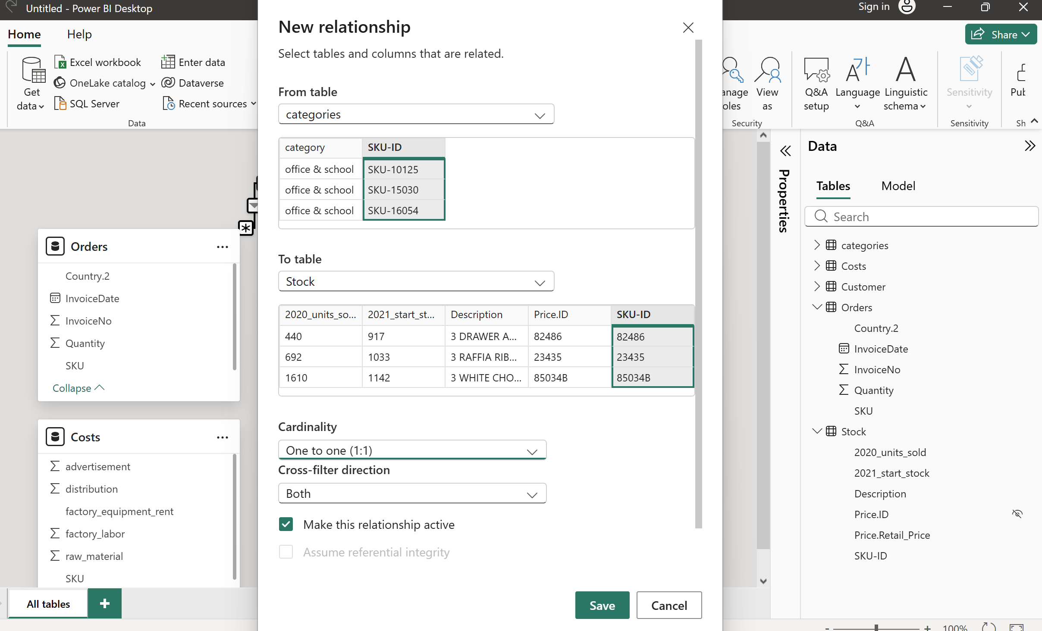
Figure 14
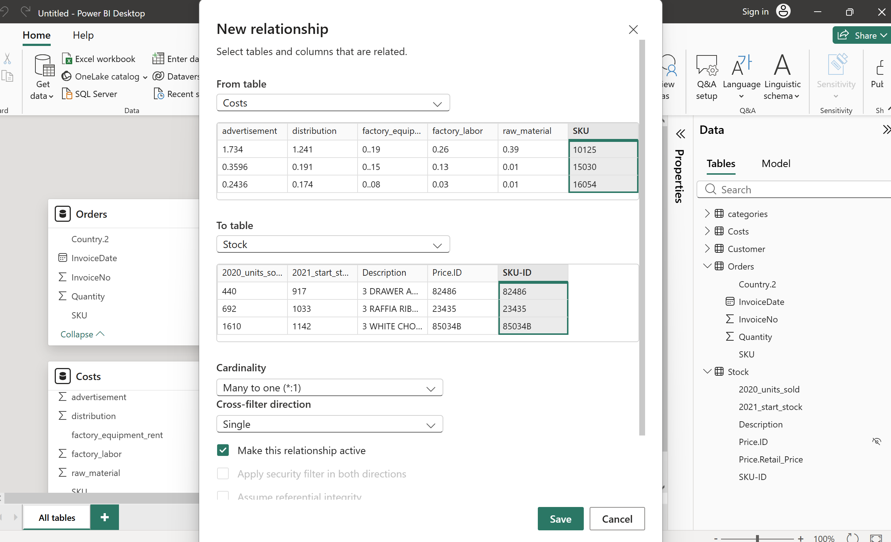
Figure 15
Step 11. Proportion of total quantity of sales in Spain corresponding to decorations 19.72%
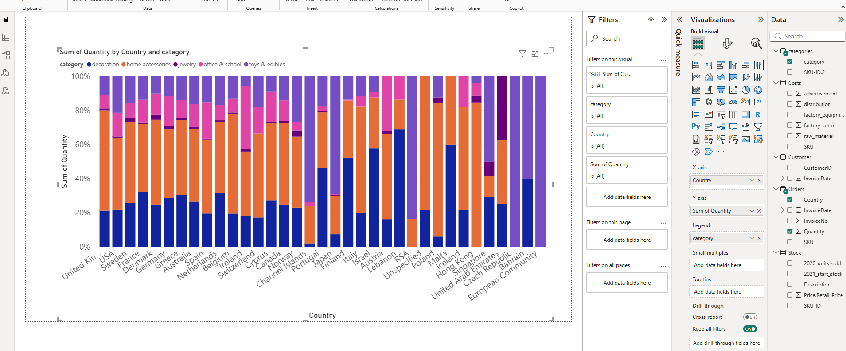
Figure 16
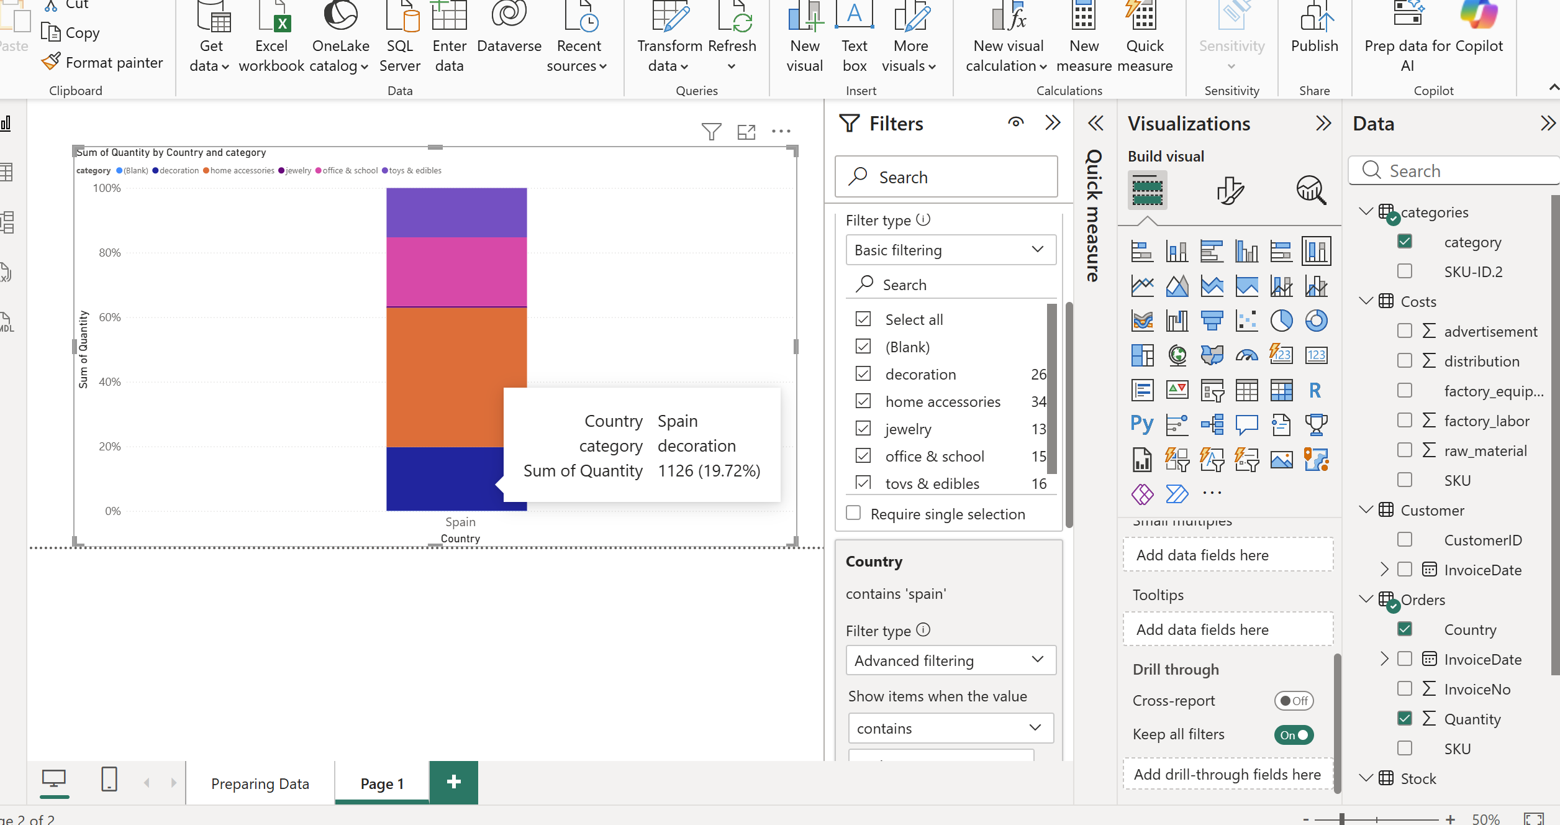
Figure 17
Step 12. In cost table removed duplicates from SKU column, in factory_equipment_rent column header replaced the from .. to .
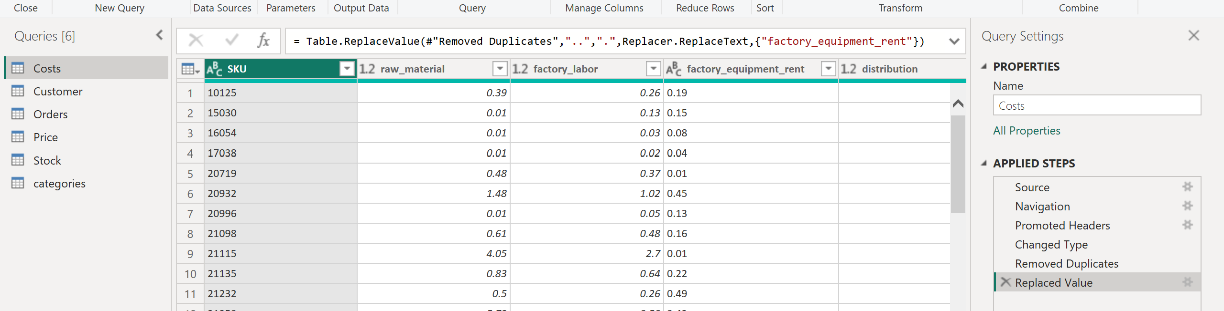
Figure 18

3. Cost, Revenue & Profit Analysis
Step 13. Created calculated column, clicked add column – created column - COGS = raw_material + factory_labor + factory_equipment_rent
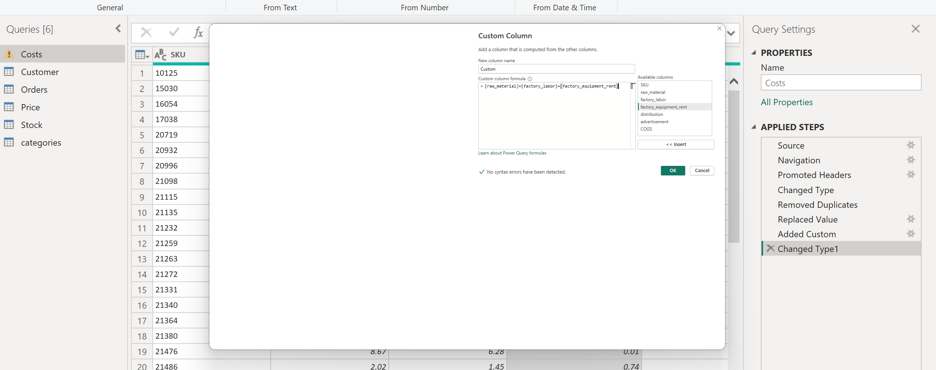
Figure 19
Step 14. Merged COGS column, into stock table.
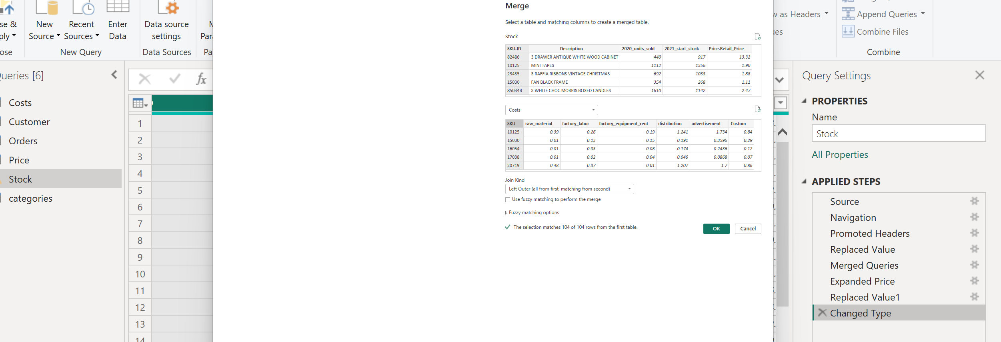
Figure 20
Step 15. COGS, Revenue and Profit. Added stacked bar chart to visual. Added category to y axis and average of cogs.
To answer the question – avg of COGS in category home acc is $ 4.7718.
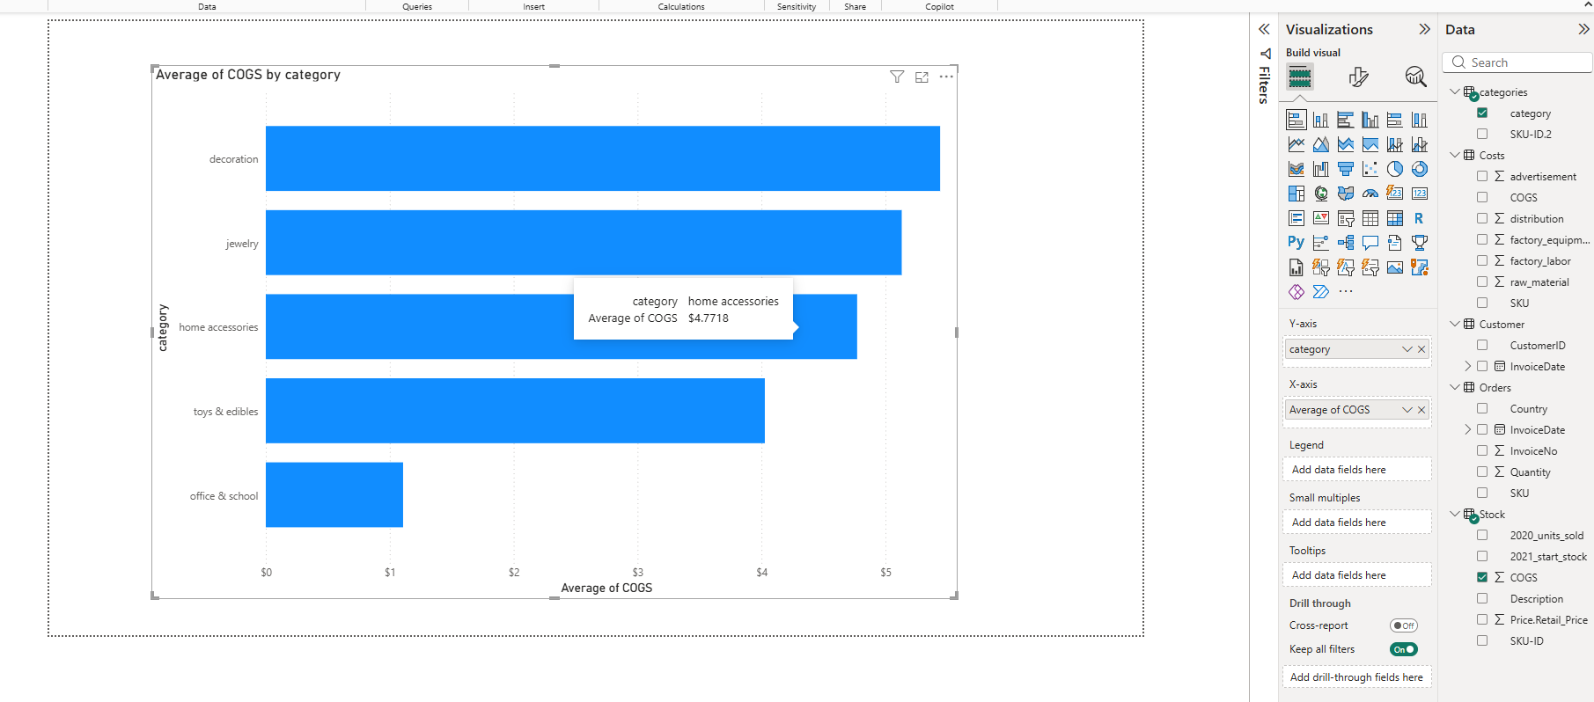
Figure 21
Step 16. Created calculated columns for revenue 2020 and profit 2020 in stock table.
- Revenue_2020 = 2020_units_sold * Retail_Price.
- Profit_2020 = Revenue_2020 - 2020_units_sold * COGS
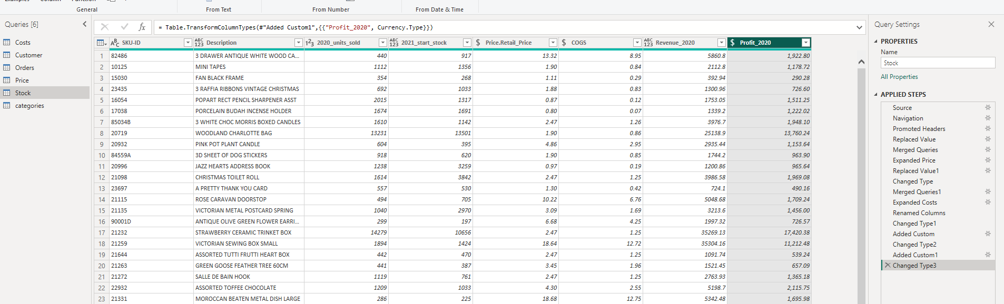
Figure 22
Step 17. Category that generates more profit in 2020 will be Home Accessories which is $ 110,007.48
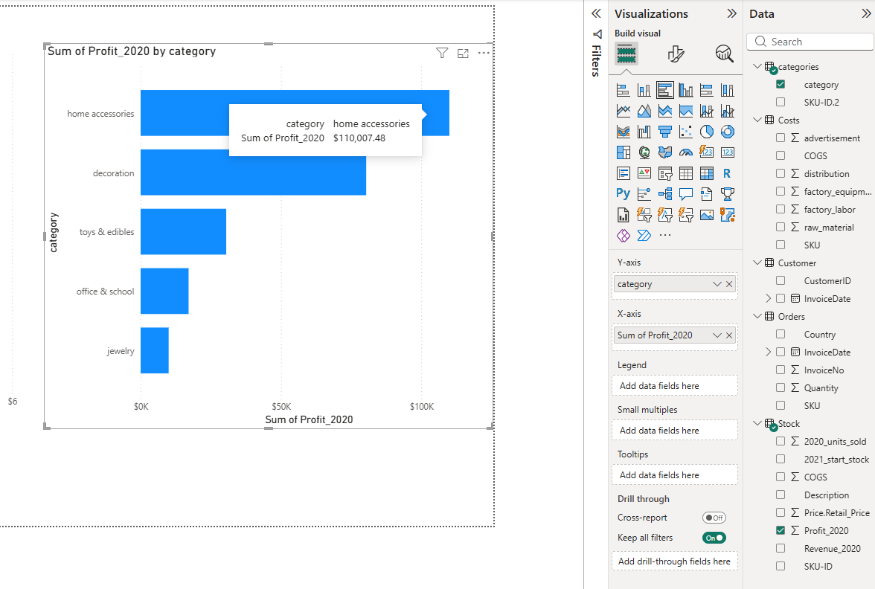
Figure 23

4. Sales Trend Analysis
Step 18. Created a calculated column called year. Year = orders.[invoice.date] .[year]
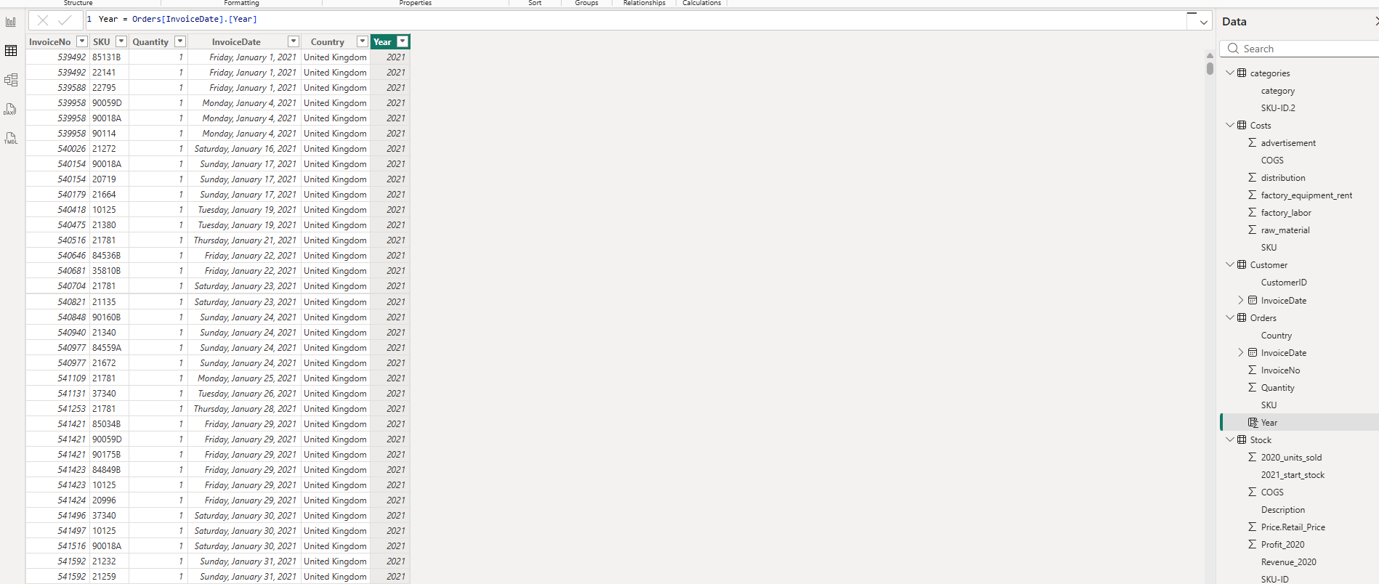
Figure 24
Step 19. To find the total orders, created a new column in stock table,
Total_orders = CALCULATE(sum(Orders[Quantity]),FILTER( Orders, Stock[SKU-ID] = Orders[SKU] ))
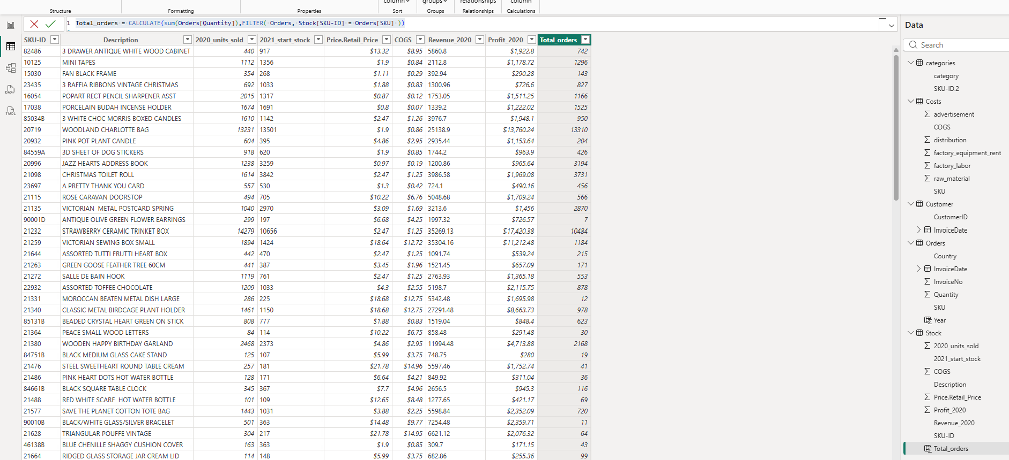
Figure 25
Step 20. Calculated 2 columns, for quantity 2021 and 2022.
Quantity_2021 = CALCULATE(sum(Orders[Quantity]), FILTER(Orders,Orders[SKU] = Stock[SKU-ID] && Orders[Year]=2021))
Quantity_2022 = CALCULATE(sum(Orders[Quantity]), FILTER(Orders,Orders[SKU] = Stock[SKU-ID] && Orders[Year]=2022))
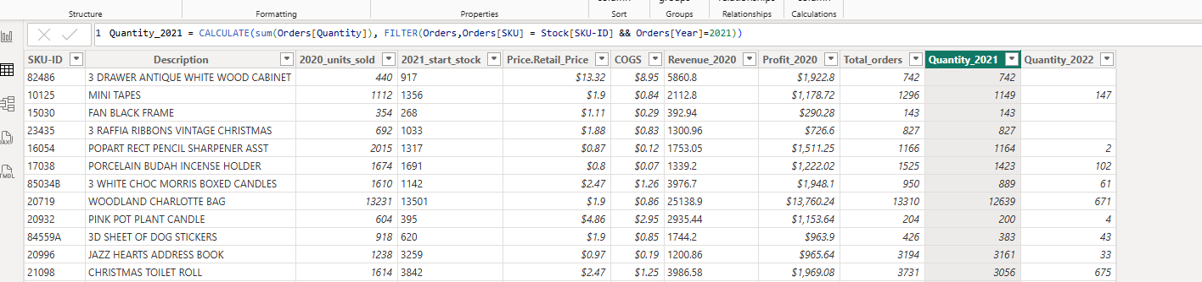
Figure 26
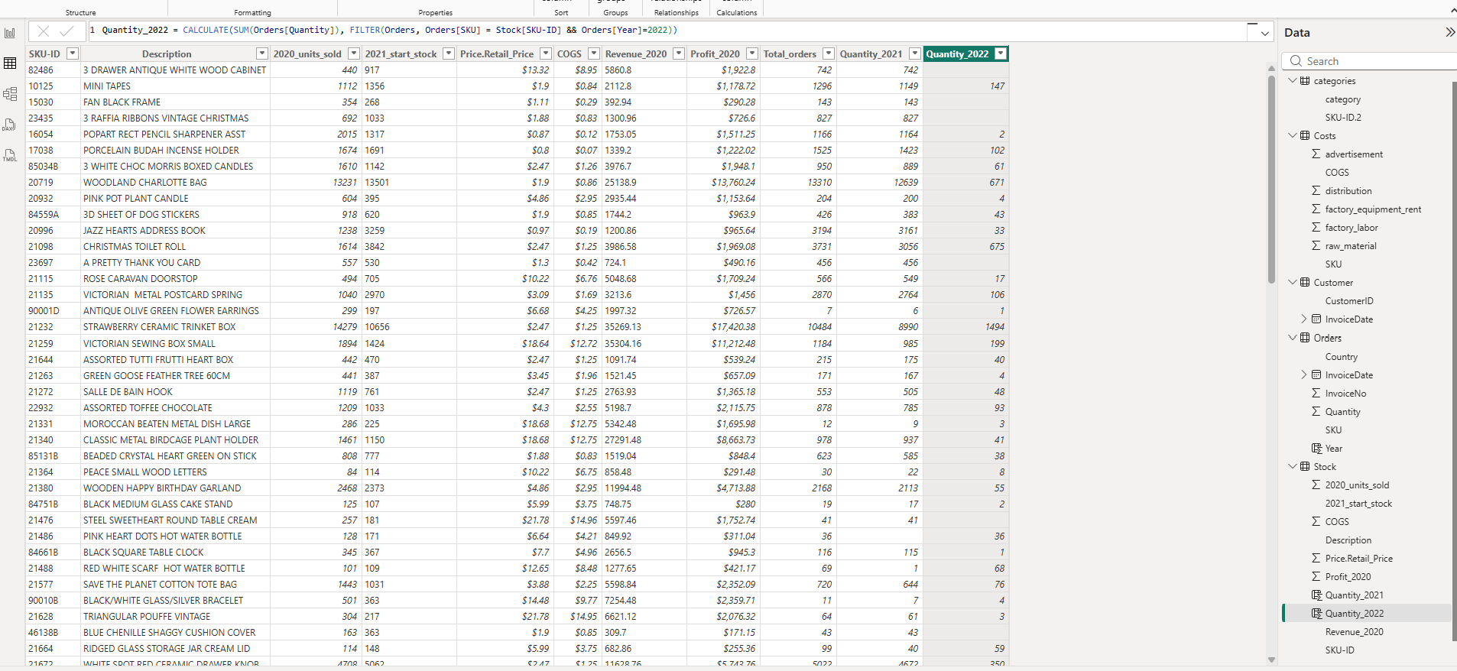
Figure 27
Step 21. Total quantity of order by year. 2021 has more sales than 2022.
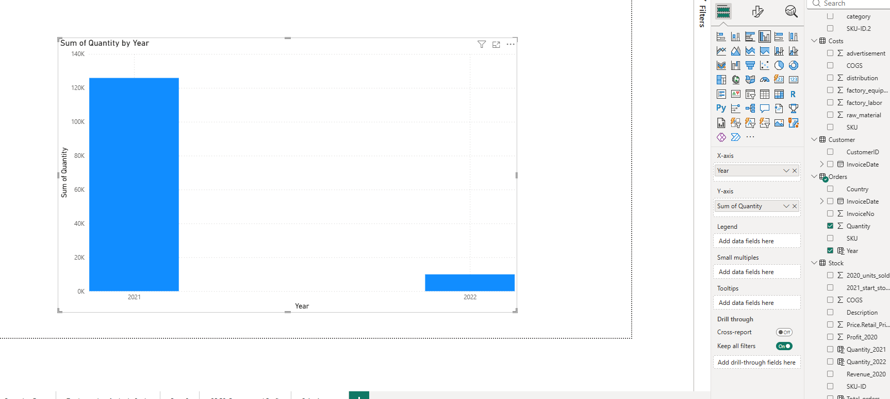
Figure 28
Step 22. Percentage of highest sold item, - Grow A FLYTRAP OR SUNFLOWER IN TIN , which is 10.85%.
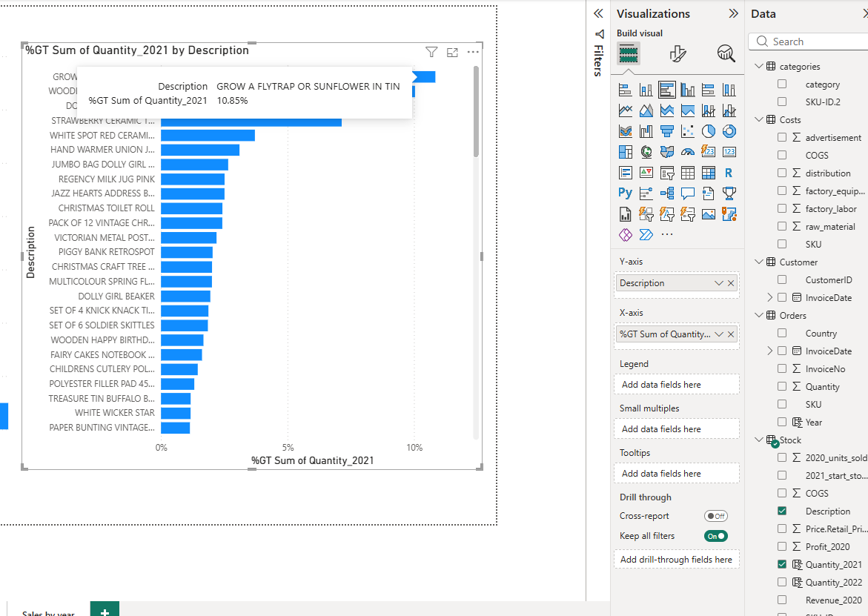
Figure 29

5. Inventory Turnover
Step 23. Inventory Turnover
Created a new table using DAX selectcolumns function.
Turnover = SELECTCOLUMNS(Stock,"SKU-ID", Stock [SKU-ID],"Description",stock[DESCRIPTION],"2021_start_stock",Stock[2021_start_stock],"Quantity_2021",Stock[Quantity_2021],"COGS",Stock[COGS])
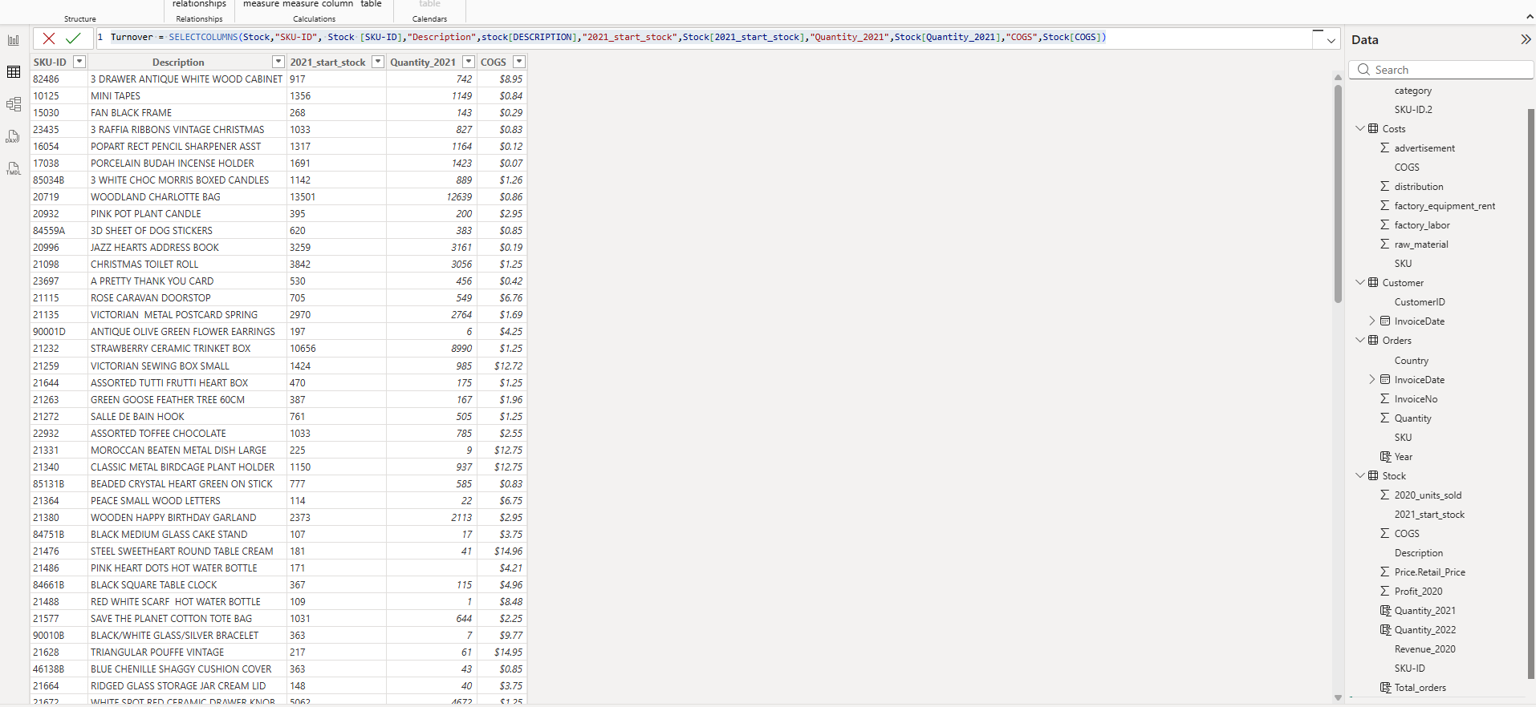
Figure 30
Step 24. Added 3 calculated columns, 2021_Endstock, Average_ Inventory, Inventory_turnover to the Turnover Table.
- Column 2021_Endstock = Turnover[2021_start_stock] - Turnover[Quantity_2021]
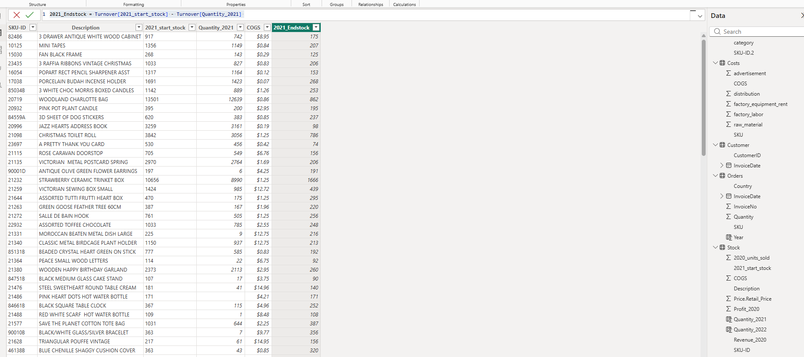
Figure 31
- Column Avg_Inventory = Avg_Inventory =
VAR StartingValue = Turnover[2021_start_stock] * Turnover[COGS]
VAR EndingValue = Turnover[2021_Endstock] * Turnover[COGS]
RETURN
(StartingValue + EndingValue) / 2
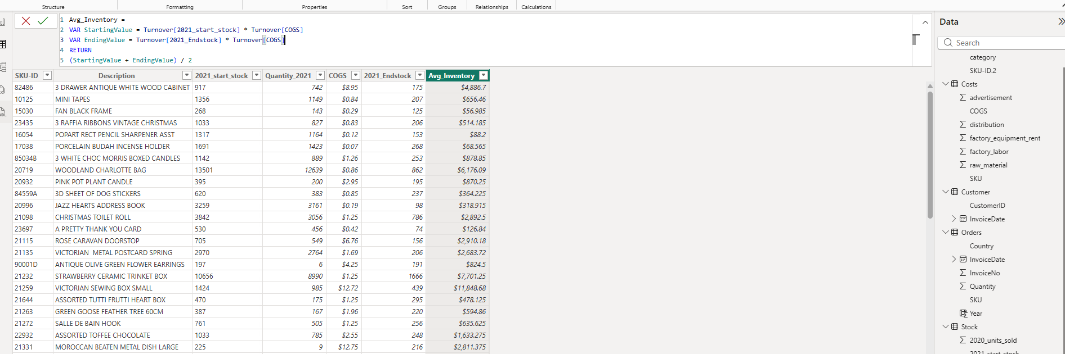
Figure 32
- Column Inventory _Turnover = (Turnover [Quantity_2021] * Turnover[COGS]) / Turnover[Avg_Inventory]
Step 25. Highest value inventory - DOUGHNUT LIP GLOSS – 1.97
Figure 33

6. Revenue Growth & ABC (Pareto) Classification
Step 26. Revenue 2021, calculated column on stock table
Revenue_2021 = Stock [Quantity_2021] * Stock [Price.Retail_Price]
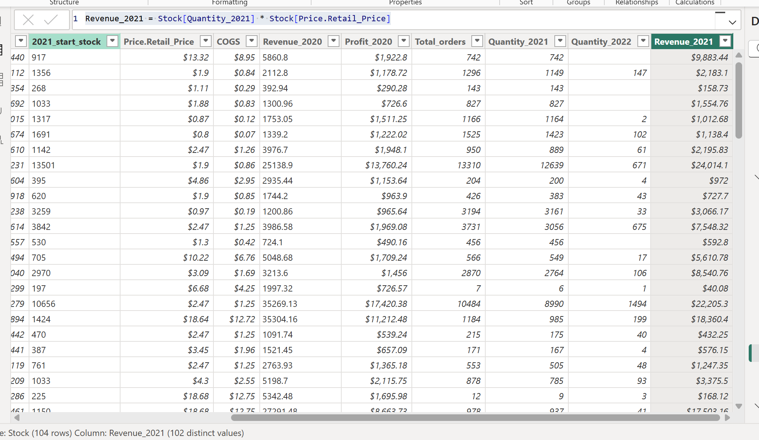
Figure 34
Step 27. Percentage Revenue 2021 and 2020.
2021 - percent_revenue2021 = Stock[Revenue_2021] / sum(Stock[Revenue_2021]) * 100
2020 - percent_revenue2020 = Stock[Revenue_2020] / sum(Stock[Revenue_2020])*100
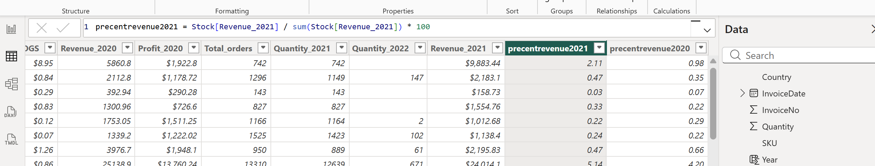
Figure 35
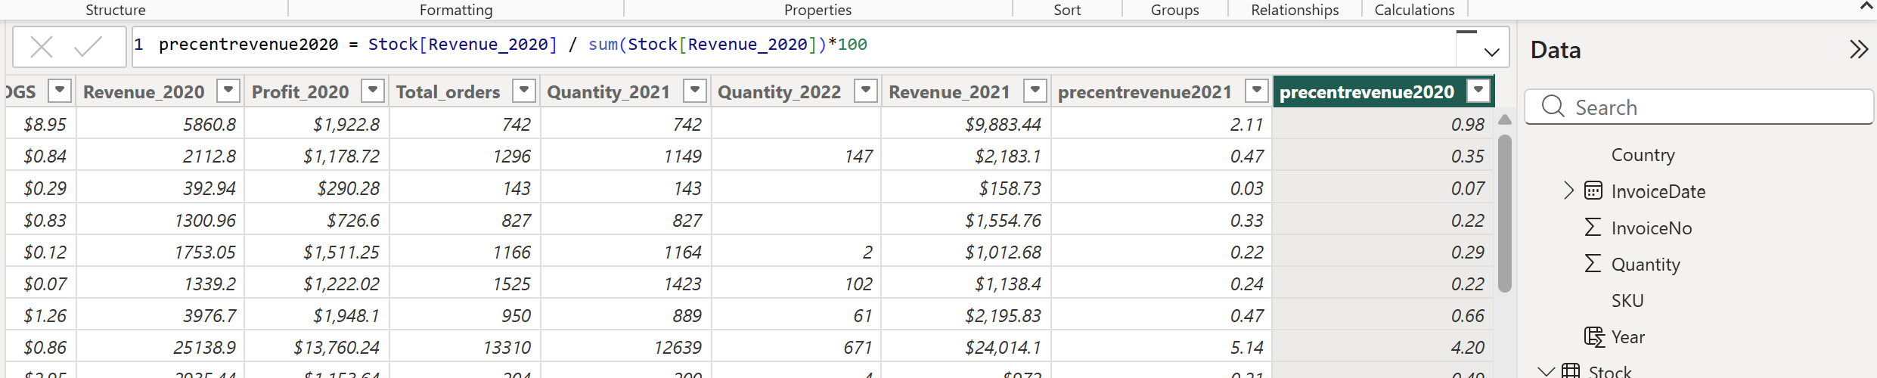
Figure 36
Step 28. Among the top 10 items with highest percentage of total revenue from 2020 to 2021 will be - SET OF 6 SOLDIER SKITTLES with 3.7% growth in 2021.
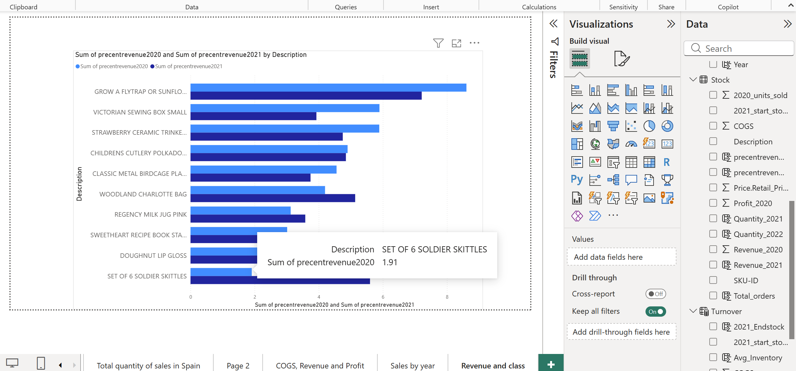
Figure 37
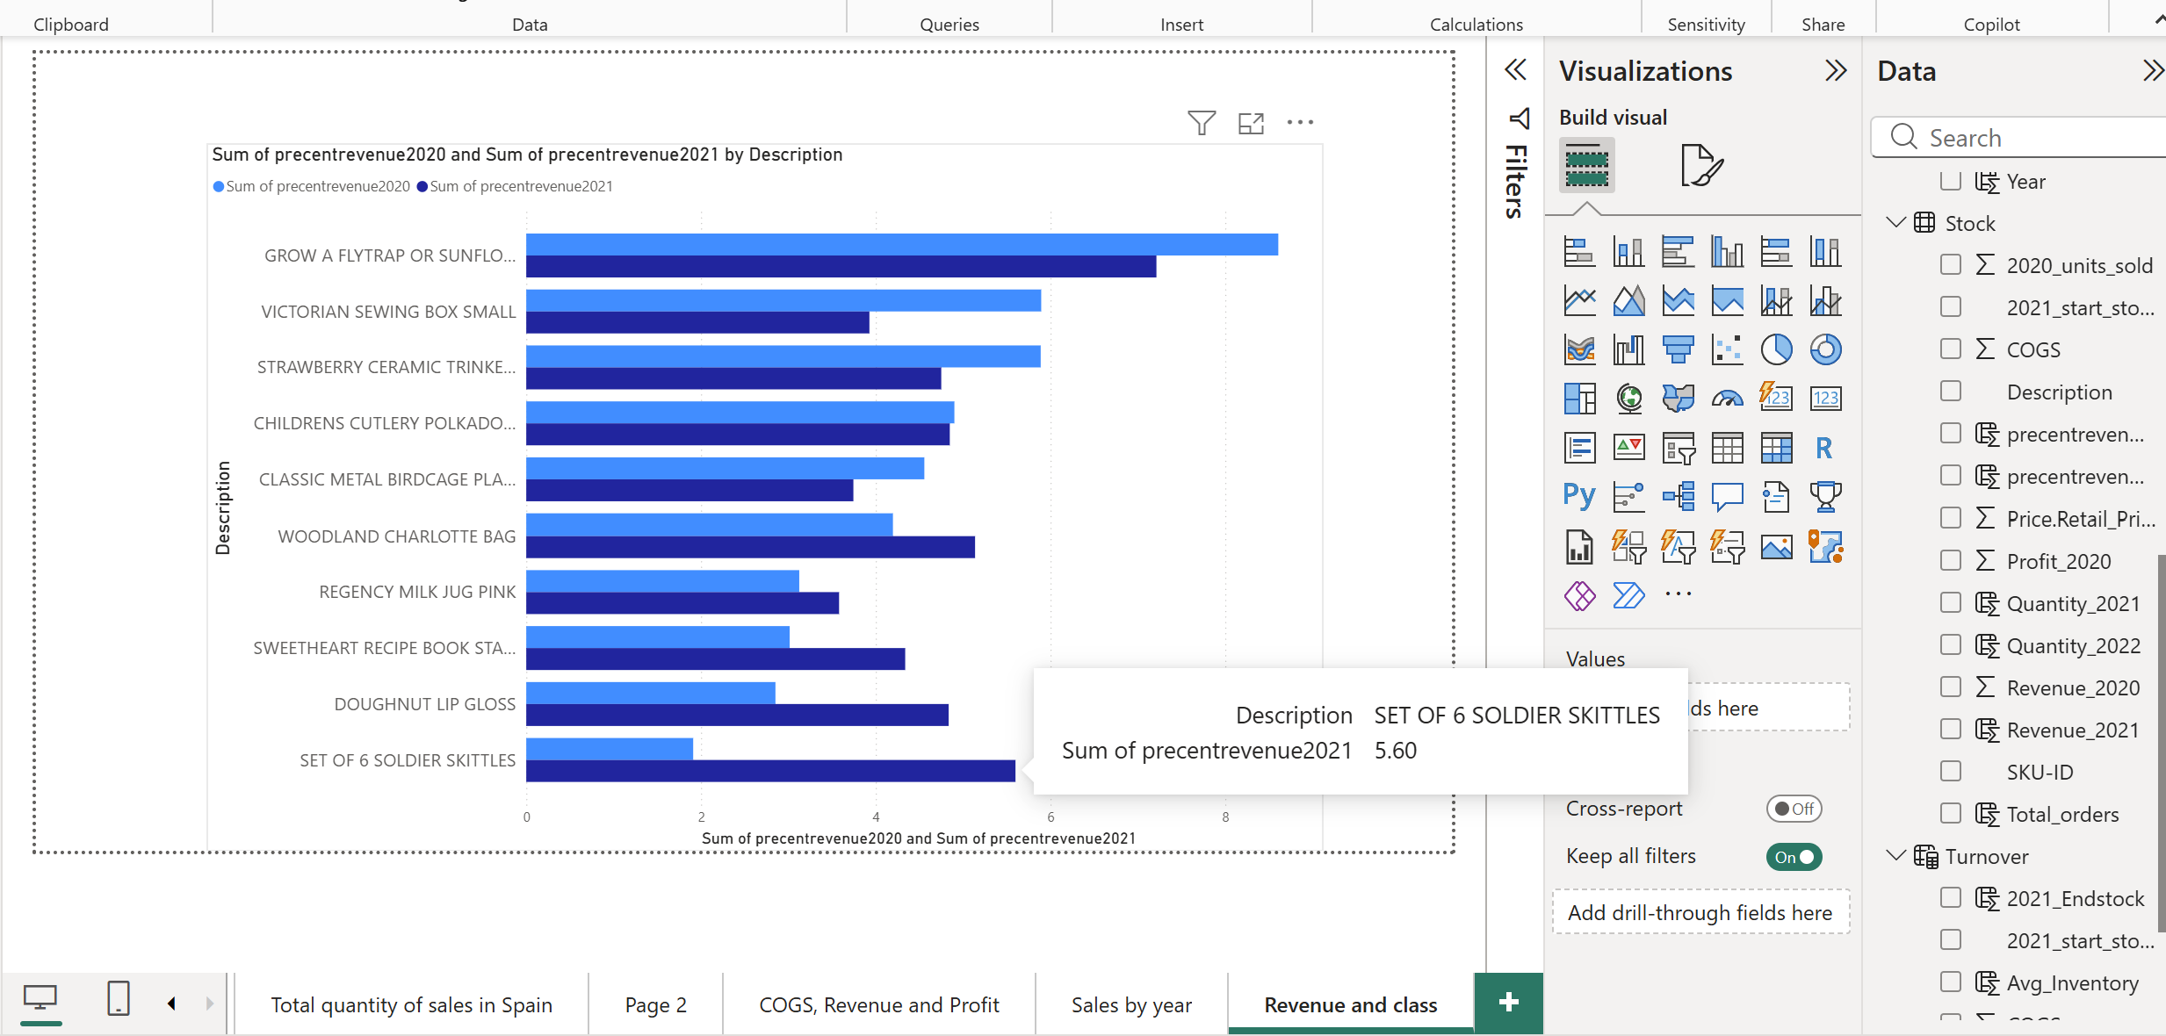
Figure 38
29. Created a new table ABC= SELECTCOLUMNS(Stock,"SKU-ID",Stock[SKU-ID],"Description",Stock[Description],"Revenue_2021",Stock[Revenue_2021],"percent_revenue_2021",Stock[precentrevenue2021])
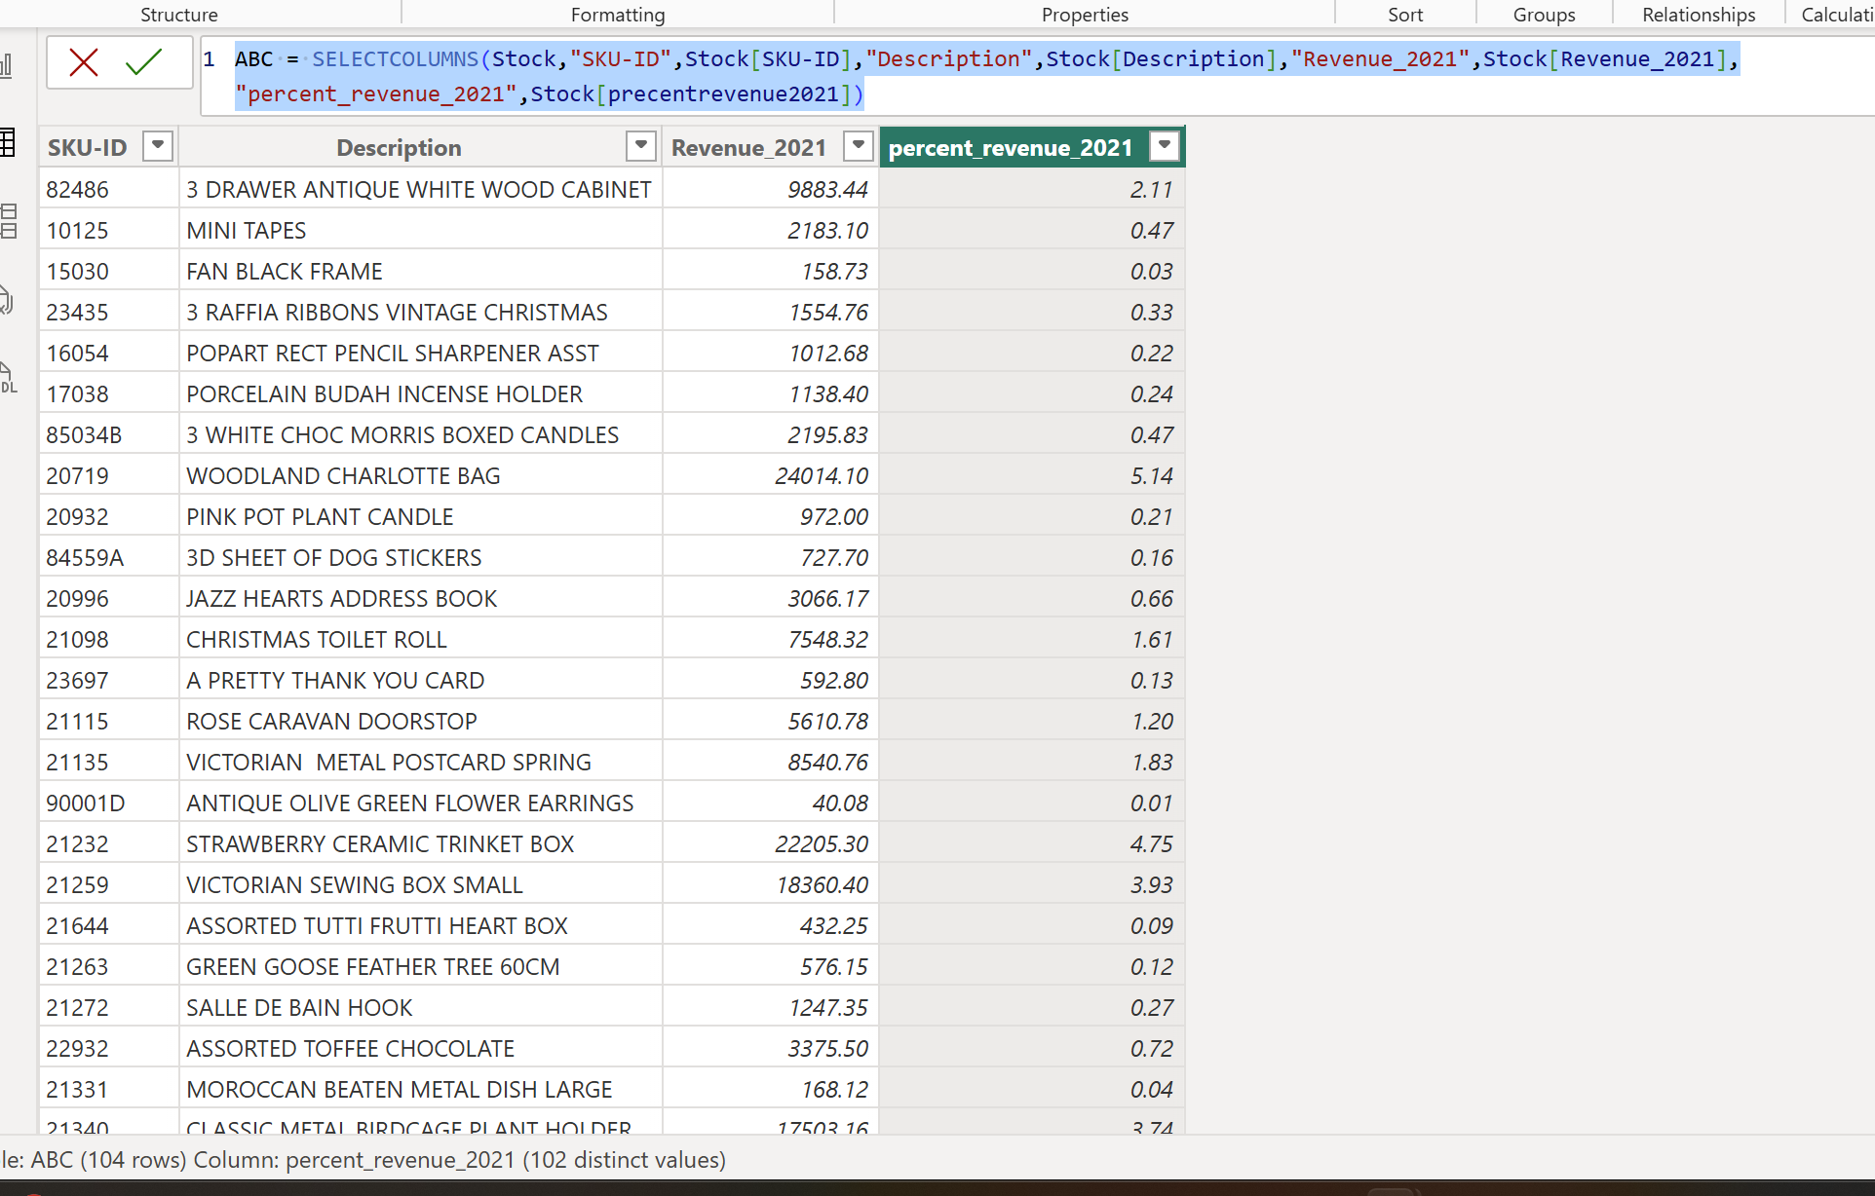
Figure 39
30. Calculated new column in table ABC - CP_revenue = CALCULATE(SUM(ABC[percent_revenue_2021]),FILTER(ABC,[percent_revenue_2021]>=EARLIER(ABC[percent_revenue_2021])))
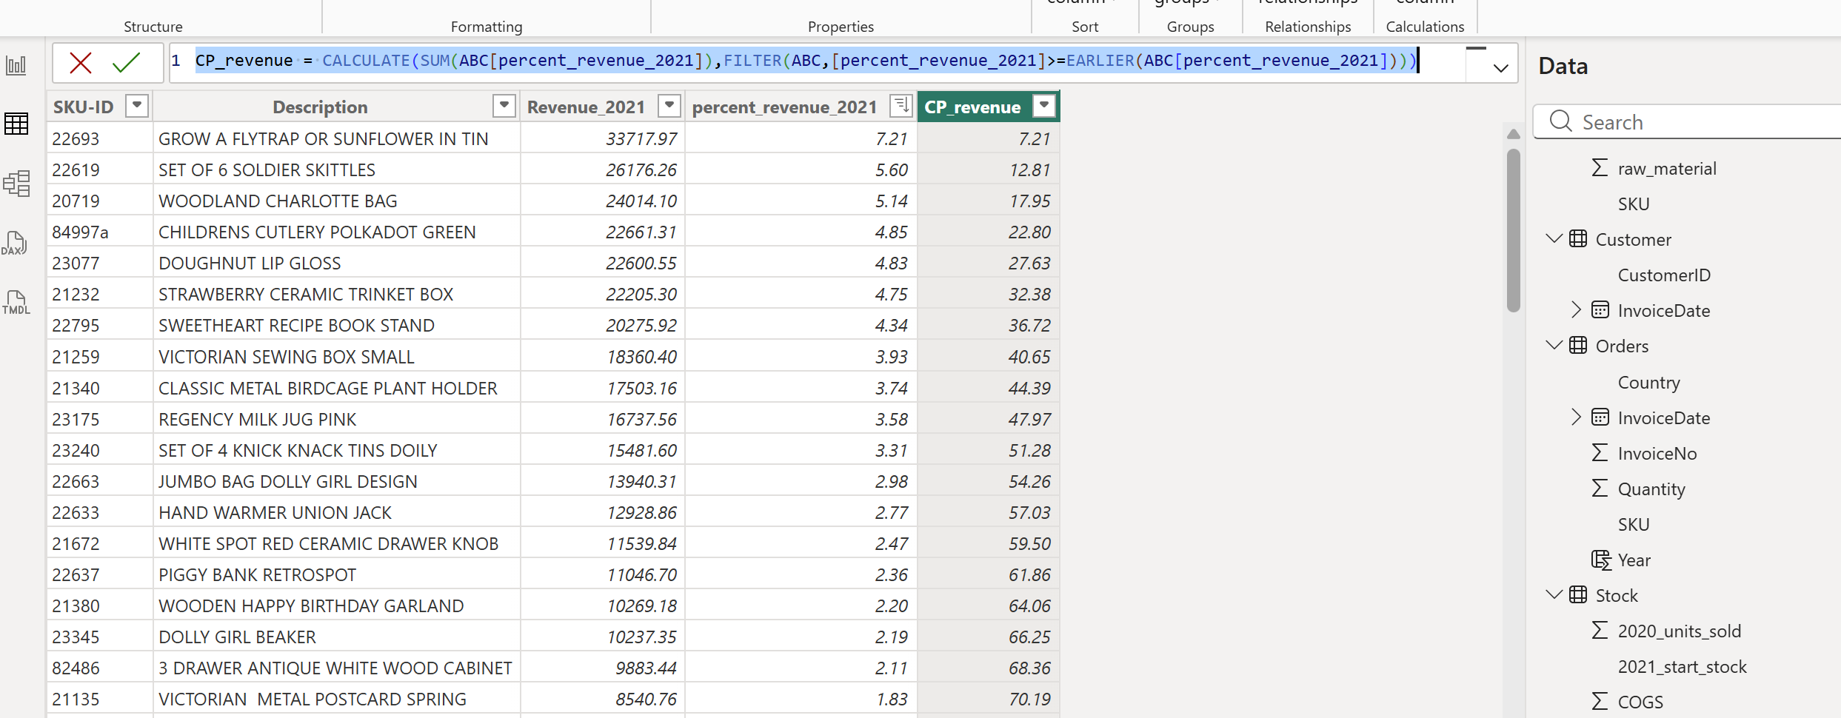
Figure 40
Step 31. Calculated a new column ABC_class in ABC table, to classify the items to A, B, C with nested IF function.
ABC_Class = IF(ABC[CP_revenue] <=70, "A [High Value]",IF(ABC[CP_revenue] <=90,"B [Medium Value]", "c[Low Value]"))
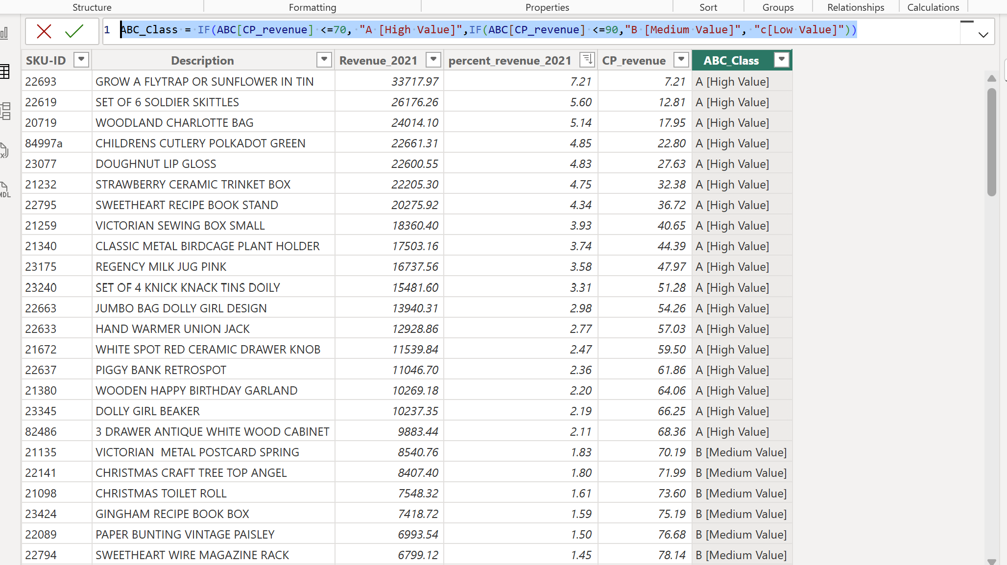
Figure 41
Step 32. Total revenue of the last item in the category A- will be $9,883.44,- 3 DRAWER ANTIQUE WHITE WOOD CABINET
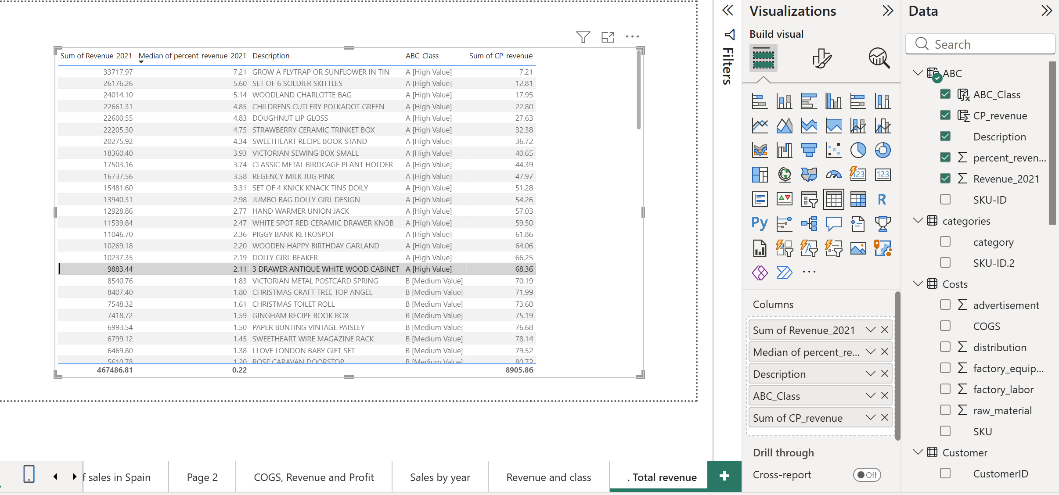
Figure 42

7. Visualizations & Dashboard
Step 33. Preliminary results
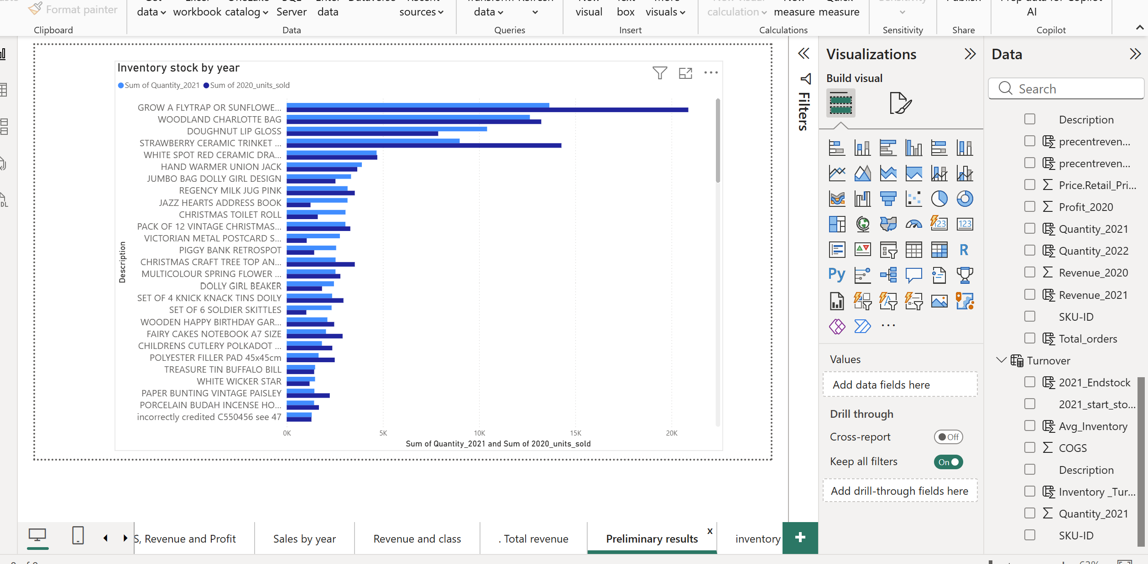
Figure 43
Step 34. Inventory_turnover
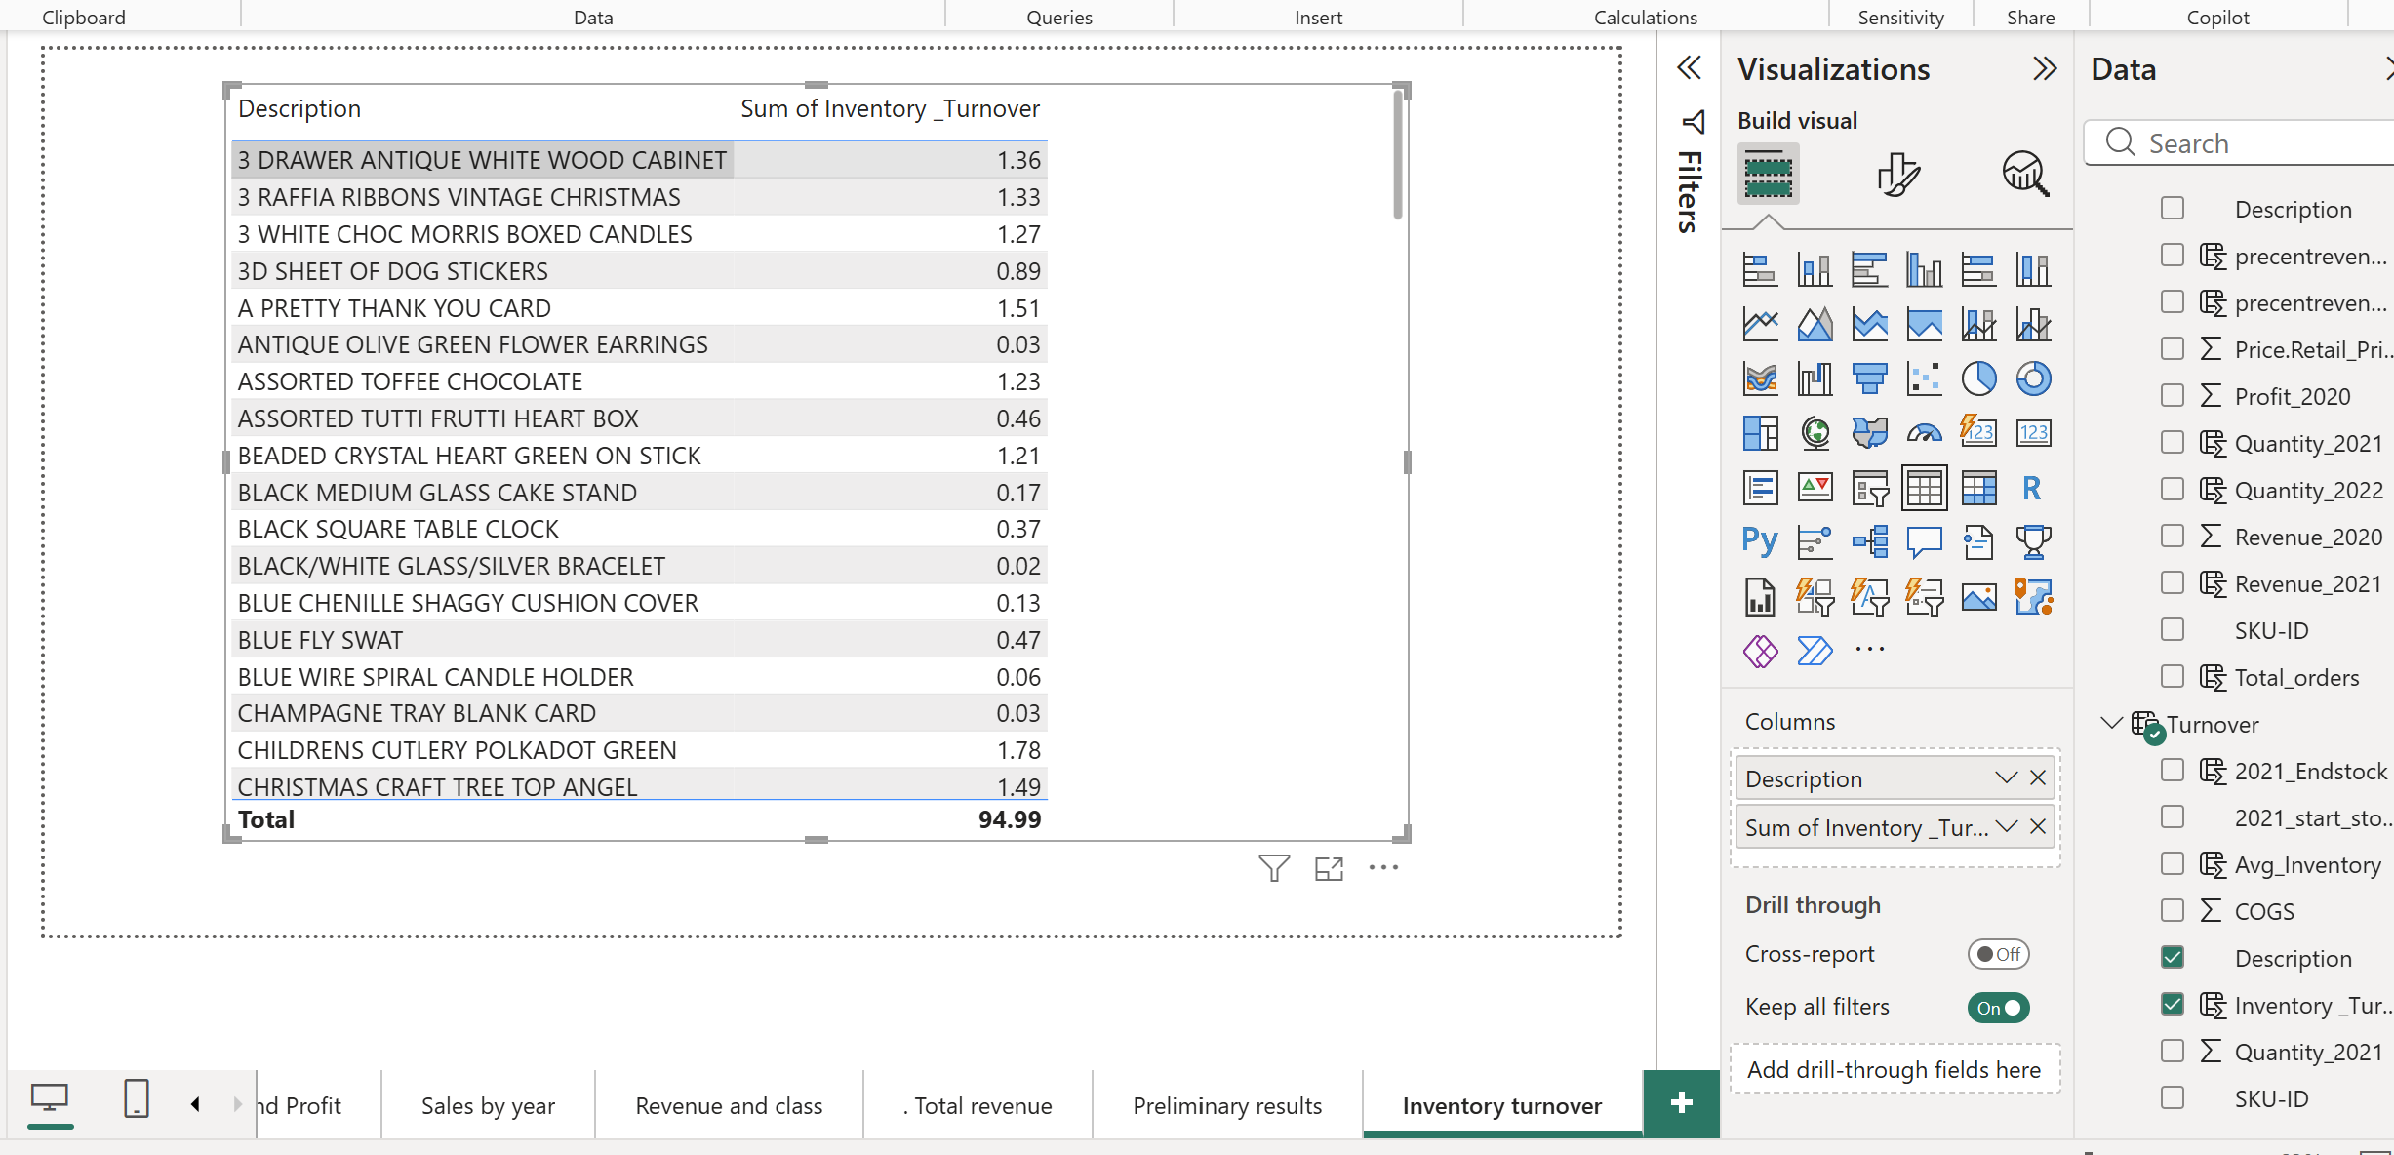
Figure 44
Step 35. Percentage Of Revenue
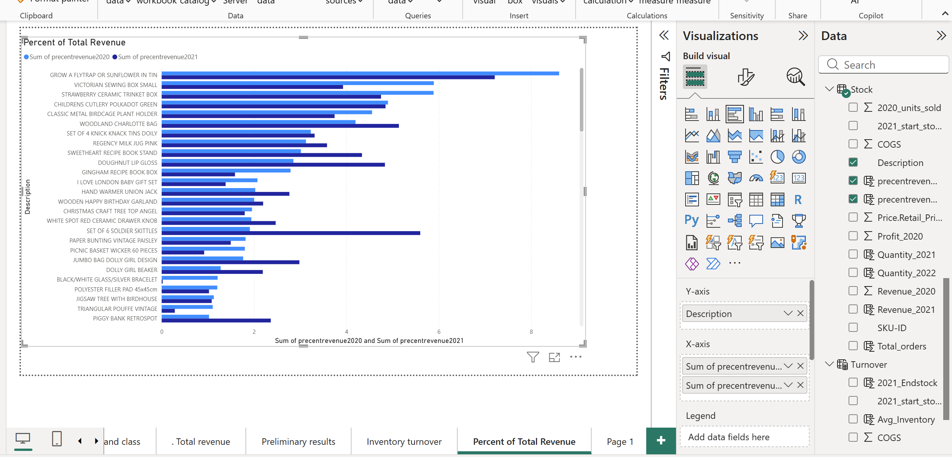
Figure 45
Step 36. Table visual - Woodland Charlotte Bag is A class with near-equal sales.
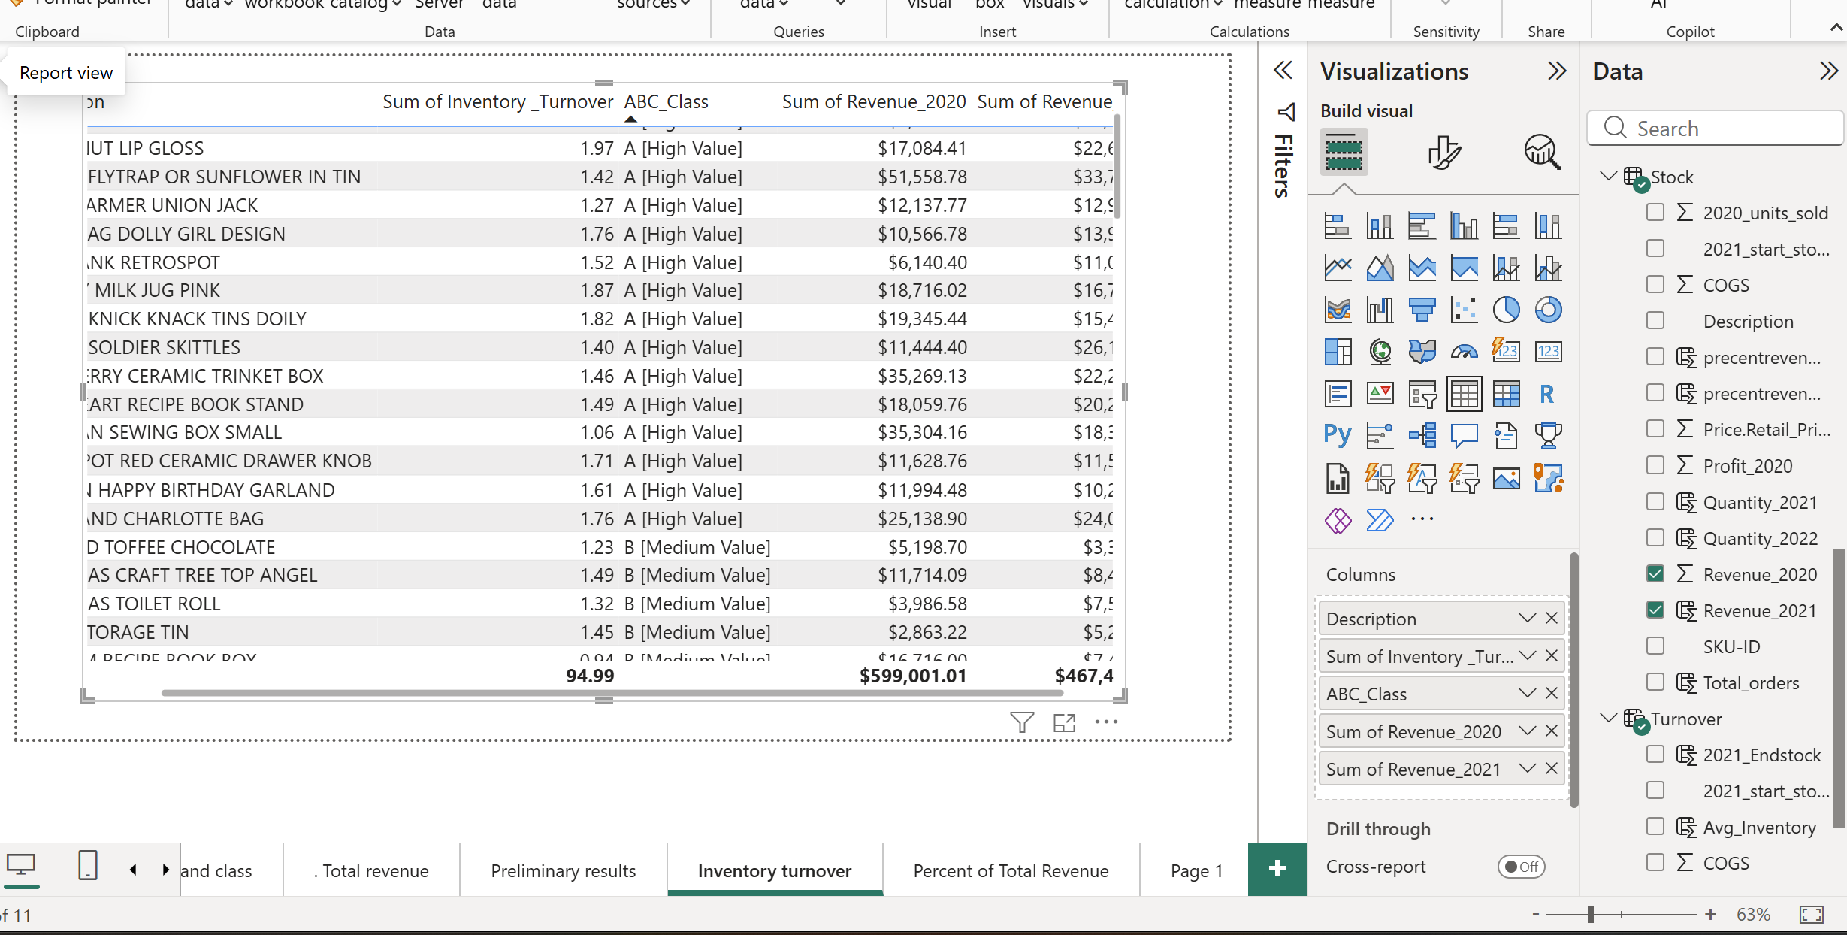
Figure 46
Step 37. Smart Purchasing
- Created a new column in stock table - TotalCOGS2021 = Stock[Quantity_2021] * Stock[COGS]
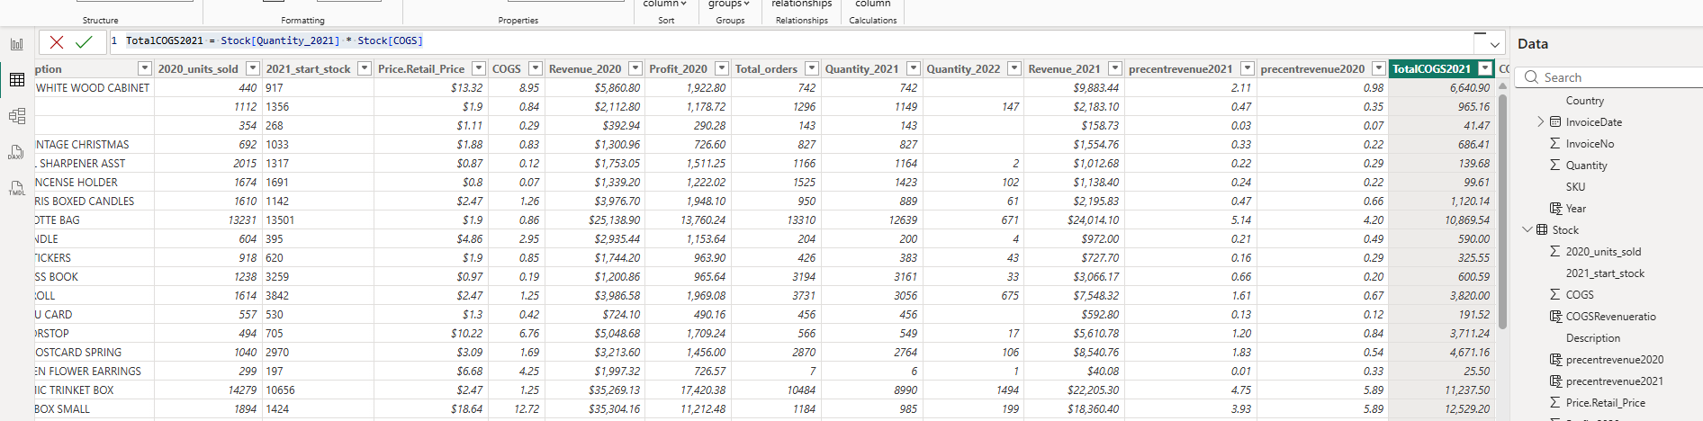
Figure 47
- Created one more column - COGSRevenueratio = COGSRevenueratio = Stock[TotalCOGS2021] / Stock[Revenue_2021]
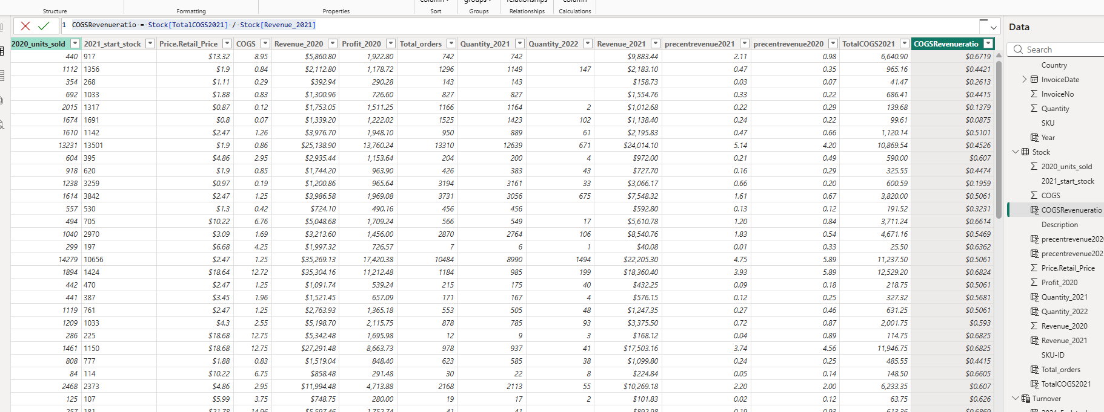
Figure 48
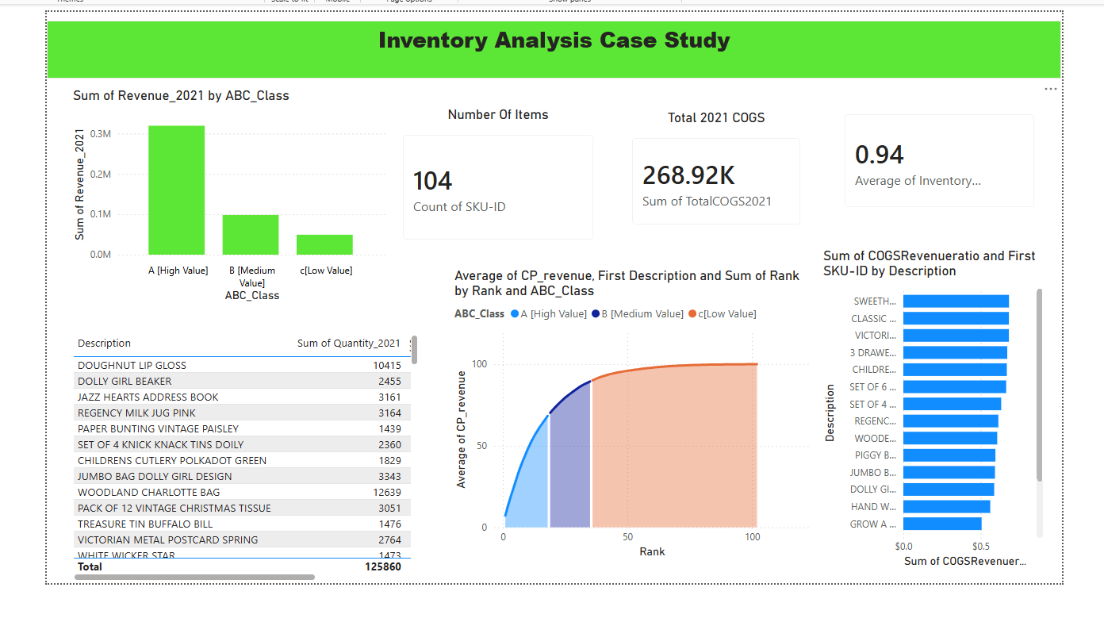
Figure 49
Step 38. Inspecting Categories
Created column chart, to classify ABC class difference and 2021 quantity.
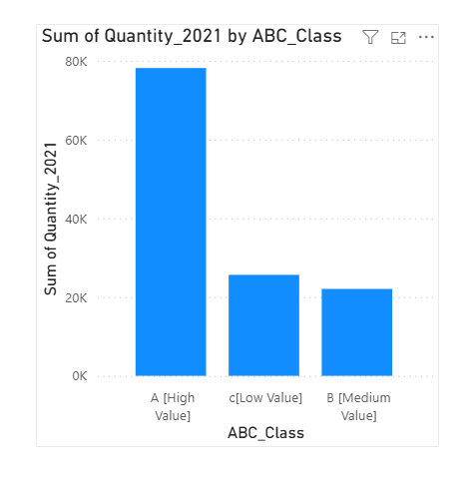
Figure 50
Step 39. Average Inventory Turnover Visual.
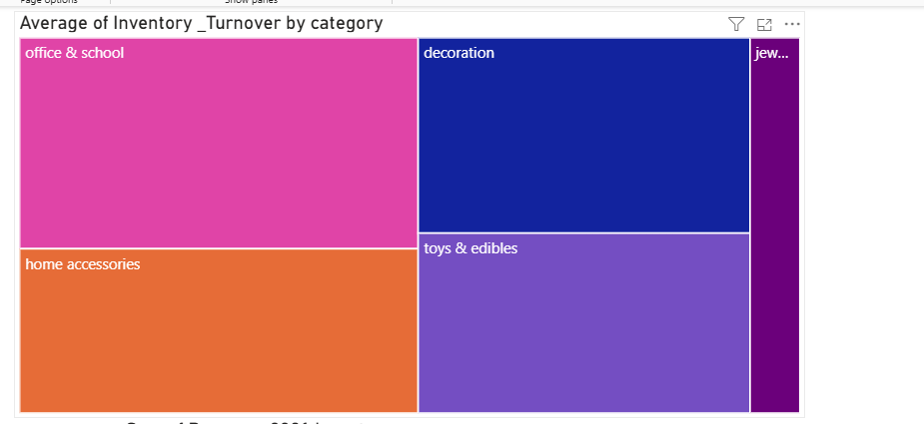
Figure 51
Step 40. Total Revenue Visual.
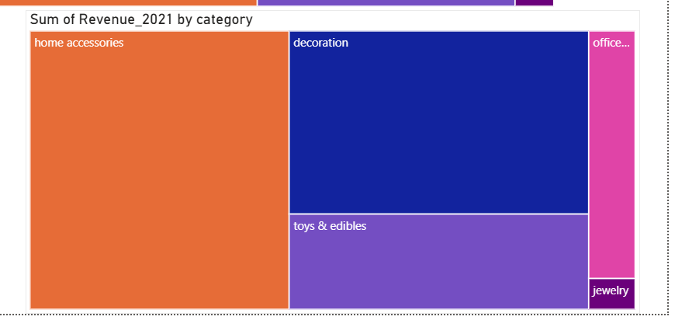
Figure 52
Step 41. Control Decisions – created table visual
Inventory turnover for Quantity_2021
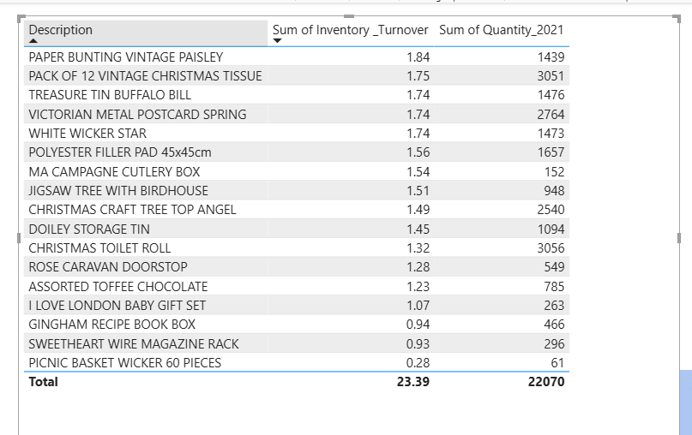
Figure 53
Step 42. Revenue by Item Chart – Bar chart.
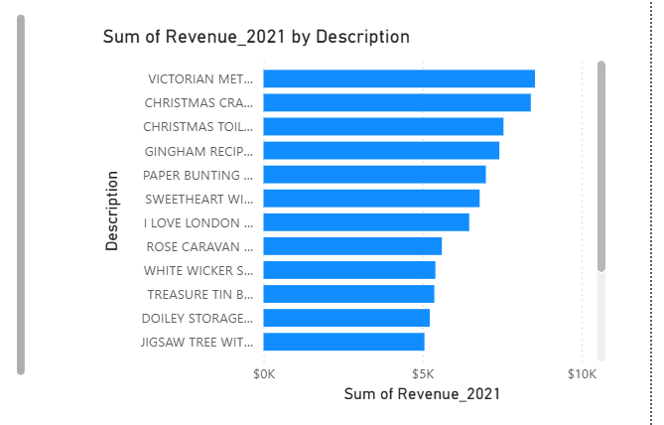
Figure 54
Step 43. Orders by Country Map – Map visual
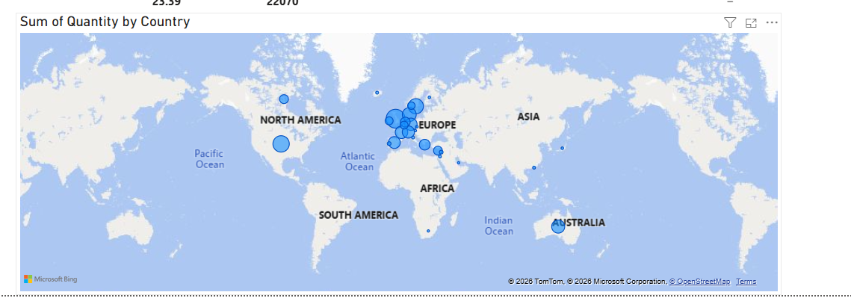
Figure 55

8. Key Analytical Findings
Answers derived from the completed model and interactive dashboard.
Q While filtering for medium value items, which category disappears?
A jewelry
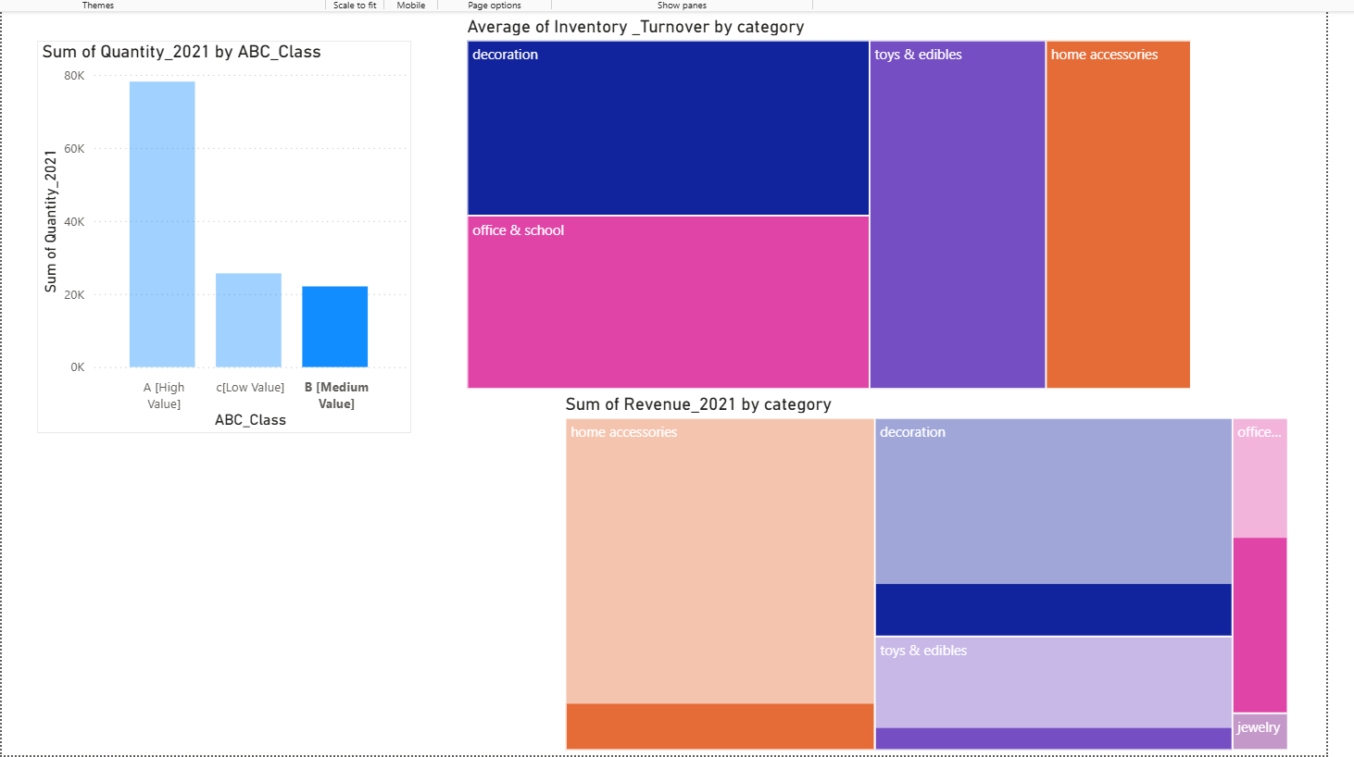
Figure 56
Q Inventory Turnover Value- highest-revenue B item
A 1.74.
Q Which country makes most orders of item?
A Denmark.
Q Average Inventory Turnover for Class A and Class B
A 0.21
Q Cumulative percentage value for rank 10 is
A 47.97%

Final Dashboard
Interactive single-page dashboard summarising inventory value, COGS, turnover and ABC classification.
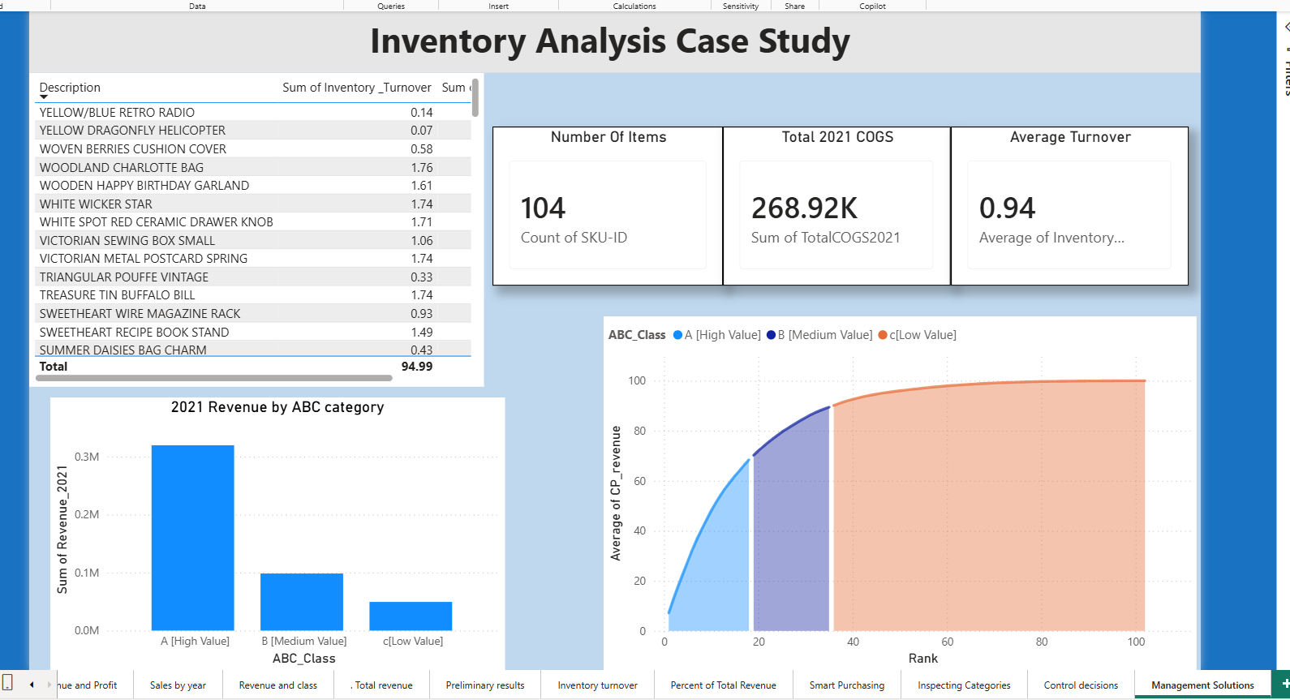
Figure 57

