NovaTech Electronics - Power BI Analytics Bootcamp Project
Retail sales, profitability, targets, and returns dashboard solution
Tool | Power BI
Analysis focus | Sales cleaning, star schema modeling, DAX measures, targets, returns, and dashboard pages
Methods used | Power Query, star schema, DAX, time intelligence, KPI dashboards
Evidence included | 5 dashboard screenshots plus DAX/model documentation

Phase 1- Data Loading
- Data was shared in 7 files which contained 8 tables. Files were shared in CSV and Excel sheets.
- Files were loaded and transformed into power query editor.

Phase 2 - Power Query:

Data Cleaning & Transformation
Data was cleaned in power query editor, steps followed to clean this data. Changing data type, adding column by example to fix date format, splitting column by delimiter to separate customer phone number and email id, fixing category typo, removed duplicate transactions, used append queries to combine two separate sales table into one, merged product pricing and product listings into one product table, replaced values.

PHASE 3 — Building the Data Model
1.Created a date table - Time-intelligence (YTD, last month, moving average) needs one continuous calendar with every day of 2023. Tells Power BI “this is the calendar.”
2. Verified that dimension side of every relationship has a unique key. Products Product_Code (42), Customers Customer_ID (150), Stores Store_ID (10), Returns Return_ID (100), Combined_Sales Transaction_ID (1,363 unique).
3. Relationship- Using start schema, connected the fact and dimension table using bridge table

PHASE 4 — DAX Measures
Created a measure table.

1. CORE REVENUE MEASURES
1.Total Revenue = SUMX(Combined_Sales, Combined_Sales[Quantity] * Combined_Sales[Selling_Price])
2. Total Cost = SUMX(Combined_Sales, Combined_Sales[Quantity] * RELATED(Products[Cost_Price]))
3.Gross Profit = [Total Revenue] - [Total Cost]
4.Gross Margin % = DIVIDE([Gross Profit], [Total Revenue])
5. Total Transactions = COUNTROWS(Combined_Sales)
6. Total Units Sold = SUM(Combined_Sales[Quantity])
7.Avg Transaction Value = DIVIDE([Total Revenue], [Total Transactions])
8.Total Target = SUM(Targets[Target_Amount])

CALCULATE
Online Revenue = CALCULATE([Total Revenue], Combined_Sales[Channel] = "Online")
2. In-Store Revenue = CALCULATE([Total Revenue], Combined_Sales[Channel] = "InStore")
South Region Revenue = CALCULATE([Total Revenue], Stores[Region] = "South")
Premium Customer Revenue = CALCULATE([Total Revenue], Customers[Customer_Segment] = "Premium")
Laptops Revenue = CALCULATE([Total Revenue], Combined_Sales[Category] = "Laptops")
Revenue Excl Accessories = CALCULATE([Total Revenue], Combined_Sales[Category] <> "Accessories")
Q4 Revenue = CALCULATE([Total Revenue], 'Date'[Quarter] = "Q4")
All Category Revenue = CALCULATE([Total Revenue], ALL(Combined_Sales[Category]))

TIME INTELLIGENCE
1.Revenue LY = CALCULATE([Total Revenue], SAMEPERIODLASTYEAR('Date'[Date])) -- BLANK (no 2022 data) — expected
2.Revenue MTD = TOTALMTD([Total Revenue], 'Date'[Date])
3.Revenue QTD = TOTALQTD([Total Revenue], 'Date'[Date])
4.Revenue YTD = TOTALYTD([Total Revenue], 'Date'[Date])
5.YoY Growth Amount = IF(ISBLANK([Revenue LY]), BLANK(), [Total Revenue] - [Revenue LY]) -- blank-safe: without the IF, a blank LY makes this just equal Total Revenue
- 6.YoY Growth % = DIVIDE([YoY Growth Amount], [Revenue LY])
7.3-Month Moving Avg Revenue = CALCULATE(DIVIDE([Total Revenue], 3), DATESINPERIOD('Date'[Date], LASTDATE('Date'[Date]), -3, MONTH))
8.Cumulative Revenue = CALCULATE([Total Revenue], DATESYTD('Date'[Date]))

4.ITERATORS
Avg Revenue Per Transaction = AVERAGEX(Combined_Sales, Combined_Sales[Quantity] * Combined_Sales[Selling_Price])
Max Single Transaction = MAXX(Combined_Sales, Combined_Sales[Quantity] * Combined_Sales[Selling_Price])
Min Transaction Value = MINX(FILTER(Combined_Sales, Combined_Sales[Quantity] > 0), Combined_Sales[Quantity] * Combined_Sales[Selling_Price])
Avg Units per Transaction = AVERAGEX(Combined_Sales, Combined_Sales[Quantity])
Revenue per Customer = AVERAGEX( SUMMARIZE(Combined_Sales, Combined_Sales[Customer_ID], "Cust_Rev", [Total Revenue]), [Cust_Rev])

5.RANKING
1.Product Rank = RANKX(ALL(Products[Product_Name]), [Total Revenue], , DESC, DENSE)
2.Store Rank = RANKX(ALL(Stores[Store_Name]), [Total Revenue], , DESC, DENSE)
3.Is Top 5 Product = IF([Product Rank] <= 5, "⭐ Top 5", BLANK())
4.Category Revenue Share % = DIVIDE([Total Revenue], CALCULATE([Total Revenue], ALL(Combined_Sales[Category])))

KPI & RETURNS
1.Total Refunds = SUM(Returns[Refund_Amount])
2.Net Revenue = [Total Revenue] - [Total Refunds]
3. Total Returns Count = COUNTROWS(Returns)
4.Return Rate % = DIVIDE([Total Returns Count], [Total Transactions])
5.Target Achievement % = DIVIDE([Total Revenue], [Total Target])
6.Revenue vs Target Gap = [Total Revenue] - [Total Target]
7.Processed Refunds = CALCULATE([Total Refunds], Returns[Return_Status] = "Processed")
8.Pending Refunds = CALCULATE([Total Refunds], Returns[Return_Status] = "Pending")
9.Returns by Return Date = CALCULATE( [Total Returns Count], USERELATIONSHIP(Returns[Return_Date], 'Date'[Date]), CROSSFILTER(Returns[Original_Txn_ID], Combined_Sales[Transaction_ID], None)

Phase 5 -Dashboard

Page 1: Executive Summary
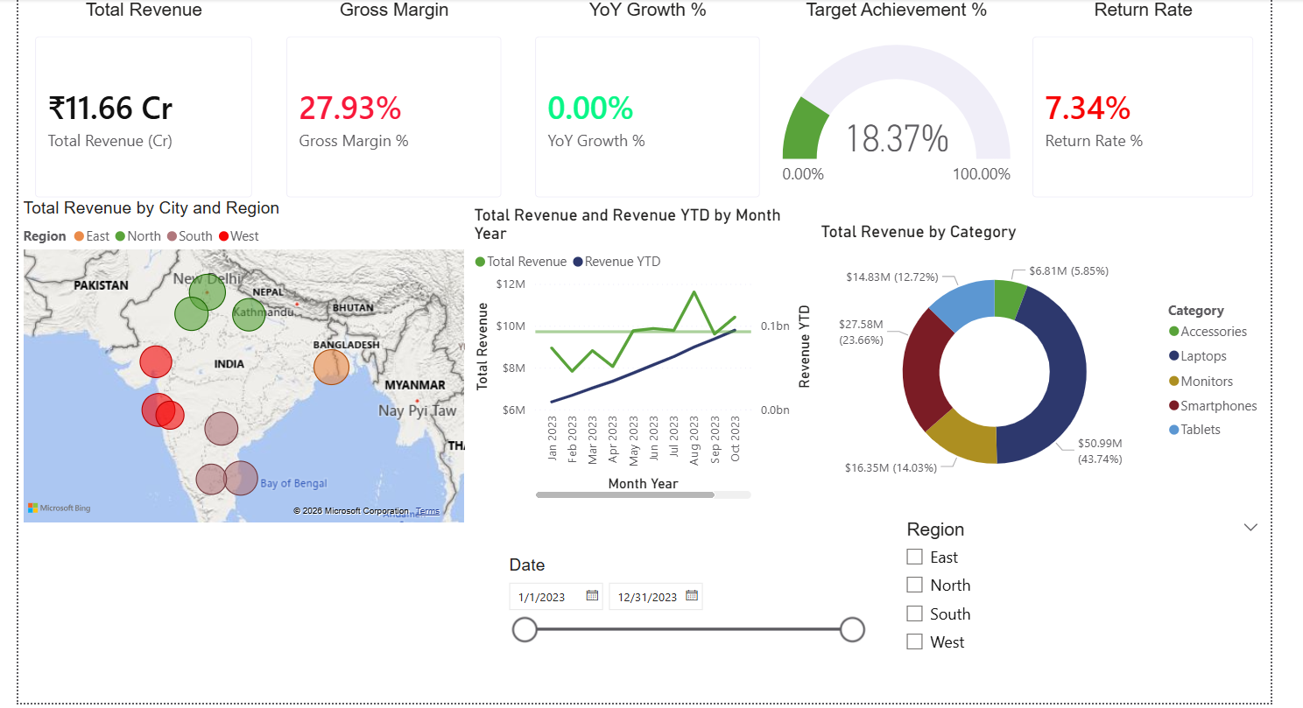

Page 2: Store & Regional Performance
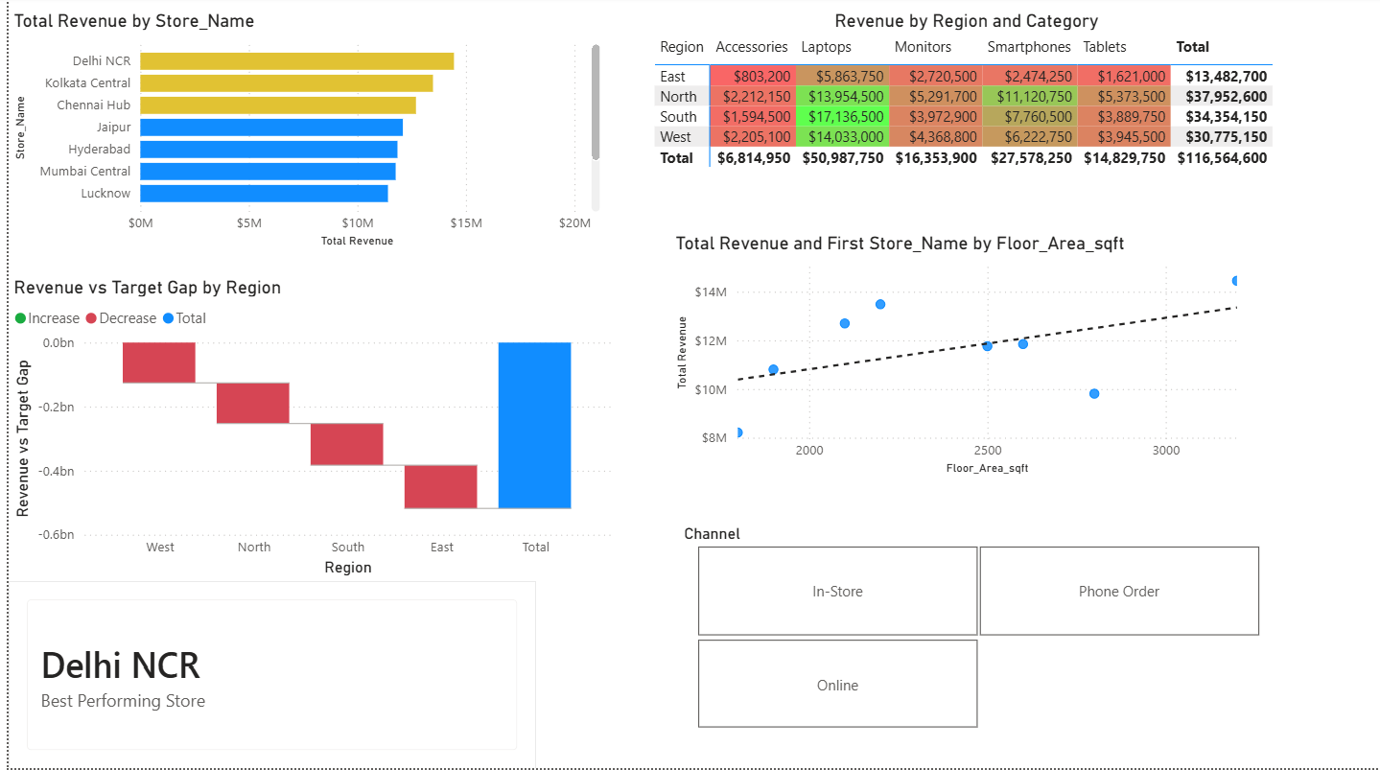

Page 3: Product & Customer Analytics
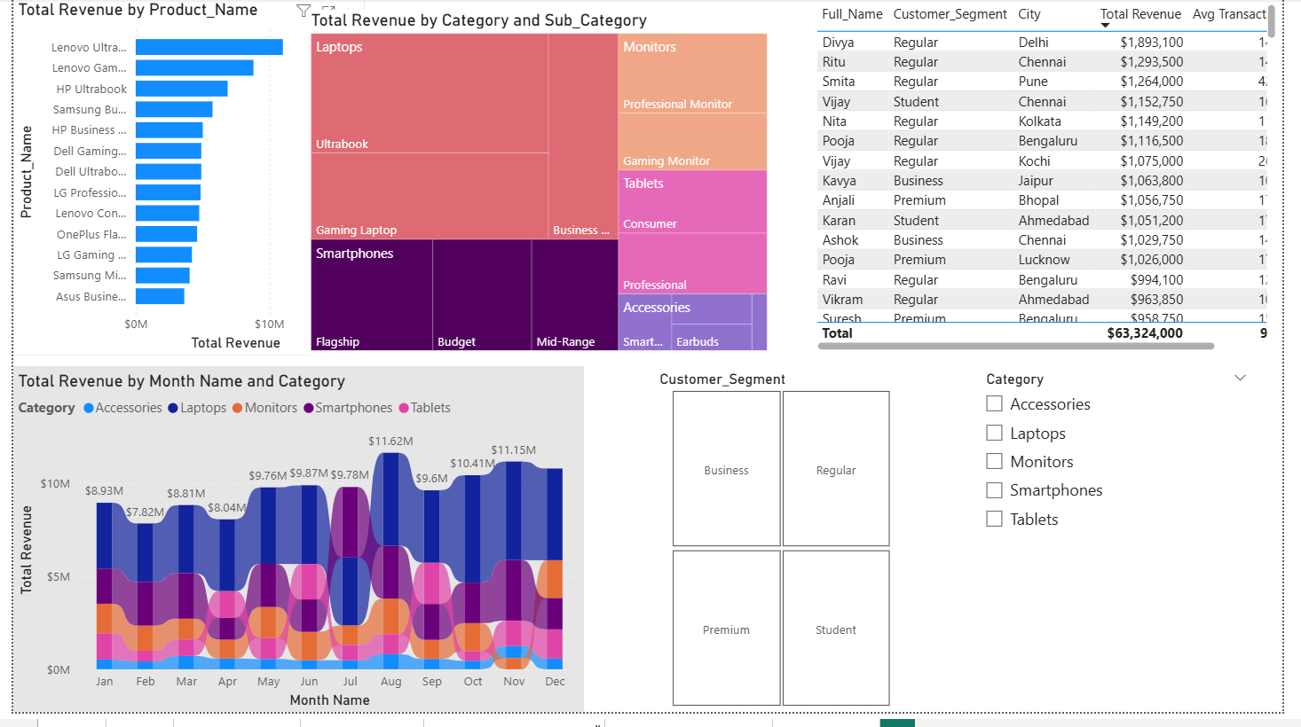

Page 4: Time Intelligence Deep Dive
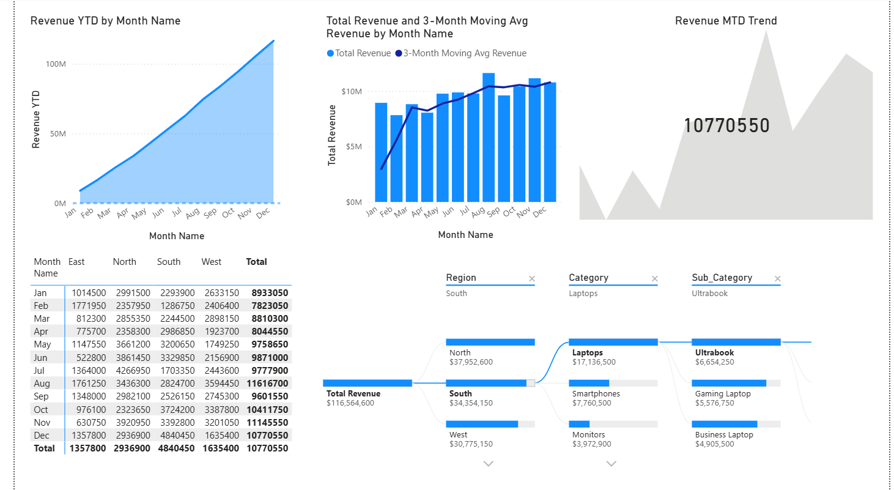

Page 5: Returns Tracker
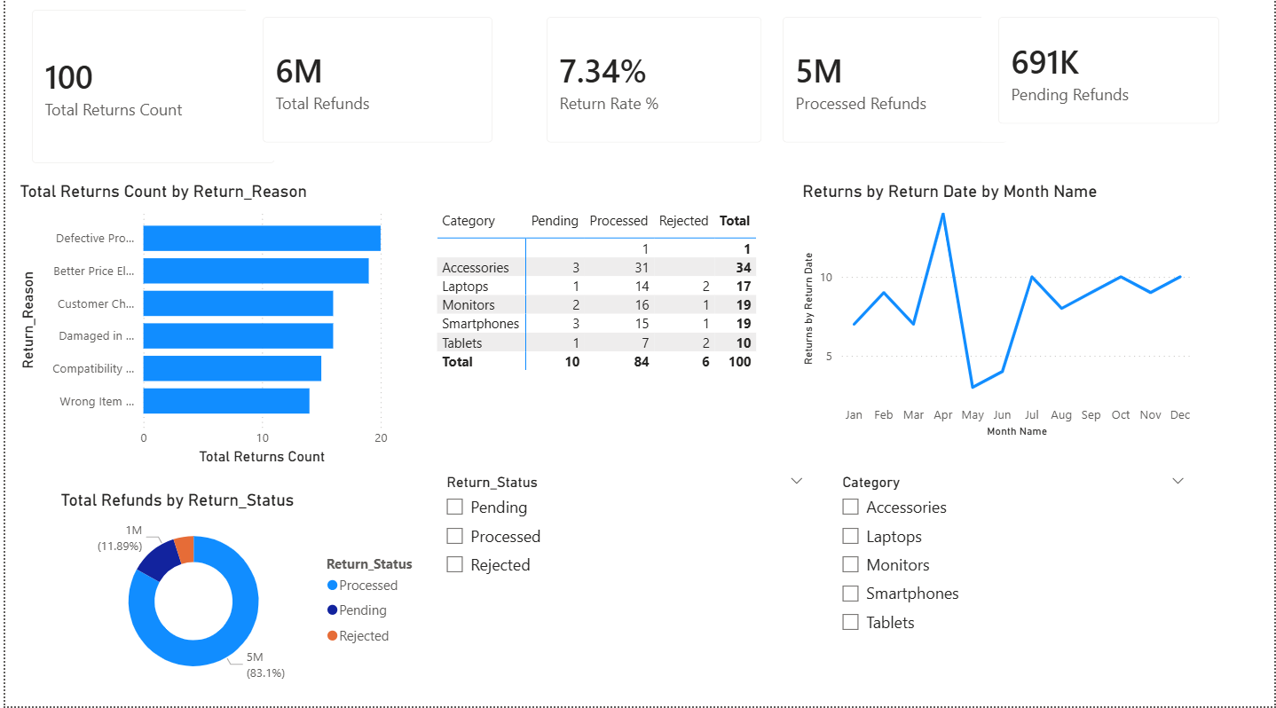

Business Questions to Answer
- Highest gross profit %? Same as highest revenue? No. Highest margin = West at 28.57% (East 28.42%, North 27.91%, South 27.20%). Highest revenue = North (₹3.80 Cr)
- Overall Target Achievement 2023? Which region furthest behind? 18.37% overall. East is furthest behind at 9.1% -Page-2 waterfall.
- Highest return-rate category? Monitors (9.0%), Accessories close behind and highest by volume - Page-5 matrix
- Store size vs revenue? weak with all stores, clearly positive once you hide the 2 zero-area stores - Page-2 scatter.
- Best month? August, which is also closest to target - Page-1/4 line
- Online vs In-Store? In-Store 63.5%, Online 21.6%, Phone 14.9%
- Top 3 customers? Divya Tiwari, Ritu Chatterjee, Smita Chatterjee — all Regular - Page-3 table
- Top Accessories sub-category? Smartwatch- Page 3 Treemap.
- Store to close? Pune City - Page-2 bar/scatter → ST005
- Q4 vs Q1 moving average? Q4 ≈ ₹1.08 Cr/mo vs Q1 ≈ ₹0.85 Cr/mo (~26% higher) - Page-4 line+column

