Manufacturing Process Control - SQL Window Functions
Statistical process control analysis for manufacturing parts
Tool | SQL
Analysis focus | SPC control limits, volume ranking, outliers, rolling averages, and operator-level analysis
Methods used | Window functions, nested queries, ranking, Z-score checks, rolling calculations
Evidence included | 11 query/result screenshots

This project is about a Manufacturing process, where statistical process control (SPC) method is used to monitor and control the process using SQL window functions and nested queries.

Data Cleaning
Data is imported from csv file and few data cleaning has been done. The data is available in the “manufacturing_parts” table.

Calculate volume & rank items per operator
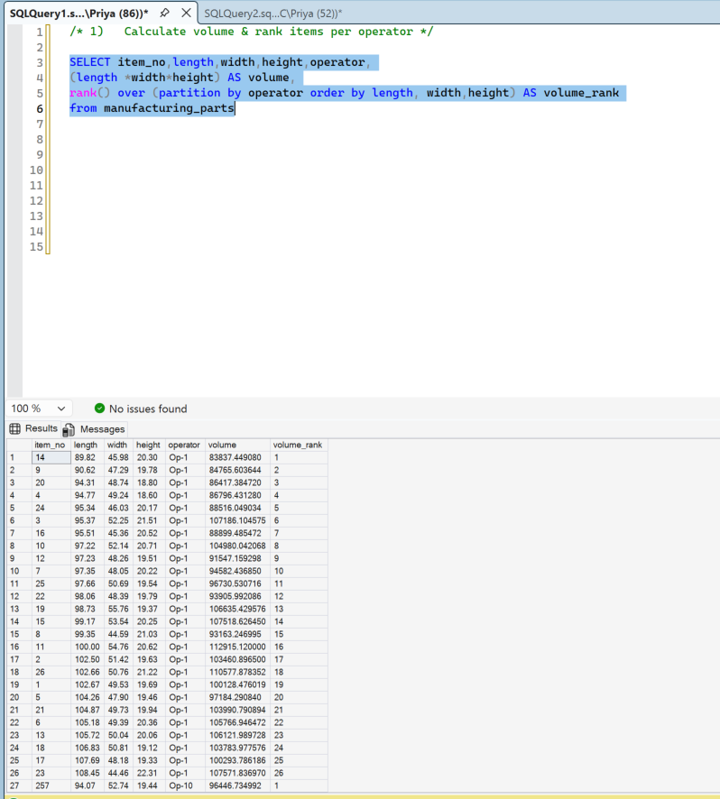

2.Top 3 largest items (by volume) per operator
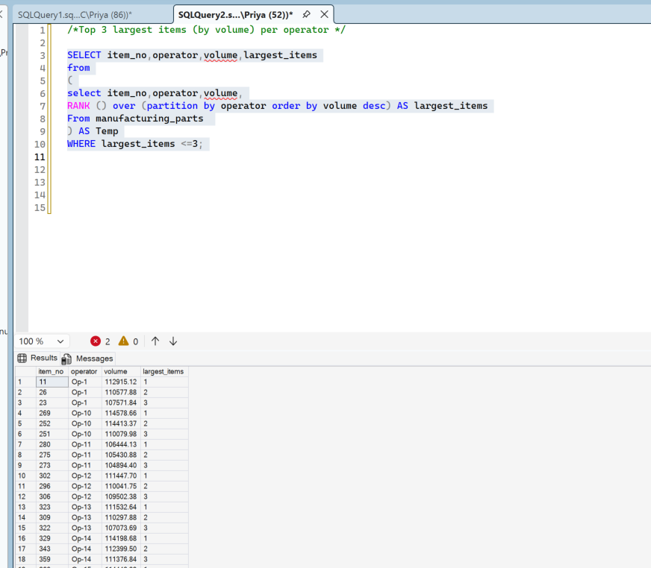

3.Operators whose average volume is above overall average
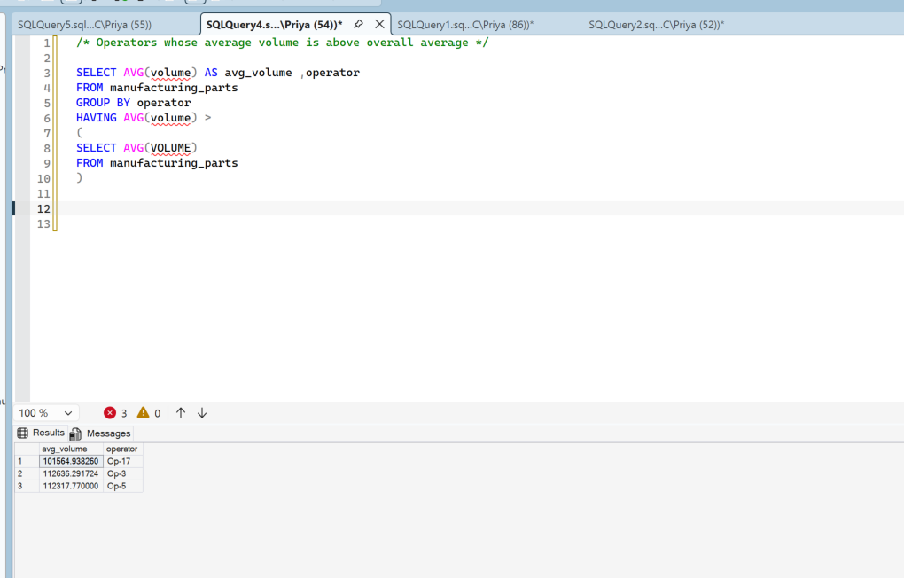

4.Find average dimensions per operator + deviation from average.
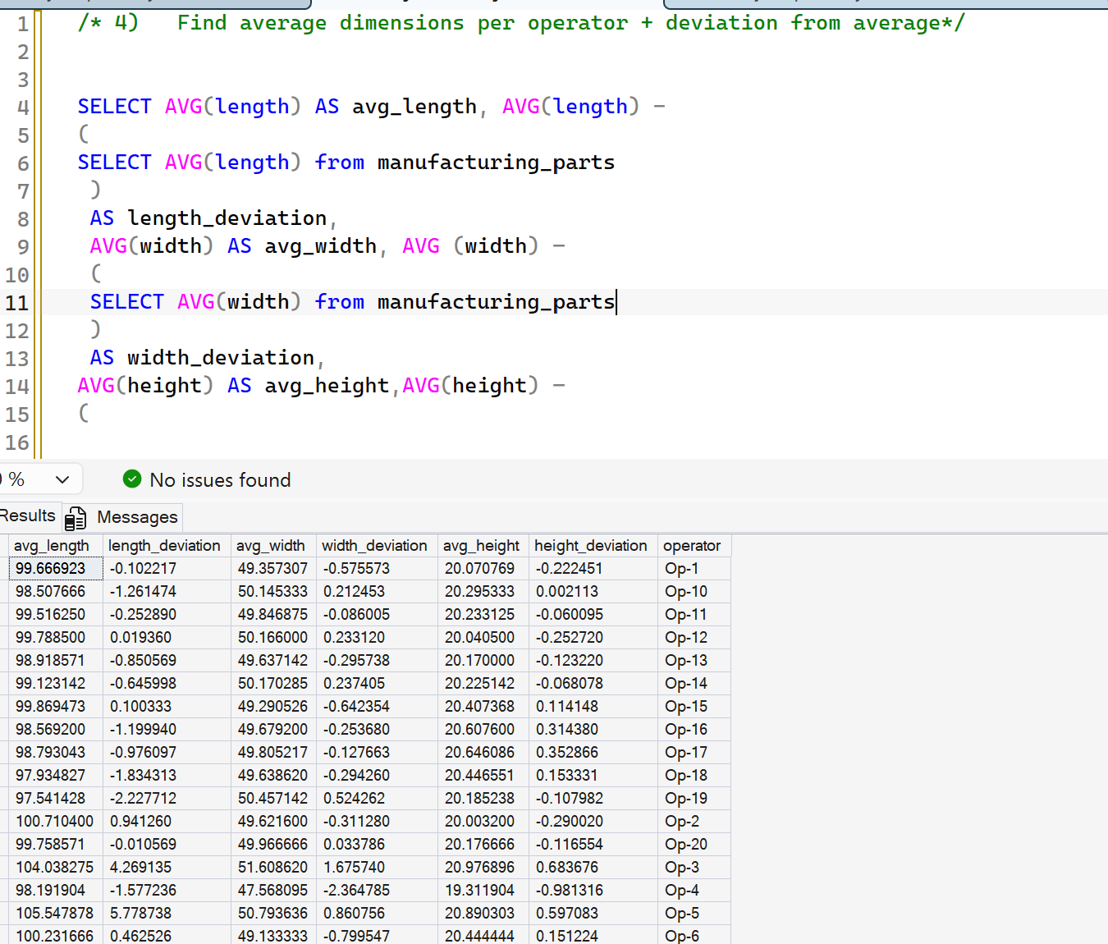

5.Identify outliers using Z-Score
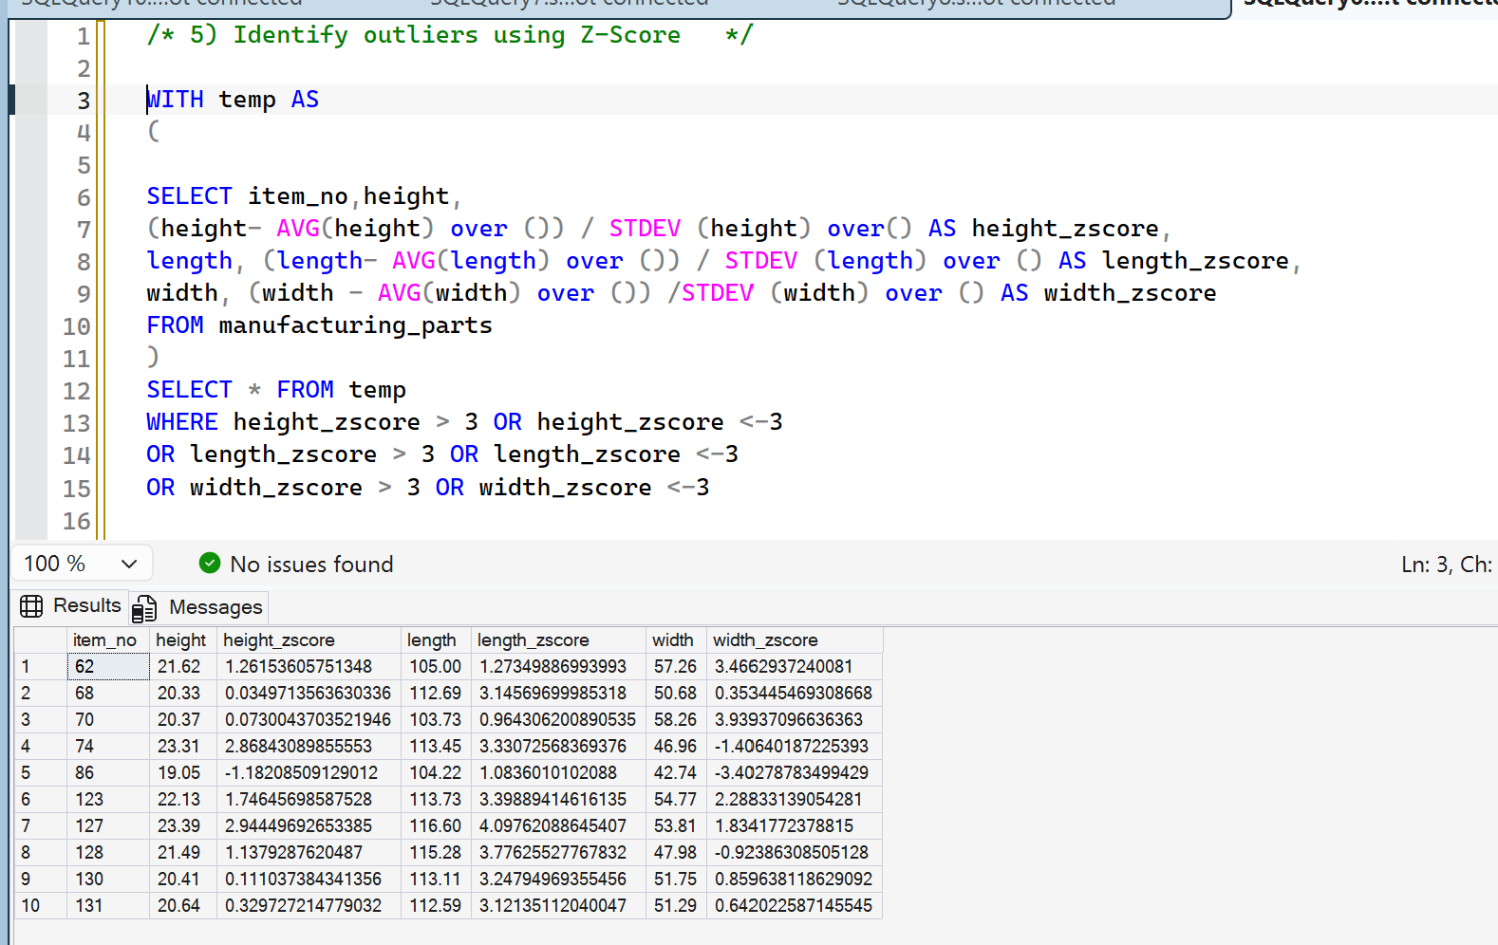

6.Rolling average of length (last 3 items)
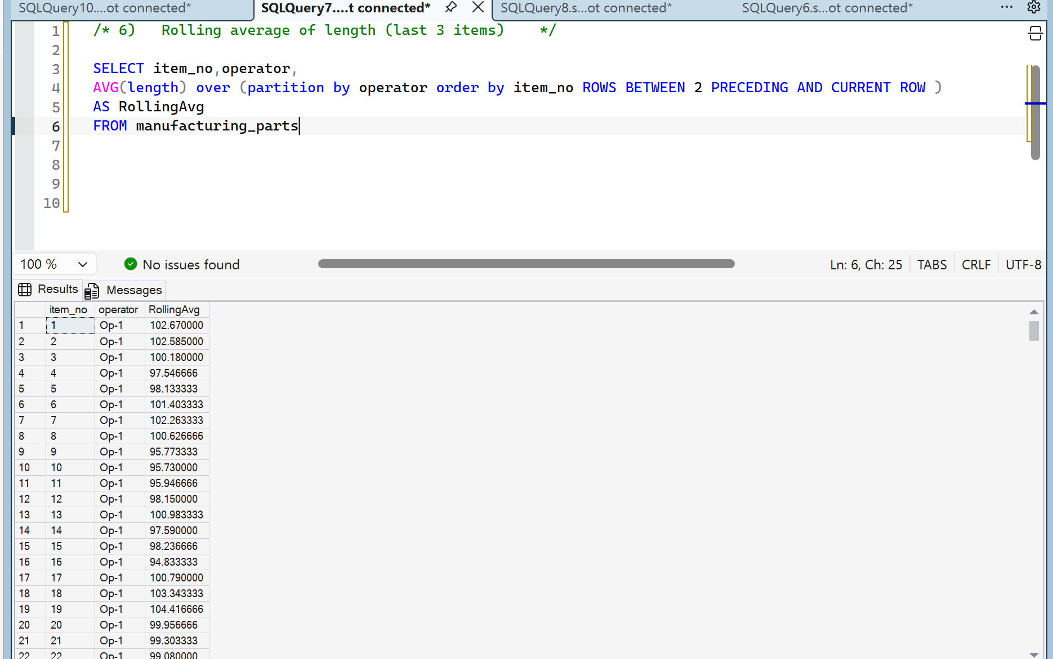

7.Percentage contribution of each operator to total volume
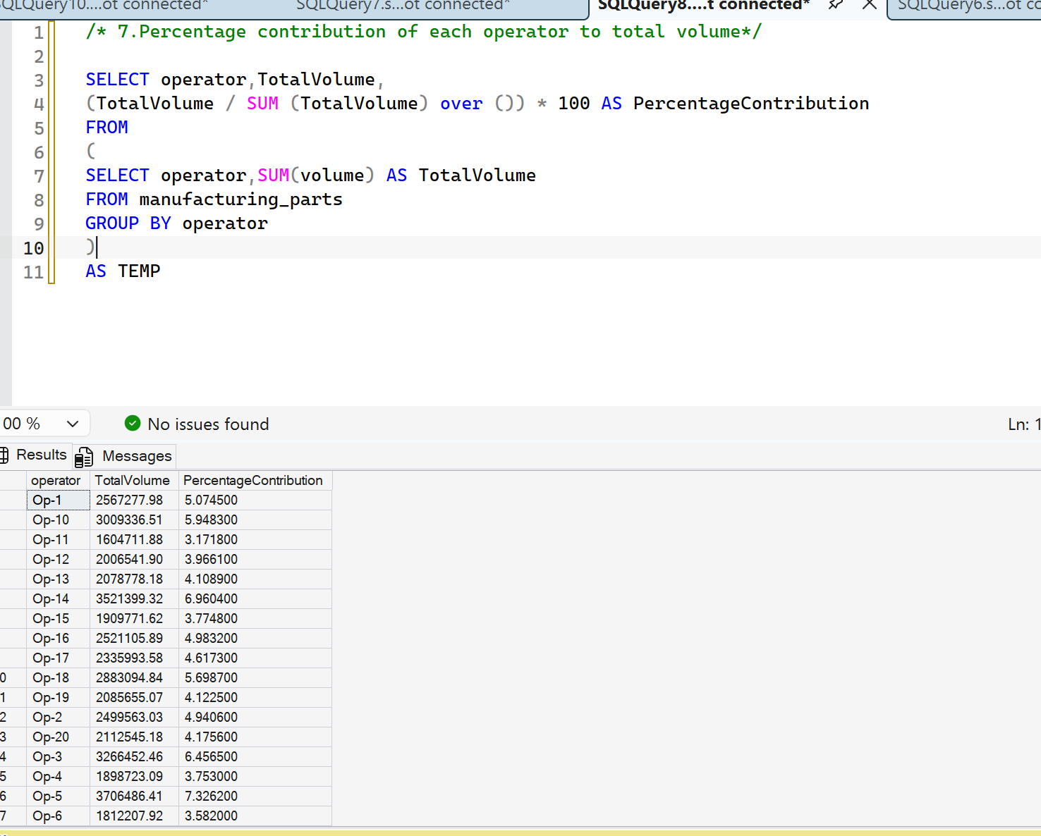

8.Count of items by size category
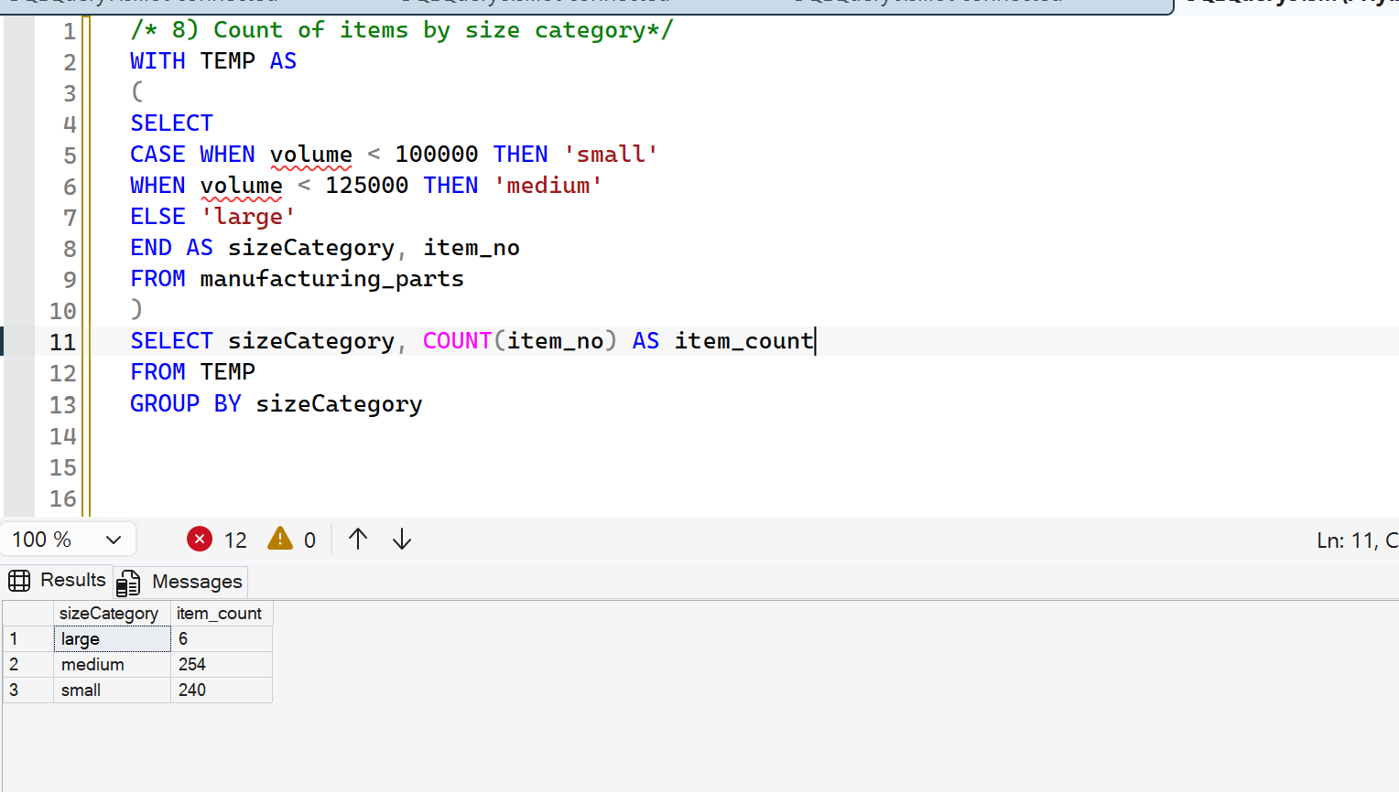

9. Analyze the manufacturing_parts table and determine whether the manufacturing process is performing within acceptable control limits:.
Create an alert that flags whether the height of a product is within the control limits for each operator using the formulas provided in the workbook.
The final query should return the following fields: operator, row_number, height, avg_height, stddev_height, ucl, lcl, alert, and be ordered by the item_no.
The alert column will be your boolean flag.
Use a window function of length 5 to calculate the control limits, considering rows up to and including the current row; incomplete windows should be excluded from the final query output.
