SRI CHANDRASEKHARENDRA SARASWATHI VISWA MAHAVIDYALAYA

(UNIVERSITY ESTABLISHED under section 3 of UGC Act 1956)

ENATHUR, KANCHIPURAM – 631 561



OBJECT ORIENTED PROGRAMMING IN JAVA

LABORATORY RECORD

Name : S. DEVIPRIYA

Reg. No : 112534006

Class : I YEAR BCA

Subject : UCAF252T50 – OOP in Java Lab

SRI CHANDRASEKHARENDRA SARASWATHI

VISWA MAHAVIDYALAYA
(University Established under section 3 of UGC Act 1956)



BONAFIDE CERTIFICATE

This is to Certify that this is the bonafide record of work done by Mr. S. DEVIPRIYA, with Reg. No 112534006 of I Year BCA in the Object Oriented Programming in Java Lab during the year 2026.

Staff-in-charge Head of the Department

Submitted for the Practical Examination held on ________________________

Internal Examiner External Examiner.

INDEX

S.No. | Date | Title | Page No. | Signature
1 | 05 Feb 2026 | PROGRAM USING CLASS, OBJECT, OVERLOADED METHODS, COMMAND LINE ARGUMENTS | 01
2 | 12 Feb 2026 | PROGRAM TO EXPLORE JAVA.LANG.MATH CLASS METHODS AND CUSTOM PACKAGE | 05
3 | 12 Feb 2026 | PROGRAM TO EXPLORE STRING AND STRINGBUFFER METHODS | 09
4 | 19 Feb 2026 | PROGRAM TO DEMONSTRATE INHERITANCE,  DYNAMIC DISPATCH CONCEPTS | 14
5 | 26 Feb 2026 | PROGRAM TO EXPLORE BUILT IN EXCEPTIONS AND STATIC METHODS | 23
6 | 05 Mar 2026 | PROGRAM TO EXPLORE USER-DEFINED (CUSTOM) EXCEPTIONS | 26
7 | 26 Mar 2026 | PROGRAM TO EXPLORE MULTI THREADING | 30
8 | 26 Mar 2026 | PROGRAM TO EXPLORE FILE OPERATIONS | 34
9 | 02 Apr 2026 | PROGRAM TO EXPLOREL COLLECTIONS FRAMEWORK (DATASTRUCTURES) AND JAVADOC | 37
10 | 09 Apr 2026 | SAMPLE GUI WITH EVENT HANDLING USING JAVA SWINGS | 45
11 | 16 Apr 2026 | DATABASE PROGRAMMING WITH JAVA.SQL | 49

1 | PROGRAM USING CLASS, OBJECT, OVERLOADED METHODS, COMMAND LINE ARGUMENTS | 05 Feb 2026

AIM:
To demonstrate the use of classes, packages, method overloading, and command-line arguments in Java.

UML DIAGRAMS:
Package Diagram:
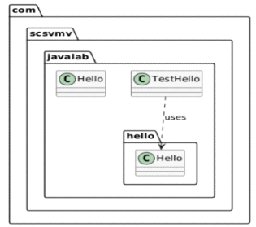

Class Diagram:
com.scsvmv.javalab.hello.Hello
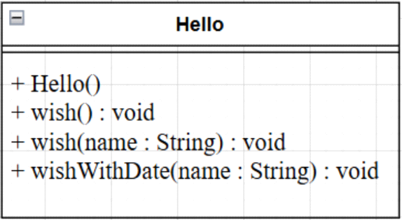

com.scsvmv.javalab.Hello
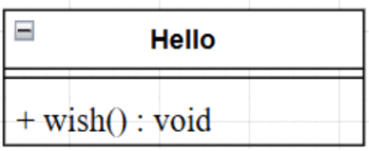

com.scsvmv.javalab.TestHello
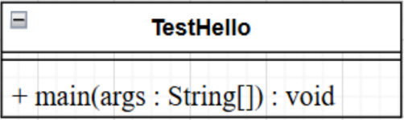

Folder structure:
src/
└── com/
└── scsvmv/
└── javalab/
├── Hello.java
├── TestHello.java
└── hello/
└── Hello.java

SOURCE CODE:
https://github.com/devipriya790/java-lab/tree/main/program1/src/com/scsvmv/javalab

package com.scsvmv.javalab.hello;
import java.util.Date;
/*
*Hello class
*Demonstrates method overloading and command-line arguments
*/
public class Hello
{
//Default constructor
public Hello()
{
}
//Generic wish
public void wish()
{
System.out.println("Hello World");
}
//Overloaded wish method with name parameter
public void wish(String name)
{
System.out.println("Hello"+name);
}
//wish with name and today's date
public void wishWithDate(String name)
{
Date today=new Date();
System.out.println("Hello"+name+"|Date:"+today);
}
}

com.scsvmv.javalab.Hello.java
package com.scsvmv.javalab;
/*
* Simple Hello class
* Always wishes Hello World
*/
public class Hello {
public void wish() {
System.out.println("Hello World");
}
}

com.scsvmv.javalab.Testhello.java
package com.scsvmv.javalab;
import com.scsvmv.javalab.hello.Hello;
/*
*TestHello class
*Demonstrates passing command-line arguments
*/
public class TestHello
{
public static void main(String[] args)
{
//Using Hello class from parent package
Hello simpleHello=new Hello();
simpleHello.wish();
//using Hello class from child package
com.scsvmv.javalab.hello.Hello h=new com.scsvmv.javalab.hello.Hello();
//check for command-line arguments
if(args.length>0)
{
h.wish(args[0]); //pass CLI argument
h.wishWithDate(args[0]);
}
else
{
System.out.println("usage:");
System.out.println("java com.scsvmv.javalab.TestHello<name>");
System.out.println("Example:");
System.out.println("java com.scsvmv.javalab.TestHello Student");
}
}
}

Steps to Compile the Program
- Open Command Prompt / Terminal
- Navigate to the src folder using cd command
- Compile all Java files
Note: Always compile from the src folder, not inside package folders.
…..src>javac com/scsvmv/javalab/hello/Hello.java
…..src>javac com/scsvmv/javalab/Hello.java
…..src>javac com/scsvmv/javalab/TestHello.java

✔ .class files will be generated in the same package folders.

Steps to Run the Program

Run with command-line argument:
java com.scsvmv.javalab.TestHello Seetharaman

If no argument is passed:
java com.scsvmv.javalab.TestHello

Sample Output (with argument)
Hello World
Hello Lithik
Hello Lithik | Date: Thu Feb 05 10:30:15 IST 2026

Output (without argument)
Hello World
Usage:
java com.scsvmv.javalab.TestHello <name>
Example:
java com.scsvmv.javalab.TestHello Lithik

OUTPUT:

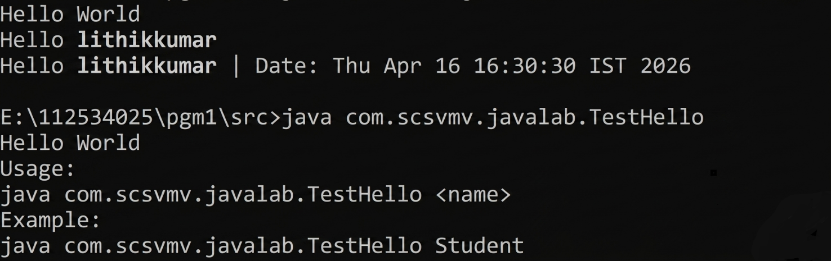

2 | PROGRAM TO EXPLORE JAVA.LANG.MATH CLASS METHODS AND CUSTOM PACKAGE | 12 Feb 2026

AIM:
To demonstrate the use of important methods in java.lang.Math class and to experiment custom packages in Java.

UML DIAGRAMS:
Class Diagram:
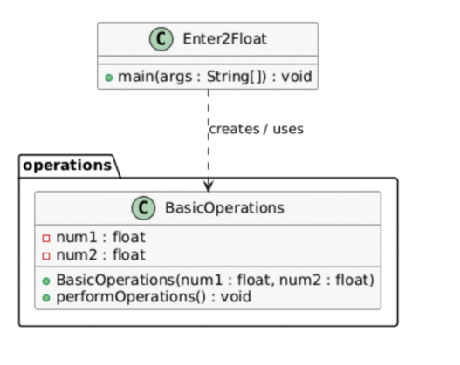
Sequence Diagram:
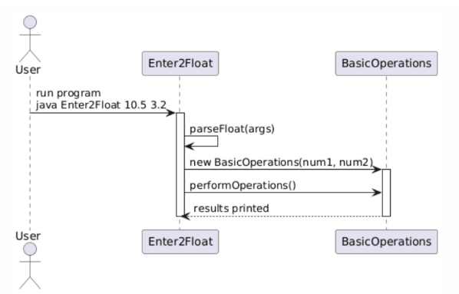

Package Diagram:

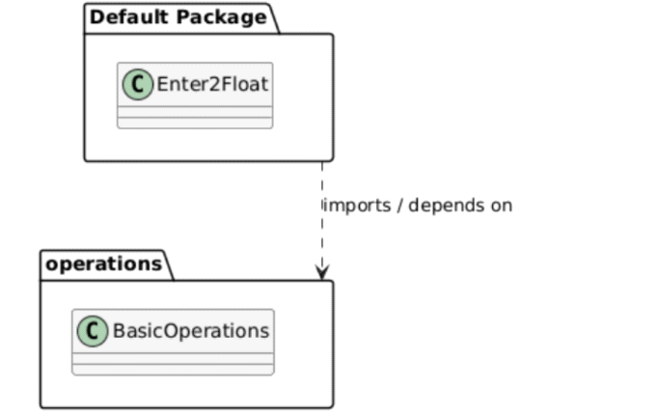

SOURCE CODE:
https://github.com/devipriya790/java-lab/tree/main/program2
operations.BasicOperations
package operations;
public class BasicOperations {
private float num1;
private float num2;
// Constructor for float values
public BasicOperations(float num1, float num2) {
this.num1 = num1;
this.num2 = num2;
}
// Overloaded constructor for int values
public BasicOperations(int num1, int num2) {
// Convert ints to float
this.num1 = (float) num1;
this.num2 = (float) num2;
}
public void performOperations() {
System.out.println("--- Basic Arithmetic ---");
System.out.println("Addition: " + (num1 + num2));
System.out.println("Subtraction: " + (num1 - num2));
System.out.println("Multiplication: " + (num1 * num2));
if (num2 != 0) {
System.out.println("Division: " + (num1 / num2));
System.out.println("Modulus: " + (num1 % num2));
} else {
System.out.println("Division and Modulus: Cannot divide by zero");
}
System.out.println("\n--- Math Class Methods ---");
System.out.println("Absolute value of num1: " + Math.abs(num1));
System.out.println("Maximum: " + Math.max(num1, num2));
System.out.println("Minimum: " + Math.min(num1, num2));
System.out.println("Power (num1^num2): " + Math.pow(num1, num2));
System.out.println("Square root of num1: " + Math.sqrt(num1));
System.out.println("Rounded num1: " + Math.round(num1));
System.out.println("Floor of num1: " + Math.floor(num1));
System.out.println("Ceil of num1: " + Math.ceil(num1));
System.out.println("Random number (0-1): " + Math.random());
}
}

operations.BasicOperations. Enter2Float.java
import operations.BasicOperations;
public class Enter2Float {
public static void main(String[] args) {
if (args.length != 2) {
System.out.println("Usage: java Enter2Float <num1> <num2>");
return;
}
try {
float num1 = Float.parseFloat(args[0]);
float num2 = Float.parseFloat(args[1]);
// Using float constructor
BasicOperations obj1 = new BasicOperations(num1, num2);
obj1.performOperations();
// Using int constructor
BasicOperations obj2 = new BasicOperations(10, 3);
obj2.performOperations();
} catch (NumberFormatException e) {
System.out.println("Please enter valid float numbers.");
}
}
}

OUTPUT:

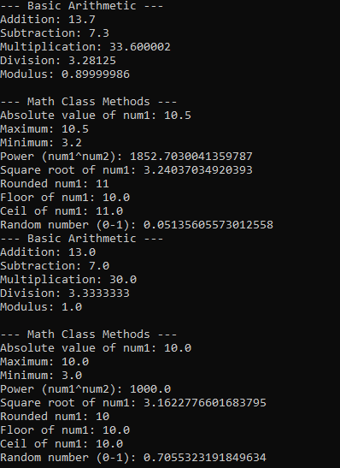

3 | PROGRAM TO EXPLORE STRING AND STRINGBUFFER METHODS | 12 Feb 2026

AIM:
To demonstrate the use of String and StringBuffer methods in Java using command-line arguments.

UML DIAGRAMS:
Class Diagram
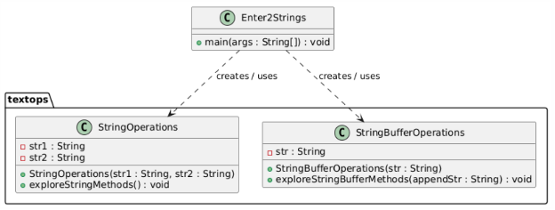

Package Diagram
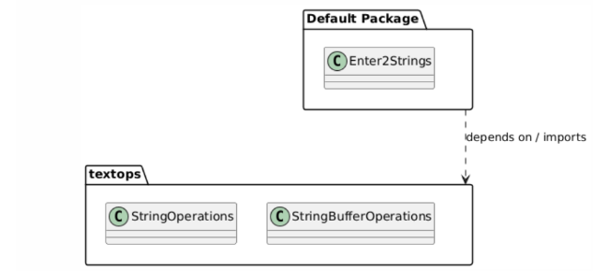
Sequence Diagram
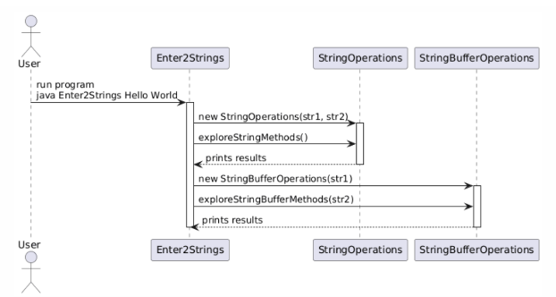

SOURCE CODE :
https://github.com/devipriya790/java-lab/tree/main/program3

textops. StringBufferOperations.java
package textops;
public class StringBufferOperations
{
private String str;
public StringBufferOperations(String str)
{
this.str=str;
}
public void exploreStringBufferMethods(String appendstr)
{
System.out.println("\n----StringBufferMethods----");
//Create a StringBuffer object from str
StringBuffer sb=new StringBuffer(str);
System.out.println("Original StringBuffer:"+sb);
//append() adds text to the end of the buffer(mutable)
sb.insert(0,"Start-");
System.out.println("After insert:"+sb);
//replace() replaces characters between start and end index(mutable)
sb.replace(0,5,"Begin");
System.out.println("After replace:"+sb);
//delete() remove characters between start and end index(mutable)
sb.delete(0,6);
System.out.println("After delete:"+sb);
//reverse() reverse the buffer content(mutable)
sb.reverse();
System.out.println("After reverse:"+sb);
//capacity() shows current buffer size;it automatically increases as needed
System.out.println("Capacity:"+sb.capacity());
//length() shows the number of characters cuurently in the buffer
System.out.println("Length:"+sb.length());
//Note:Unlike String,these operations modify the same object
//String operations(concat,replace,etc.)return new String objects
}
}
textops.StringOperations.java
package textops;
public class StringOperations
{
private String str1;
private String str2;
public StringOperations(String str1,String str2)
{
this.str1=str1;
this.str2=str2;
}
public void exploreStringMethods()
{
System.out.println("----StringMethods----");
System.out.println("Length of str1:"+str1.length());
System.out.println("Uppercase str1:"+str1.toUpperCase());
System.out.println("Lowercase str1:"+str1.toLowerCase());
System.out.println("Concatenation:"+str1.concat(str2));
System.out.println("Equals:"+str1.equals(str2));
System.out.println("Equals Ignore Case:"+str1.equalsIgnoreCase(str2));
System.out.println("Contains str2 in str1:"+str1.contains(str2));
System.out.println("Substring of str1(0,3):"+(str1.length()>=3?str1.substring(0,3):"Too Short"));
System.out.println("Replace 'a' with 'x' in str1:"+str1.replace('a','x'));
System.out.println("Index of str2 in str1:"+str1.indexOf(str2));
System.out.println("Trim str1:"+str1.trim());
}
}
textops.StringOperations, textops.StringBufferOperationsEnter2Strings.java
import textops.StringOperations;
import textops.StringBufferOperations;
public class Enter2Strings
{
public static void main(String[] args)
{
if(args.length !=2)
{
System.out.println("Usage:java Enter2Strings<str1><str2>");
return;
}
String str1=args[0];
String str2=args[1];
//instantiate and call StringOpeartions
StringOperations StringOps=new StringOperations(str1,str2);
StringOps.exploreStringMethods();

//instantiate and call StringBufferOperations
StringBufferOperations sbOps=new StringBufferOperations(str1);
sbOps.exploreStringBufferMethods(str2);
}
}

OUTPUT:

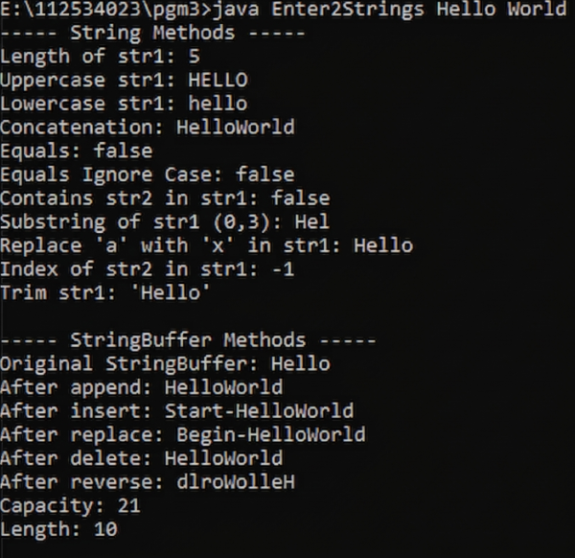

4 | PROGRAM TO DEMONSTRATE INHERITANCE,  DYNAMIC DISPATCH CONCEPTS | 19 Feb 2026

AIM:
To demonstrate interfaces, inheritance, polymorphism (static & dynamic), and use of super keyword in Java.
UML DIAGRAMS:
Package and Class Diagram:
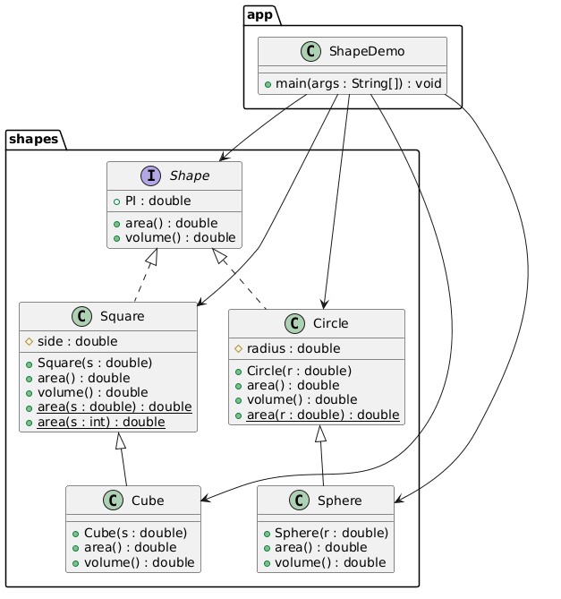

Sequence Diagram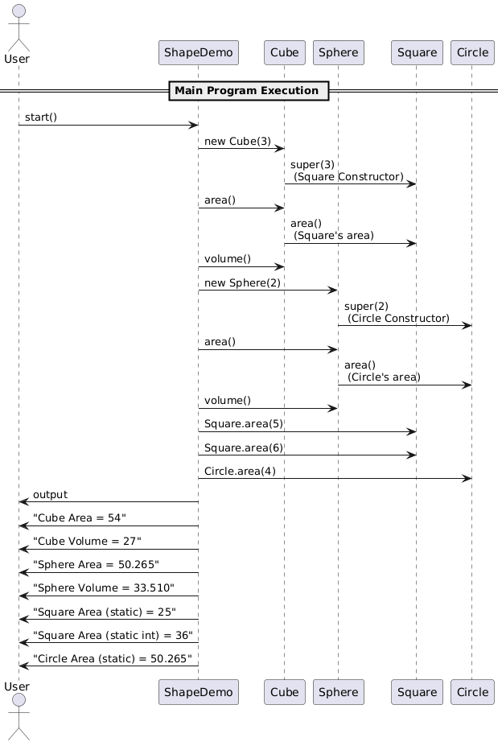:

SOURCE CODE:
https://github.com/devipriya790/java-lab/tree/main/program%204

App.ShapeDemo.java

package app;
// Import all classes from shapes package
import shapes.*;
/**
* Main class to demonstrate shapes
* Shows dynamic polymorphism and static overloading
*/
public class ShapeDemo {
public static void main(String[] args) {
Shape s;
// ----------------------------
// Dynamic polymorphism examples
// ----------------------------
s = new Cube(3);
System.out.println("Cube Area = " + s.area());
System.out.println("Cube Volume = " + s.volume());
s = new Sphere(2);
System.out.println("Sphere Area = " + s.area());
System.out.println("Sphere Volume = " + s.volume());
// ----------------------------
// Static polymorphism examples
// ----------------------------
System.out.println("Square Area (static) = " + Square.area(5));
System.out.println("Square Area (static int) = " + Square.area(6));
System.out.println("Circle Area (static) = " + Circle.area(4));
}
}
Shapes. Circle.java
package shapes;
/**
* Circle class implements Shape interface
*/
public class Circle implements Shape {
/** Radius of the circle */
protected double radius;
/**
* Constructor
* @param r radius
*/
public Circle(double r) {
radius = r;
}
/**
* Calculate area of the circle
* @return PI * r^2
*/
public double area() {
return PI * radius * radius;
}
// ----------------------------
// Static overloaded method
// ----------------------------
/**
* Calculate area for a given radius
* @param r radius
* @return area
*/
public static double area(double r) {
return PI * r * r;
}
/**
* Circle has no volume
* @return 0
*/
public double volume() {
return 0;
}
}

Shapes.Cube.java
package shapes;
/**
* Cube class extends Square
* Demonstrates use of super() and super.area()
*/
public class Cube extends Square {
/**
* Constructor calls Square constructor
* @param s side length
*/
public Cube(double s) {
super(s); // super() calls parent constructor
}
/**
* Calculate surface area of cube
* Uses one face area from Square
* @return surface area
*/
public double area() {
double tmp = super.area(); // reuse Square area
return 6 * tmp;
}
/**
* Calculate cube volume
* @return volume
*/
public double volume() {
return side * side * side;
}
}

Shapes. Shape.java

package shapes;

/**

* Interface representing geometric shapes.

* All shapes must implement methods to calculate area and volume.

*/

public interface Shape {

/** Constant value of PI */

double PI = 3.14159;

/**

* Calculate the area of the shape.

* @return area as double

*/

double area();

/**

* Calculate the volume of the shape.

* @return volume as double

*/

double volume();

}

Shapes. Sphere.java
package shapes;
/**
* Sphere class extends Circle
* Demonstrates reuse of Circle area using super.area()
*/
public class Sphere extends Circle {
/**
* Constructor calls Circle constructor
* @param r radius
*/
public Sphere(double r) {
super(r); // super() call
}
/**
* Calculate surface area of sphere
* Reuses Circle's area method
* @return surface area
*/
public double area() {
double tmp = super.area(); // circle area
return 4 * tmp;
}
/**
* Calculate volume of sphere
* @return volume
*/
public double volume() {
return (4.0 / 3.0) * PI * radius * radius * radius;
}
}

Shapes. Square.java

package shapes;

/**

* Class representing a square.

* Implements the Shape interface.

*/

public class Square implements Shape {

/** Side length of the square */

protected double side;

/**

* Constructor to initialize square side

* @param s side length

*/

public Square(double s) {

side = s;

}

/**

* Calculate area of the square

* @return side^2

*/

public double area() {

return side * side;

}

// ----------------------------

// Static overloaded methods

// ----------------------------

/**

* Calculate area for a given side (double)

* @param s side length

* @return area

*/

public static double area(double s) {

return s * s;

}

/**

* Calculate area for a given side (int)

* @param s side length

* @return area

*/

public static double area(int s) {

return s * s;

}

/**

* Square does not have volume

* @return 0

*/

public double volume() {

return 0;

}

}

OUTPUT:

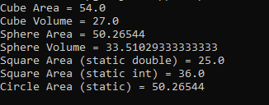

5 | PROGRAM TO EXPLORE BUILT IN EXCEPTIONS AND STATIC METHODS | 26 Feb 2026

AIM:
To demonstrate built-in exception handling and the use of static methods in Java.

UML DIAGRAM:

Class Diagram:
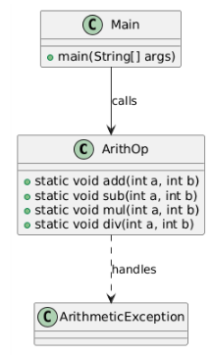
Sequence Diagram:

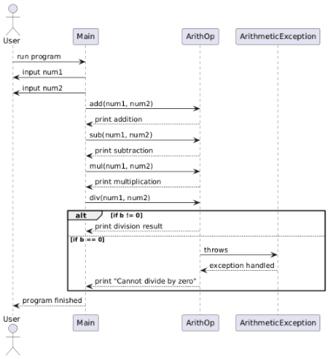
SOURCE CODE:

https://github.com/devipriya790/java-lab/tree/main/program5
ArithOp.arithop

public class ArithOp {
public static void add(int a, int b) {
int result = a + b;
System.out.println("Addition = " + result);
}
public static void sub(int a, int b) {
int result = a - b;
System.out.println("Subtraction = " + result);
}
public static void mul(int a, int b) {
int result = a * b;
System.out.println("Multiplication = " + result);
}
/**
* Performs division of two integers.
* Handles division by zero using try-catch.
*
* @param a Dividend
* @param b Divisor
*/
public static void div(int a, int b) {
try {
// Attempt to divide a by b
int result = a / b;
System.out.println("Division = " + result);
}
catch (ArithmeticException e) {
// This block executes if b is zero
System.out.println("Error: Cannot divide by zero.");
}
finally {
// This block always executes regardless of exception
System.out.println("Division operation finished.");
}
}
}

java.util.Scanner. Main.java
import java.util.Scanner;
public class Main {
public static void main(String[] args) {
Scanner sc = new Scanner(System.in);
System.out.print("Enter first number: ");
int num1 = sc.nextInt();
System.out.print("Enter second number: ");
int num2 = sc.nextInt();
// Call static methods directly using class name
ArithOp.add(num1, num2);
ArithOp.sub(num1, num2);
ArithOp.mul(num1, num2);
ArithOp.div(num1, num2);
sc.close();
}
}

OUTPUT:
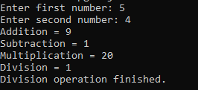

6 | PROGRAM TO EXPLORE USER-DEFINED (CUSTOM) EXCEPTIONS | 05 March 2026

AIM:
To demonstrate custom exception in Java.

UML DIAGRAM:

Class Diagram:

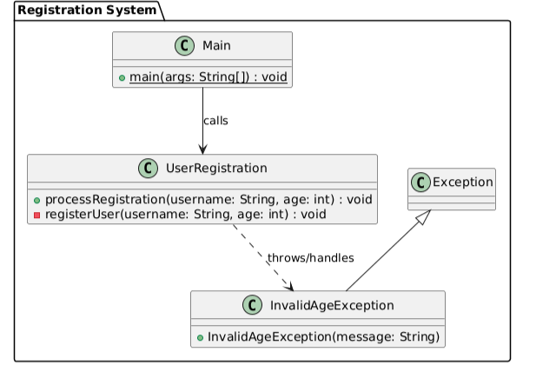

Sequence Diagram:
Failure scenario

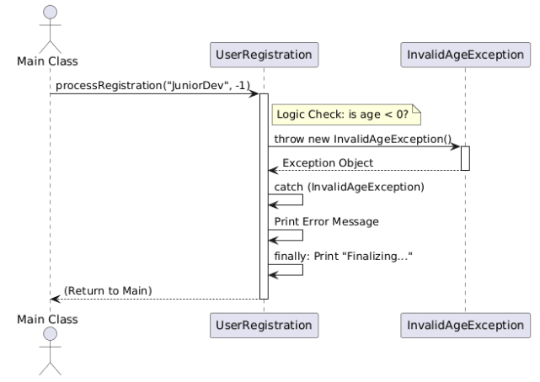

Sequence Diagram: Success Flow

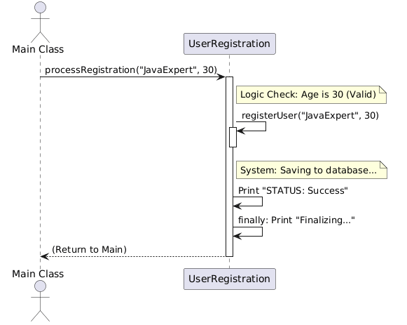

SOURCE CODE:
https://github.com/devipriya790/java-lab/tree/main/program6

InvalidAgeException. InvalidAgeException

// File: InvalidAgeException.java
public class InvalidAgeException extends Exception {
public InvalidAgeException(String message) {
super(message);
}
}

Main.Main.java

// File: Main.java
public class Main {
public static void main(String[] args) {
UserRegistration app = new UserRegistration();
// Scenario 1: Valid
app.processRegistration("JavaExpert", 30);
// Scenario 2: Invalid Age
app.processRegistration("JuniorDev", -1);
// Scenario 3: Invalid Username
app.processRegistration("", 20);
}
}

UserRegistration. UserRegistration.java

// File: UserRegistration.java

public class UserRegistration {

/**

* Logic and Validation moved here (The Calling Method)

*/

public void processRegistration(String username, int age) {

System.out.println(">>> Processing registration for: " + userna

try {

// Validation Logic (Moved here per request)

if (age < 0) {

throw new InvalidAgeException("Age cannot be negative (" + age + ").");

}

if (username == null || username.trim().isEmpty()) {

throw new InvalidAgeException("Username is required.");

}

// If validation passes, call the registration/save action

registerUser(username, age);

System.out.println("STATUS: Success.");

} catch (InvalidAgeException e) {

// Handle Failure Scenario

System.err.println("STATUS: Failed - " + e.getMessage());

} finally {

System.out.println("Finalizing request...\n");

}

}

/**

* The simple action method

*/

private void registerUser(String username, int age) {

System.out.println("System: Saving " + username + " (Age: " + age + ") to database.");

}

}

OUTPUT:

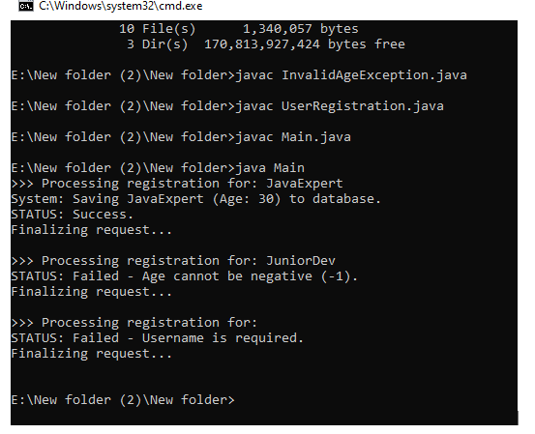

7 | PROGRAM TO EXPLORE MULTI THREADING | 26 March 2026

AIM:
To demonstrate Multithreading in Java.

UML DIAGRAM:

Class Diagram:

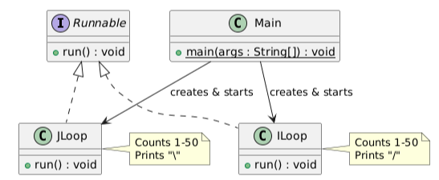
Sequence Diagram:
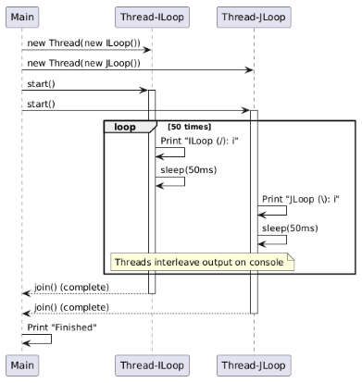
SOURCE CODE:

https://github.com/devipriya790/java-lab/tree/main/program7

CountThreads.java

// ILoop: Prints 1 to 50 with a '/' symbol
class ILoop implements Runnable {
@Override
public void run() {
for (int i = 1; i <= 50; i++) {
System.out.println("ILoop (/): " + i);
try {
// Short sleep to allow the other thread to take turns
Thread.sleep(50);
} catch (InterruptedException e) {
Thread.currentThread().interrupt();
}
}
}
}
// JLoop: Prints 1 to 50 with a '\' symbol
class JLoop implements Runnable {
@Override
public void run() {
for (int i = 1; i <= 50; i++) {
System.out.println("JLoop (\\): " + i);
try {
Thread.sleep(50);
} catch (InterruptedException e) {
Thread.currentThread().interrupt();
}
}
}
}
public class CountThreads {
public static void main(String[] args) {
System.out.println("--- Starting Concurrent Count ---\n");
Thread t1 = new Thread(new ILoop());
Thread t2 = new Thread(new JLoop());
t1.start();
t2.start();
try {
t1.join();
t2.join();
} catch (InterruptedException e) {
e.printStackTrace();
}
System.out.println("\n--- Both threads finished counting! ---");
}
}

OUTPUT:
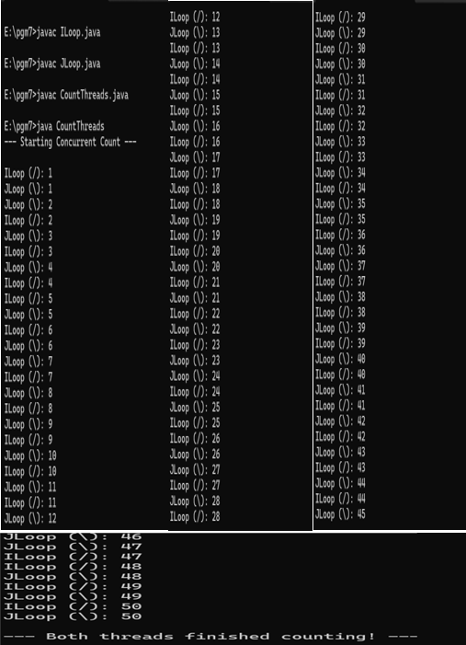

8 | PROGRAM TO EXPLORE FILE OPERATIONS | 26 March 2026

AIM:
To demonstrate File Operations using java.io package classes in Java.

UML DIAGRAM:

Class Diagram:
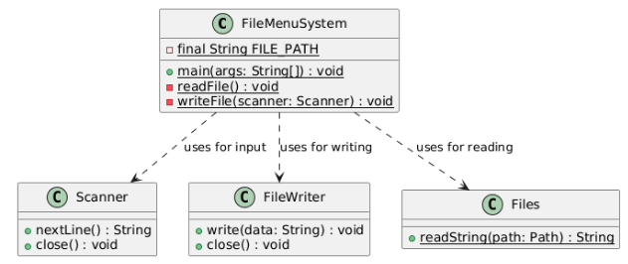
Activity Diagram:
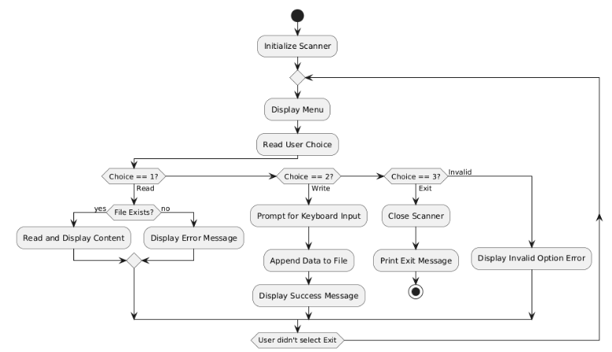

FileMenuSystem. FileMenuSystem .java
import java.util.Scanner;
import java.io.*;
import java.nio.file.*;

public class FileMenuSystem {
private static final String FILE_PATH = "userdata.txt";

public static void main(String[] args) {
Scanner scanner = new Scanner(System.in);
boolean running = true;

while (running) {
System.out.println("\n--- FILE MANAGER MENU ---");
System.out.println("1. Read File");
System.out.println("2. Write to File");
System.out.println("3. Exit");
System.out.print("Select an option: ");
String choice = scanner.nextLine();

switch (choice) {
case "1":
readFile();
break;
case "2":
writeFile(scanner);
break;
case "3":
System.out.println("Exiting program...");
running = false;
break;
default:
System.out.println("Invalid option. Please try again.");
}
}
scanner.close();
}

private static void readFile() {
try {
File file = new File(FILE_PATH);
if (!file.exists()) {
System.out.println("Error: File does not exist yet. Write something first!");
return;
}
String content = Files.readString(Path.of(FILE_PATH));
System.out.println("\n--- FILE CONTENT ---");
System.out.println(content);
System.out.println("---------------------");
} catch (IOException e) {
System.err.println("Failed to read: " + e.getMessage());
}
}

private static void writeFile(Scanner scanner) {
System.out.print("Enter text to save to file: ");
String data = scanner.nextLine();

try (FileWriter writer = new FileWriter(FILE_PATH, true)) { // 'true' enables appending
writer.write(data + System.lineSeparator());
System.out.println("Success: Data saved to " + FILE_PATH);
} catch (IOException e) {
System.err.println("Failed to write: " + e.getMessage());
}
}
}

OUTPUT:

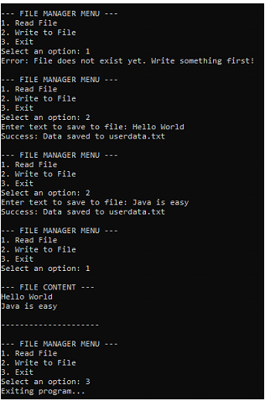
9 | PROGRAM TO EXPLOREL COLLECTIONS FRAMEWORK (DATASTRUCTURES) AND JAVADOC | 02 Apr 2026

AIM:
To demonstrate Data Structure Operations using java.util collections framework and to experiment Javadoc feature.

UML DIAGRAM:

Class Diagram:
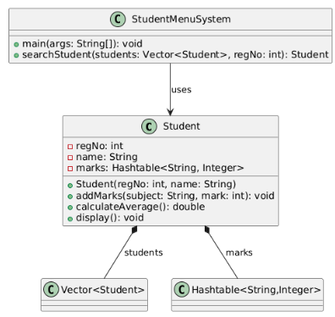
Use Case Diagram:
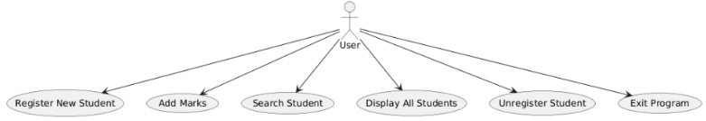

Activity Diagram:
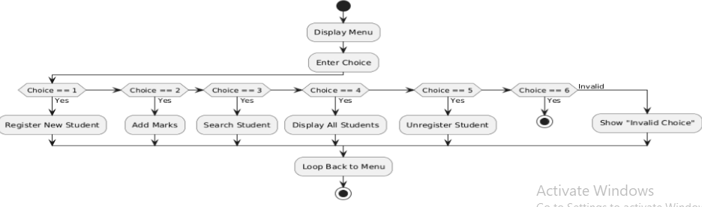

Sequence Diagram (addMarks()):

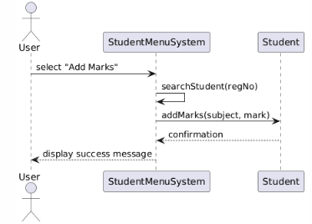
SOURCE CODE:

https://github.com/lithikkumar/JAVALAB/blob/main/program9/StudentMenuSystem.java

Student. Student.java
import java.util.Scanner;
import java.util.Vector;
import java.util.Hashtable;
import java.util.Iterator;

/**
* Represents a Student with registration number, name, and marks.
* Demonstrates OOP concepts and uses Hashtable for subject → marks mapping.
*/

class Student {
int regNo;
String name;
Hashtable<String, Integer> marks;

/**
* Constructs a Student object with registration number and name.
* Initializes the marks Hashtable.
*
* @param regNo registration number of the student
* @param name name of the student
*/

Student(int regNo, String name) {
this.regNo = regNo;
this.name = name;
marks = new Hashtable<>();
}

/**
* Adds a subject and its marks to the student's record.
*
* @param subject name of the subject
* @param mark marks obtained in the subject
* @throws IllegalArgumentException if mark is negative or greater than 100
*/

void addMarks(String subject, int mark) throws IllegalArgumentException {
if (mark < 0 || mark > 100) {
throw new IllegalArgumentException("Mark must be between 0 and 100.");
}
marks.put(subject, mark); }

/**
* Calculates the average marks of the student

*
* @return average of all marks as double
*/
double calculateAverage() {
int sum = 0;
for (int m : marks.values()) {
sum += m;
}
return marks.size() == 0 ? 0.0 : (double) sum / marks.size();
}

/**
* Displays student details including registration number, name, subjects, and average marks.
*/

void display() {
System.out.println("RegNo: " + regNo);
System.out.println("Name: " + name);
System.out.println("Marks: " + marks);
System.out.println("Average: " + calculateAverage());
System.out.println("----------------------");
}
}

/**
* Menu-driven Student Management System.
* Features:
* - Register new student
* - Add marks
* - Search student by registration number
* - Display all students
* - Unregister student
*/
StudentMenuSystem. StudentMenuSystem.java
import java.util.*;
public class StudentMenuSystem {

/**
* Searches for a student in the Vector by registration number.
*
* @param students Vector of Student objects
* @param regNo registration number to search
* @return the Student object if found; null otherwise
*/
public static Student searchStudent(Vector<Student> students, int regNo) {
for (Student s : students) {
if (s.regNo == regNo) {
return s;
}
}
return null;
}

/**
* Main method for the menu-driven Student Management System.
* Provides a looped menu to perform operations like register, add marks, search, display,
unregister, and exit.
*
* @param args command-line arguments
* @throws IllegalArgumentException if marks entered are invalid
*/
public static void main(String[] args) throws IllegalArgumentException {
Scanner sc = new Scanner(System.in);
Vector<Student> students = new Vector<>();
int choice;
do {
System.out.println("\n--- Student Management System ---");
System.out.println("1. Register New Student");
System.out.println("2. Add Marks");
System.out.println("3. Search Student");
System.out.println("4. Display All Students");
System.out.println("5. Unregister Student");
System.out.println("6. Exit");
System.out.print("Enter your choice: ");
choice = sc.nextInt();
sc.nextLine(); // consume newline
switch (choice) {
case 1:
// Register new student
System.out.print("Enter RegNo: ");
int regNo = sc.nextInt();
sc.nextLine();
System.out.print("Enter Name: ");
String name = sc.nextLine();

if (searchStudent(students, regNo) != null) {
System.out.println("Student with this RegNo already exists!");
} else {
students.add(new Student(regNo, name));
System.out.println("Student registered successfully.");
}
break;

case 2:
// Add marks
System.out.print("Enter RegNo to add marks: ");
int regSearch = sc.nextInt();
sc.nextLine();
Student s = searchStudent(students, regSearch);
if (s != null) {
System.out.print("Enter subject name: ");
String subject = sc.nextLine();
System.out.print("Enter marks: ");
int mark = sc.nextInt();
sc.nextLine();
try {
s.addMarks(subject, mark);
System.out.println("Marks added successfully.");
} catch (IllegalArgumentException e) {
System.out.println("Error: " + e.getMessage());
}
} else {
System.out.println("Student not found!");
}
break;

case 3:
// Search student
System.out.print("Enter RegNo to search: ");
int searchReg = sc.nextInt();
sc.nextLine();
Student found = searchStudent(students, searchReg);
if (found != null) {
System.out.println("\nStudent Found:");
found.display();
} else {
System.out.println("Student not found!");
}
break;

case 4:
// Display all students
if (students.isEmpty()) {
System.out.println("No students registered.");
} else {
System.out.println("\n--- All Students ---");
Iterator<Student> it = students.iterator();
while (it.hasNext()) {
Student st = it.next();
st.display();
}
}
break;
case 5:
// Unregister student
System.out.print("Enter RegNo to unregister: ");
int delReg = sc.nextInt();
sc.nextLine();
Student removeStu = searchStudent(students, delReg);
if (removeStu != null) {
students.remove(removeStu);
System.out.println("Student unregistered successfully.");
} else {
System.out.println("Student not found!");
}
break;
case 6:
System.out.println("Exiting program...");
break;
default:
System.out.println("Invalid choice! Try again.");
}
} while (choice != 6);
sc.close();
}
}

OUTPUT:

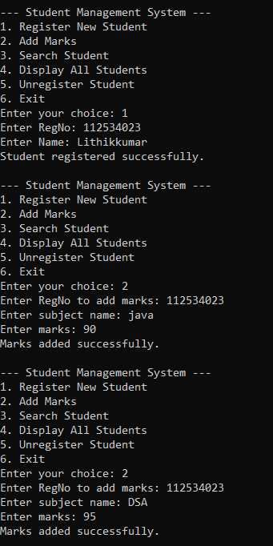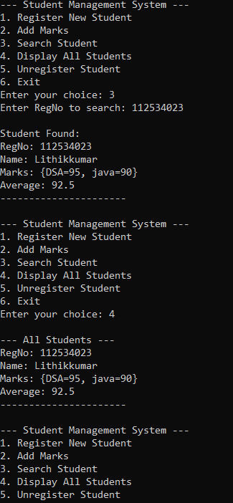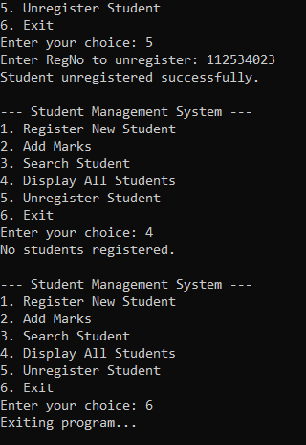
10 | SAMPLE GUI WITH EVENT HANDLING USING JAVA SWINGS | 09 Apr 2026

AIM:
To demonstrate java Graphical User Interface and Event handling features using javax.swing components.

UML DIAGRAM:

Package and Class Diagram:
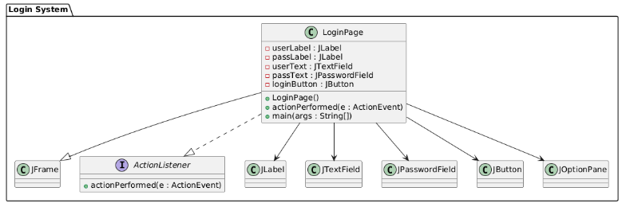
Sequence Diagram:
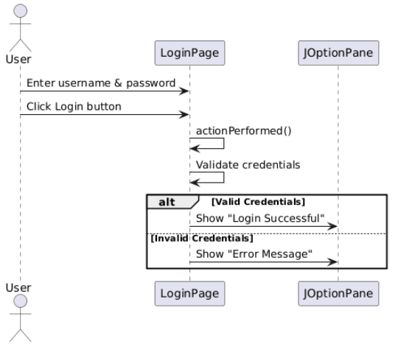

SOURCE CODE:

https://github.com/lithikkumar/JAVALAB/blob/main/program10/LoginPage.java

LoginPage. LoginPage.java

// Importing required Swing and AWT libraries
import javax.swing.*;
import java.awt.*;
import java.awt.event.*;
// Creating a class that extends JFrame (window)
// and implements ActionListener (for button click handling)
public class LoginPage extends JFrame implements ActionListener {
// Declaring GUI components
JLabel userLabel, passLabel;
JTextField userText;
JPasswordField passText;
JButton loginButton;
// Constructor to set up the GUI
LoginPage() {
setTitle("Login Page");
setSize(350, 200);
setLayout(null);
// Labels for username and password
// Text field for username input
// Password field (hides input)
// Login button
// Set window title
// Set window size
// Use absolute positioning
setDefaultCloseOperation(JFrame.EXIT_ON_CLOSE); // Close app on exit
// Username Label
userLabel = new JLabel("Username:");
userLabel.setBounds(30, 30, 80, 25); // Set position and size
add(userLabel); // Add to frame

// Username Text Field
userText = new JTextField();
userText.setBounds(120, 30, 150, 25);
add(userText);

// Password Label
passLabel = new JLabel("Password:");
passLabel.setBounds(30, 70, 80, 25);
add(passLabel);

// Password Field
passText = new JPasswordField();
passText.setBounds(120, 70, 150, 25);
add(passText);

// Login Button
loginButton = new JButton("Login");
loginButton.setBounds(120, 110, 100, 30);
loginButton.addActionListener(this); // Register button click event
add(loginButton);

setVisible(true); // Make the frame visible
}
// This method is called when the button is clicked
public void actionPerformed(ActionEvent e) {
// Get entered username
String username = userText.getText();

// Get entered password (converted from char array to String)
String password = new String(passText.getPassword());

// Simple validation (hardcoded values)
if (username.equals("admin") && password.equals("1234")) {
// Show success message
JOptionPane.showMessageDialog(this, "Login Successful!");
} else {
// Show error message
JOptionPane.showMessageDialog(this, "Invalid Username or Password");
}
}

// Main method - entry point of the program
public static void main(String[] args) {
new LoginPage(); // Create and display the login page
}
}

OUTPUT:

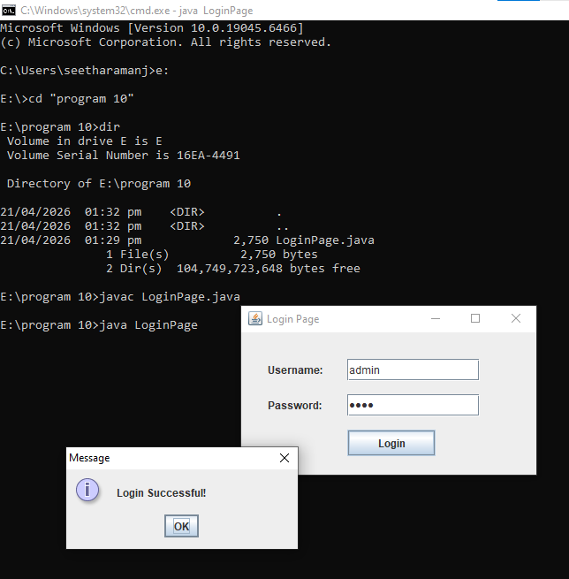
11 | DATABASE PROGRAMMING WITH JAVA.SQL | 16 Apr 2026

AIM:
To demonstrate data base connectivity capabilities with java.sql and mysql

UML DIAGRAM:

Class Diagram:

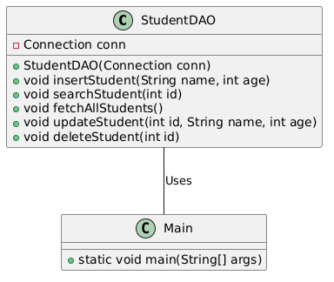
Component Diagram:
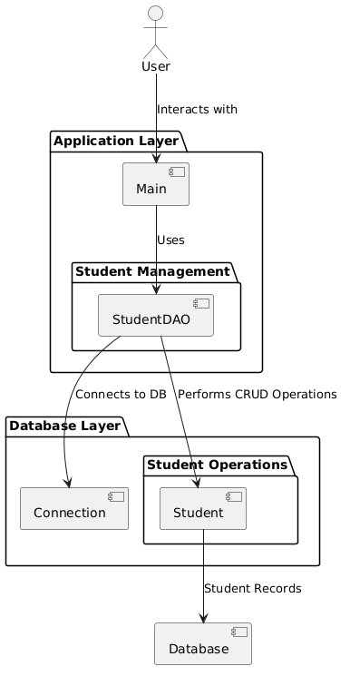

Sequence Diagram – Insert:

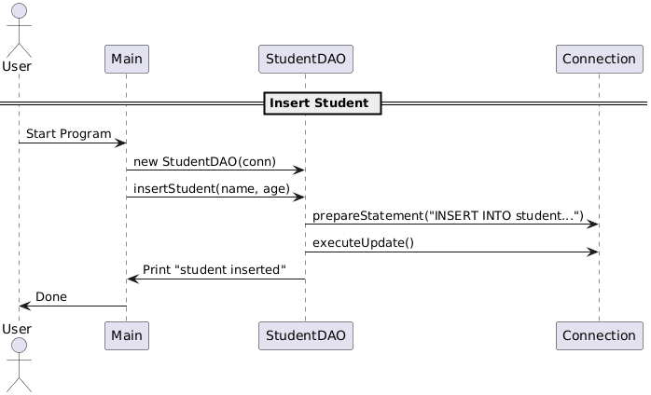

Project Structure:
StudentApp/
├── src/
│ ├── Main.java
│ └── StudentDAO.java
├── db.properties
├── lib/
│ └── mysql-connector-java-8.x.x.jar

db.properties:
db.url=jdbc:mysql://localhost:3306/school
db.user=root
db.pass=password

SOURCE CODE:

https://github.com/lithikkumar/JAVALAB/tree/main/program11

lib.create_table.sql.

CREATE DATABASE school;

USE school;

CREATE TABLE student (
id INT PRIMARY KEY AUTO_INCREMENT,
name VARCHAR(50),
age INT
);

Main. Main.java
import java.sql.*;
import java.util.Properties;
import java.io.FileInputStream;
import java.io.IOException;
import java.util.Scanner;

public class Main {
public static void main(String[] args) {
Properties props = new Properties();

// Load DB properties
try (FileInputStream fis = new FileInputStream("db.properties")) {
props.load(fis);
} catch (IOException e) {
System.out.println("Error: Could not find db.properties file.");
return;
}

String url = props.getProperty("db.url");
String user = props.getProperty("db.user");
String pass = props.getProperty("db.pass");

// DB connection
try (Connection conn = DriverManager.getConnection(url, user, pass);
Scanner sc = new Scanner(System.in)) {

System.out.println("Connected to database successfully.");
StudentDAO dao = new StudentDAO(conn); // Create DAO object

while (true) {
// CORRECTED: Combined into one line to fix the "unclosed string literal" error
System.out.println("\n1. Insert Student\n2. Search Student\n3. Fetch All Students\n4. Update Student\n5. Delete Student\n6. Exit");

System.out.print("Choose option: ");
int choice = sc.nextInt();
sc.nextLine(); // Consume newline

switch (choice) {
case 1:
System.out.print("Enter name: ");
String name = sc.nextLine();
System.out.print("Enter age: ");
int age = sc.nextInt();
dao.insertStudent(name, age);
break;
case 2:
System.out.print("Enter ID to search: ");
int id = sc.nextInt();
dao.searchStudent(id);
break;
case 3:
dao.fetchAllStudents();
break;
case 4:
System.out.print("Enter ID to update: ");
int updateId = sc.nextInt();
sc.nextLine();
System.out.print("Enter new name: ");
String newName = sc.nextLine();
System.out.print("Enter new age: ");
int newAge = sc.nextInt();
dao.updateStudent(updateId, newName, newAge);
break;
case 5:
System.out.print("Enter ID to delete: ");
int deleteId = sc.nextInt();
dao.deleteStudent(deleteId);
break;
case 6:
System.out.println("Exiting...");
return;
default:
System.out.println("Invalid option!");
}
}
} catch (SQLException e) {
e.printStackTrace();
}
}
}

StudentDAO. StudentDAO.java

import java.sql.*;
// Data Access Object (DAO) for Student table
public class StudentDAO {
private Connection conn;
// Constructor receives DB connection
public StudentDAO(Connection conn) {
this.conn = conn;
}
// Insert a student
public void insertStudent(String name, int age) throws SQLException {
String sql = "INSERT INTO student (name, age) VALUES (?, ?)";
try (PreparedStatement ps = conn.prepareStatement(sql)) {
ps.setString(1, name);
ps.setInt(2, age);
int rows = ps.executeUpdate();
System.out.println(rows + " student inserted.");
}
}
// Search student by ID
public void searchStudent(int id) throws SQLException {
String sql = "SELECT * FROM student WHERE id=?";
try (PreparedStatement ps = conn.prepareStatement(sql)) {
ps.setInt(1, id);
try (ResultSet rs = ps.executeQuery()) {
if (rs.next()) {
System.out.println("ID: " + rs.getInt("id"));
System.out.println("Name: " + rs.getString("name"));
System.out.println("Age: " + rs.getInt("age"));
} else {
System.out.println("Student not found.");
}
}
}
}

// Fetch all students
public void fetchAllStudents() throws SQLException {
String sql = "SELECT * FROM student";
try (Statement stmt = conn.createStatement();
ResultSet rs = stmt.executeQuery(sql)) {

System.out.println("\n--- All Students ---");
while (rs.next()) {
System.out.println("ID: " + rs.getInt("id") +
", Name: " + rs.getString("name") +
", Age: " + rs.getInt("age"));
}
}
}

// Update student details by ID
public void updateStudent(int id, String name, int age) throws SQLException {
String sql = "UPDATE student SET name=?, age=? WHERE id=?";
try (PreparedStatement ps = conn.prepareStatement(sql)) {
ps.setString(1, name);
ps.setInt(2, age);
ps.setInt(3, id);
int rows = ps.executeUpdate();
System.out.println(rows + " student updated.");
}
}

// Delete student by ID
public void deleteStudent(int id) throws SQLException {
String sql = "DELETE FROM student WHERE id=?";
try (PreparedStatement ps = conn.prepareStatement(sql)) {
ps.setInt(1, id);
int rows = ps.executeUpdate();
System.out.println(rows + " student deleted.");
}
}
}

db.properties

db.url=jdbc:mysql://localhost:3306/school
db.user=root
db.pass=password

