Create a faculty table with the following attributes (columns) and

Insert values in sqlite3.

fid fname fsubject experience

666 A Vanathi CO 18

334 K DeviPriya Python 14

678 K N S L Kumar CO 17

Create

Insert

Select

Select colnames from tablename where columname='value';

Write a query to display faculty name and subject who are

dealing python

>>select *from Faculty where fsubject='Python';

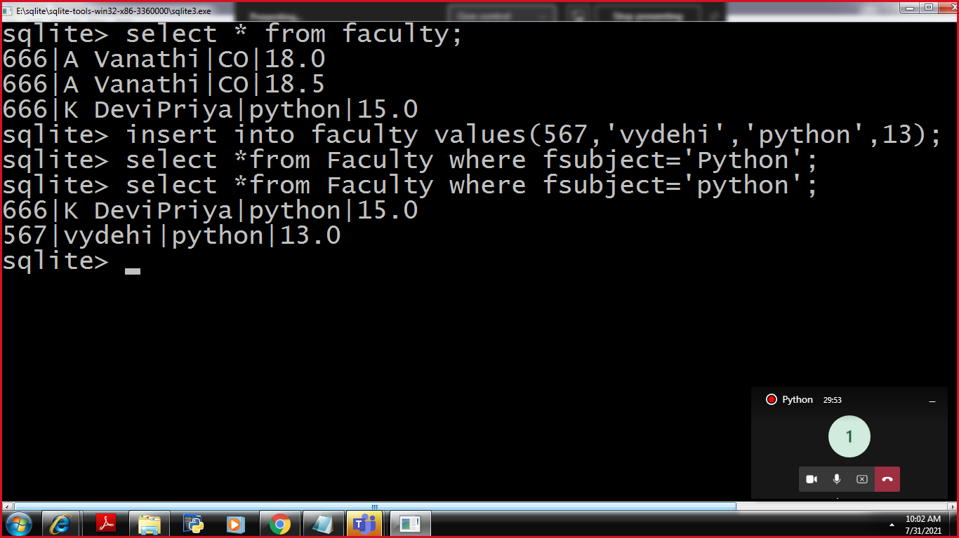

Screen:Display facultyDetails

Write a query to display the faculty details whose id is 666

select from faculty where fid=666;

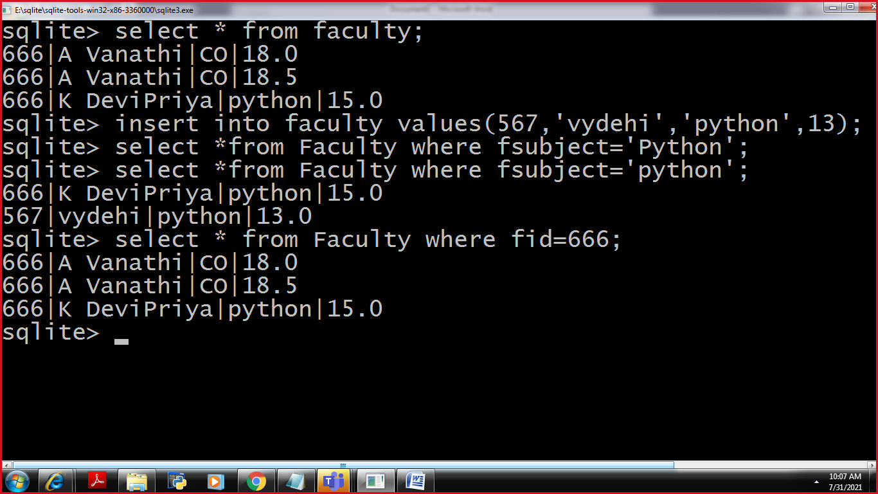

**Update**

**Update-The existed data is updated with new values**

**update table_name set column_name=new_value,column_name=new_value...**

**where condition;**

**Update the id of devipriya from 666 to 334**

**update faculty set fid=334**

**where expereince=15.0**

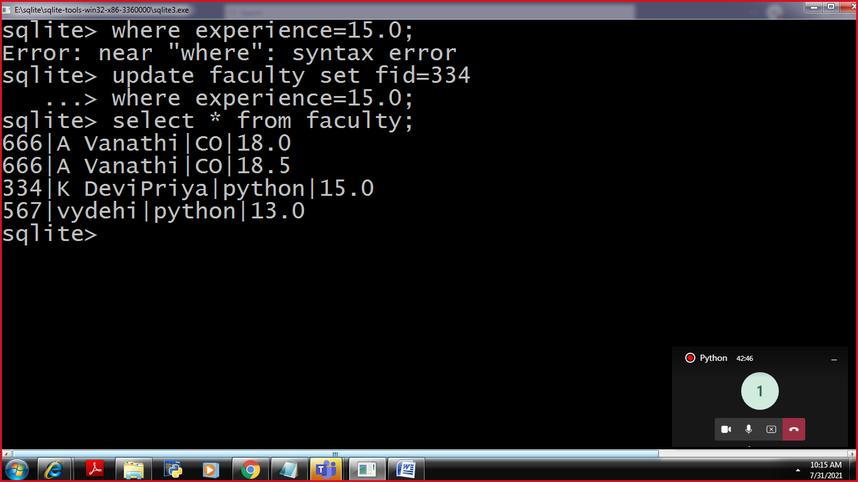

Change the subject name from python to java whose id is 334

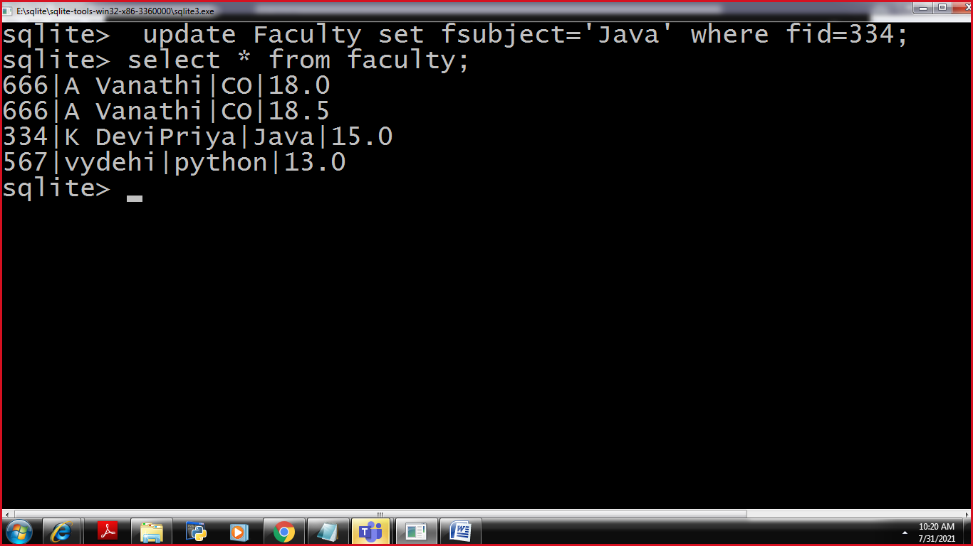

**Deletion**

Delete the duplicate record of vanathi madam whose expereince is 18.0

Delete from tablename where columnname=value;

Delete from faculty where experience=18.0;

