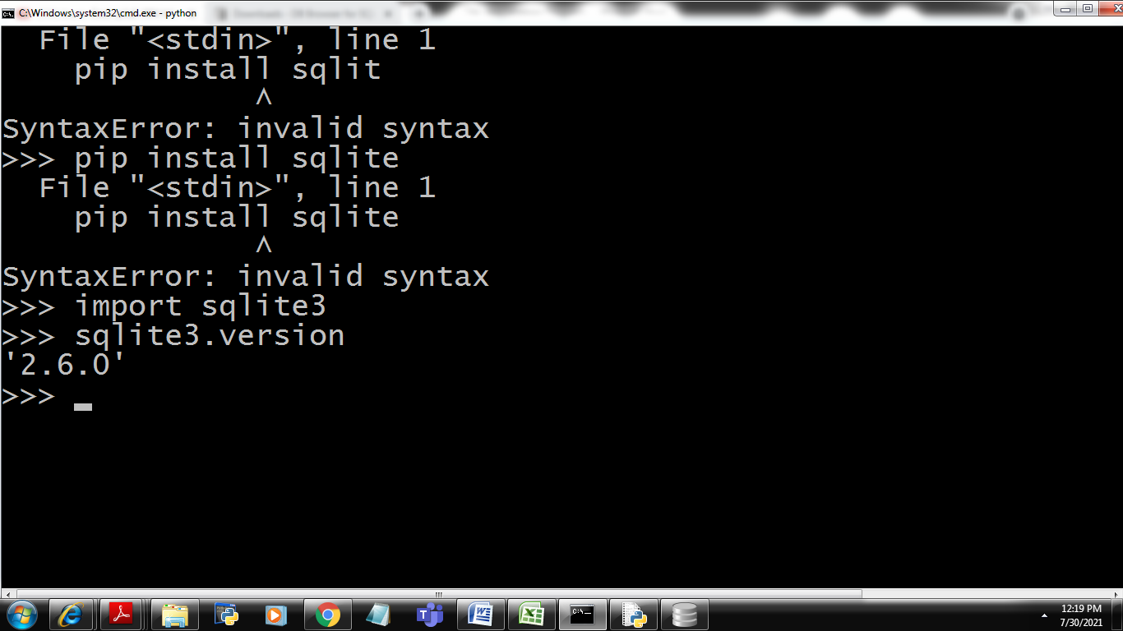

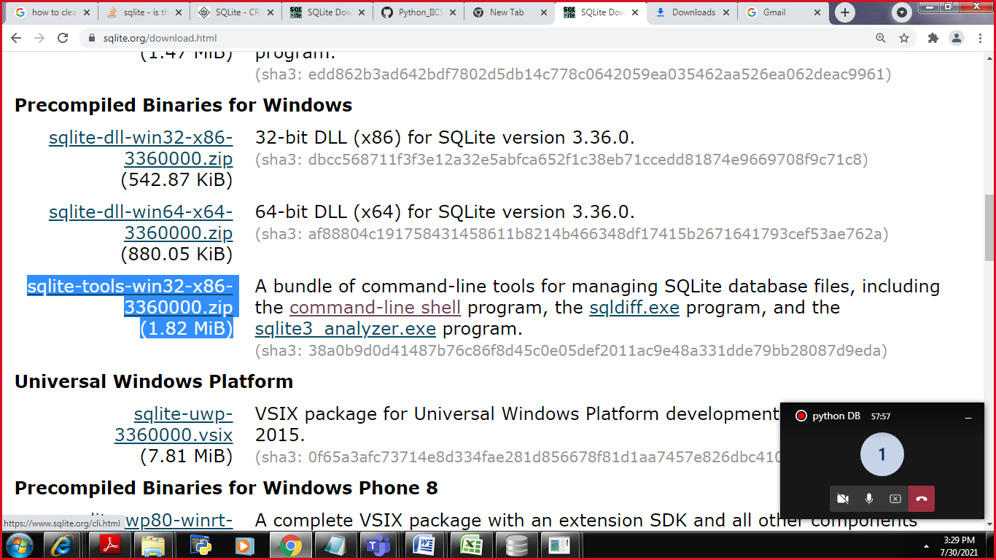

unzip

click on sqlite3

execute commands

Student

|  |  |  |
| --- | --- | --- |
| Sid | Sname | Hobbies |

Create table table_name(column_name datatype,columnname datatype,….);

Sqlite3

Integer

real

text

blob

Example:

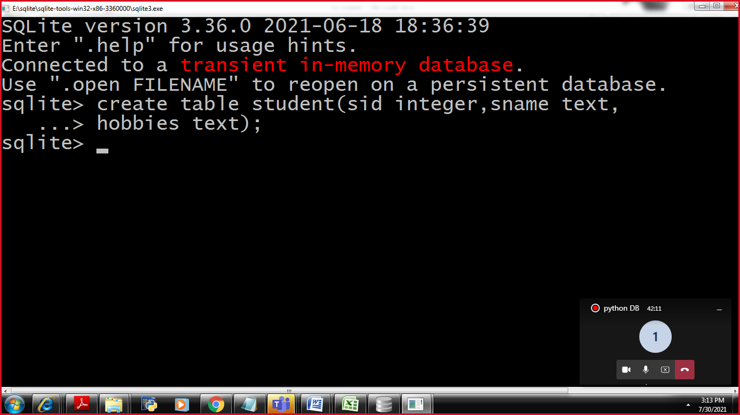

|  |  |  |
| --- | --- | --- |
| Sid | Sname | Hobbies |
| 1 | Rahul | Cricket |
| 2. | David | Chess |
| 3 | Ram | Cricket |
| 4 | Rohitha | Chess |

Insertion

insert into table_name values(value1,valu2,value3…);

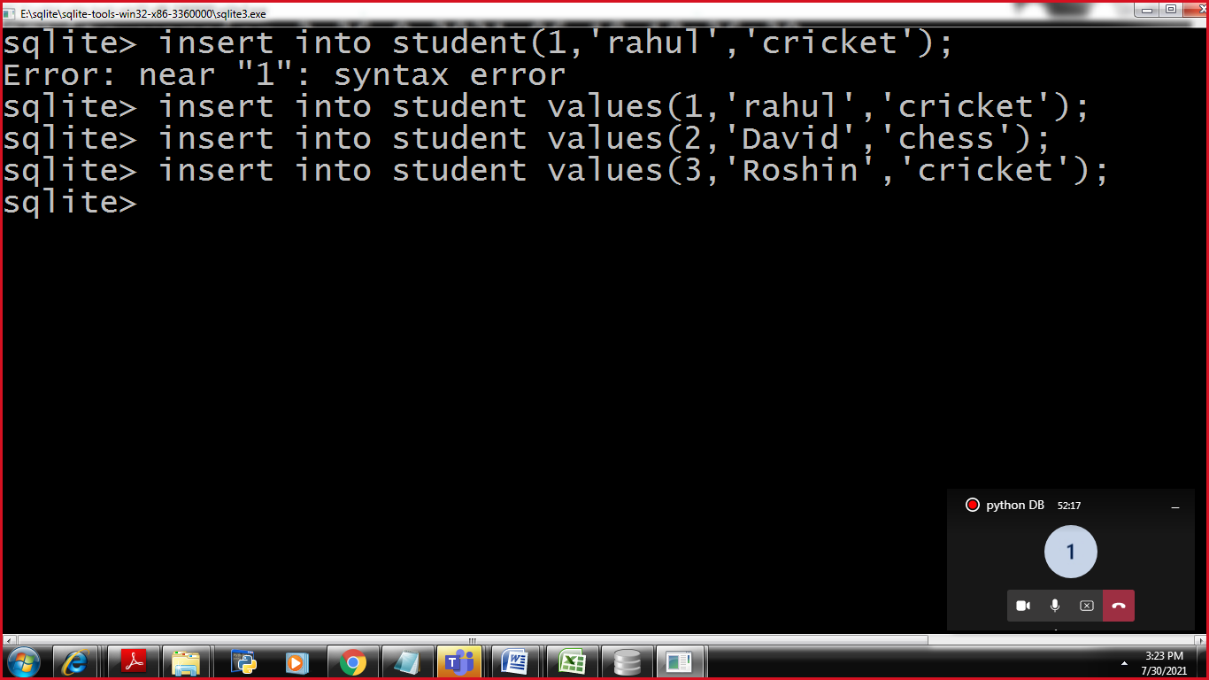

3.Fetching of inserted Records

Select columnname,columnname,……

From tablename;

