**Image insertion**

* To insert the image in the browser use <img>tag.
* <img src=”Address of image” width=”pixels” height=”pixels”

Alt=”Display details in case of image unavailability”/>

Eg:

<!DOCTYPE html>

<html>

<body>

<p>Insert an image from another folder:</p>

<img src="C:\Users\Admin\Desktop\Devipriya.jpg" alt="Stickman" width="100" height="100"

style="border:5px solid black" align="right">

</body>

</html>

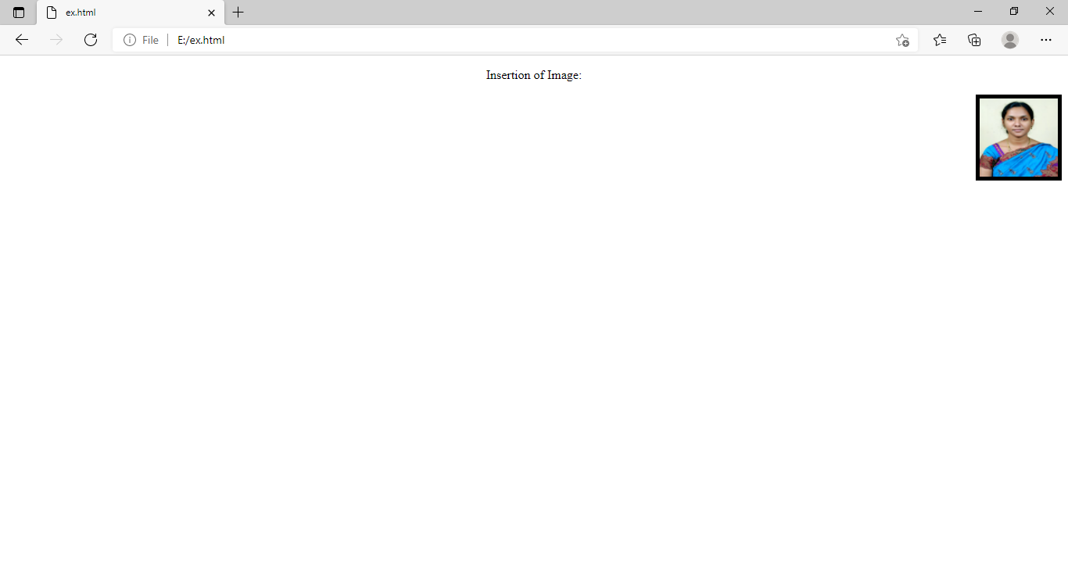

Anchor Tag:

Linking of documents is possible through the anchor tag which is possible through <a>

Syntax:

<a href=”Address of document” >

Text

</a>

**Example**

<!DOCTYPE html>

<html>

<body>

<a href="ex.html">Click Here</a>

</body>

</html>

Output:

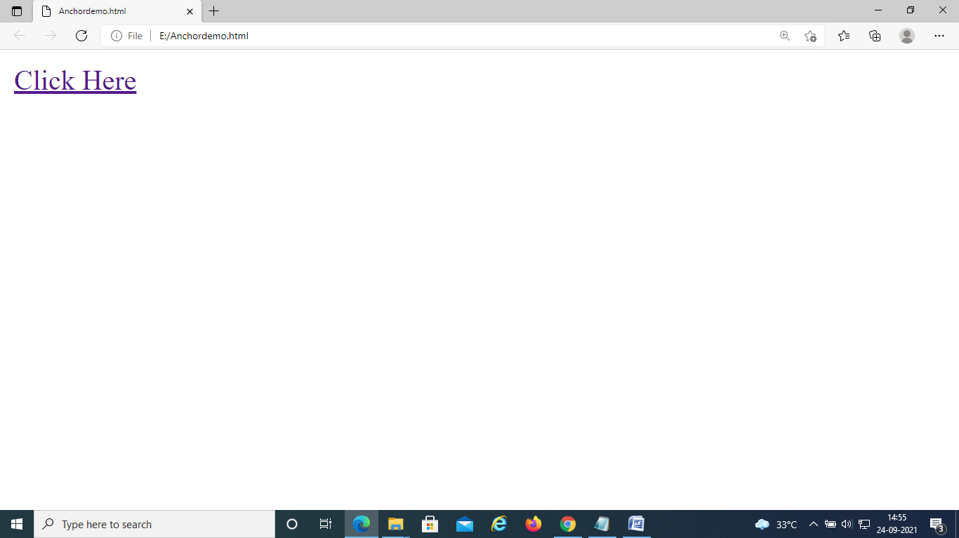

Fig:AnchorDemo.html

By clicking the above file the following ex.html file is opened.

