PROJECT REPORT: SCHEMESENTINEL
Smart Fraud Detection & Prevention Ecosystem for National Welfare

1. Introduction
Government welfare programs like PM-KISAN, MGNREGA, and PDS are the lifelines of the Indian economy, designed to funnel critical subsidies to deserving citizens. However, as these systems digitize, they become prime targets for organized digital fraud syndicates. A critical challenge is that as the frauds usually understand the pattern of fraud detection they will easily overcome it soo we will follow dynamic pattern system. SchemeSentinel is built on this principle, moving beyond static checks to an evolving, data-driven defense mechanism that ensures every rupee reaches its verified beneficiary.

2. Problem Statement
The core problem is the massive financial leakage in welfare distribution caused by coordinated fraud rings. These groups exploit metadata loopholes—using a single mobile device to manage dozens of accounts or linking multiple "beneficiaries" to one shared bank account. In current infrastructures, there is no real-time way to track these patterns across different schemes. Furthermore, because as the frauds usually understand the pattern of fraud detection they will easily overcome it soo we will follow dynamic pattern system that identifies anomalies in behavior, hardware fingerprints, and geospatial footprints.

3. Existing System
Current verification systems rely heavily on manual KYC and isolated database checks within individual departments. These systems lack cross-scheme visibility and hardware fingerprinting. Their primary limitation is their predictable, rule-based nature. As the frauds usually understand the pattern of fraud detection they will easily overcome it soo we will follow dynamic pattern system to replace these static barriers with evolving safeguards that track relational data rather than isolated entries.

4. Objectives
- Eliminate data silos between different government departments through a unified monitoring interface.
- Provide investigators with visual evidence of organized fraud syndicates and hidden networks.
- Implement a security layer where, as the frauds usually understand the pattern of fraud detection they will easily overcome it soo we will follow dynamic pattern system to stay ahead.

5. System Design & Prototype Architecture
SchemeSentinel is a full-stack dashboard that integrates real-time data analysis with graph-theoretical visualization. Recognizing that as the frauds usually understand the pattern of fraud detection they will easily overcome it soo we will follow dynamic pattern system by utilizing an adaptive backend that correlates disparate data points across multiple welfare schemes.

5.1 Main Dashboard & Risk Overview
This interface provides a high-level view of the entire welfare ecosystem. It tracks 'Total Applications', 'Suspicious Cases', and 'Active Fraud Rings'. The heatmap identifies geographic hotspots, ensuring that as the frauds usually understand the pattern of fraud detection they will easily overcome it soo we will follow dynamic pattern system to monitor regional shifts in fraudulent activity.
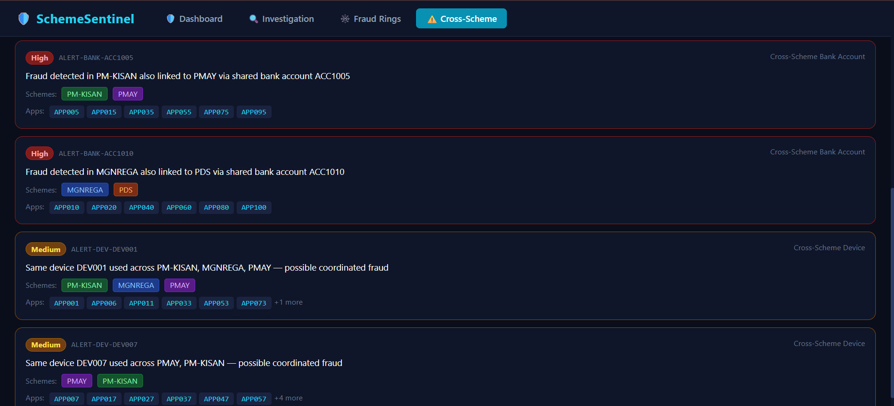

5.2 Granular Applicant Investigation
By entering an Applicant ID, the system retrieves a full profile. This includes the capturing of IP Addresses, mapping actual vs. declared locations, and providing the admin with 'Accept', 'Block', or 'Monitor' toggles. This ensures that as the frauds usually understand the pattern of fraud detection they will easily overcome it soo we will follow dynamic pattern system by reviewing the evidence list provided in this module.
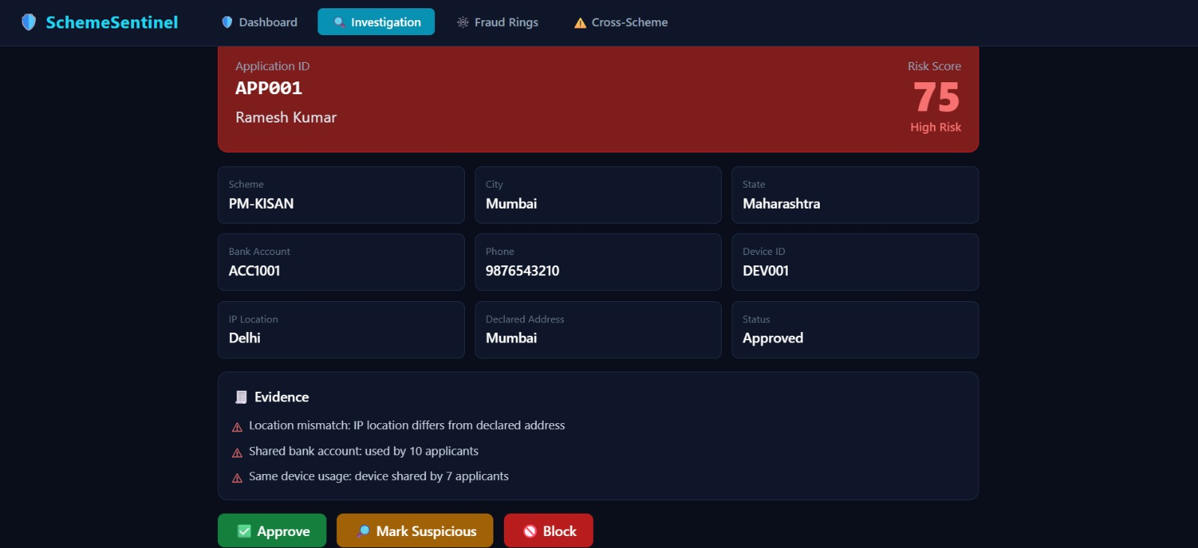

5.3 Advanced Fraud Ring Detection
This feature visualizes clusters of applicants sharing metadata like Bank Accounts or Device IDs. It uncovers organized syndicates managing fake identities. Because as the frauds usually understand the pattern of fraud detection they will easily overcome it soo we will follow dynamic pattern system using relationship mapping to find hidden connections between seemingly independent applicants.
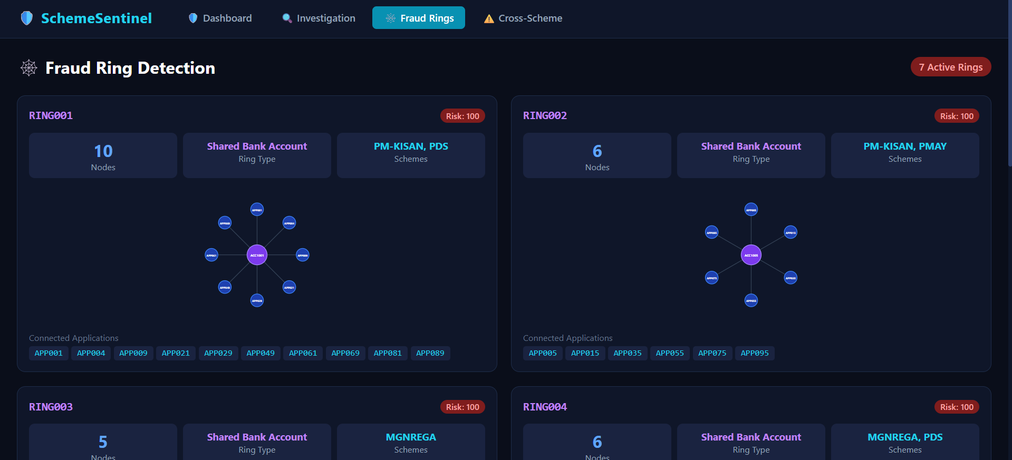

5.4 Multi-Scheme Fraud Tracking
This module monitors if a single suspicious entity appears across PM-KISAN, MGNREGA, or PDS. It ensures that as the frauds usually understand the pattern of fraud detection they will easily overcome it soo we will follow dynamic pattern system that breaks departmental silos to stop multi-scheme leakage.
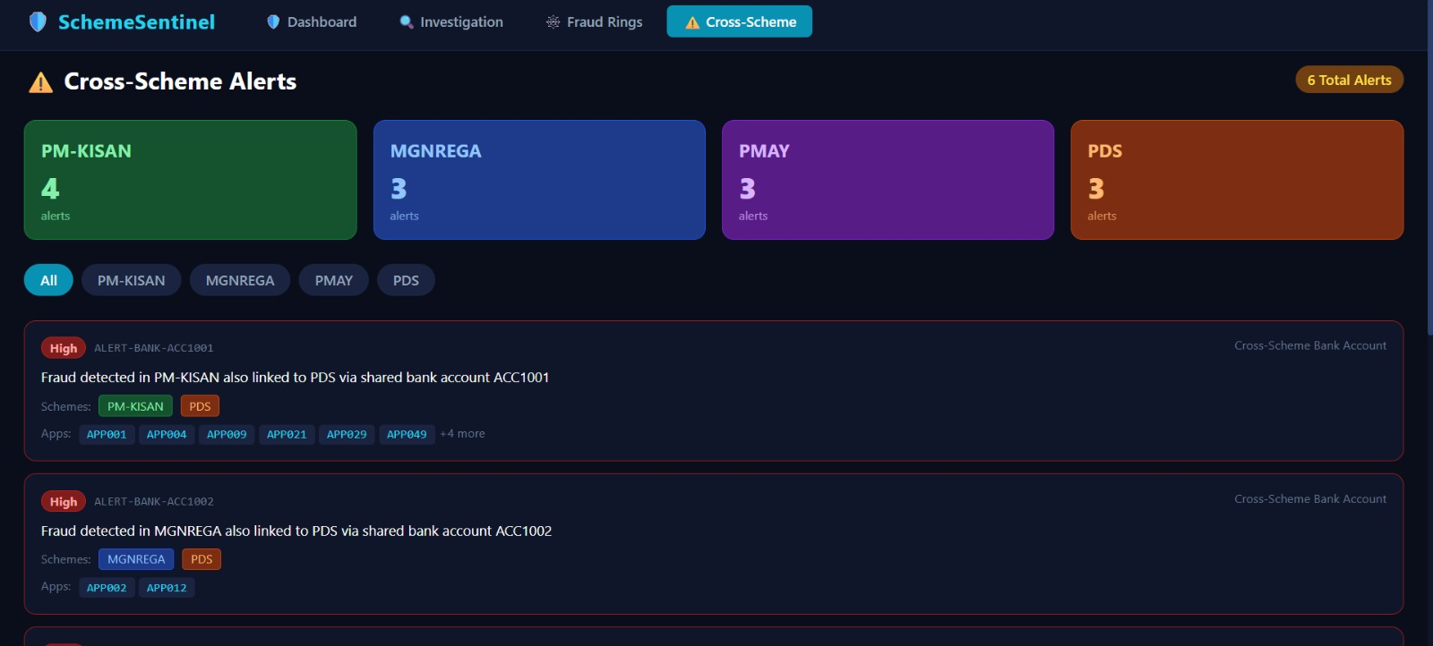

6. Technology Stack & Graph Neural Networks (GNN)
The stack includes React.js, Tailwind CSS, Flask, and Pandas. To ensure that as the frauds usually understand the pattern of fraud detection they will easily overcome it soo we will follow dynamic pattern system, we implement a structured GNN approach:
- Node Identification: Applicants and Bank Accounts as Nodes.
- Relationship Mapping: Creating Edges based on shared Device IDs.
- Message Passing: Propagating risk scores through the network.
- Dynamic Classification: Identifying fraudulent hubs in real-time.

7. Conclusion
SchemeSentinel provides a realistic roadmap for protecting welfare distribution. Acknowledging that as the frauds usually understand the pattern of fraud detection they will easily overcome it soo we will follow dynamic pattern system, we have created a tool that ensures transparency.

8. Future Work
Future plans include Aadhaar biometric integration and Blockchain ledgers. We will continue to evolve the system because as the frauds usually understand the pattern of fraud detection they will easily overcome it soo we will follow dynamic pattern system.

