IBM University Engagement Project Submission
“Exploring the Power of Agentic AI with IBM Granite and LangFlow”

Project Tile – [Write your project title here]

Domain of Project – [ like Agriculture / Education / Healthcare / … ]

Student Name | Recent Passport Photo | Email ID | Mobile number [WhatsApp]
 | 
Recommended font style and size: Font Style: Arial
Font Size (Heading): 28 Font Size (Content): 20

Problem Statement -

Problem Statement : Nutrition Agent The Challenge
Good nutrition is the foundation of health, but individuals often struggle with diet planning, portion control, and tracking
nutritional intake. Information about healthy diets, disease-specific nutrition, and food composition is scattered across unreliable sources. Without personalized, real-time guidance, many fail to maintain balanced diets or make informed food choices.

The Objective
Build an AI-powered Nutrition Agent that delivers personalized dietary insights and guidance for individuals, families, and health professionals. The solution should:
- Personalized Diet Plans – Recommend meals based on age, health conditions, allergies, cultural preferences, and fitness goals.
- Food Data RAG Retrieval – Fetch and summarize nutritional values (calories, macros, vitamins) from reliable sources.
- Diet Tracking & Feedback – Allow users to log meals via text, images, or voice, and provide instant nutritional analysis.
- Preventive Health Focus – Suggest diets for chronic disease management (e.g., diabetes-friendly or heart-healthy plans).

Multi-Agent System –
- Nutrition Knowledge Agent (fetches nutritional data)
- Diet Recommendation Agent (personalized meal plans)
- Health Advisory Agent (preventive health suggestions)
- Food Log & Feedback Agent (meal tracking + analysis)
- Visualization Dashboard – Show daily/weekly nutrient intake, deficiencies, and progress toward health goals.

Proposed Solution -

Proposed Solution: AI-Powered Nutrition Agent
The proposed solution is a multi-agent AI-powered Nutrition Agent built using LangFlow, IBM watsonx.ai, and Granite Models to provide personalized, real-time dietary guidance. The system addresses challenges in diet planning, nutrition tracking, and preventive healthcare through an intelligent, modular architecture.
At its core, the solution uses a Retrieval-Augmented Generation (RAG) pipeline to fetch accurate nutritional data from trusted sources such as USDA and WHO datasets. This data is embedded and stored in a vector database, enabling the system to retrieve and summarize food nutrition details (calories, macros, vitamins) using Granite models.
The system consists of four key agents:
Nutrition Knowledge Agent retrieves and summarizes nutritional information using RAG.
Diet Recommendation Agent generates personalized meal plans based on user inputs such as age, health conditions, dietary preferences, and fitness goals.
Health Advisory Agent provides preventive health suggestions, including disease-specific diets (e.g., diabetes-friendly or heart-healthy plans).
Food Log & Feedback Agent allows users to log meals via text, voice, or images and delivers instant nutritional analysis with actionable feedback.
The solution includes a user-friendly dashboard (built with Streamlit or React) that visualizes daily and weekly nutrient intake, highlights deficiencies, and tracks progress toward health goals.
LangFlow is used to orchestrate agent workflows, while watsonx.ai ensures scalable model deployment, embeddings, and AI governance. Granite models power reasoning, summarization, and personalization.
Overall, this solution delivers an end-to-end intelligent nutrition assistant that promotes healthier lifestyles through personalized insights, real-time feedback, and preventive healthcare recommendations.

Technology Used

  - Langflow platform -For designing and orchestrating multi-agent workflows visually

  - IBM Grainte model - for eg – ibm-granite-3-2-8b – For natural language understanding, reasoning, and personalization

  - IBM Cloud – It provides the infrastructure to build, deploy, and scale the Nutrition Agent efficiently. IBM Cloud enables a reliable, secure, and scalable environment for deploying the Nutrition Agent.

  - RAG– RAG to fetch real data first, then generate intelligent answers, making the Nutrition Agent more trustworthy and effective.

  - IBM Watsonx.ai - For model deployment, embeddings, and AI governance

  - Vector Database (FAISS/Chroma) – For RAG-based nutritional data retrieval

Langflow component Used -
- Chat Input – Interface where users enter their queries, preferences, or meal details (text/voice/image).

- IBM watsonx AI Agent - Processes user input using Granite models to generate personalized nutrition insights and recommendations.

- Name of IBM Granite model - Granite-4.0-8B-Instruct → Fast, efficient for real-time diet recommendations

- Chat output -Displays AI-generated responses such as diet plans, nutritional analysis, and health suggestions.

- File component - Stores and retrieves user data, meal logs, and nutritional datasets for analysis and tracking.

- Add name of any other component used.

Langflow workflow -

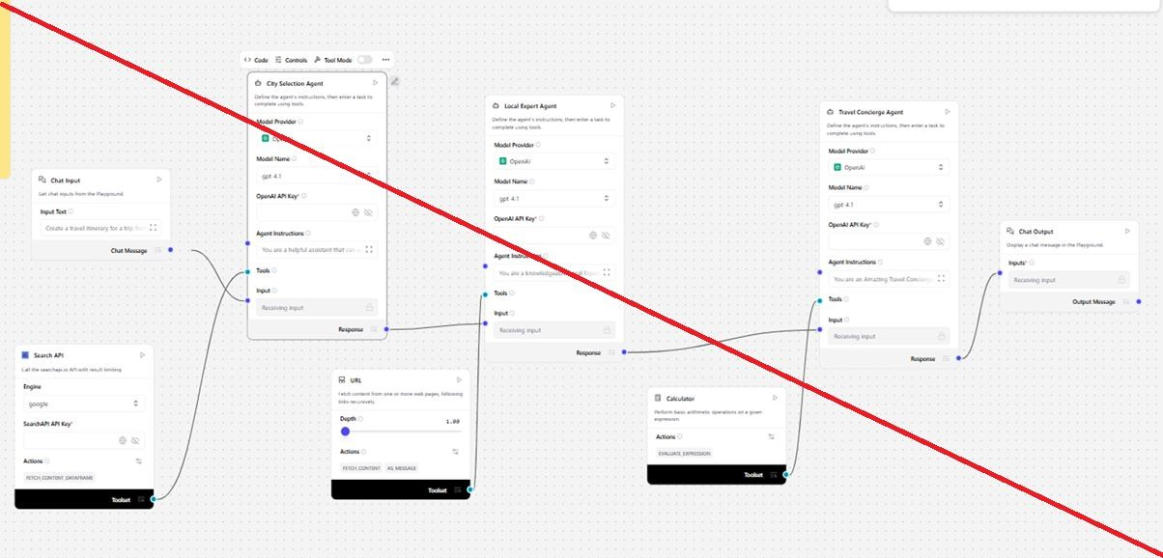

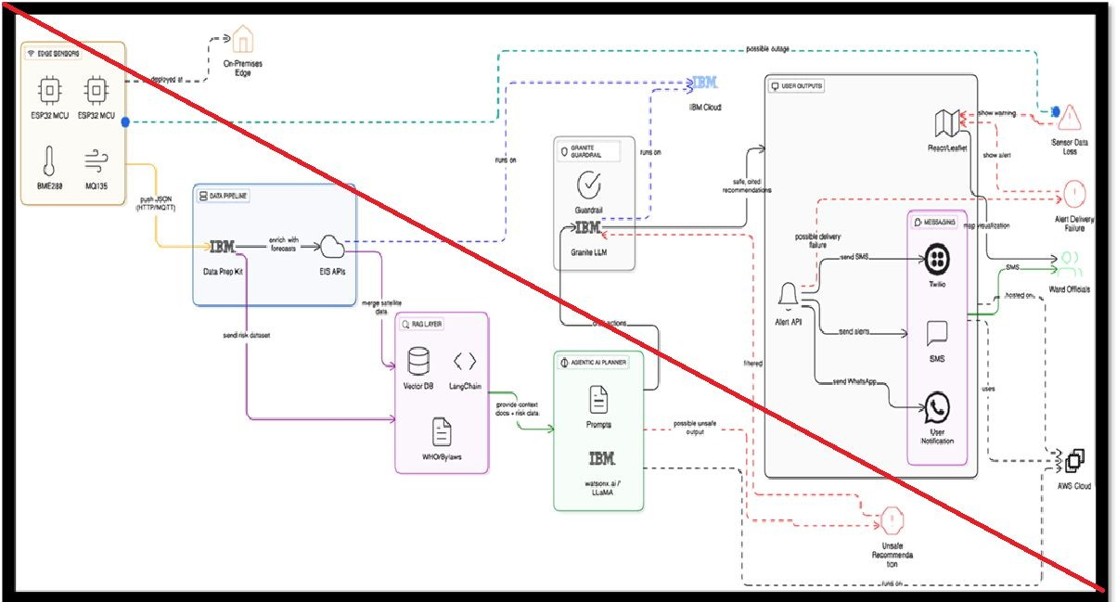
Architecture blueprint

Role of Agentic AI in the solution


Role of Agentic AI in Nutrition Agent
Agentic AI enables the Nutrition Agent to function as an intelligent, autonomous system rather than a simple chatbot. Using IBM watsonx.ai and IBM Granite models, it coordinates multiple specialized agents to deliver personalized nutrition guidance.
Each agent performs a specific role—such as retrieving nutritional data, generating diet plans, providing health advice, and analyzing food logs—while working collaboratively. This multi-agent approach ensures efficient task execution and accurate results.
Agentic AI also brings context awareness, understanding user details like age, health conditions, and fitness goals to generate tailored recommendations. It supports real-time adaptation, continuously updating suggestions based on user inputs like daily meals.
Additionally, agents communicate with each other, enabling better decision-making and improved outcomes.
Overall, Agentic AI makes the system proactive, personalized, and goal-driven, acting like a
smart digital nutritionist that helps users maintain a healthy lifestyle.

Token Usage
·

·

11,761 token are used

Before Prompt After the Prompt

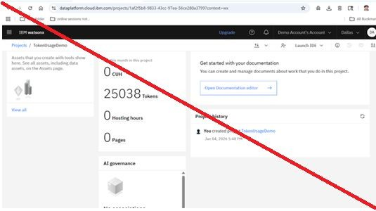
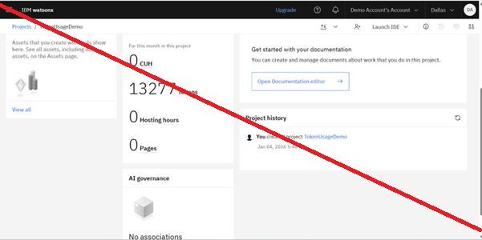
·

Novelty and Uniqueness

The proposed Nutrition Agent stands out by combining Agentic AI, RAG, and personalization into a single intelligent system.

Multi-Agent Intelligence – Instead of a single chatbot, multiple specialized agents collaborate to deliver accurate and context-aware nutrition guidance.
RAG-Based Accuracy – Integrates real-time data retrieval with AI generation, reducing misinformation and ensuring trustworthy recommendations.
Hyper-Personalization – Tailors diet plans based on health conditions, cultural preferences, and fitness goals.
Real-Time Feedback Loop – Continuously adapts recommendations based on daily food logs and user behavior.
Multi-Modal Input – Supports text, voice, and image-based meal tracking for better usability.
Preventive Healthcare Focus – Goes beyond diet planning to provide disease-specific nutrition advice. Scalable & Enterprise-Ready – Built on IBM watsonx.ai with IBM Granite models, ensuring reliability and governance.

This makes the solution a smart, adaptive, and proactive digital nutritionist, not just a static diet recommendation tool.

Git Hub Link

· Please create public github repository (Enable Add README button while creating repository) with format –
Please test and Paste the working Github URL –

Make sure you have Uploaded following three files into your github repository
1) app.json file , 2) yourproblemstatement.pdf file 3) your projectpresntation.pptx file 4)any
·other files

·

·

Future Scope

Integration with Wearables & Health Devices –
The system can be integrated with smartwatches and fitness trackers to collect real-time data such as steps, calories burned, heart rate, and sleep patterns. This will enable the Nutrition Agent to provide more accurate and dynamic diet recommendations based on actual user activity and health metrics.
·

AI-Powered Voice Assistant & Multilingual Support –
Enhancing the system with a voice-enabled assistant and support for multiple languages will i·mprove accessibility. Users can interact naturally in their preferred language, making the solution more inclusive and suitable for diverse populations, especially in regions with varied l·inguistic backgrounds.

Certificates Earned:

Please add your credly certificate

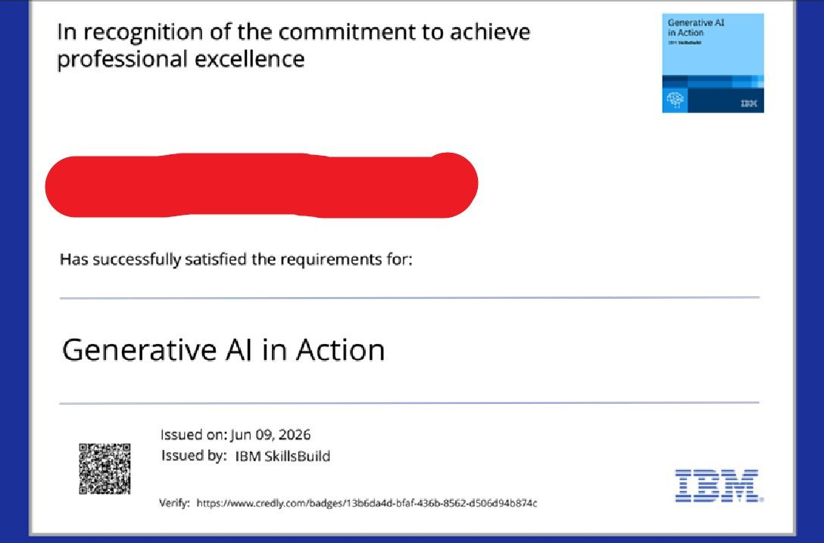

Certificates Earned:

Add your IBM BOB Certificate





