**package** com.testautomation.grid;

**import** org.openqa.selenium.WebDriver;

**import** org.openqa.selenium.chrome.ChromeDriver;

**import** org.openqa.selenium.firefox.FirefoxDriver;

**import** org.openqa.selenium.remote.DesiredCapabilities;

**import** org.openqa.selenium.remote.RemoteWebDriver;

**import** org.testng.annotations.Test;

**import** java.net.URL;

**public** **class** SeleniumGridDemo {

@Test

**public** **void** runTestOnChrome() **throws** Exception {

DesiredCapabilities capabilities = DesiredCapabilities.*chrome*();

WebDriver driver = **new** RemoteWebDriver(**new** ~~URL~~(" http://172.16.226.24:4444/wd/hub"), capabilities);

driver.get("https://www.google.com");

System.***out***.println("Page title on Chrome: " + driver.getTitle());

driver.quit();

}

@Test

**public** **void** runTestOnFirefox() **throws** Exception {

DesiredCapabilities capabilities = DesiredCapabilities.*firefox*();

WebDriver driver = **new** RemoteWebDriver(**new** ~~URL~~(" http://172.16.226.24:4444/wd/hub"), capabilities);

driver.get("https://www.google.com");

System.***out***.println("Page title on Firefox: " + driver.getTitle());

driver.quit();

}

}

java -jar selenium-server-4.29.0.jar hub

java -jar selenium-server-4.29.0.jar node --detect-drivers true

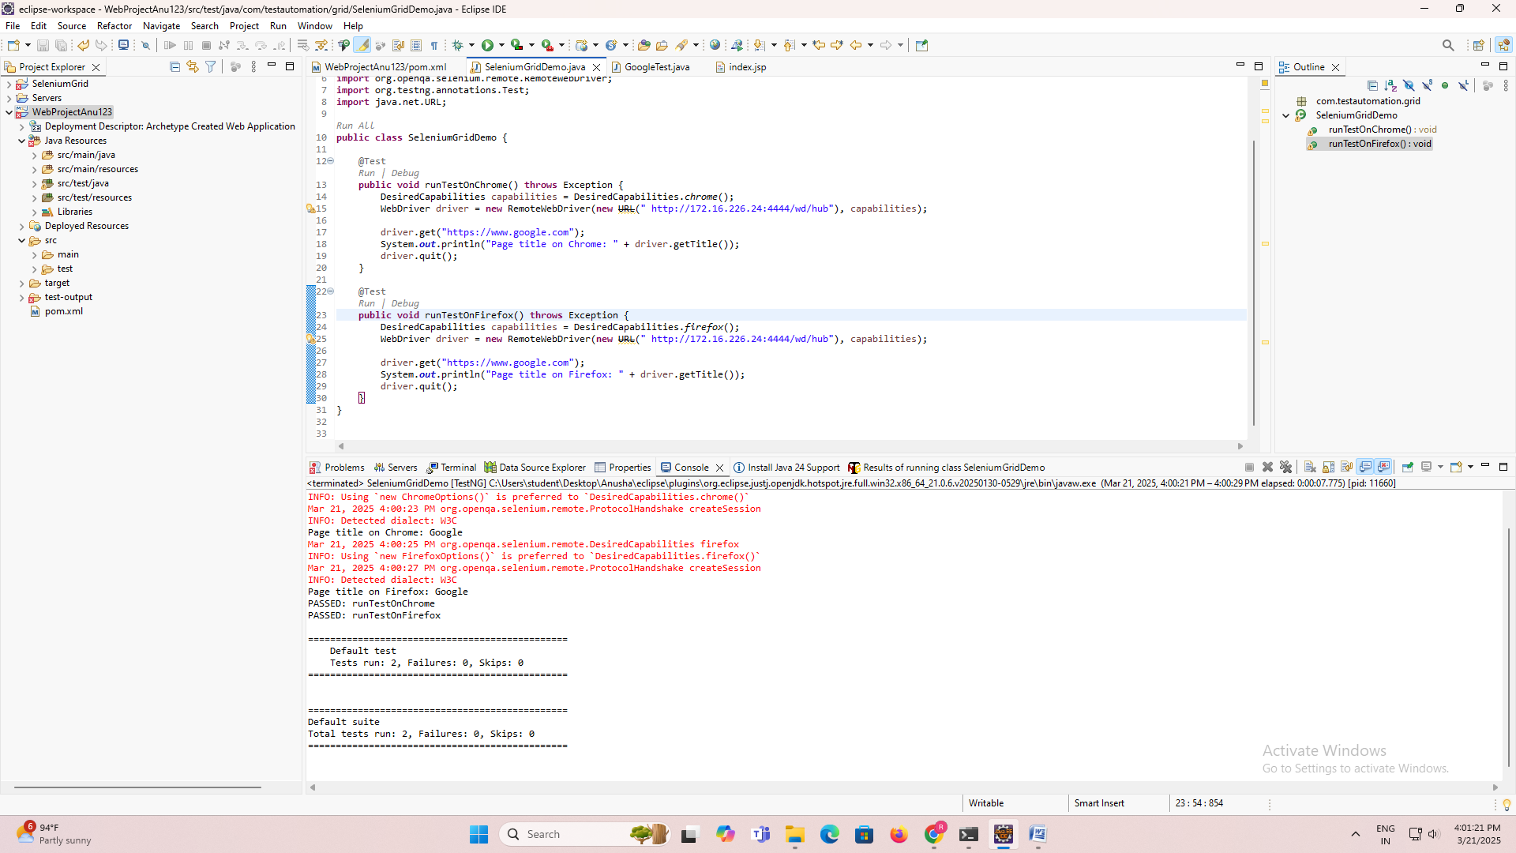

To set up and deploy a Selenium Grid that can run tests on **Chrome** and **Firefox** browsers, you need to set up the **Selenium Grid Hub** and **Selenium Node** for both Chrome and Firefox. The setup allows you to distribute tests across different machines and browsers for parallel test execution.

Here’s a step-by-step guide to setting up a Selenium Grid for Chrome and Firefox:

**Prerequisites:**

1. **Java 8 or later** installed on the machine(s).
2. **Selenium WebDriver JARs** for both the Hub and Nodes.
3. **ChromeDriver** and **GeckoDriver** (for Firefox) installed.
4. **Eclipse or another IDE** to run tests (optional).

**1. Download Selenium Server Standalone Jar**

Download the **Selenium Server Standalone Jar** from the official Selenium website:

* Go to Selenium Downloads.
* Download the latest version of **Selenium Standalone Server** (e.g., selenium-server-standalone-4.x.x.jar).

**2. Setting up the Selenium Grid Hub**

The **Hub** is the central point that will manage the WebDriver requests from test scripts and distribute them to the Nodes.

**Steps to start the Selenium Grid Hub:**

1. Open a terminal or command prompt.
2. Navigate to the folder where the Selenium Standalone server JAR is located.
3. Run the following command to start the **Hub**:

bash

Copy

java -jar selenium-server-standalone-4.x.x.jar hub

This will start the **Hub** on the default address http://localhost:4444/grid/console.

You can open this URL in your browser to check the status of your Grid.

**3. Setting up the Selenium Node for Chrome**

You need to configure a Node that will run tests on **Chrome**.

**Steps to start the Chrome Node:**

1. Download the **ChromeDriver** that matches your version of Chrome from the ChromeDriver download page.
2. Start the **Node** with Chrome support by running the following command:

bash

Copy

java -Dwebdriver.chrome.driver=/path/to/chromedriver -jar selenium-server-standalone-4.x.x.jar node --hub http://localhost:4444/grid/register --browser "browserName=chrome"

Make sure to replace /path/to/chromedriver with the correct path to the **ChromeDriver** on your machine.

This will register the node to the Grid Hub and it will be available to run tests on Chrome.

**4. Setting up the Selenium Node for Firefox**

Similarly, you need to configure a Node that will run tests on **Firefox**.

**Steps to start the Firefox Node:**

1. Download the **GeckoDriver** that matches your version of Firefox from the [GeckoDriver download page](https://github.com/mozilla/geckodriver/releases).
2. Start the **Node** with Firefox support by running the following command:

bash

Copy

java -Dwebdriver.gecko.driver=/path/to/geckodriver -jar selenium-server-standalone-4.x.x.jar node --hub http://localhost:4444/grid/register --browser "browserName=firefox"

Replace /path/to/geckodriver with the correct path to **GeckoDriver** on your machine.

This will register the Firefox node to the Grid Hub, and it will be available to run tests on Firefox.

**5. Verify Grid Configuration**

* You can now verify that both Chrome and Firefox nodes are connected to the hub.
* Open http://localhost:4444/grid/console in your browser, and you should see two available browsers (Chrome and Firefox) listed under the "Nodes" section.

**6. Run Selenium Tests on the Grid**

Now you can create a Selenium WebDriver test that uses the Grid and specifies which browser to run the test on.

**Example TestNG Code to Run Tests on the Grid:**

Here’s an example of how you can write a Selenium WebDriver test that runs on **Chrome** and **Firefox** using the Selenium Grid:

java

Copy

import org.openqa.selenium.WebDriver;

import org.openqa.selenium.chrome.ChromeDriver;

import org.openqa.selenium.firefox.FirefoxDriver;

import org.openqa.selenium.remote.DesiredCapabilities;

import org.openqa.selenium.remote.RemoteWebDriver;

import org.testng.annotations.Test;

import java.net.URL;

public class GridTest {

@Test

public void runTestOnChrome() throws Exception {

DesiredCapabilities capabilities = DesiredCapabilities.chrome();

WebDriver driver = new RemoteWebDriver(new URL("http://localhost:4444/wd/hub"), capabilities);

driver.get("https://www.google.com");

System.out.println("Page title on Chrome: " + driver.getTitle());

driver.quit();

}

@Test

public void runTestOnFirefox() throws Exception {

DesiredCapabilities capabilities = DesiredCapabilities.firefox();

WebDriver driver = new RemoteWebDriver(new URL("http://localhost:4444/wd/hub"), capabilities);

driver.get("https://www.google.com");

System.out.println("Page title on Firefox: " + driver.getTitle());

driver.quit();

}

}

**Explanation:**

* The RemoteWebDriver is used to run tests remotely on the Selenium Grid.
* DesiredCapabilities is used to specify the browser (Chrome or Firefox) on which you want to run the test.
* The test connects to the **Hub** at http://localhost:4444/wd/hub.

**7. Running the Test**

To run the test on both Chrome and Firefox:

1. Ensure the **Hub** and **Nodes** (for Chrome and Firefox) are running.
2. Run the GridTest class as a **TestNG** test (or as a JUnit test, depending on your setup).

**8. Scaling the Grid**

To scale your Selenium Grid (add more nodes for more parallel tests):

* You can add additional machines or virtual machines as nodes.
* Ensure each node has its respective driver (chromedriver or geckodriver) and is registered with the Hub.
* For scaling, you can use Docker to spin up multiple containers as nodes for parallel test execution.

**9. Stopping the Grid**

* To stop the Hub, press **Ctrl + C** in the terminal where it's running.
* To stop the Nodes, press **Ctrl + C** in the terminal where they are running.

**Conclusion:**

By following these steps, you have successfully set up a **Selenium Grid** that allows you to run tests on both **Chrome** and **Firefox**. This setup will allow you to distribute and parallelize your tests across multiple browsers for faster test execution.

Let me know if you have any issues or need further help with your setup!

**You said:**

how to add testng option in run as place to run as class to test ng

**ChatGPT said:**

To run your test as a **TestNG test** in Eclipse, you need to configure the **TestNG plugin** properly, so the option appears in the **Run As** context menu.

**Here's how to add the "Run As TestNG Test" option to Eclipse:**

**1. Install the TestNG Plugin in Eclipse (If not already installed)**

If you haven't already installed the **TestNG plugin** in Eclipse, follow these steps:

1. Open **Eclipse**.
2. Go to **Help** > **Eclipse Marketplace**.
3. In the **Eclipse Marketplace** dialog, search for **TestNG**.
4. Click **Go** and find **TestNG for Eclipse** in the list.
5. Click **Install** next to **TestNG** and follow the prompts to install it.
6. Restart Eclipse after the installation completes.

After this, the **TestNG** plugin will be installed and the **"Run As TestNG Test"** option should appear in the **Run As** context menu.

**2. Run the TestNG Class**

Once **TestNG** is installed, you can run any **TestNG** class as follows:

1. **Open your TestNG class** in Eclipse.
2. Right-click on the class name in the **editor** or in the **Project Explorer**.
3. From the context menu, select **Run As** > **TestNG Test**.

This will run your TestNG tests within Eclipse.

**3. If the "TestNG Test" Option is Not Available:**

In some cases, the **"TestNG Test"** option may not show up because the **TestNG framework** is not properly set up or the necessary files are missing.

**Here’s how to fix it:**

1. **Ensure TestNG is Added to the Build Path**:
   * Right-click on your project in **Project Explorer**.
   * Select **Build Path** > **Configure Build Path**.
   * Go to the **Libraries** tab and check if **TestNG** is listed.
   * If not, you will need to add **TestNG** manually (see the steps below for adding TestNG using **Maven** or **Manual Jar** method).

**4. Adding TestNG to Your Project (if not already done)**

**A. Using Maven (Recommended for easy dependency management):**

1. Open your pom.xml file.
2. Add the following dependency for TestNG:

xml

Copy

<dependency>

<groupId>org.testng</groupId>

<artifactId>testng</artifactId>

<version>7.4.0</version> <!-- Make sure to use the latest version -->

<scope>test</scope>

</dependency>

1. Save the pom.xml file and right-click on the project.
2. Select **Maven** > **Update Project** to download and add TestNG to your project.

**B. Manually Adding TestNG JAR (if not using Maven):**

1. Download the **TestNG JAR** from the TestNG official website or Maven repository.
2. Right-click your project in **Project Explorer**.
3. Select **Build Path** > **Configure Build Path**.
4. In the **Libraries** tab, click **Add External JARs**.
5. Browse to the location where you downloaded **TestNG JAR** and select it.
6. Click **Apply and Close**.

After this, TestNG should be recognized in your project, and the **"Run As TestNG Test"** option should appear.

**5. Running the Test**

Once TestNG is properly added to your project, you can run your test as follows:

1. Right-click the **TestNG class** or **test method**.
2. Select **Run As** > **TestNG Test**.
3. The **TestNG** test results will appear in the **Console** and **TestNG Results** view.

**6. Using a TestNG XML Configuration (Optional)**

If you have multiple tests and want to organize and run them together, you can create a **TestNG XML file**. Here's how:

1. **Create a TestNG XML file**:
   * Right-click your project > **New** > **Other** > **TestNG** > **TestNG XML**.
   * Select the methods or classes you want to include in the XML.
   * Click **Finish**.
2. **Run using TestNG XML**:
   * Right-click the **TestNG XML** file.
   * Select **Run As** > **TestNG Suite**.

This will run all the tests specified in the **TestNG XML** file.

**Conclusion:**

To summarize, to add the "Run As TestNG Test" option in Eclipse:

1. Install the **TestNG plugin** from the **Eclipse Marketplace**.
2. Ensure **TestNG** is added to your project (via Maven or manually).
3. Right-click on your TestNG class or method and select **Run As** > **TestNG Test**.

If you're still facing issues, let me know and I’ll help troubleshoot further!

**You said:**

how to select testng class

**ChatGPT said:**

To select and run a **TestNG class** in Eclipse, follow these steps:

**1. Ensure TestNG is Properly Set Up**

Before running your TestNG class, make sure:

1. **TestNG is added to your project** (either via Maven or manually).
2. The **TestNG plugin** is installed in Eclipse.

If you’ve already done this, you should be able to select and run the TestNG class without issues.

**2. Open the TestNG Class**

Navigate to your **TestNG class** in the **Project Explorer** or **Package Explorer**.

A **TestNG class** typically contains methods annotated with @Test. Here’s an example of a simple TestNG class:

java

Copy

import org.testng.annotations.Test;

public class SampleTest {

@Test

public void testMethod() {

System.out.println("This is a TestNG test method.");

}

}

**3. Right-click the TestNG Class**

1. **In the Project Explorer** or **Package Explorer**, locate your **TestNG class** (the file that contains the test method(s) annotated with @Test).
2. Right-click on the **TestNG class** file (e.g., SampleTest.java).

**4. Run the TestNG Class**

After right-clicking the class, do the following:

1. From the context menu, select **Run As** > **TestNG Test**.
   * If the **"Run As TestNG Test"** option is missing, ensure you have installed the **TestNG plugin** and added TestNG to your project.
2. **Eclipse will now run the TestNG class**:
   * The results will appear in the **Console** and the **TestNG Results** view.
   * You will also see a **TestNG** tab showing the results of each test (whether it passed, failed, or was skipped).

**5. Running Individual Test Methods (Optional)**

If you want to run a specific **test method** instead of the entire class, do the following:

1. **Open the TestNG class** and locate the method you want to run.
2. Right-click on the **test method** (for example, testMethod()).
3. From the context menu, select **Run As** > **TestNG Test**.

This will run **only the selected test method** in that class.

**6. Using TestNG XML for Running Multiple Tests**

If you have multiple **TestNG classes** or methods and want to organize and run them together, you can use a **TestNG XML configuration** file:

1. **Create a TestNG XML file**:
   * Right-click your project > **New** > **Other** > **TestNG** > **TestNG XML**.
   * Select the **TestNG classes** or **test methods** you want to include.
   * Click **Finish**.
2. **Run the TestNG XML**:
   * Right-click on the **TestNG XML file** (e.g., testng.xml).
   * Select **Run As** > **TestNG Suite**.

**7. Running from the Run Configurations (Alternative Method)**

1. In the **Run Configurations** dialog:
   * Go to **Run** > **Run Configurations...**.
   * Select **TestNG** on the left side.
   * Click on the **New launch configuration** button (a small icon with a plus sign).
   * Under the **TestNG** tab, click on **Browse...** to select your **TestNG class**.
   * Click **Apply** and then **Run**.

This allows you to configure specific settings for your TestNG execution.

**Summary:**

1. **Open** the TestNG class in the **Project Explorer**.
2. **Right-click** the class file and select **Run As** > **TestNG Test** to run the entire class.
3. Alternatively, you can **right-click** on an individual test method and select **Run As** > **TestNG Test** to run only that method.
4. For running multiple tests, you can use a **TestNG XML file** and run the suite.

Let me know if you need further clarification!