**CMSC203 Assignment 1 Implementation**

Class: CMSC203 CRN 24307

 Program: Assignment 1

Instructor: Prof Tsai

 Summary of Description: Implement the design for project 1.

 Due Date: 09/12/2021

 Integrity Pledge: I pledge that I have completed the programming assignment independently.

 I have not copied the code from a student or any source.

**Part1: Pseudo Code:** Here is a pseudo code for Assignment 1 program:

1. **Introduce program and purpose**
2. **Instruct the user to reboot their computer**
3. **Ask if user is able to connect to the internet, take input as a string**
4. **If yes, end the program. If no, tell the user to reboot their router**
5. **Ask if the user is able to connect to the internet, take input again.**
6. **If yes, end the program. If no, tell the user to check the router’s cables.**
7. **Ask if the user is able to connect to the internet, take input again.**
8. **If yes, end the program, If no, tell the user to move their computer closer to their router.**
9. **Ask if the user is able to connect to the internet, take input again.**
10. **If yes, end the program. If no, tell the user to contact their ISP and end the program.**

**Part2: Comprehensive Test Plan**

A good test plan should be comprehensive. This means you should have a few test cases that test when the input is in and out of range, division by 0, incorrect Data type, etc (Provide valid and invalid input)

| Cases | Input | Expected Output | Actual Output | Did Test Pass? |
| --- | --- | --- | --- | --- |
| Case 1 | Yes | Rebooting your computer seemed to work | Rebooting your computer seemed to work | Yes |
| Case 2 | No  No  No  No | Make sure your ISP is hooked up to your router. | Make sure your ISP is hooked up to your router. | Yes |
| Case 3 | No  Yes | Rebooting your router seemed to work | Rebooting your router seemed to work | Yes |
| Case 4 | No  No  No  Yes | Moving your computer seemed to work | Moving your computer seemed to work | Yes |

**Part3: Screenshots related to the Test Plan:**

**Case 1**

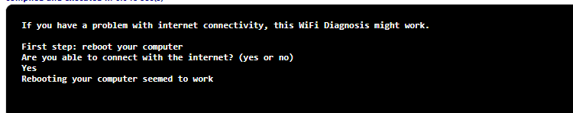

**Case 2**

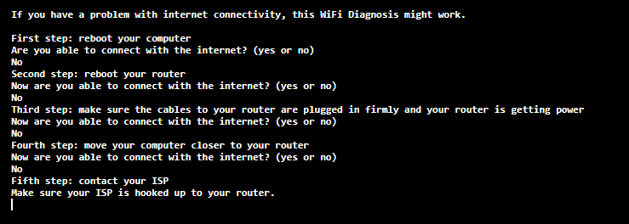

**Case 3**

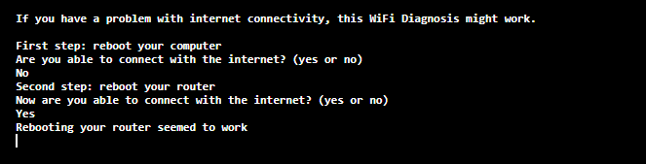

**Case 4**

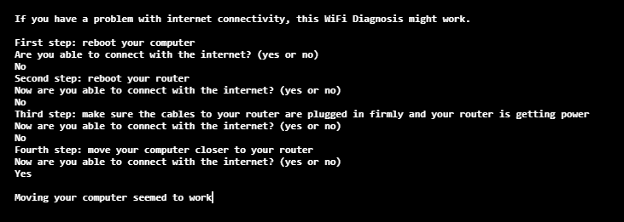

**Lessons Learned** <Provide answers to the questions listed below>**:**

Write about your Learning Experience, highlighting your lessons learned and learning experience from working on this project.

What have you learned?

What did you struggle with?

What would you do differently on your next project?

What parts of this assignment were you successful with, and what parts (if any) were you not successful with?

Provide any additional resources/links/videos you used to while working on this assignment/project.

**While finishing this project, I learned that Java does not do string comparison the same as C++ does. In C++, you can just compare strings using the == operator. In Java, however, you use the methods of the string class to compare them, such as “equals()” and “equalsIgnoreCase()”. I initially struggled with program flow errors, where the program would go onto the next step even though it wasn’t supposed to. I fixed this using nested if statements. On my next project, I will make sure to make comments while I code to arrange my thoughts better and create a more efficient project and faster. I was successful with every part of the assignment, it works just as I want now.**

**Check List:** <Provide answers to the column Y/N or N/A >**:**

| **#** |  | **Y/N** | **Comments** |
| --- | --- | --- | --- |
|  | **Assignment files:** |  |  |
|  | * FirstInitialLastName_ Assignment#_Moss.zip | **Yes or No** | **Yes** |
|  | * FirstInitialLastName_Assignment#.docx/.pdf | **Yes or No** | **Yes** |
|  | * Source java files | **Yes or No** | **Yes** |
|  | **Program compiles** | **Yes or No** | **Yes** |
|  | **Program runs with desired outputs related to a Test Plan** | **Yes or No** | **Yes** |
|  | **Documentation file:** |  |  |
|  | * Comprehensive Test Plan | **Yes or No** | **Yes** |
|  | * Screenshots related to the Test Plan | **Yes or No** | **Yes** |
|  | * Screenshots of your GitHub account with submitted Assignment# (if required) | **Yes or No or N/A** | **Yes** |
|  | * UML Diagram (if required) | **Yes or No or N/A** | **N/A** |
|  | * Algorithms/Pseudocode (if required) | **Yes or No or N/A** | **Yes** |
|  | * Flowchart (if required) | **Yes or No or N/A** | **N/A** |
|  | * Lessons Learned | **Yes or No** | **Yes** |
|  | * Checklist is completed and included in the Documentation | **Yes or No** | Yes |