**CMSC203 Assignment 2 Implementation (Documentation)**

Class: CMSC203 CRN 24307

 Program: Assignment 2

Instructor: Prof Tsai

 Summary of Description: Make a random number guessing game

 Due Date: 09/26/2021

 Integrity Pledge: I pledge that I have completed the programming assignment independently.

 I have not copied the code from a student or any source.

**Part1: Pseudo Code:** Here is a pseudo code for Assignment 2 program:

1. **Generate a random number 0-100**
2. **Ask for user’s guess and take answer as input**
3. **Compare the input with the random number:**

* **If input < rand, set low to input and tell the user they guessed too low**
* **If input > rand, set high to input and tell the user they guessed too high**
* **If input = rand, congratulate user and end the program**

1. **Now, tell the user to guess a number between their lowest guess and their highest guess, if applicable. Then compare with the random number:**

* **If input < rand, set low to input and tell the user they guessed too low**
* **If input > rand, set high to input and tell the user they guessed too high**
* **If input = rand, congratulate user and end the program**

1. **Repeat step 4, keep track of how many times the user guesses and display each time.**

**Part2: Comprehensive Test Plan**

A good test plan should be comprehensive. This means you should have a few test cases that test when the input is in and out of range, division by 0, incorrect Data type, etc. (Provide valid and invalid input)

| Cases | Input | Expected Output | Actual Output | Did Test Pass? |
| --- | --- | --- | --- | --- |
| Case 1 | rng: 21  50  25  12  20  23  22  21  no | too high  too high  too low  too low  too high  too high  correct | too high  too high  too low  too low  too high  too high  correct | Yes |
| Case 2 | rng: 26  50  60  0  25  30  35  27  26  no | too high  invalid  invalid  too low  too high  invalid  too high  correct  no | too high  invalid  invalid  too low  too high  invalid  too high  correct  no | Yes |
| Case 3 | 50  75  87  94  95  yes  50  75  60  no | too low  too low  too low  too low  correct  too low  too high  correct | too low  too low  too low  too low  correct  too low  too high  correct | Yes |
| Case 4 | 50  75  84  92  96  98  no | too low  too low  too low  too low  correct | too low  too low  too low  too low  correct | Yes |

**Part3: Screenshots related to the Test Plan:**

**Case 1**

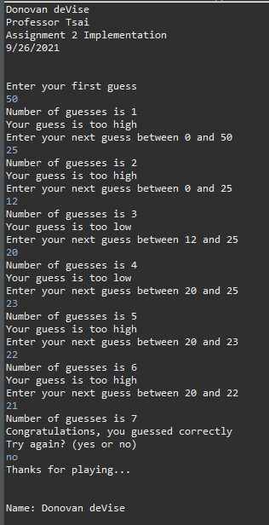

**Case 2**

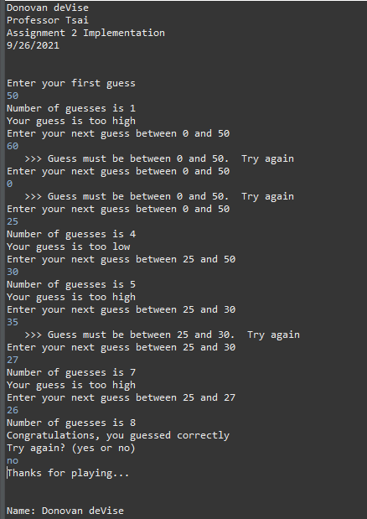

**Case 3**

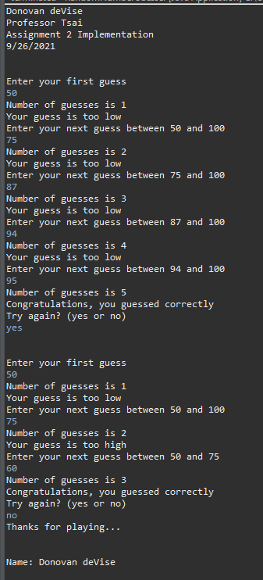

**Case 4**

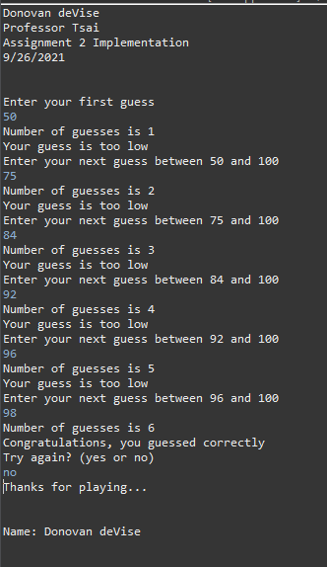

**Lessons Learned** <Provide answers to the questions listed above>**:**

Write about your Learning Experience, highlighting your lessons learned and learning experience from working on this project.

What have you learned?

What did you struggle with?

What would you do differently on your next project?

What parts of this assignment were you successful with, and what parts (if any) were you not successful with?

Provide any additional resources/links/videos you used to while working on this assignment/project.

**I learned about how to create a random number in Java and how to use the continue statement effectively. At first, I used the break statement, but that broke out of the loop which is not what I wanted, so I replaced it with a continue statement and it was fixed. I struggled with getting the count variable to show accurately at first, and I also struggled with input validation. On my next project, I will make sure to add comments as I code to finish the assignment more efficiently. I was successful in finishing the entire assignment, so there was nothing I was not successful in.**

**Check List:** <Provide answers to the column Y/N or N/A >**:**

| **#** |  | **Y/N** | **Comments** |
| --- | --- | --- | --- |
|  | **Assignment files:** |  |  |
|  | * FirstInitialLastName_ Assignment#_Moss.zip | **Yes or No** |  |
|  | * FirstInitialLastName_Assignment#.docx/.pdf | **Yes or No** |  |
|  | * Source java files | **Yes or No** | **Yes** |
|  | **Program compiles** | **Yes or No** | **Yes** |
|  | **Program runs with desired outputs related to a Test Plan** | **Yes or No** | **Yes** |
|  | **Documentation file:** |  |  |
|  | * Comprehensive Test Plan | **Yes or No** | **Yes** |
|  | * Screenshots related to the Test Plan | **Yes or No** | **Yes** |
|  | * Screenshots of your GitHub account with submitted Assignment# (if required) | **Yes or No or N/A** | **Yes** |
|  | * UML Diagram (if required) | **Yes or No or N/A** | **N/A** |
|  | * Algorithms/Pseudocode (if required) | **Yes or No or N/A** | **Yes** |
|  | * Flowchart (if required) | **Yes or No or N/A** | **N/A** |
|  | * Lessons Learned | **Yes or No** | **Yes** |
|  | * Checklist is completed and included in the Documentation | **Yes or No** | Yes |

