CMSC 204

Huffman Lab

1. Create a Huffman Tree and generate the codes for each character of the following input:

create a huffman tree

For consistency:

1. If same frequency – put in priority queue alphabetically; put space before other characters of the same frequency
2. Add subtrees to end of group with same priority
3. Lower number has higher priority (goes to front)

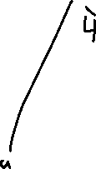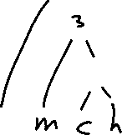

|  |  |
| --- | --- |
| Char | Freq |
| Space | 3 |
| a | 3 |
| c | 1 |
| e | 4 |
| f | 2 |
| h | 1 |
| m | 1 |
| n | 1 |
| r | 2 |
| t | 2 |
| u | 1 |

Queue: chmnu frt [space]a e

|  |  |  |  |
| --- | --- | --- | --- |
| Char | Code | Freq | Total Bits |
| Space | 101 | 3 | 9 |
| a | 00 | 3 | 6 |
| c | 1111110 | 1 | 7 |
| e | 01 | 4 | 8 |
| f | 1100 | 2 | 8 |
| h | 1111111 | 1 | 7 |
| m | 111110 | 1 | 6 |
| n | 11110 | 1 | 5 |
| r | 1101 | 2 | 8 |
| t | 100 | 2 | 6 |
| u | 1110 | 1 | 4 |

Now encode “create a huffman tree”

|  |  |  |  |
| --- | --- | --- | --- |
| Char | Code | Freq | Total Bits |
| Space | 101 | 3 | 9 |
| a | 00 | 3 | 6 |
| c | 1111110 | 1 | 7 |
| e | 01 | 4 | 8 |
| f | 1100 | 2 | 8 |
| h | 1111111 | 1 | 7 |
| m | 111110 | 1 | 6 |
| n | 11110 | 1 | 5 |
| r | 1101 | 2 | 8 |
| t | 100 | 2 | 6 |
| u | 1110 | 1 | 4 |

Total Bits: 9+6+7+8+8+7+6+5+8+6+4 = 74 bits

c r e a t e a h u f f m a n t r e e

1111110 1101 01 00 100 01 101 00 101 1111111 1110 1100 1100 111110 00 11110 101 100 1101 01 01

11111101101010010001101001011111111111011001100111110001111010110011010101

1. Based on the following Huffman tree and binary sequence, what is the text

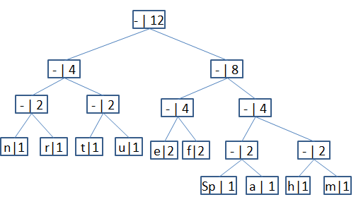

1110011101101111111010001100010001100100

|  |  |  |
| --- | --- | --- |
| Char | Freq | Code |
| Space | 1 | 1100 |
| a | 1 | 1101 |
| e | 2 | 100 |
| f | 2 | 101 |
| h | 1 | 1110 |
| m | 1 | 1111 |
| n | 1 | 000 |
| r | 1 | 001 |
| t | 1 | 010 |
| u | 1 | 011 |

1110 011 101 101 1111 1101 000 1100 010 001 100 100

h u f f m a n Spc t r e e

Answer: huffman tree