**INEURON(ASSIGNMENT-1)**

Q1) Write a program(WAP) to print INEURON using pattern programming logic.

Ans) code:-

**public** **class** fifth {

**public** **static** **void** main(String[] args) {

**for** (**int** a = 0; a < 7; a++)

{

**for** (**int** i = 0; i < 7; i++)

{

**if** (a == 0 || a == 6 || i == (7 / 2))

{

System.***out***.print ("*");

}

**else**

{

System.***out***.print (" ");

}

}

System.***out***.print (" ");

**for** (**int** n = 0; n < 7; n++)

{

**if** (n == 0 || (a == n) || n == 6)

{

System.***out***.print ("*");

}

**else**

{

System.***out***.print (" ");

}

}

System.***out***.print (" ");

**for** (**int** e = 0; e < 7; e++)

{

**if** (e == 0 || a == 0 || a == (7 / 2) || a == 6)

{

System.***out***.print ("*");

}

**else**

{

System.***out***.print (" ");

}

}

System.***out***.print (" ");

**for**(**int** u=0;u<7;u++)

{

**if**(a==6||u==0||u==6)

{

System.***out***.print("*");

}

**else**{

System.***out***.print(" ");

}

}

System.***out***.print(" ");

**for**(**int** r=0;r<7;r++)

{

**if**(r==0||a==0||(a<=(7/2)&&r==6)||a==(7/2)||(a>=(7/2)&&(a-r)==0))

{

System.***out***.print("*");

}

**else**{

System.***out***.print(" ");

}

}

System.***out***.print(" ");

**for**(**int** o=0;o<7;o++)

{

**if**(o==0||o==6||a==6||a==0)

{

System.***out***.print("*");

}

**else**{

System.***out***.print(" ");

}

}

System.***out***.print(" ");

**for**(**int** n=0;n<7;n++)

{

**if**(n==0||(a==n)||n==6)

{

System.***out***.print("*");

}

**else**{

System.***out***.print(" ");

}

}

System.***out***.print(" ");

System.***out***.println (" ");

}

}

}

Output:-

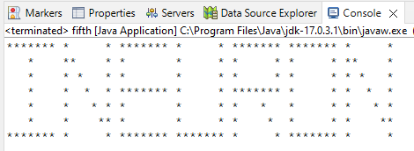

Q-2) Write a program to print

1 1 1 1

2 2 2 2

3 3 3 3

4 4 4 4

Ans) code:-

**public** **class** first {

**public** **static** **void** main(String args[])

{

**for**(**int** i=1;i<=4;i++)

{

**for**(**int** j=0;j<4;j++)

{

System.***out***.print(i+" ");

}

System.***out***.println("");

}

}

}

Output:-

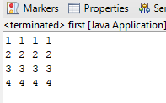

Q3) 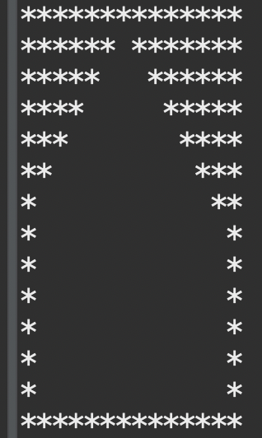

Ans) code:-

**public** **class** fourth {

**static** **int** *z*=7;

**public** **static** **void** main(String[] args) {

**for**(**int** i=0;i<=14;i++)

{

System.***out***.print("*");

}

System.***out***.println("");

**for**(**int** i=7;i>0;i--)

{

**for**(**int** a=0;a<i;a++)

{

System.***out***.print("*");

}

**for**(**int** j=0;j<=7-i;j++)

{

System.***out***.print(" ");

}

**for**(**int** j=0;j<=7-i-1;j++)

{

System.***out***.print(" ");

}

**for**(**int** j=0;j<i;j++)

{

System.***out***.print("*");

}

System.***out***.println("");

}

**for**(**int** i=0;i<6;i++)

{

**for**(**int** j=0;j<=14;j++)

{

**if**(j==0||j==14){

System.***out***.print("*");

}

**else**

{

System.***out***.print(" ");

}

}

System.***out***.println("");

}

**for**(**int** r=0;r<=14;r++)

{

System.***out***.print("*");

}

}

}

Output:-

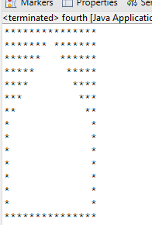

Q4) 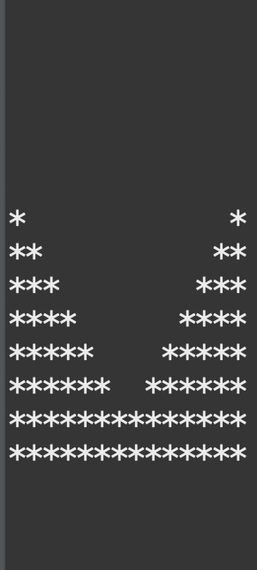

Ans) code:-

**public** **class** second {

**public** **static** **void** main(String[] args) {

// **TODO** Auto-generated method stub

**int** n=7;

**for**(**int** i=0;i<n;i++)

{

**for**(**int** j=0;j<n;j++)

{

System.***out***.print(" ");

}

System.***out***.println("");

}

**for**(**int** i=0;i<n;i++)

{

**for**(**int** j=0;j<i+1;j++)

{

System.***out***.print("*");

}

**for**(**int** k=1;k<n-i;k++)

{

System.***out***.print(" ");

}

**for**(**int** k=1;k<n-i;k++)

{

System.***out***.print(" ");

}

**for**(**int** j=0;j<i+1;j++)

{

System.***out***.print("*");

}

System.***out***.println("");

}

**for**(**int** i=0;i<2*n;i++)

{

System.***out***.print("*");

}

}

}

Output:-

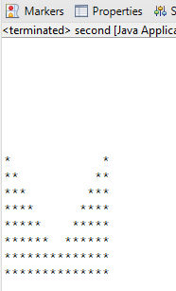

Q5) 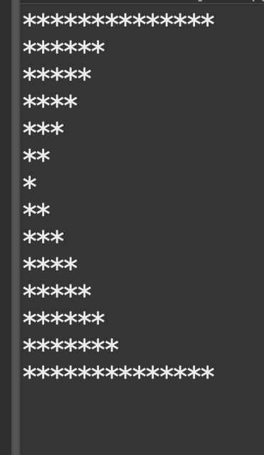

Ans)code:-

**public** **class** third {

**public** **static** **void** main(String[] args) {

**for**(**int** i=0;i<7;i++)

{

**if**(i==0)

{

**for**(**int** j=0;j<2*7;j++)

{

System.***out***.print("*");

}

System.***out***.println("");

}

**else**

{

**for**(**int** j=0;j<7-i+1;j++)

{

System.***out***.print("*");

}

System.***out***.println("");

}

}

**for**(**int** i=0;i<8;i++)

{

**if**(i+1!=8)

{

**for**(**int** k=0;k<i+1;k++)

{

System.***out***.print("*");

}

System.***out***.println("");

}

**else**

{

**for**(**int** s=0;s<=2*7;s++)

{

System.***out***.print("*");

}

}

}

}

}

Output:-

