**Assignment-2(Solution)**

Ans)code:-

import java.util.Scanner;

import java.lang.Math;

class Guesser

{

int guessNum;

public int guessNumber()

{

Scanner scan=new Scanner(System.in);

System.out.println("Guesser kindly guess the number");

guessNum=scan.nextInt();

while(guessNum<0)

{

guessNum=scan.nextInt();

}

return guessNum;

}

}

class Player

{

int pguessNum;

int rank;

public int guessNumber()

{

Scanner scan=new Scanner(System.in);

System.out.println("Player kindly guess the number");

pguessNum=scan.nextInt();

while(pguessNum<0)

{

pguessNum=scan.nextInt();

}

return pguessNum;

}

}

class Umpire

{

int numFromGuesser;

int numFromPlayer1;

int numFromPlayer2;

int numFromPlayer3;

int pdiff1=Math.abs(numFromGuesser-numFromPlayer1);

int pdiff2=Math.abs(numFromGuesser-numFromPlayer2);

int pdiff3=Math.abs(numFromGuesser-numFromPlayer3);

int ranks[] = new int[3];

public void collectNumFromGuesser()

{

Guesser g=new Guesser();

numFromGuesser=g.guessNumber();

}

public void collectNumFromPlayer()

{

Player p1=new Player();

Player p2=new Player();

Player p3=new Player();

numFromPlayer1=p1.guessNumber();

numFromPlayer2=p2.guessNumber();

numFromPlayer3=p3.guessNumber();

}

void compare()

{

if(numFromGuesser==numFromPlayer1)

{

if(numFromGuesser==numFromPlayer2 && numFromGuesser==numFromPlayer3)

{

System.out.println("Game tied all three players guessed correctly");

ranks[0]=1;

ranks[1]=1;

ranks[2]=1;

}

else if(numFromGuesser==numFromPlayer2)

{

System.out.println("Player 1 and Player2 won the game");

ranks[0]=1;

ranks[1]=1;

ranks[2]=2;

}

else if(numFromGuesser==numFromPlayer3)

{

System.out.println("Player 1 and Player3 won ");

ranks[0]=1;

ranks[1]=2;

ranks[2]=1;

}

else

{

System.out.println("Player 1 won the game");

if(pdiff2<=pdiff3)

{

if(pdiff2<pdiff3)

{

ranks[0]=1;

ranks[1]=2;

ranks[2]=3;

}

else if(pdiff2==pdiff3)

{

ranks[0]=1;

ranks[1]=2;

ranks[2]=2;

}

else

{

ranks[0]=1;

ranks[2]=2;

ranks[1]=3;

}

}

}

}

else if(numFromGuesser==numFromPlayer2)

{

if(numFromGuesser==numFromPlayer3)

{

System.out.println("Player 2 and Player3 won the game");

ranks[0]=2;

ranks[1]=1;

ranks[2]=1;

}

else

{

System.out.println("Player 2 won the game");

if(pdiff1<=pdiff3)

{

if(pdiff1<pdiff3)

{

ranks[0]=2;

ranks[1]=1;

ranks[2]=3;

}

else if(pdiff2==pdiff3)

{

ranks[0]=2;

ranks[1]=1;

ranks[2]=2;

}

else

{

ranks[0]=3;

ranks[2]=2;

ranks[1]=1;

}

}

}

}

else if(numFromGuesser==numFromPlayer3)

{

System.out.println("Player 3 won the game");

if(pdiff1<=pdiff2)

{

if(pdiff1<pdiff2)

{

ranks[0]=2;

ranks[1]=3;

ranks[2]=1;

}

else if(pdiff2==pdiff3)

{

ranks[0]=2;

ranks[1]=2;

ranks[2]=1;

}

else

{

ranks[0]=3;

ranks[2]=1;

ranks[1]=2;

}

}

}

else

{

System.out.println("Game lost! try again , but ranking will be there accordingly");

if((pdiff1==pdiff2)&&(pdiff1==pdiff3))

{

ranks[0]=1;

ranks[1]=1;

ranks[2]=1;

}

else if(pdiff1==pdiff2)

{

if(pdiff1<pdiff3) {

ranks[0]=1;

ranks[1]=1;

ranks[2]=2;

}

else

{

ranks[0]=1;

ranks[1]=2;

ranks[2]=1;

}

}

else if(pdiff1==pdiff3)

{

if(pdiff1<pdiff2)

{

ranks[0]=1;

ranks[2]=1;

ranks[1]=2;

}

else

{

ranks[1]=1;

ranks[0]=2;

ranks[2]=2;

}

}

else if((pdiff1<pdiff2)&&(pdiff1<pdiff3))

{

if(pdiff2<pdiff3)

{

ranks[0]=1;

ranks[1]=2;

ranks[2]=3;

}

else

{

ranks[0]=1;

ranks[1]=3;

ranks[2]=2;

}

}

else if(pdiff2<pdiff3)

{

if(pdiff1<pdiff3)

{

ranks[0]=2;

ranks[1]=1;

ranks[2]=3;

}

else

{

ranks[1]=1;

ranks[0]=3;

ranks[2]=2;

}

}

else

{

if(pdiff1<pdiff2)

{

ranks[0]=2;

ranks[1]=3;

ranks[2]=1;

}

else

{

ranks[0]=3;

ranks[1]=2;

ranks[2]=1;

}

}

}

}

void printingRanking()

{

System.out.println("Ranking of the players are:-");

System.out.println("PLAYERS\t\t\tRANKING");

System.out.println("-----------------------------------");

System.out.print("Player 1\t\t");

System.out.println(ranks[0]);

System.out.print("Player 2\t\t");

System.out.println(ranks[1]);

System.out.print("Player 3\t\t");

System.out.println(ranks[2]);

}

}

public class Launchgame {

public static void main(String[] args) {

// TODO Auto-generated method stub

Umpire u=new Umpire();

u.collectNumFromGuesser();

u.collectNumFromPlayer();

u.compare();

u.printingRanking();

}

}

Output:-

Different scenarios of output:-

1. 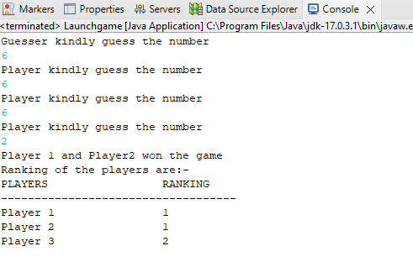

2) 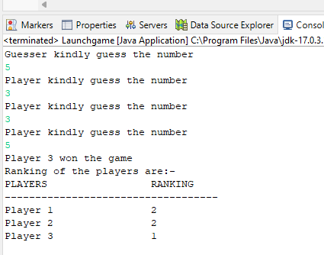

3) 