tar -xvzf community_images.tar.gz

cp default.settings.php settings.php

https://10.10.222.214/drupal-8.3.5/index.php/admin

1. Take backup of database before making any of the below changes.

2. cd /[drupal-home] composer remove drupal/globallink with data

3. composer remove drupal/tmgmt

4. composer require drupal/tmgmt:1.x-dev

5. composer require drupal/globallink

6. cd /[drupal-home]/modules/(contib)/tmgmt

7. git reset --hard (If any local code changes have been made in tmgmt code, only then run this command)

8. curl https://www.drupal.org/files/issues/support_translatable-2903783-7.patch | patch -p1(this is a old patch

New 2 patch given on 29th Aug

9. cd /[drupal-home]/modules/(contib)/globallink

10. curl https://www.drupal.org/files/issues/globallink-job-no-translator-2905342-2.patch |patch -p1

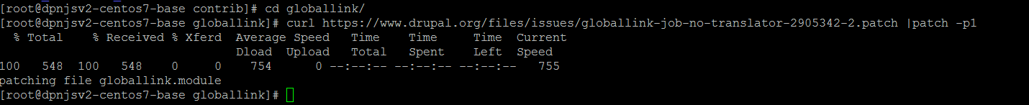

11. cd /[drupal-home]/modules/(contib)/tmgmt

Curl <https://www.drupal.org/files/issues/support_translatable-2903783-10.patch> |patch -p1

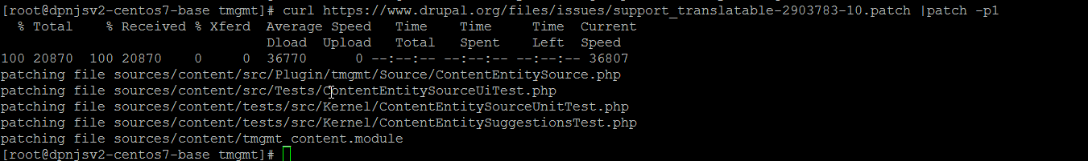

composer update --with-dependencies(first remove composer.lock file and vendors and then run this command to update these files again.)

I am able to reproduce the error on our instance

For a content type added a new field Content_ref for which ‘Users may translate this field’ is not checked

The website encountered an unexpected error. Please try again later.  
  
*InvalidArgumentException*: The URI 'íîntéérnãäl:/één/íînvééstöõrs/cöõrpöõrãätéé-göõvéérnãäncéé/géénéérãäl-méééétíîngs#sýúb-ãärtíîcléé-1851' is invalid. You must use a valid URI scheme. in *Drupal\Core\Url::fromUri()* (line *281* of *core/lib/Drupal/Core/Url.php*).

Drupal\link\Plugin\Field\FieldType\LinkItem->getUrl() (Line: 241)

Drupal\link\Plugin\Field\FieldFormatter\LinkFormatter->buildUrl(Object) (Line: 179)

Drupal\link\Plugin\Field\FieldFormatter\LinkFormatter->viewElements(Object, 'fi') (Line: 80)

Drupal\Core\Field\FormatterBase->view(Object, 'fi') (Line: 259)

Drupal\Core\Entity\Entity\EntityViewDisplay->buildMultiple(Array) (Line: 320)

Drupal\Core\Entity\EntityViewBuilder->buildComponents(Array, Array, Array, 'liftup') (Line: 24)

Drupal\node\NodeViewBuilder->buildComponents(Array, Array, Array, 'liftup') (Line: 263)

Drupal\Core\Entity\EntityViewBuilder->buildMultiple(Array) (Line: 220)

Drupal\Core\Entity\EntityViewBuilder->build(Array)

call_user_func(Array, Array) (Line: 376)

Drupal\Core\Render\Renderer->doRender(Array, ) (Line: 195)

Drupal\Core\Render\Renderer->render(Array) (Line: 490)

Drupal\Core\Template\TwigExtension->escapeFilter(Object, Array, 'html', NULL, 1) (Line: 72)

__TwigTemplate_60593d4a11880d51dd0c0155e05b958888146e54ffcc059dc07f0c3df95a211b->doDisplay(Array, Array) (Line: 379)

Twig_Template->displayWithErrorHandling(Array, Array) (Line: 347)

Twig_Template->display(Array) (Line: 358)

Twig_Template->render(Array) (Line: 64)

twig_render_template('themes/vaisala/templates/field/field.html.twig', Array) (Line: 384)

Drupal\Core\Theme\ThemeManager->render('field', Array) (Line: 435)

Drupal\Core\Render\Renderer->doRender(Array, ) (Line: 195)

Drupal\Core\Render\Renderer->render(Array) (Line: 590)

Drupal\Core\Template\TwigExtension->renderVar(Array) (Line: 133)

__TwigTemplate_ffa040f9e00286fd71ffce3a87a566bc4dbcbd2dd1f6481f0b2f8dc4dc80cda0->doDisplay(Array, Array) (Line: 379)

Twig_Template->displayWithErrorHandling(Array, Array) (Line: 347)

Twig_Template->display(Array) (Line: 358)

Twig_Template->render(Array) (Line: 64)

twig_render_template('themes/vaisala/templates/node/node--basic-page.html.twig', Array) (Line: 384)

Drupal\Core\Theme\ThemeManager->render('node', Array) (Line: 435)

Drupal\Core\Render\Renderer->doRender(Array, ) (Line: 195)

Drupal\Core\Render\Renderer->render(Array, ) (Line: 226)

Drupal\Core\Render\MainContent\HtmlRenderer->Drupal\Core\Render\MainContent\{closure}() (Line: 574)

Drupal\Core\Render\Renderer->executeInRenderContext(Object, Object) (Line: 227)

Drupal\Core\Render\MainContent\HtmlRenderer->prepare(Array, Object, Object) (Line: 117)

Drupal\Core\Render\MainContent\HtmlRenderer->renderResponse(Array, Object, Object) (Line: 90)

Drupal\Core\EventSubscriber\MainContentViewSubscriber->onViewRenderArray(Object, 'kernel.view', Object) (Line: 111)

Drupal\Component\EventDispatcher\ContainerAwareEventDispatcher->dispatch('kernel.view', Object) (Line: 149)

Symfony\Component\HttpKernel\HttpKernel->handleRaw(Object, 1) (Line: 64)

Symfony\Component\HttpKernel\HttpKernel->handle(Object, 1, 1) (Line: 57)

Drupal\Core\StackMiddleware\Session->handle(Object, 1, 1) (Line: 47)

Drupal\Core\StackMiddleware\KernelPreHandle->handle(Object, 1, 1) (Line: 99)

Drupal\page_cache\StackMiddleware\PageCache->pass(Object, 1, 1) (Line: 78)

Drupal\page_cache\StackMiddleware\PageCache->handle(Object, 1, 1) (Line: 50)

Drupal\ban\BanMiddleware->handle(Object, 1, 1) (Line: 72)

Drupal\shield\ShieldMiddleware->handle(Object, 1, 1) (Line: 47)

Drupal\Core\StackMiddleware\ReverseProxyMiddleware->handle(Object, 1, 1) (Line: 50)

Drupal\Core\StackMiddleware\NegotiationMiddleware->handle(Object, 1, 1) (Line: 23)

Stack\StackedHttpKernel->handle(Object, 1, 1) (Line: 656)

Drupal\Core\DrupalKernel->handle(Object) (Line: 19)

