1. **Explain in your own words and examples, what is Shell Scripting for DevOps.**

**SHELL: -**

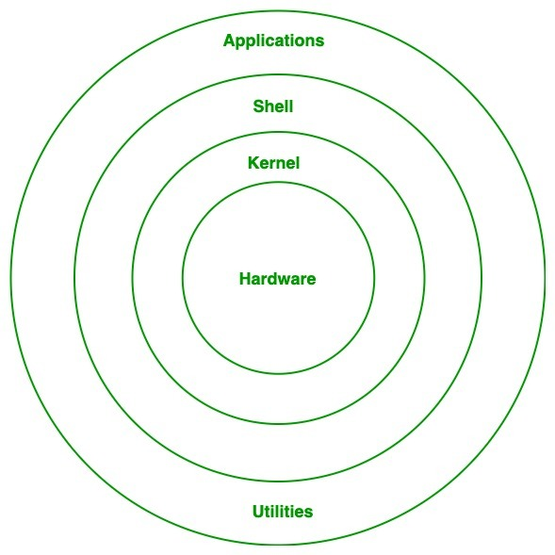

* Shell is responsible to read commands/applications provided by user
* Shell will check whether command is valid or not and whether it is properly used or not. If everything is proper then shell interprets (converts) that command into kernel understandable form. That interpreted command will be handover to kernel.
* Kernel is responsible to execute that command with the help of hardware. Shell acts as interface between user and kernel. Shell & kernel is nothing but operating system.

**Types of Shells:**

There are multiple types of shells are available.

**Bourne Shell:**

* This is the first shell which is developed for UNIX.
* By using sh command we can access this shell.

**BASH Shell:**

* BASH - Bourne Again Shell.
* It is advanced version of Bourne Shell.
* This is the default shell for most of the Linux flavours.
* By using bash command, we can access this shell.

**Korn Shell:**

* It is developed by David Korn.
* Mostly this shell used in IBM AIX operating system.
* By using ksh command, we can access this shell.

**CShell:**

* Developed by Bill Joy.
* C meant for California University.
* It is also by default available with UNIX.
* By using csh command, we can access this shell.

**What is Shell Script:**

A sequence of commands saved to a file and this file is nothing but shell script. Inside shell script, we can also use programming features conditional statements, loops, functions etc. Hence, we can write scripts very easily for complex requirements also. Best suitable for automated tasks.

1. **What is #! /bin/bash? can we write #! /bin/sh as well?**

**By using she -bang, we can specify the interpreter which is responsible to execute the script.**

# Sharp

! Bang

#! Sharp Bang or Shebang or Shebang

#! /bin/bash - It means the script should be executed by bash

#! /bin/sh - It means the script should be executed by Bourne Shell

#! /usr/bin/python3 -t means the script should be executed by Python3 interpreter If we write shebang in our script at the time of execution, we are not required to provide command to execute and we can execute script directly.

1. **Write a Shell Script which prints I will complete #90DaysOofDevOps challenge.**

