**Business Intelligence**

**By Devi Sri Charan**

Functional Analysis of Claims Data 2

BI Tool Integration 3

Extract the Data 3

Load the Data into Power BI 3

Data Quality Dashboard 3

KPI Development 3

a. Claim Resolution Efficiency: 3

i. Average time to settle a claim from the date of filing. 3

ii. Percentage of claims settled within the target resolution time. 4

b. Claim Volume Trends: 4

i. Total number of claims filed per month. 4

ii. Percentage change in claims volume month-over-month and year-over-year. 5

c. Financial Indicators 6

i. Total payout for claims per month 6

ii. Average claim payout amount 6

Analytics Assessment 7

Role based access control 8

Dashboard and Reports Access 8

Row Level Security 8

# Functional Analysis of Claims Data

## BI Tool Integration

### Extract the Data

* First, unzip the provided dataset.

### Load the Data into Power BI

* Open Power BI Desktop.
* Click on `Get Data` and choose the appropriate data source (e.g., CSV, Excel) from the unzipped folder.
* Load the data into Power BI.

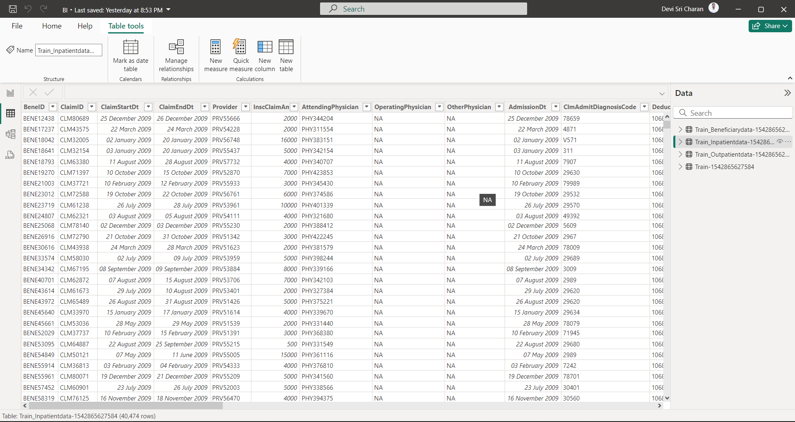

## Data Quality Dashboard

Since the claims management data from MongoDB has client-side and server-side data validation. There are no null values, invalid claim amounts, invalid date ranges etc.

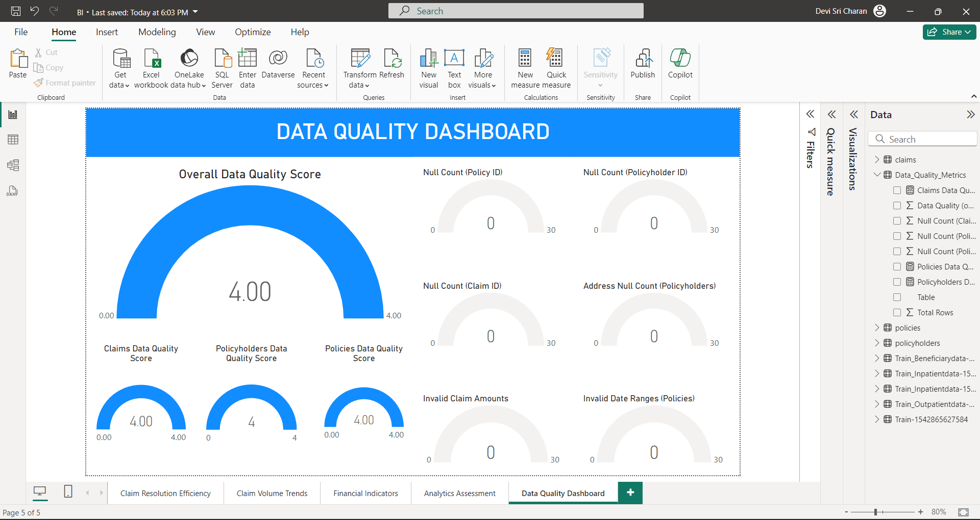

## KPI Development

### a. Claim Resolution Efficiency:

#### i. Average time to settle a claim from the date of filing.

**Create a Calculated Column for Claim Settlement Time**

Go to Modeling -> New Column and enter the following DAX formula:

Claim_Settlement_Time = DATEDIFF(ClaimsTable[ClaimStartDt, ClaimsTable[ClaimEndDt], DAY)

**Add a Card Visualization**

In the Report view, click on Gauge in the Visualizations pane.

Drag the Claim_Settlement_Time column to the Values field to show the average time.

#### ii. Percentage of claims settled within the target resolution time.

**Create a Measure for the Percentage:**

Go to Modeling -> New Measure and enter the following DAX formula:

Percentage_Settled_In_Target =   
DIVIDE(COUNTROWS(FILTER(ClaimsTable, ClaimsTable[Claim_Settlement_Time] <= 26)), COUNTROWS(ClaimsTable)  
)  
**Add a Gauge Visualization:**

In the Report view, click on Gauge in the Visualizations pane.

Drag the Percentage_Settled_In_Target measure to the Values field.

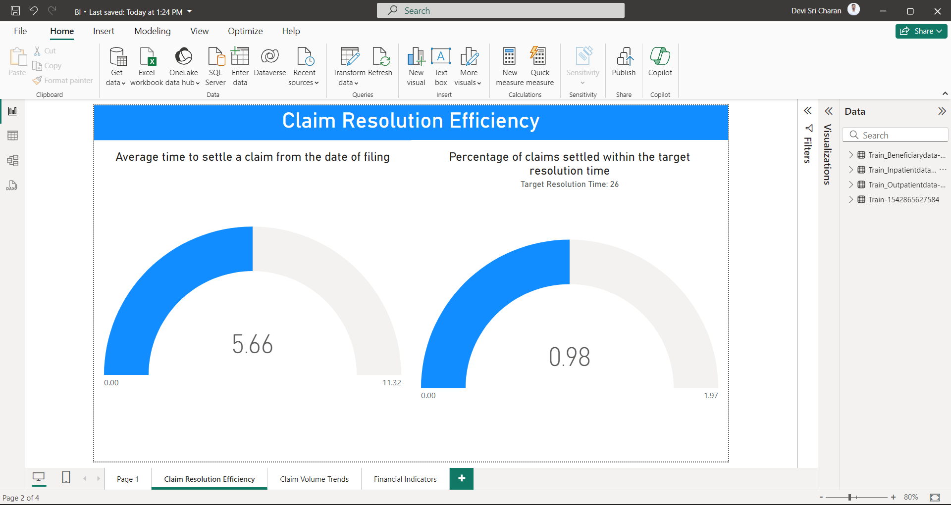

### b. Claim Volume Trends:

#### i. Total number of claims filed per month.

**Create a Bar Chart:**

In the Report view, click on Bar Chart in the Visualizations pane.

Use ClaimStartDt by month on the x-axis and Count of claimID on the y-axis.

#### ii. Percentage change in claims volume month-over-month and year-over-year.

**Create Measures for Month-over-Month and Year-over-Year Changes:**

Go to Modeling -> New Measure and enter the following DAX formulas:

previousMonth =

CALCULATE(

DISTINCTCOUNT(ClaimsTable '[ClaimID]),

DATESINPERIOD(

'Train_Inpatientdata-1542865627584'[ClaimStartDt],

STARTOFMONTH(NEXTMONTH('Train_Inpatientdata-1542865627584'[ClaimStartDt])),

-1,

MONTH

)

)

MoM =

DIVIDE(

DISTINCTCOUNT('Train_Inpatientdata-1542865627584'[ClaimID]) - [previousMonth],

[previousMonth],

0

) * 100

**Create a Chart:**

Display the MoM changes over time using the Line Chart visualization.

For YoY changes over time: Select ClaimStartDt as Year on x-axis and Count of claimID column on y-axis using the Bar Chart visualization

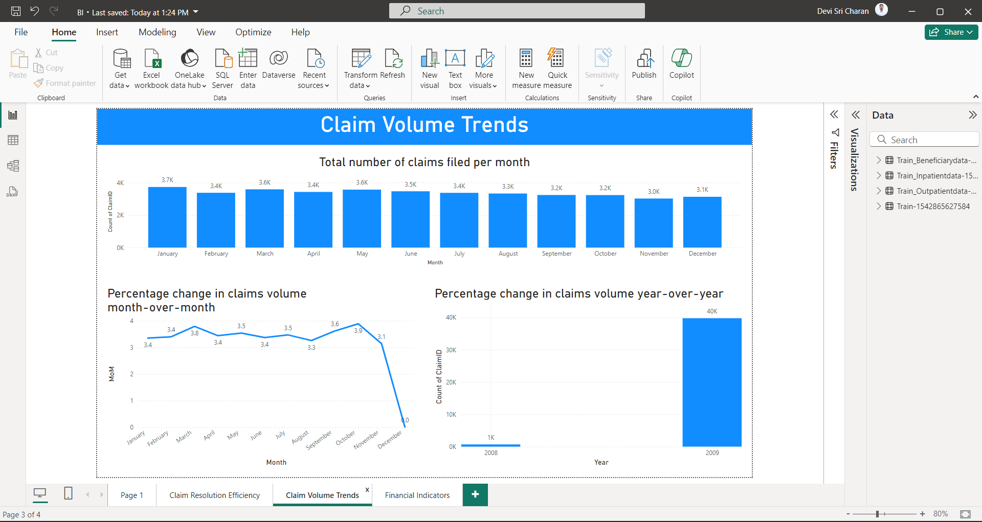

### c. Financial Indicators

#### i. Total payout for claims per month

Select InscClaimAmtReimbursed as SUM on y-axis and ClaimStartDt as

month column on x-axis.

#### ii. Average claim payout amount

Select InscClaimAmtReimbursed as Average using Gauge Visualization.

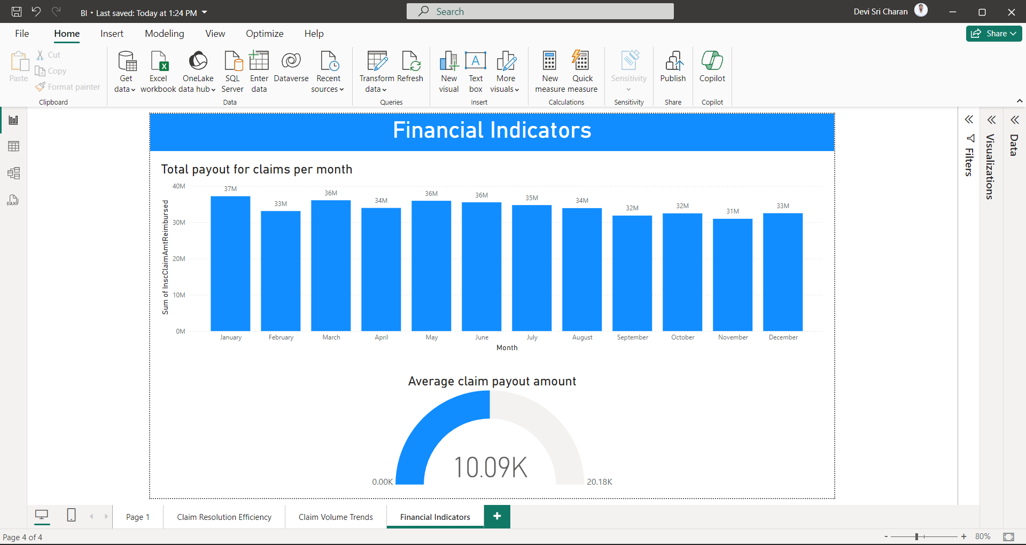

## Analytics Assessment

a) Select a Pie Chart and on it use legend as status column and values as count of claimID.

b) Create a new column HighCostClaim.

HighCostClaim = IF(ClaimsTable[InscClaimAmtReimbursed] > 25000, "High Cost", "Standard Cost")

Select ClaimEndDt as month on x-axis and count of InscClaimAmtReimbursed on Y-axis. Use legend as HighCostClaim column 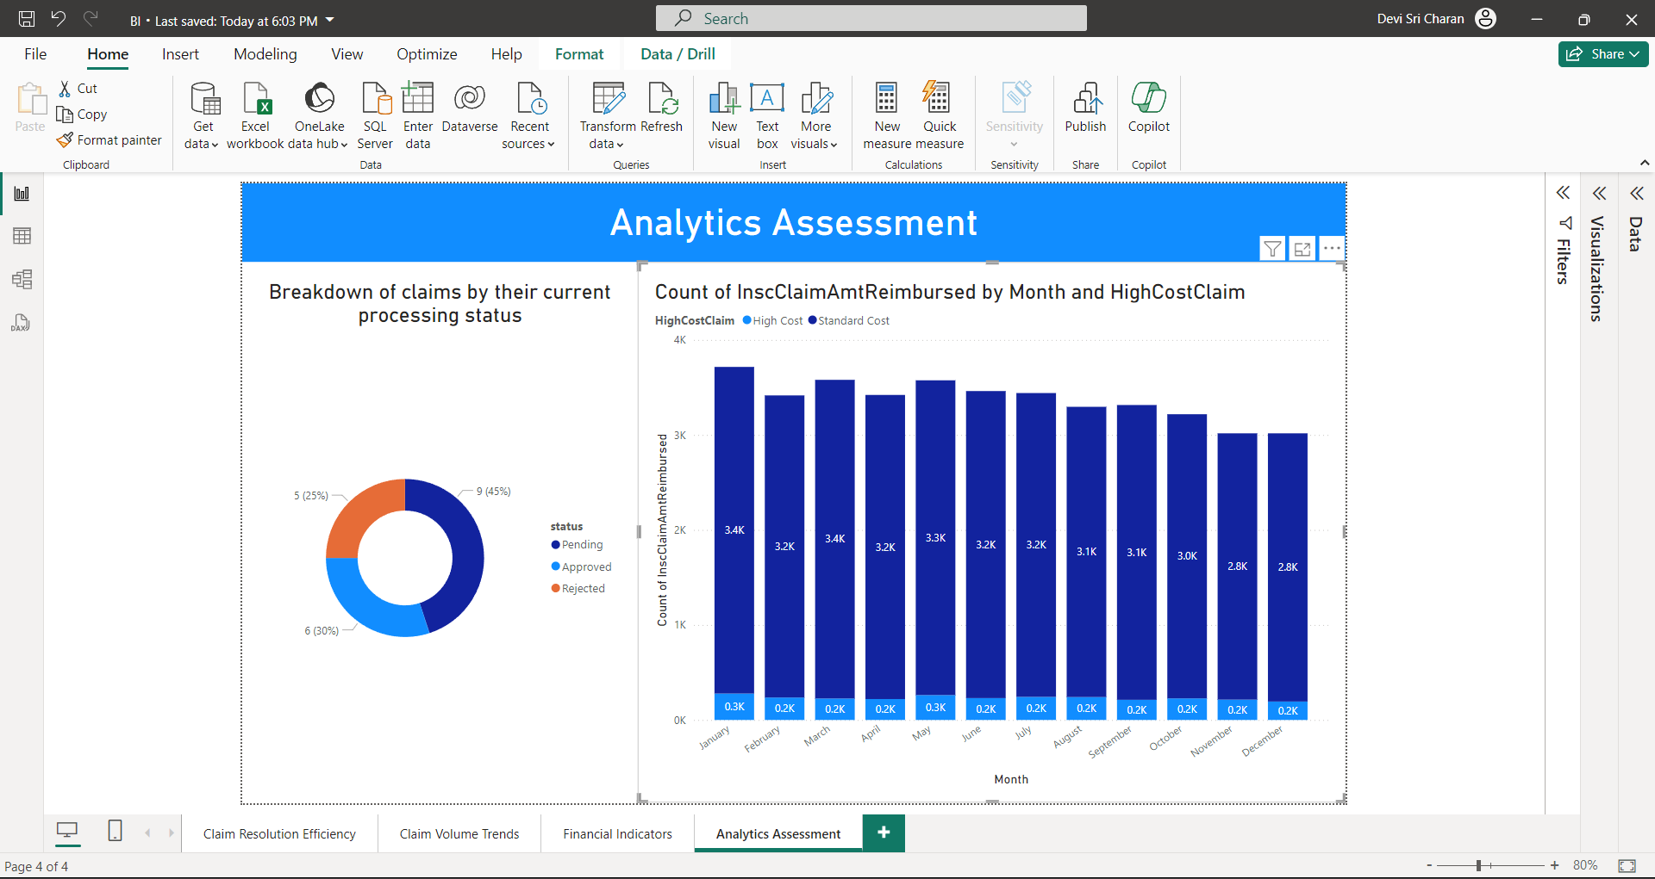

## Role based access control

### Dashboard and Reports Access

Save the .pbix file to OneDrive. Then create a workspace and publish the file to PowerBI. There we can add people and give access to view or edit or as admin.

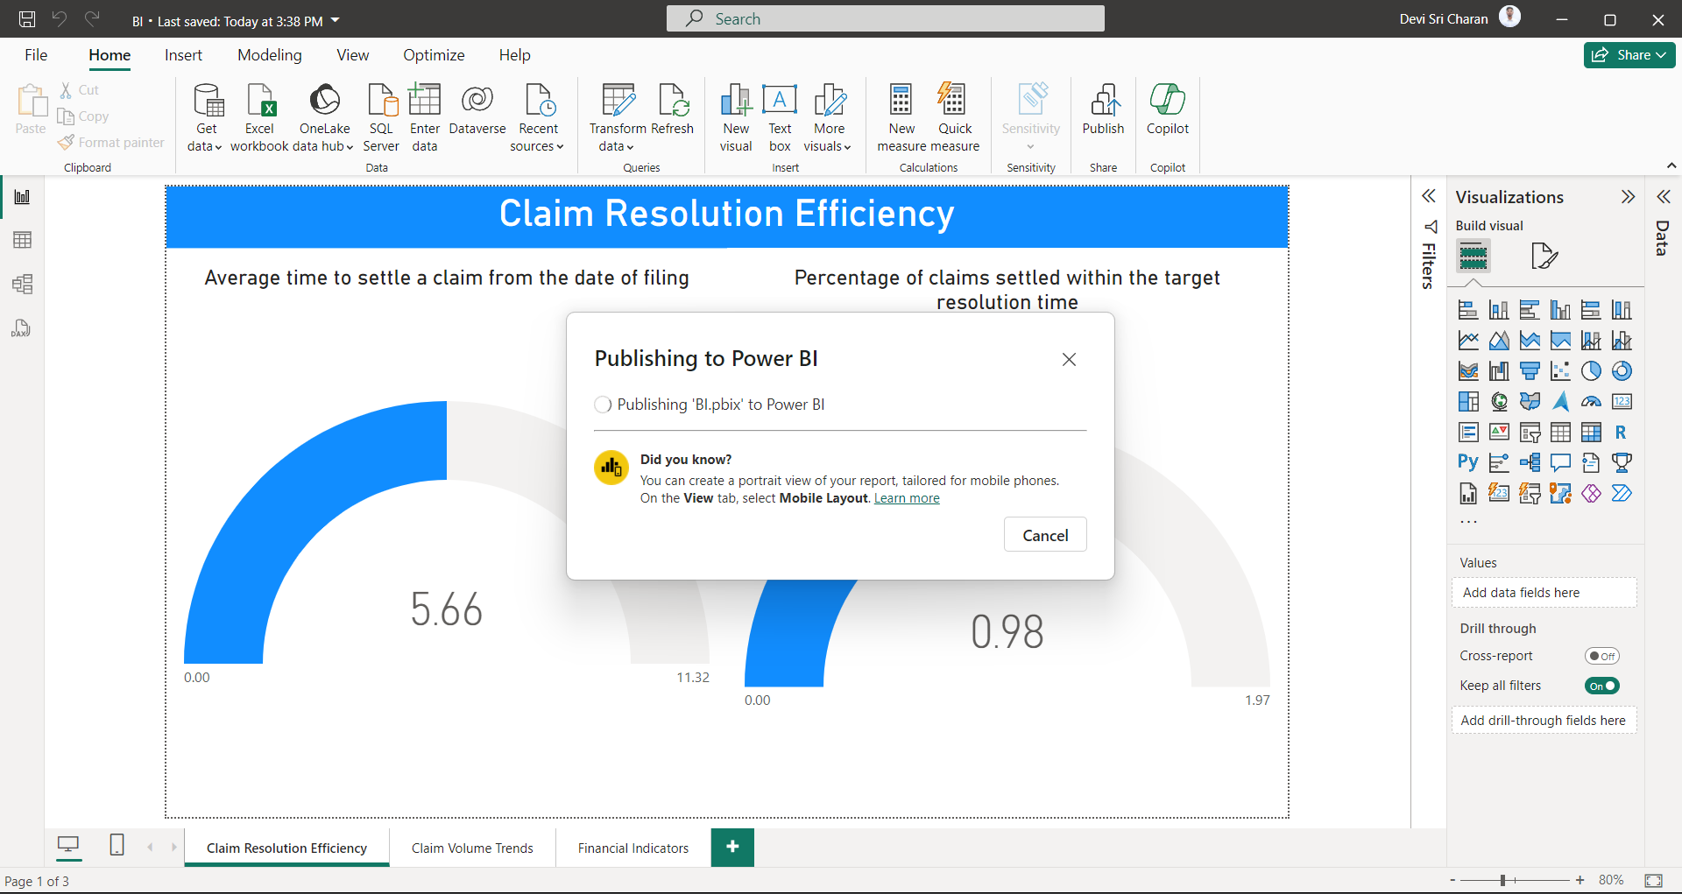

### Row Level Security

1. Go to manage roles in Modelling section.
2. Add new roles
3. Select the table where you want to apply.
4. For role Viewer 1 in Train Inpatient Table the viewer sees charts that contain data of table with claimTable[ClaimStartDt] after "05-02-2009"

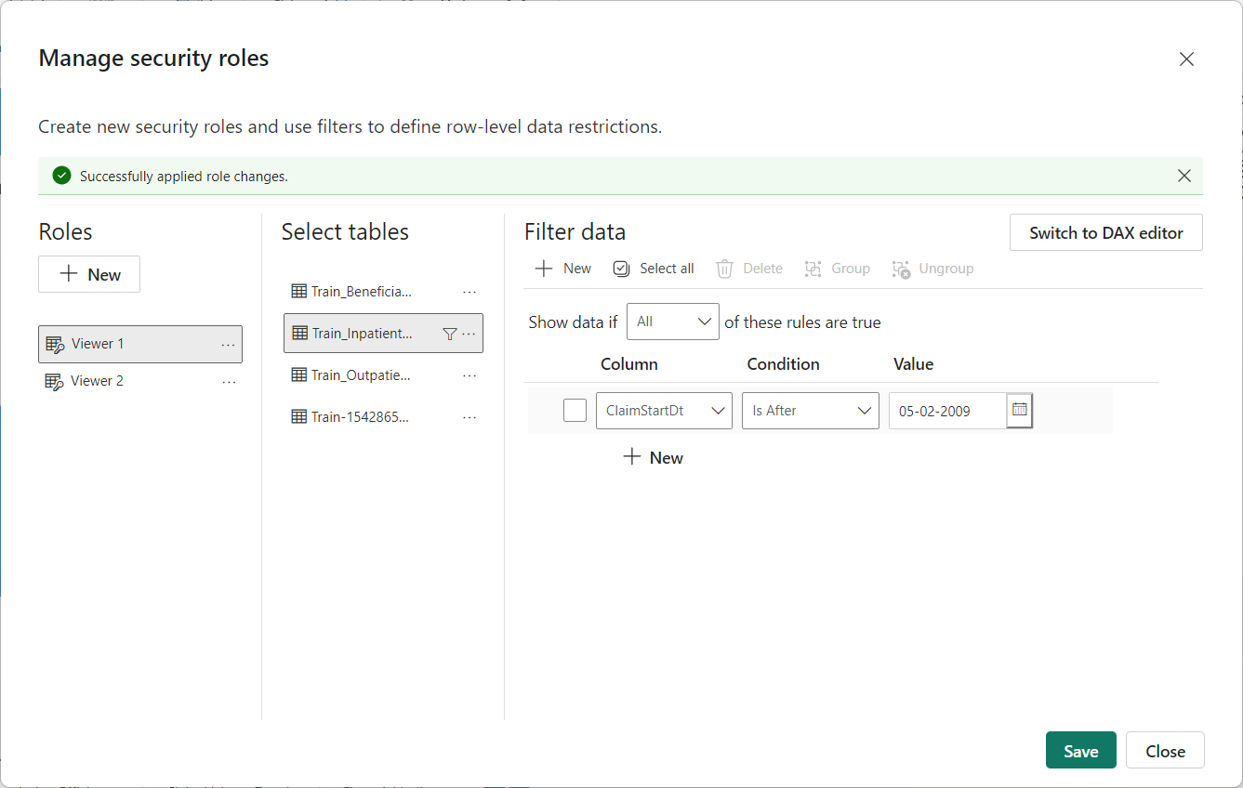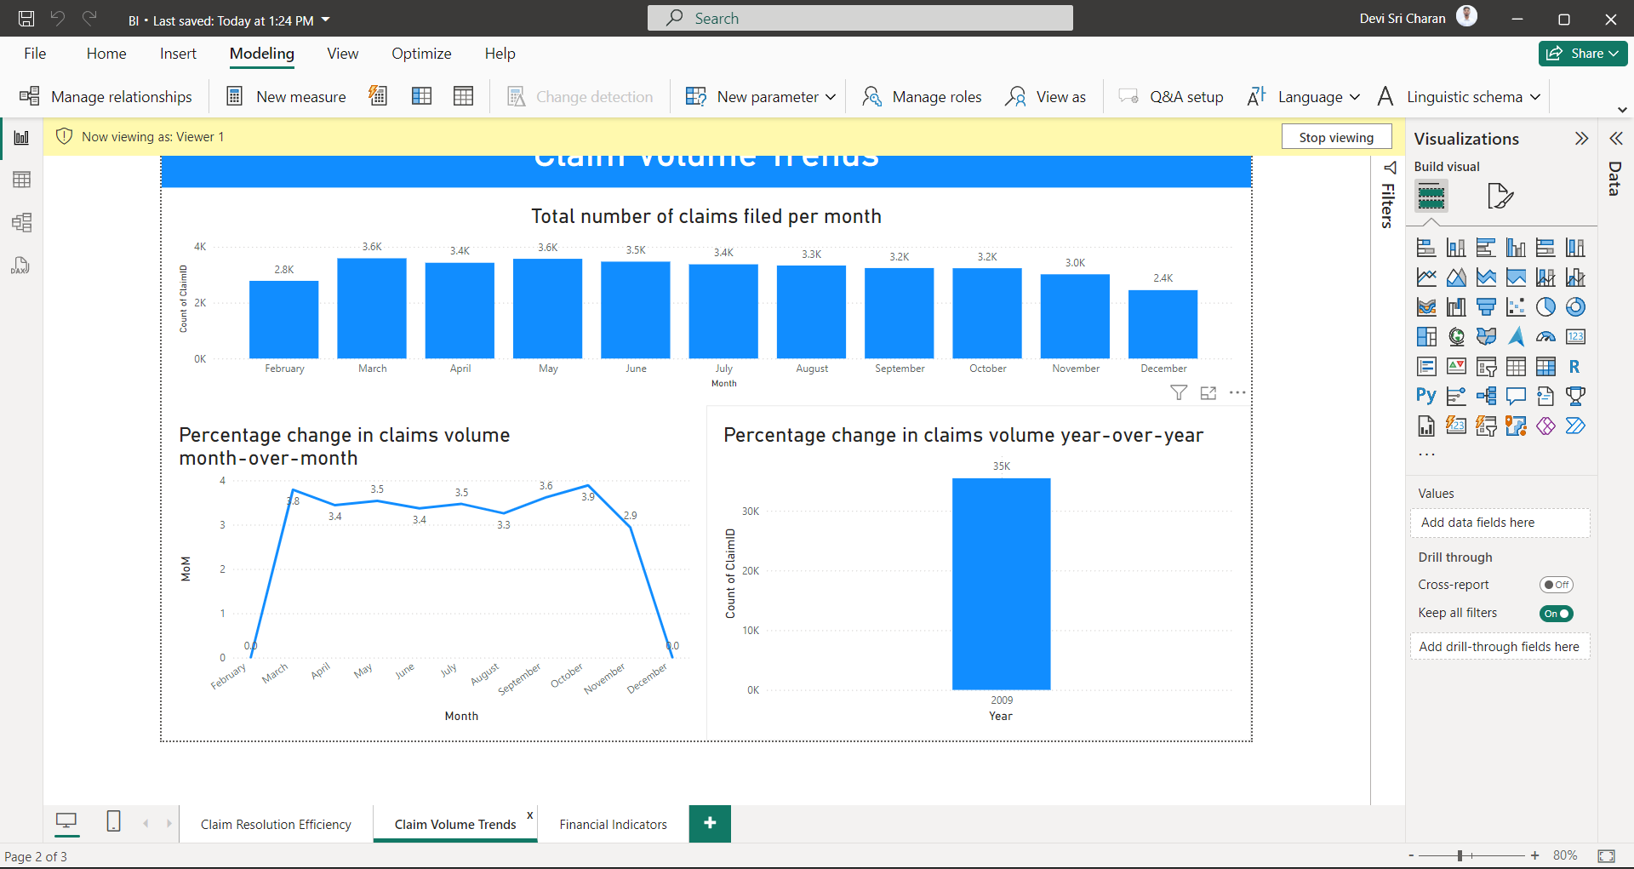

### Column Level Security

1. Download Tabular Editor
2. Go to External Tools > Go to Tabular Editor
3. Select the Tables
4. Select the Column you want.
5. Go to Object Level Security
6. Now for the role you want to restrict give value None.