**Data Engineering**

**By Devi Sri Charan**

Claims Management Data Engineering for Analytics 2

Incremental Update Mechanism Development 3

Implementation: 3

Code Snippet: 3

Data Format Implementation 4

Implementation: 4

Code Snippet: 4

Data Quality Automation 5

Implementation: 5

Code Snippet: 5

Data Transformation 6

a. Dataset Creation 6

Implementation: 6

Code Snippet: 6

b. PII Data Encryption and Masking 6

Implementation: 6

Code Snippet: 6

Workflow Orchestration 6

Implementation: 6

Code Snippet: 6

# Claims Management Data Engineering for Analytics

## Incremental Update Mechanism Development

To reliably identify and extract new or updated entries from the database, I used the `updatedAt` timestamp from MongoDB. I created a Python function to query entries that have changed since the last run.

### Implementation:

* **Function: get_last_run_date()**: Retrieves the timestamp of the last successful run to ensure only new or updated entries are processed.
* **Function: update_last_run_date()**: Updates the timestamp of the last successful run.
* **Function: extract_incremental_updates()**:
  + Utilizes the last run date to query the MongoDB database for entries in claims, policies, and policyholders tables that have been updated since the last run.
  + Converts the queried data into pandas DataFrames and saves them as JSON files for further processing.
  + Updates the last run date upon successful extraction.

### Code Snippet:

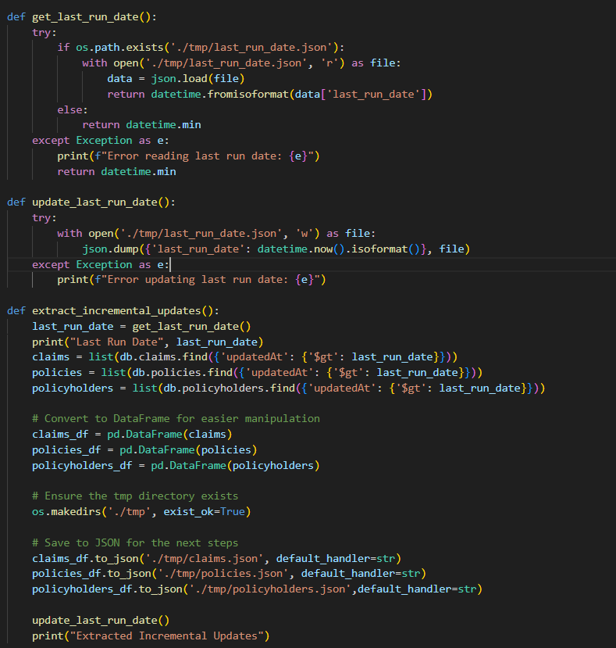

## Data Format Implementation

### Implementation:

* **Function: save_data_formats()**:
  + Reads the previously saved JSON files.
  + Converts the data into CSV and Parquet formats, providing flexibility and efficiency in data storage and access.

### Code Snippet:

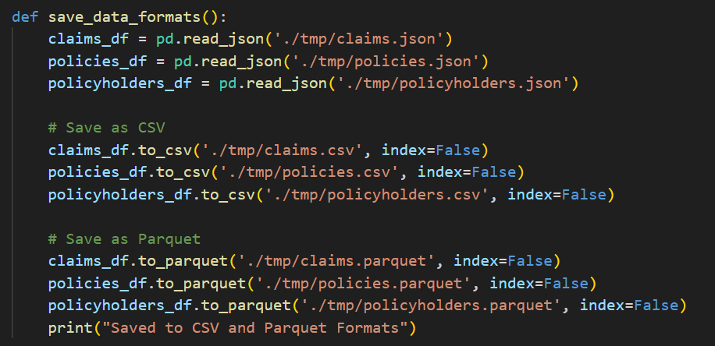

## Data Quality Automation

### Implementation:

* **Function: data_quality_checks()**:
  + Performs various checks on the claims and policies DataFrames, including:
    - Null value checks.
    - Date range validation.
    - Duplicate value checks.
    - Reference validity checks.
    - Claim amount validation against policy coverage.
  + Raises errors if any check fails to ensure data quality.

### Code Snippet:

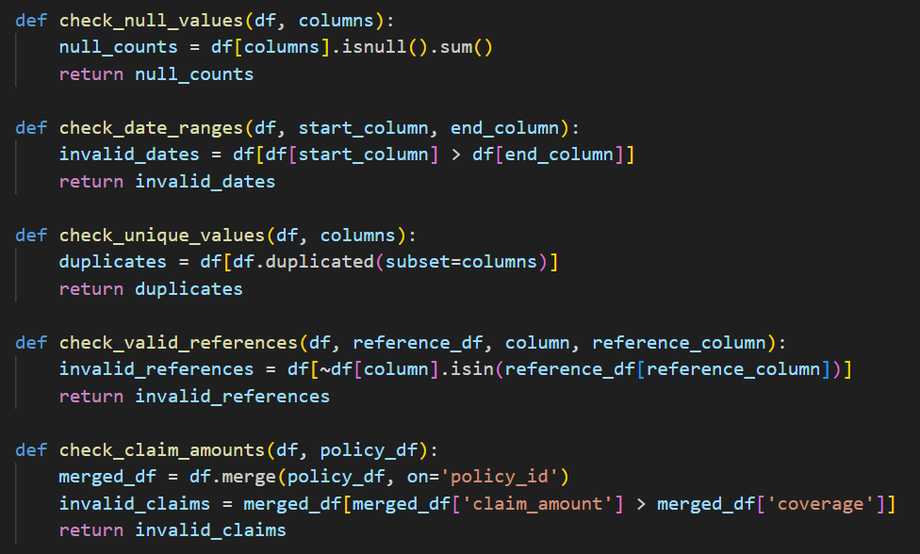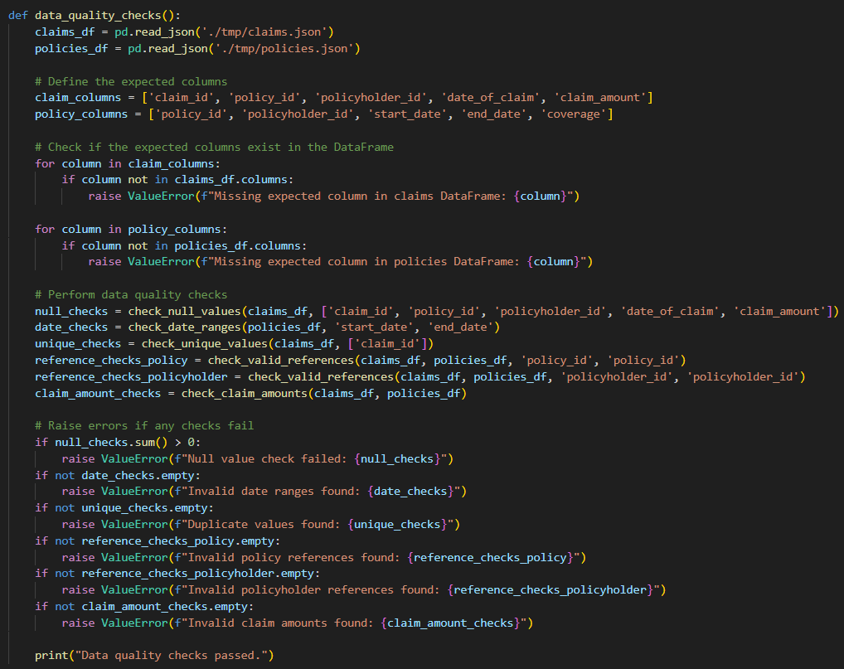

## Data Transformation

### a. Dataset Creation

#### Implementation:

* **Function: transform_data()**:
  + Merges claims, policies, and policyholders DataFrames to enrich the dataset with policy information.
  + Calculates the number of open and closed claims per policy.
  + Merges the counts back into the policies DataFrame.
  + Saves the transformed data for further processing.

#### Code Snippet:

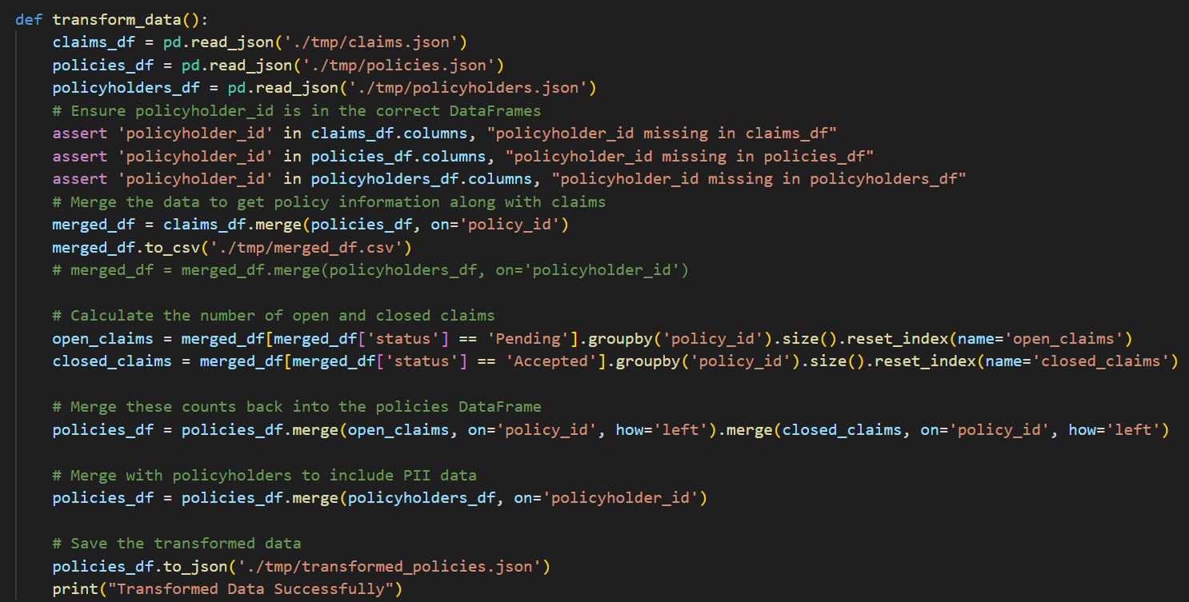

### b. PII Data Encryption and Masking

#### Implementation:

* **Function: encrypt_pii()**:
  + Encrypts sensitive columns in the transformed policies DataFrame using the cryptography library.
  + Saves the encrypted data to a JSON file for secure storage.

#### Code Snippet:

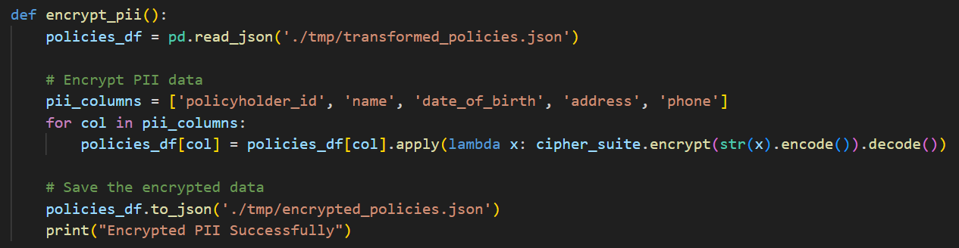

## Workflow Orchestration

### Implementation:

* **Airflow DAG Configuration**:
  + Defines a directed acyclic graph (DAG) to schedule and execute the data pipeline tasks sequentially.
  + Tasks include extraction, data format conversion, data quality checks, data transformation, and PII encryption.
  + Error handling and logging are integrated into each task to ensure robust execution and monitoring.

### Code Snippet:

